Excel Is Fun!
Excel 2003

How to build efficient systems of spreadsheets to save time, get promoted and have extra time for vacation

An Excel book that takes you from the beginning theories of how to construct efficient systems of spreadsheets towards the Beautiful Excel infinity at the other end

By Michael “Excel Is Fun!” Girvin

Warning, because this book is free, I could not afford an editor. So you will have to put up with the occasional spelling/grammatical error. If you find any kind of error, please e-mail me at mgirvin@highline.edu.

Dedication:
This book is dedicated to Dennis “Big D” Ho, my step-son, because he loves books so much!
Table of Contents
Introduction 4
What Is Excel? 5
Rows, Columns, Cells, Range Of Cells 6
Worksheet, Sheet Tab, Workbook 7
Menus And The Alt Key 9
Toolbars 10
Save As is different than Save 10
Two Magic Symbols In Excel 11
Math 17
Formulas 21
Functions 26
Cell References 36
Assumption Tables/Sheets 51
Cell Formatting 61
Charts 85
Analyze Data 95
Conclusion: 103

Introduction
Excel is Fun! Why? Because your efficient use of Excel can turn a three hour payroll calculating chore or a five hour reporting task into a five minute breeze. You save a lot of time. That time adds up to extra time for your more enjoyable endeavors in life such as vacations! In addition, your bosses and employees will notice that you are efficient and can produce professional looking reports that impress. This of course leads to promotion more quickly. Still, further, your knowledgeable and efficient use of Excel can land you a job during an interview. Employers are like dry sponges ready to soak up any job candidate that can make their entity more efficient with Excel skills! Save time?, get promoted?, get the job?, and have more time for vacation? – That sounds like a great skill to have!

In the working world, almost everyone is required to use Excel. Amongst the people who are required to use it, very few know how to use it well; and even amongst the people who know it well, very few of those people know how to use it efficiently to the point where grace and beauty can be seen in a simple spreadsheet!

This handout will take you from the very beginning basics of Excel and then straight into a simple set of efficiency rules that will lead you towards Excel excellence.

Rule # 1: Learn Excel well so you can have fun working efficiently, gain promotions quickly, and have more vacation time

What Is Excel?
You use Word to create letters, flyers, books and mail merges. You use PowerPoint to create visual, audio and text presentations. You use Google to research a topic and find the local pizza restaurant. You use Excel to make Calculations, Analyze Data and Create Charts. Although databases (such as Access) are the proper place to store data and create routine calculating queries, many people around the planet earth use Excel to complete these tasks. Excel’s row and column format and ready ability to store data and make calculations make it easy to use when compared to a database program. However, Excel’s essential beauty is that you can make calculations and analyze/manipulate data quickly and easily “on the fly!” This easy to use, planet earth “default” program must be learned if you want to succeed in today’s working world.

Open up The Excel Is Fun!.xls workbook and click on the “What is Excel” sheet tab

Here is an example of how Excel can make payroll calculation quickly and with fewer errors than by hand (Figure 1):
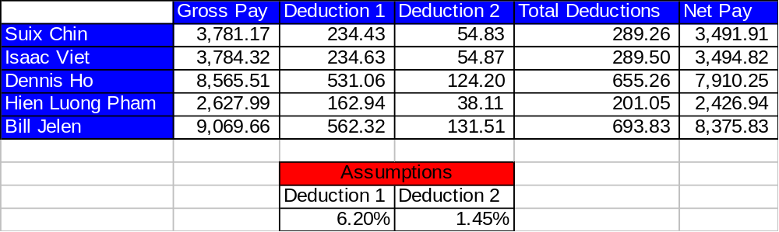

Figure 1
Here is an example of how Excel can manage data, sorting by time, quickly and with fewer errors than by hand (Figure 2 and Figure 3):

Before Sort:
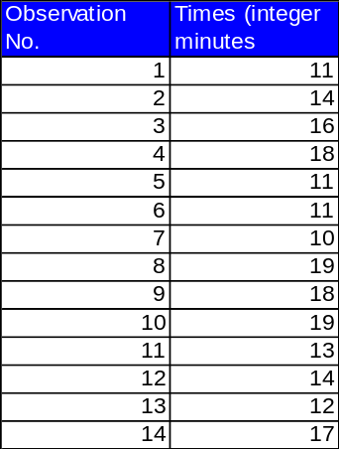

Figure 2
After Sort
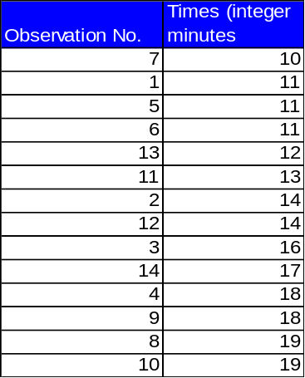

Figure 3

Rows, Columns, Cells, Range Of Cells
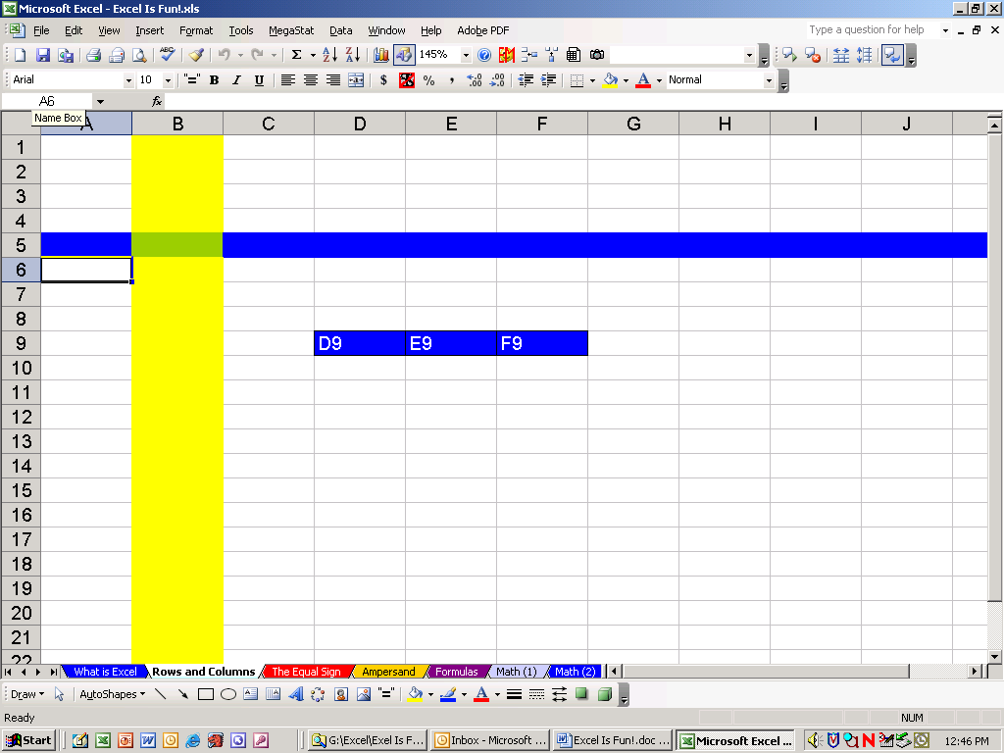

Figure 4
Rows are horizontal and are represented by numbers. In our example (Figure 4) the color blue has been added to show row 5.
Columns are vertical and represented by letters. In our example (Figure 4) the color yellow has been added to show Column B.
A cell is an intersection of a row and a column. In our example the color green has been added to show cell B5. In our example column B and row 5 can be detected because the column and row headers are highlighted in a light-steel-blue color (Figure 4). In addition, you can see that the name box shows that cell B5 is selected (Figure 4 and Figure 5).
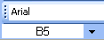

Figure 5
B5 is the name of this cell. It can be thought of as the address for this cell. It is like the intersection of two streets. If we wanted to hang out at the corner of Column B Street and Row 5 Street, we would be hanging out at the cell address B5.
Later when we make calculations in Excel (making formulas), B5 will be called a cell reference.
A range of cells is two or more cells that are adjacent. For example you can see three blue cells D9, E9, and F9. This range would properly be expressed as D9:F9, where the colon means from cell D9 all the way to cell F9

Worksheet, Sheet Tab, Workbook
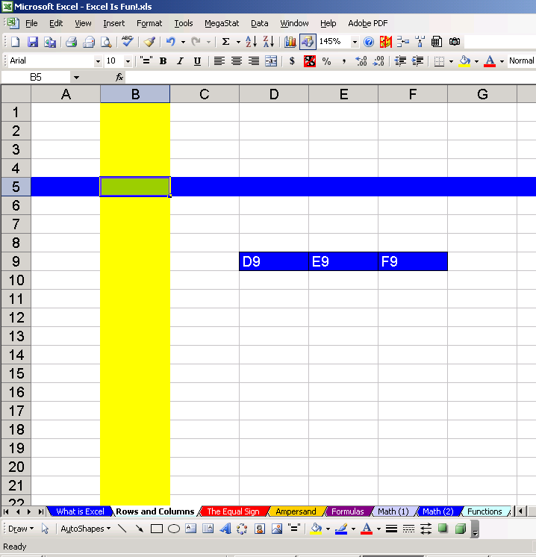

Figure 6
A worksheet is all the cells (65536 rows, 256 columns worth of cells). A worksheet is commonly referred to as “sheet.”
The Sheet tab is the name of the sheet. By default they are listed as Sheet1, Sheet2. In our example (Figure 6) the sheet we are viewing is named “Rows and Columns.” You can see other worksheets that have been given names in our example. Can you say what they are?

Rule # 2 = Always name your worksheets so that you can identify amongst the various worksheets
Naming your sheets helps you to keep track of things in a methodical way. Navigating through a workbook, understanding formulas and creating headers/footers is greatly enhanced when you name sheets. To name your sheet, double-click the sheet tab (this highlights the sheet tab name) and type a logical name that describes the purpose of the sheet. Navigating through a workbook, understanding formulas and creating headers/footers is greatly enhanced when you name sheets.
A workbook is all the sheets (up to 256 worksheets). To name your workbook click the File menu and then Save As (Keyboard Shortcut = F12). Figure 7 shows the Save As dialog box:
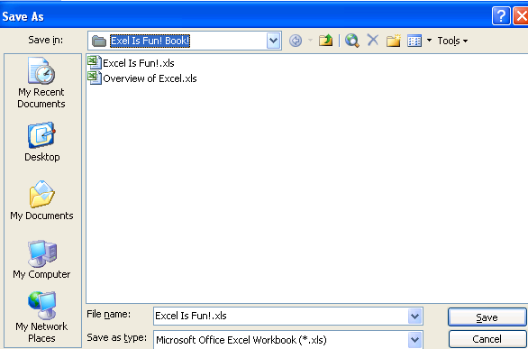

Figure 7
Save in = Where do you want to save it?
File name = what do you want to call it?
Save as type = what type of file is it? (.xls? or .htm? or .xlt?)

Naming your workbook helps you to find it later and helps to create headers/footers.

Rule # 3 = Always name your workbook and save it to a location that you will be able to find later

Menus And The Alt Key
Menus allow you to access many of Excel’s wonderful features. For example, if you want to change the page setup from portrait to landscape, you could click the File menu and then click on Page Setup as seen in Figure 8 Figure 9:
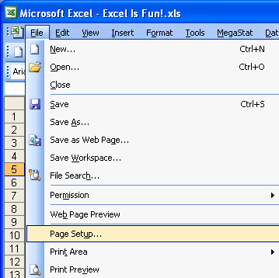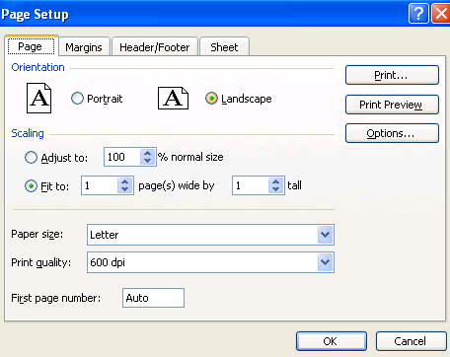

Figure 8 Figure 9
Notice that “File has an underlined F and that Page Setup has an underlined u. Now try to open up Page Setup with this keyboard shortcut: Hold down the Alt key, then tap F once, then tap U once. The keyboard shortcut for opening Page Setup = Alt + F + U.

Also notice in Figure 8 Figure 9 that your menu may not have the MegaStat menu. Don’t be alarmed. Not all menus are exactly the same. This is because you can edit them and personalize them to suit your own needs.

Copy = Ctrl + C

Cut = Ctrl + X

Paste = Ctrl + V

Add bold to cell content = Ctrl + B

Add Underline to cell content = Ctrl + U

Add Italic to cell content = Ctrl + I

Select two cells and everything in-between = Click on first cell, hold Shift, Click on last cell

Select cell ranges that are not next to each other = click on cell or range of cells, Hold Ctrl, click on any number of other cells or range of cells

Ctrl + arrow key = move to end of range of data, or to beginning of next range of data

Rule # 4 = Learn key board shortcuts in order to save time

Toolbars
You can click on toolbar icons to access many of Excel’s wonderful features. For example, you could highlight one cell in the column of times and click the Sort Ascending button as seen in Figure 10 (notice when you hover your cursor over a button, a screen tip pops up and names the button – in our case it says “Sort Ascending”):
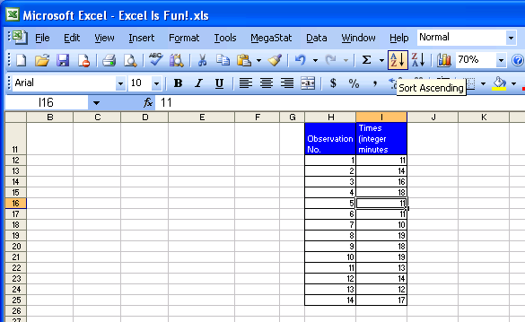

Figure 10
You could also click the Save, Spelling and Undo buttons as seen in Figure 11:
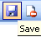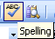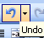

Figure 11
However, instead of using these three buttons learn your keyboard shortcuts: Save = Ctrl + S, Spelling = F7, Undo = Ctrl + Z.
Save and Undo are your best friends. Save often so that when your computer crashes you don’t have to do double work. Use undo when you accidentally do the wrong action. You can also use Save and Undo in tandem: Click Save before you want to try a risky maneuver, then try the risky maneuver up to 16 actions. Then click undo to go back to the point where you saved (the down arrow next to Undo will allow you to highlight a few undoes, click, and that will undo multiple actions).

Look at the toolbar in Figure 10, then go back and look at the toolbar in Figure 6. They are both different (these are actual screen shots from my two different computers). Don’t be alarmed. All toolbars are not the same. This is a good thing because it means that they are customizable (a topic for a later time).

Save As is different than Save
Save updates the already saved file by replacing the stored file with the most recent changes.
Save As gives you the power to: 1) Save the file to a new location 2) save file with a new name 3) change the file type such as a template (.xlt), an earlier version of Excel (Microsoft Excel 5.0/95 Workbook (*.xls)), or a web page (*.htm;*.html). In this way the Save As dialog box is very powerful.

Two Magic Symbols In Excel
The equal sign, “=,” and the join-operator (ampersand), “&,” are two magic symbols in Excel. We will look at the equal sign first.

The equal sign tells Excel to create a formula in a cell. For example, in Figure 12, if you would like to calculate the net pay for Suix Chin in cell F2, what would you need to do? You would need to take the net pay and subtract from it the total deductions. In order to make this calculation in cell F2, you must first tell Excel that you want to make a calculation by typing an equal sign: “=”.
Here are the steps to make your first calculation in Excel:
- Using your “white, diagonally-pointing: cursor click on the sheet tab named “The Equal Sign”. Next, using your “thick, white-cross” cursor (it also has a black shadow) click in cell F2 in order to highlight the cell. See Figure 12. Make sure that the name box shows F2.
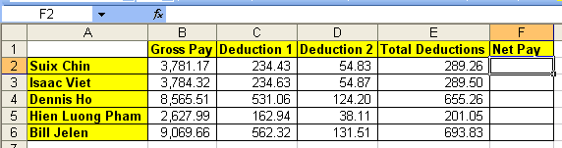

Figure 12
- Type an equal sign. See Figure 13:
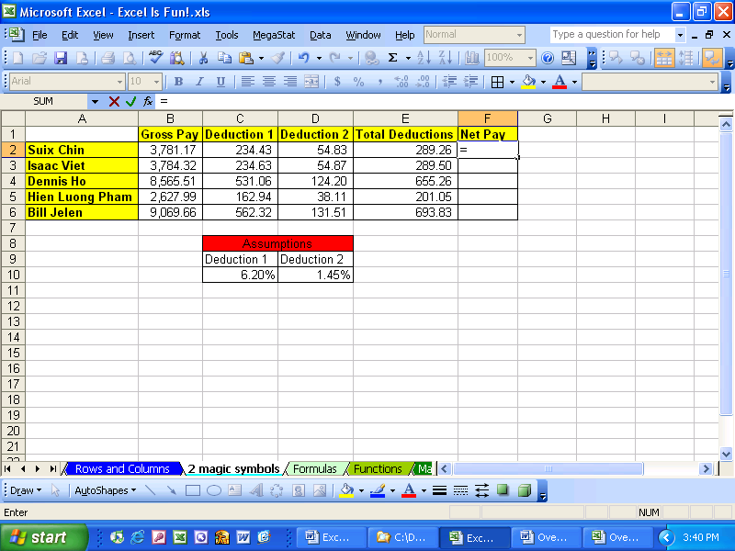

Figure 13
- Notice the equal sign in the formula bar as seen in Figure 14. (Don’t be alarmed that the name box has converted to an “Insert Function” dropdown arrow – we’ll talk about this later).

Figure 14
- Notes:
If you click the red x in Figure 14, you will cancel the formula in the middle of creating it (Shortcut key = Esc)
If you click the green check mark, The formula is entered in the cell and the cell is selected (Shortcut key = hold Ctrl then tap Enter)
The f_{x} is a symbol from algebra that means “f of x”, or function, or formula
- Next, using your “thick, white-cross” cursor, click in cell four to the left of F2 (cell B2). Like magic, Excel inserts the proper CELL REFERENCE after the equal sign (see Figure 15). In addition, Excel shines the blue and yellow flashlight around the cell B2 (these are the colorful marching ants that march around the cell telling you that you have placed the CELL REFERENCE B2 behind the equal sign).
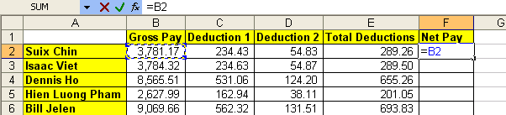

Figure 15
- The formula is now looking at a cell that is four cells to the left of F2 – looking at the cell named B2 which holds Suix Chin’s Gross Pay. Because our goal is to calculate Net Pay, we still have to subtract the Total Deductions.
- Type a minus sign, then using your “thick, white-cross” cursor, click in cell E2, which is one cell to the left of F2. You should see this (Figure 16):
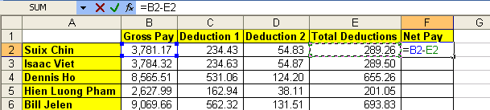

Figure 16
- Hold the Ctrl key, and then tap the Enter key once. This is what you should see (Figure 17):
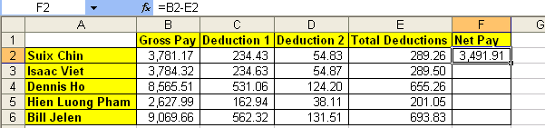

Figure 17
- You have just created your first calculating formula in Excel by using the equal sign as the first character in a cell. Although the cell F2 displays the take home pay of 3,491.91, what is actually in the cell can be seen in the formula bar. Our formula reads: please look at Suix Chin’s Gross Pay (four cells to the left in B2) then subtract the Total Deductions (one cell to the left in E2).
- We have creating our first calculation in Excel, and what we actually created is called a formula. Because the equal sign is the first character in the cell we told Excel to create a formula. If there was no equal sign, there would be no formula. In addition, we used CELL REFERENCES. CELL REFERENCES are our way of telling our formula to look into a different cell and use that value in our formula!

Rule # 5 = When the equal sign is placed as the first character in a cell that has not been pre-formatted as Text, it tells Excel to create a formula.
- What would have happened if you did not place an equal sign in the cell as the first character but you still typed the rest of the formula (Figure 18)? Excel would obey you and not create a formula, but instead place the typed text “B2-E2” in the cell.
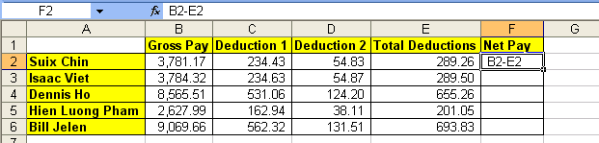

Figure 18

- What would happen if you type the number for gross pay and the number for total deductions in the formula instead of the cell references? Here is an example of this situation, however, please burn this image into you brain as something you should NEVER do (Figure 19):
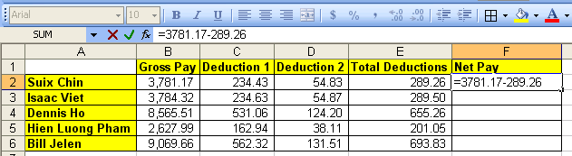

Figure 19

- Excel will obey you and calculate an answer. However, if you want to become even moderately efficient with using Excel, NEVER TYPE NUMBERS THAT CAN VARY INTO A FORMULA. When you enter numbers that can change (or text) into formulas instead of references to other cells:
    - Editing the formulas later on can become nearly impossible
    - What-if or scenario analysis becomes cumbersome
    - The true magic of Excel is greatly dimmed, as if a magnificent rainbow that fills the sky with refreshing color is suddenly all one color of grey.
- Numbers such as the number 12 that represents months is OK to type into a formula. Similar numbers would be things like 7 days in a week, 24 hours in a day.

Rule # 6 = Do not type data that can vary into a formula. Instead place the data in a cell and refer to it using a cell reference. (A tax rate is a good example of a number that can vary; 12 months in a year is an example of data that will not change).
The second magic symbol in Excel is the Ampersand (more commonly known as the “and” symbol) “&”. This symbol joins the content from two or more cells, results from formulas, or text, and places them all into one cell. To see an example, click on the sheet tab named “Ampersand”.
Here are the steps to join the words “Your” and “Name” and place them into one cell.

- In cell A1 type “Y o u r” (letters Y, o, u, r, space). You should see this ():
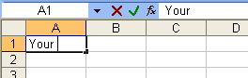

Figure 20
- Hit Tab. In cell B1 type “N a m e” (letters N , a, m, e), and then Tab. You should see (Figure 21):
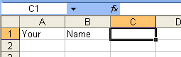

Figure 21
- In cell C1 type the an equal sign (Figure 22):
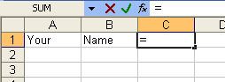

Figure 22
- Hit the left arrow key twice (Figure 23):
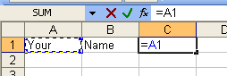

Figure 23
- Type the Ampersand (Shift + 7) (Figure 24):
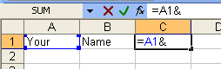

Figure 24
- Hit the left arrow key once (Figure 25):
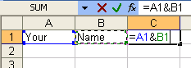

Figure 25
- Hit Ctrl + Enter (Figure 26):
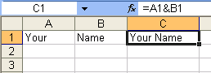

Figure 26
- In cell A1 type “Isaac ” and in cell B1 type “Newton” (Figure 27):
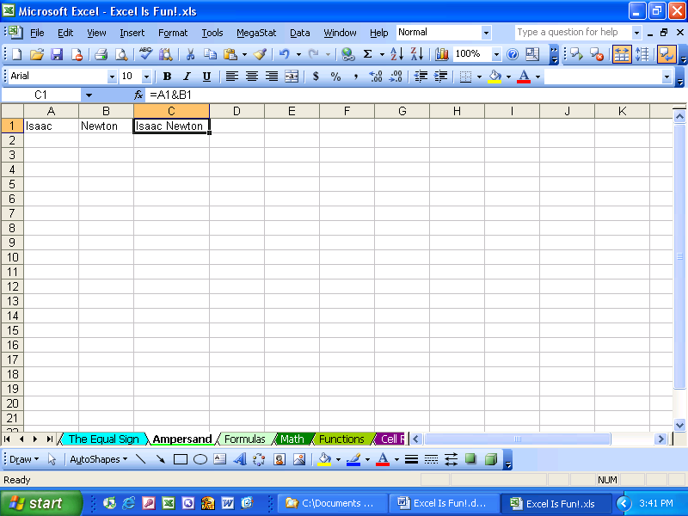

Figure 27
- Now try your own joining using the “&” (Figure 28):
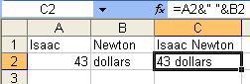

Figure 28

Method of placing cell references in formula after you have placed an equal sign as the first character in the cell: 1) use mouse to click on cell, 2) use arrow keys to move to cell reference location, 3) type the cell reference (higher probability of error)

Here are the steps to calculate a monthly interest rate on a loan
- In your “Excel Is Fun!.xls” Workbook, click on the sheet tab named “Formulas”
- As seen in Figure 29, click in cell B2 and type an equal sign. By typing the equal sign, you are telling Excel that you are creating a formula in cell B2.
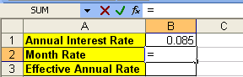

Figure 29
- Click the up arrow key (in between the letter keys and the number keys). By typing the up arrow, you are telling Excel that you would like the formula to look into the cell “one above” B2 and get the annual rate of .085. You should see what is in Figure 30:
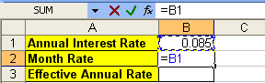

Figure 30
- Notice that by using the arrow key to select a cell reference, you save the time it would take you to grab the mouse and click on cell B1.
- Type the division symbol “/” and the number 12 (12 months in a year does not vary so that fact that this is a number does not violate Rule #6). See Figure 31:
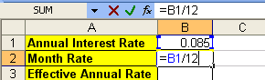

Figure 31
- Tap Enter. Taping the Enter key puts the formula in the cell and moves the cursor one cell below B2 to the cell B3. The monthly rate displayed in the cell can be seen in Figure 32:
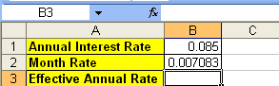

Figure 32
So far we have seen two keystrokes that tell Excel that the formula is completed and we would like to have Excel show us the result. The keystrokes “Ctrl + Enter” and “Enter” will officially enter the formula into the cell. The “Tab” key will do this also. These three keys are the safest keystrokes for putting the formula into the cell. There are other keystrokes that work some of the time, but not all the time. For safety and efficient formula creation we will only use Ctrl + Enter, Enter, or Tab to enter formulas into cells. If we use only these three keystrokes to place formulas in cells we can avoid unintended cell reference insertion that can cause our formula to be inaccurate.

To enter a formula into a cell use “Ctrl + Enter” to place the formula in the cell and select the cell, use Enter to place the formula in the cell and select the cell directly below the cell with the formula, or use Tab to place the formula in the cell and select the cell one to the right

Rule #7 = Only use “Ctrl + Enter”, “Enter”, or “Tab” to enter a formula into a cell.

- In Cell B3, type: “=(1+”, as seen in Figure 33:
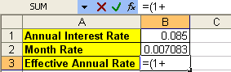

Figure 33
- Click the up arrow once, then type: “)^12-1” as seen in Figure 34 ( ^ symbol = Shift + 6):
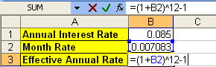

Figure 34

- We do not violate rule # 6 (DO NOT TYPE DATA THAT CAN VARY INTO A FORMULA) by typing the 1, 12, and 1 into these formulas. For calculating the annual effective rate from a month rate these numbers do not vary!
- Click Tab. You should see this (Figure 35):
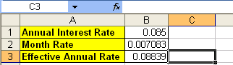

Figure 35
- But what is that “^” symbol mean???

Math
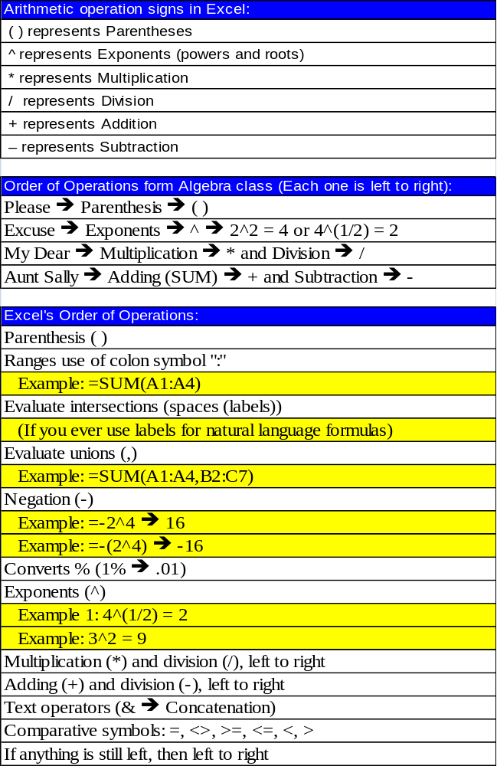

Figure 36
As seen in Figure 36, we will have to learn the Arithmetic operation signs in Excel. In addition, we will have to learn the order of operations in order to avoid analysis mistakes. For example, what is the answer to 3 + 3 * 2? Is it 12 or is it 9? Because Excel knows the order of operations, we must also know the order of operations so we can calculate correctly. For a refresher in the order of operations, read Figure 36.

Rule #8 = We must learn the symbols that Excel uses for math and we must know the order of operations.
Here are the steps to practice math and the order of operations:
- Click on the sheet tab named “Math (2)”. You should see this (Figure 37):
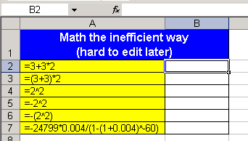

Figure 37
- Click in cell B2 and type the formula “=3+3*2”. You should see this (Figure 38):
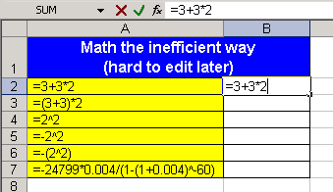

Figure 38
- Looking at the examples of formulas in column A, create the remaining formulas in column B. When you are done you should have these results (Figure 39):
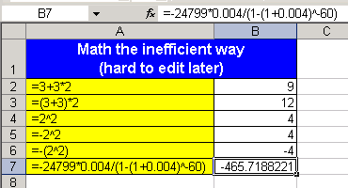

Figure 39
- The problem with what you just did (Figure 37, Figure 38, Figure 39), is that editing the formulas later is inefficient when compared to a method that employs cell references. Our next example will employ cell references.
- Click in cell E2 and type an equal sign “=” (Figure 40).
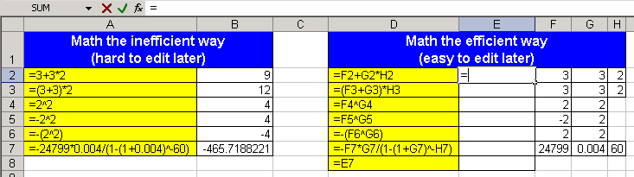

Figure 40

- Click the right arrow key, as seen in :
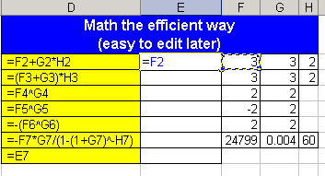

Figure 41
- Type “+”, as seen in Figure 42:
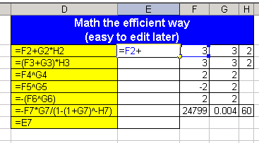

Figure 42
- Click the right arrow key twice, as seen in Figure 43:
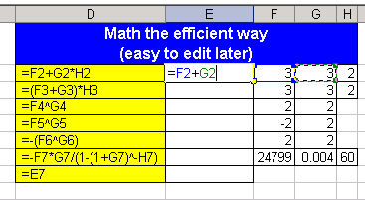

Figure 43
- Type the “*”, as seen in Figure 44:
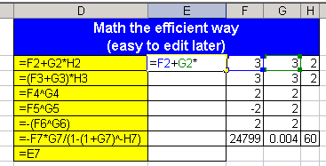

Figure 44
- Click the right arrow three times, (Figure 45):
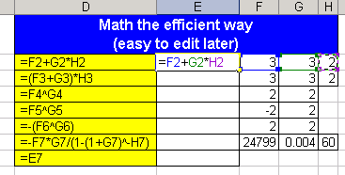

Figure 45
- Hit Enter. The answer should be 9.

- In the heading says “Math the efficient way”. The efficiency comes from the fact that it is easy to edit these formulas because you have utilized cell reference that point to numbers typed into cells. Change the number in cell F3 to 12 and watch your formula change ():
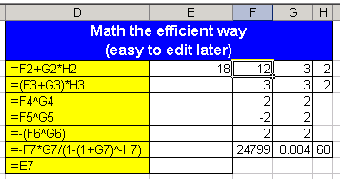

Figure 46
- Look at the formulas in column D) and create the corresponding formulas in column E. When you are done you should see this (Figure 47):
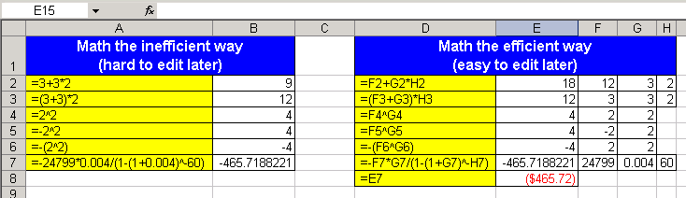

Figure 47
- But what is going on in cell E8? How come when cell E8 looks at cell E7 it shows us a dollar figure? The answer comes from formatting. We will talk about formatting later (this is exciting foreshadowing)…. For the time being we have been taking about the equal sign, ampersand sign, numbers, cell references and math operators: these are all components of formulas. We will now formally define a formula in Excel ➔.

Formulas
Definition of a formula: Anything in a cell when the first character is an equal sign. (Anything in a cell or formula textbox when the first character is an equal sign and the cell is not preformatted as Text).
Advantages of a formula: You are telling Excel to do calculations, look into another cell, create text strings, or deliver a range
How to create a formula: Type “=,” followed by:
  - Cell references (also: names and sheet references)
  - Operation signs
  - Functions
  - Text that is in quotes (ex: “For The Month Ended”)
  - Ampersand symbol: &
    - To combine information from different cells, text in quotes, or functions use the ampersand: &
      - Example: ="For The Month Ended "&B5
    - To Extend the upper limit for Functions
      - Example: Extend IF upper limit of seven to more than seven
  - Numbers
    - The only numbers that ever go in a formula are numbers that will never change (such as the number of months in a year)
How to enter a formula into a cell: hit one of the following:
  - ENTER
  - Ctrl + Enter
  - Tab
Here are the steps to create five formulas:
- You are currently looking at the sheet tab named “Math (2)”. Make sure that you are in this sheet
- Hold down Ctrl, then tap the “Page Up” key twice
(Ctrl + Page Up ➔ moves you up through the sheets)
(Ctrl + Page Down moves you down through the sheets)
- You should now be located in the sheet tab named “Formulas”
- Create the following formula (as seen in Figure 48). Efficient key strokes are: “=”, up arrow twice, “-“, up arrow once.
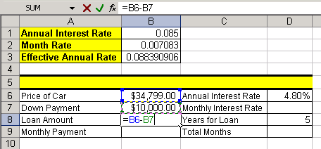

Figure 48
- Hit Tab twice, Arrow up and create this formula in D7 (Figure 49):
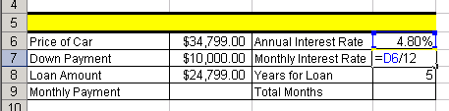

Figure 49
- The 12 represents months in a year and does not change and so it is efficient to type this number into a formula
- Hit Enter twice and create this formula in D9 (Figure 50):
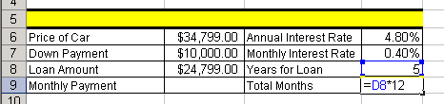

Figure 50
- Click in cell B9 and create the formula as seen in Figure 51. After you create it, hold Ctrl, and then tap Enter.
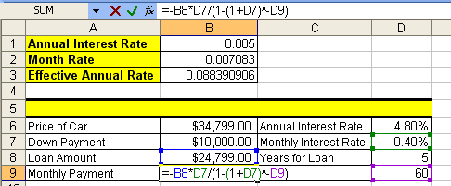

Figure 51
- Click in cell A5. The cell is merged and centered and so the formula will be created in the middle of the range. Create the following formula as seen in Figure 52:
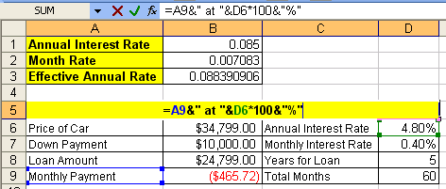

Figure 52
- This formula combines cell references, text in quotes and a calculation all joined together with the Ampersand “&”. The resulting label for our calculations can be seen in Figure 53:
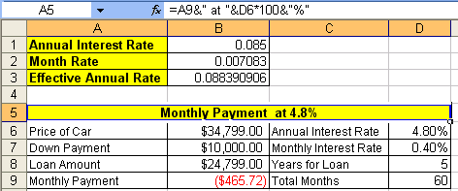

Figure 53
- The efficiency and beauty of building a spreadsheet in this manner is revealed when we change the source data and then watch our formulas change automatically.
- Click in cell B6 and change the price of the car to 50,000 (type 50000), then hit Tab twice. (Figure 54):
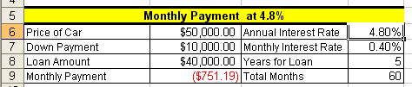

Figure 54
- Notice that the preformatted cells formatted the “50000” to appear as “$50,000.00”. Also notice that our formulas for Loan Amount and Monthly Payment updated.
- Verify that you are in cell D6 and then type “6” and then hit Enter (Figure 55):
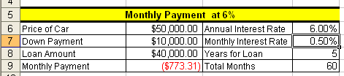

Figure 55
- Notice that the three formulas that were dependent on the Annual Interest Rate all updated when we changed the rate. This ability to check different scenarios without much effort is at the heart of using Excel efficiently. We always want to strive to build our spreadsheets efficiently so that they are easily edit-customizable at any time! By typing the numbers that can vary into cells and referring to them using cell references in our formulas we have accomplished Excel efficiency and fun!

Rule #9 = By typing the numbers that can vary into cells and referring to them in our formulas using cell references, we gain the ability to edit formulas easily and check different scenarios without much effort.

- Look in the lower left corner of Figure 56 and find the scroll arrow for sheet tabs. The little black triangle turned on its side means show me one more sheet tab. The little black triangle turned on its side with an extra vertical line means take me all the way to the last and/or first sheet tab.

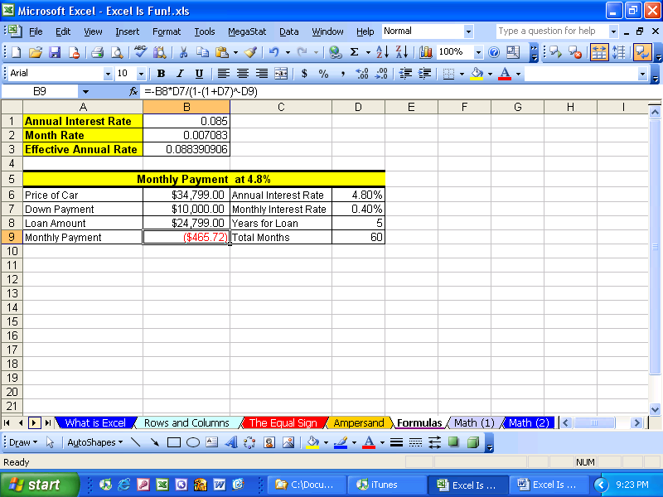
Scroll arrow that reveals more sheet tabs

Figure 56
- Click the sheet tab scroll arrow twice as seen in Figure 57:

Figure 57
- You should see a few more sheet tabs exposed. The sheet tab “Formulas” is still selected, however, by clicking the sheet tab scroll arrow more sheets are exposed (Figure 58):
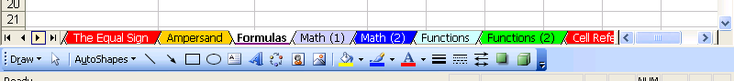

Figure 58
- Move to the sheet tab named “Functions” by either clicking on the sheet tab named “Functions”, or by Holding Ctrl, then tapping the “Page Down” key three times. You should see this (Figure 59):
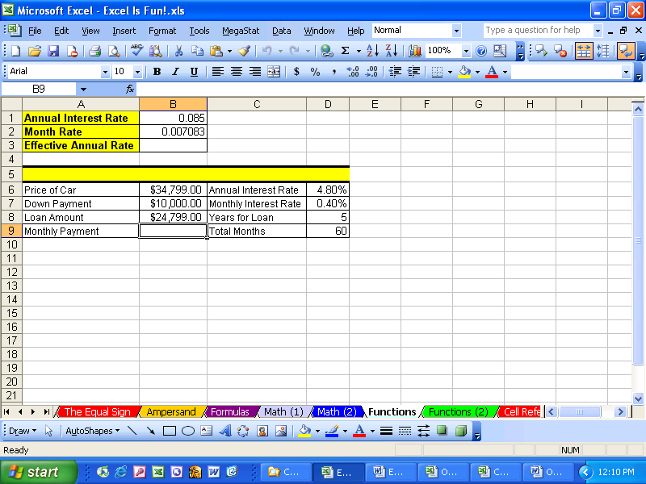

Figure 59
- Click in cell B9. What if we want to calculate the monthly payment for our car loan, but we do not know that math formula? Luckily there are built in “FUNCTIONS” that know how to do this – as long as we can tell the FUNCTION what the monthly rate, number of months and present value of our loan is, the function will do the rest!

Functions
What are functions? Built in code that will do complicated math (and other tasks) for you after you tell it which cells to look in
Examples:
SUM function (adds)
AVERAGE function (arithmetic mean)
PMT function (calculate loan payment)
COUNT function (counts numeric values)
COUNTA function (counts non-blank cells)
COUNTIF function (counts based on a condition)
ROUND function (round a number to a specified digit)
IF function (Puts one of two items into cell depending on whether the condition evaluates to true or false)
Here the steps to practice with many new Functions:
- Click in cell B9 and then click the f_{x} button (Insert function button) in the formula bar (Figure 60). (Keyboard shortcut: Shift + F3 = Open Insert Function dialog box)
Formula bar
f_{x} button ➔ the insert function button

Figure 60
- The Insert Function dialog box looks like this (Figure 61):
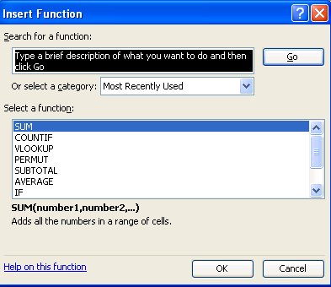

Figure 61
- There are five key parts to the Insert Function dialog box:
  - Search
  - Category
  - Select function
  - Description of selected function
  - Help
- Click in the search for a function text box and type “monthly car payment” then hit Enter (Figure 62):
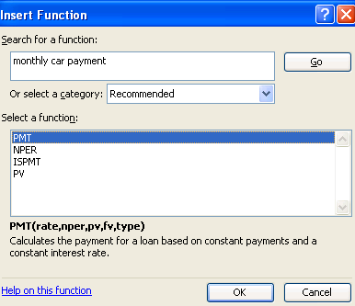

Figure 62
- In the select a function list the first function selected is “PMT”
- Below the list is the description: “Calculates the payment for a loan based on constant payments and a constant interest rate.” This sounds perfect for our need. But let’s check the others to make sure that there is not something even better. Click on “NPER.” Figure 63 shows the description of this function:
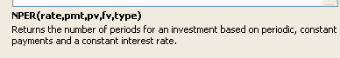

Figure 63
- After looking at each function, click back on the PMT function because, amongst the four options, it fulfills our goal most satisfactorily. Descriptions are the key to the Insert Function dialog box. You can find the most amazing functions that will do all the calculating for you if you just spend a little time “hunting” (looking through the list of functions).
- Because “hunting for the right function is the key to learning about all the wonderful built-in functions, another way is to “hunt” using the “All” category.
- Click the down-arrow next to “Select a category” and point to All (Figure 64):
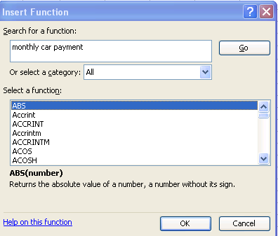

Figure 64
- Most of the functions have common sense names. See if you can find a function that will calculate “Absolute value”, “Geometric mean”, “Average”, “Straight-line depreciation”. All four of these can be found by hunting for those words in the list.

- Absolute value ():
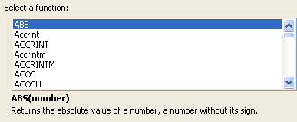

Figure 65
- Geometric mean (Figure 66):
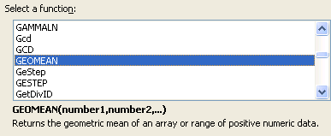

Figure 66
- Average (Figure 67):
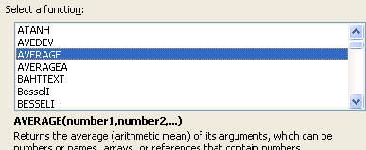

Figure 67
- Straight-line depreciation (Figure 68):
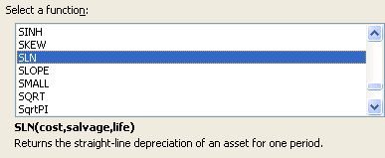

Figure 68
- Now, find the PMT function again. (Figure 69):
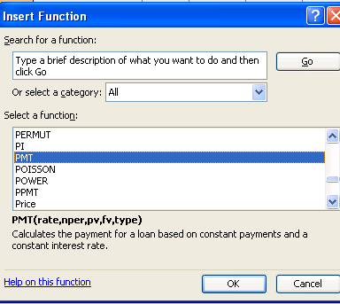

Figure 69

- Double click the highlighted PMT function to open the Functions Arguments dialog box ():
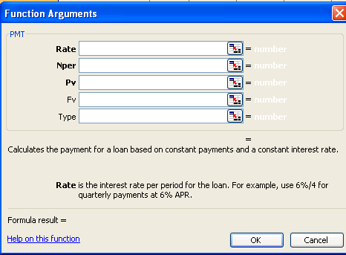

Figure 70
- The arguments “Rate” “Nper” and “Pv” are in bold and the most commonly used variables for this function and are required for the function to give you a result. The “Fv” and the “Type” are not in bold and are not required. There is a description for each argument that will help you figure out how to use the function. In addition, “Help on this function” (bottom lower left corner of Figure 70) is amazing! If you click that link it will give you a full description and example of how to use this function. The help looks like this (Figure 71):
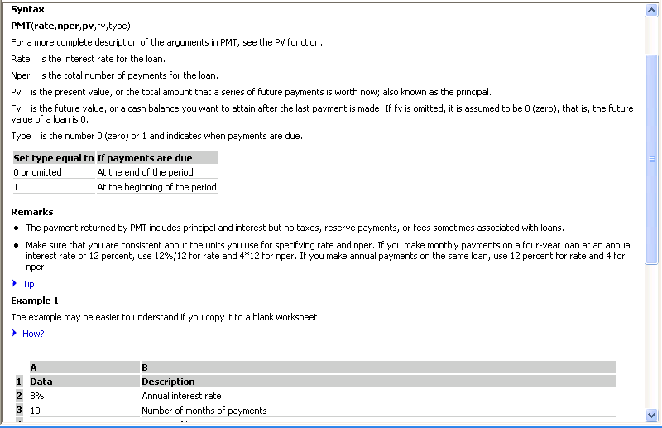

Figure 71
- If you opened up the help, close it. Make sure your curser is in the argument box for Rate, then click in cell D7 (Figure 72):
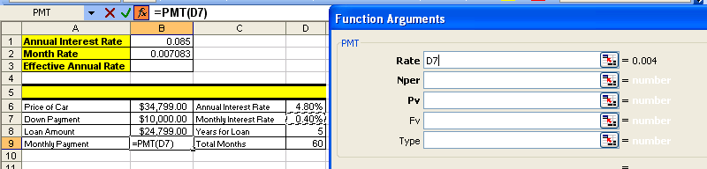

Figure 72
- Notice that when you click on cell D7 the value is shown to the right side of the argument box.
- Hit Tab to move to the next argument box, click in cell D9, Hit Tab, Click in cell B8 (Figure 73):
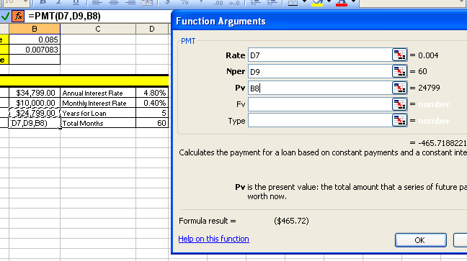

Figure 73
- In Figure 73 notice:
- Each argument box has a cell reference (this makes it easy to edit later)
- To the right of each argument box that the variable amount is shown
- The formula result is shown in two different locations (can you see both?)
- The formula bar shows that Excel has placed an equal sign in the cell for you, that the name of the function is in the formula and that the three cell references (arguments) are separated with commas.
- Click OK. The result is the same as when we made our calculations before without the use of an Excel function. (Figure 74):
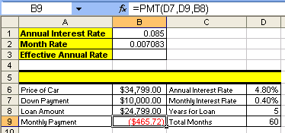

Figure 74

Rule #10 = Using Excel’s built in Functions can simplify and shorten formula creation.

Rule #11 = Finding functions in Excel can be accomplished by reading the descriptions, searching for a common sense name in the list of functions, or by using the “Search” feature in the Insert Functions dialog box. (You can search Google or the mrexcel.com site also.)

Rule #12 = Figuring out what arguments to use for a given function can be accomplished by reading the descriptions, or by clicking the help button in the Argument dialog box.
- Click in cell B3 and use the Insert Function dialog box to find a formula for calculating the Effective Annual Rate. The result should look like this (Figure 75):
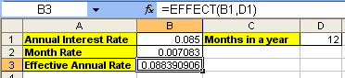

Figure 75
- Click in cell A5 and then hold the Shift key and tap the F3 key. In the Search for a function text box type “join text” (Figure 76):
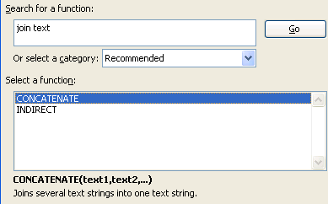

Figure 76
- Create the label for the Monthly Payment table (be sure to pay attention to the spaces before and after the word “ at “) using the Concatenation function (Figure 77):
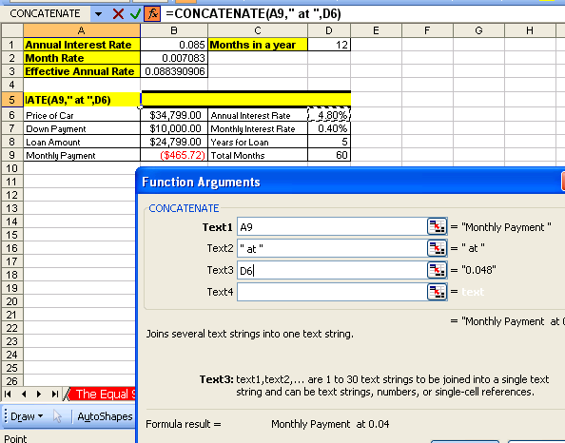

Figure 77
- The result looks like this (Figure 78):
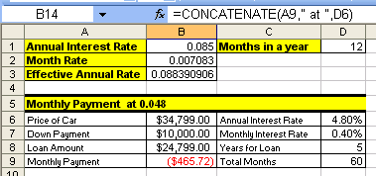

Figure 78

- Type the number “1” into cell A13 and the number “2” into cell A14. Then highlight the two cells (Figure 79):
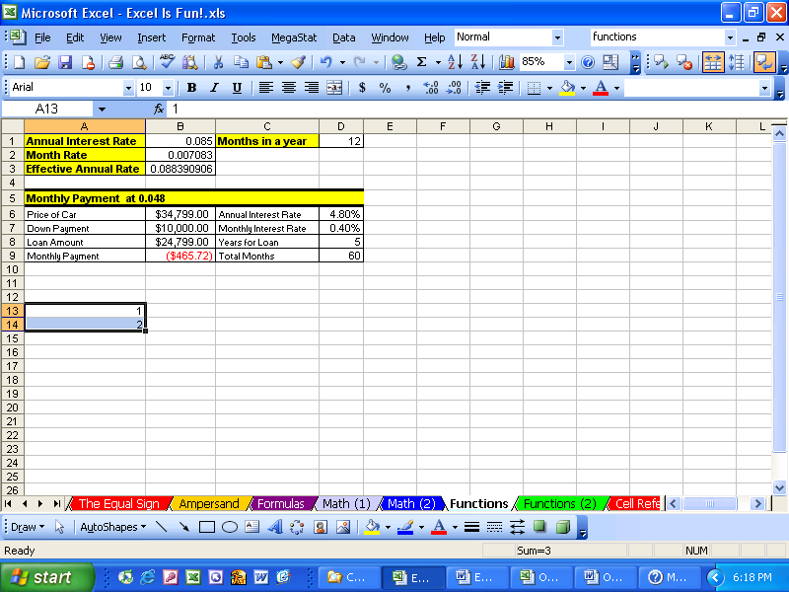

Figure 79
- Look at Figure 79. What is that little black box in the lower right corner of the highlighted range? It is called the fill handle. It is magic. Take your cursor and point to it until you see a cross hair (angry rabbit). (Figure 80):

Figure 80
- Click and drag the angry rabbit down to A17. Just like magic Excel assumes you want to add by 1 because the pattern of the number 1 and 2 is to always add 1. (Figure 81):
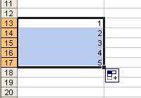

Figure 81
- Click in Cell A18. We are going to add all the numbers by using a SUM function. The keyboard shortcut for the SUM function is Alt + “=”.
- Hold the Alt key, then tap “=” (Figure 82):
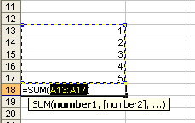

Figure 82
- In Figure 82 we see that the SUM function tries to guess what data we want to sum (it does not always guess correctly). It guessed correctly this time and so we hit Ctrl + Enter (or if we are still holding the Alt key we would tap “=” a second time. (Figure 83):
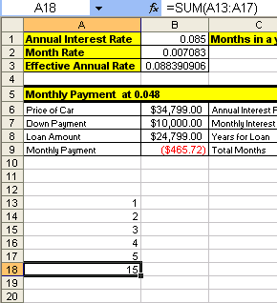

Figure 83
- It is much more efficient to use the SUM function, “=SUM(A13:A17)”, than it is to type in “=A13+A14+A15+A16+A17”. In addition there is an added bonus to using a function that uses a range such as A13:A17. Let’s take a look ➔
- Point to the row heading 15 and click to highlight the whole row (Figure 84):
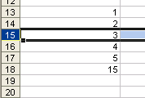

Figure 84
- With the row highlighted click on the Insert menu and point to Row without clicking (Figure 85):
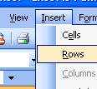

Figure 85
- Notice the I and R.
- Click Esc
- Make sure that Row 15 is highlighted and then hold the Alt key and tab I, and then tap R. The result is that you have inserted a row (Figure 86):
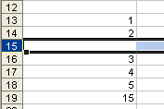

Figure 86

Keyboard shortcut Insert Row = Alt + I + R
- Click in cell A15 and type the number “100” and hit enter (Figure 87):
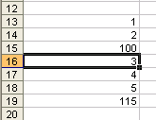

Figure 87
- Notice that the sum function updated
- Click in cell A19 and click the F2 key (Figure 88).

Keyboard shortcut for Range Finder = F2
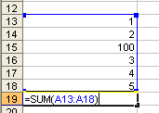

Figure 88
- Range Finder allows us to audit a formula after it is created. Look at the range we have in Figure 88 (A13:A18). Now look at the range in Figure 83. Our conclusion: by using a function with a range our formula will update when we insert rows or columns.

Rule #13 = Using functions with ranges instead of a collection of individual cells allows structural updating to spreadsheets more easily.

Example: Use “=SUM(A13:A17)” instead of “= A13+A14+A15+A16+A17”

- For more practice with Functions go to the sheet tab named “Functions (2)”
- Hover your “thick, white-cross” cursor over cell A2, then click in cell A2, hold the click, and drag your cursor to cell J9. This is how you highlight a range. The range you have highlighted is A2:J9. (Figure 89):
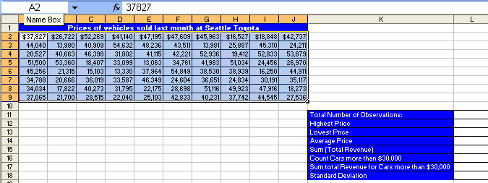

Figure 89
- Click in the Name Box (Figure 90):
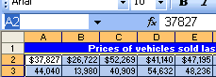

Figure 90
- After you click in the name box it will highlight the cell A2.
- Type over “A2” and replace it with “sd” (“sd” will stand for sales data). (Figure 91):
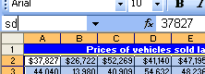

Figure 91
- Then hit Enter to register the newly named cell range. The cell range A2:J9 now has the name “sd” When we create functions that look at that range we can now simply type in “sd” instead of highlighting the range A2:J9
- Click in cell L11 and see if you can find a function that can count the number of cars that were sold last month at Seattle Toyota. When you find it, your formula result should look like this (Figure 92):
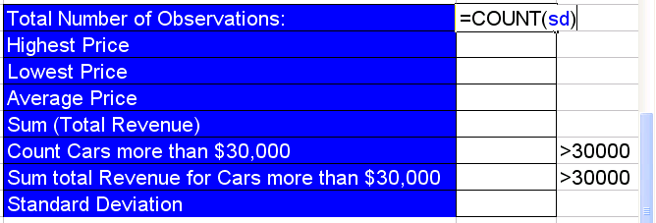

Figure 92
- See if you can find the remaining functions using your new “function hunting skills”
- When you are done you should see the same results that you see in column L in Figure 93 by using the formulas that you see in column N in Figure 93.
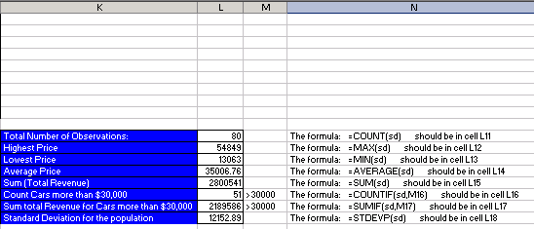

Figure 93
- We have been using cell references so often, that it is now time to investigate the different types of cell references ➔

Cell References
When we copy formulas that contain cell references to other cells, then we need to understand that there are four types of cell references:
- Relative
- Absolute
- “Mixed with Column Locked”
- “Mixed with Row Locked”

It will only be possible to understand these if we look at a few examples. Nevertheless, here are the crucial facts about cell references:

- Relative Cell References A1
No dollar signs
Moves relatively throughout copy action
- Absolute Cell References $A$1
Dollar signs before both:
Column designation = A
Row designation = 1
Remains locked on cell A1 throughout copy action
“Locks cell reference when copying it horizontally and vertically”
- “Mixed with Column Locked” $A1
Dollar sign before column designation
Remains locked when copying across columns
Remains relative when copying across rows
“Locks cell reference when copying it horizontally, but not vertically”
- “Mixed with Row Locked” A$1
Dollar sign before row designation
Remains locked when copying across rows
Remains relative when copying across columns
“Locks cell reference when copying it vertically, but not horizontally”

Keyboard shortcut F4 key: Toggles between the four types of cell references

- When creating formulas with cell references, ask two questions of every cell references:
Q1: What do you want it to do when you copy it horizontally
Is it a relative reference?
Is it a “locked” reference?
Q2: What do you want it to do when you copy it vertically
Is it a relative reference?
Is it a “locked” reference?
Here are the steps to learn about the four cell references:
- Go to the sheet tab named “Cell References” and click in cell C3 and create the formula shown in Figure 94. The formula calculates a proportion or percentage of the whole (depending on how it is formatted). In our example we are comparing Tina’s score (82 parts of the 100 whole) and comparing it to the total possible points (100 points – the whole). If you look ahead to creating the formulas for Sue and Chin and Hien, all their “parts” will have to be compared to the “whole”.
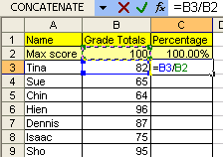

Figure 94
- Hold Ctrl, then tap Enter. You should see that the proportion of points that Tina earned is .82 (Figure 95):
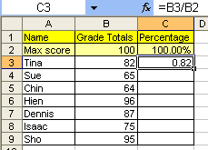

Figure 95
- To format the number “.82” as a percentage, highlight cell C3, click the % button on the formatting toolbar (Figure 96). Remember 82% is not a number. Underneath in Excel’s code (just like any other calculator), Excel sees the number “.82” even though it is formatted with a % symbol and even though what we see in the spreadsheet is 82%:
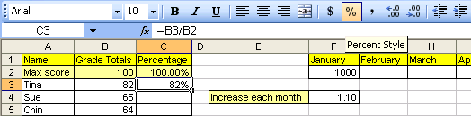

Figure 96
- Highlight the range C4:C9 and then click the %button on the formatting toolbar: this pre-formats the cells with the percentage format (Figure 97):
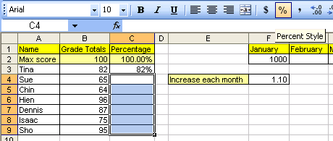

Figure 97
- Click in C4 and create the formula for calculating Sues’ percentage grade (Figure 98):
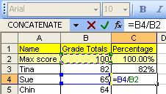

Figure 98
- Continue until you have created the percentage grades (Figure 99):
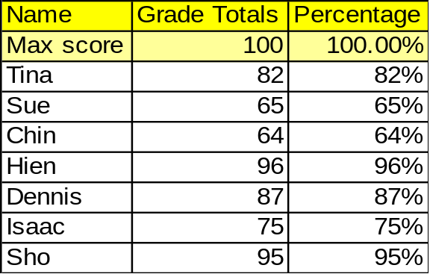

Figure 99
- What we just completed did not require that we know anything about the four different cell references. However, what we did was inefficient. There is a way to create all those formulas by just creating one formula in cell C2 and then copying it down through our range. We will have to learn how to “LOCK” or make “ABSOLUTE” some of our cell references. If we can learn how to do this, it will make tasks such as this easier to complete and will result in few errors. In addition, many of the most advanced Excel Features and tricks are only possible if we learn about these four cell references.
- Highlight the range C2:C9 and then hit the delete key (Keyboard short cut: Delete key = delete cell content but not format) (Figure 100):
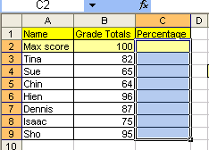

Figure 100
- Click in cell C2 and create the following formula (Figure 101):
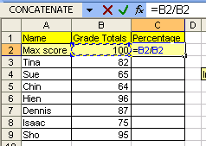

Figure 101
- Now think about this: the numerator B2 needs to always look one cell to my left and the denominator B2 always needs to be locked on B2. We have to let Excel know that the two B2s are different. (If you don’t remember the difference between numerator and denominator use Google’s definition feature to look these words up).
the numerator B2 needs to always look one cell to my left
    - This is called a relative cell reference
    - Relative to the cell the formula sits in, the cell reference always needs to look one cell to the left
    - For our example the “one-to-the-left” B2 will be entered into the formula as B2
the denominator B2 always needs to be locked on B2
    - This is called a LOCKED or ABSOLUTE cell reference
    - The secret code we need to put into our cell reference to let Excel know that the cell is locked in the “$” sign. Why the dollar sign? No reason – just think of it as the secret code).
    - But where do we put the secret code? The answer depends on which direction you will be copying the formula. In our case we will be copying up-and-down, across the rows (and rows are numbers), so the secret code goes in front of the Number 5
    - For our example the “LOCKED” B2 will be entered into the formula as B$2
- Very carefully, place your cursor in the middle of the denominator B2 and click the F4 key twice (Figure 102):
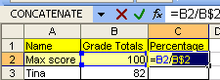

Figure 102
- Hold Ctrl, then tap Enter. You should see this (Figure 103):
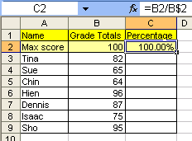

Figure 103
- Point to the fill handle and with your angry rabbit copy the formula down to cell C9 (Figure 104):
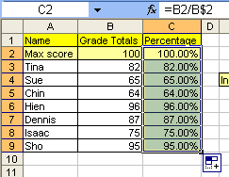

Figure 104
- Notice that it copied the yellow cell fill-color formatting down with the formula. Take you cursor and click on the blue smart tag, then click on Fill Without Formatting (this great feature copies only the formula) (Figure 105):
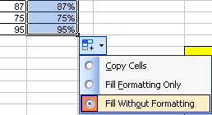

Figure 105

- Click in cell C9 and audit the formula to make sure that you actuality did create 8 formulas, but only had to create one formula which you then copied down (Figure 106):
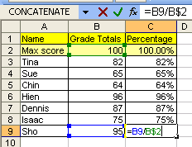

Figure 106
- Click in cell G2 and create the formula seen in Figure 107. Because the January 1000 amount will be increased by 10% each month, we need to multiply (1 + .10) or 1.10 by each previous month’s amount. But notice that the cell reference F2 is actually always going to be looking at the cell “one-to-the-left” (relative cell reference = F2) and the cell reference F4 will always be “locked” on F4 when copying it side-to-side, across the columns (columns are letters), so the secret code goes in front of the letter (locked copying it across the columns = $F4)
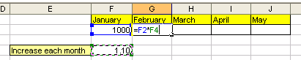

Figure 107
- Very carefully, place your cursor in the middle of the F4 and click the F4 key three times (Figure 108):
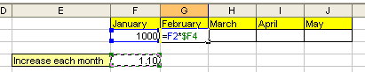

Figure 108
- Hit Ctrl + Enter. Point to the fill handle and copy to formula to J2 (Figure 109):
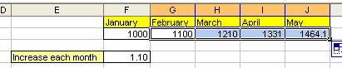

Figure 109
- Click in cell J2 to audit the formula with the F2 key (Figure 110):
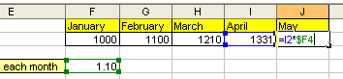

Figure 110
- Look in Figure 111 at the table titled “What will your Pension be worth when you retire?” We would like to estimate what our pension will be depending on the annual rate that we earn and how many years we save for retirement. The trick here is that we don’t want to type 54 formulas. We would like to create the whole “sea of formulas”, G13 to L21, by creating only one formula in cell G13 and then copying it to the remaining cells.
- Click in cell G13 and type “=FV(“. The screen tip will come up to help you with the arguments for this function. To calculate our retirement funds we will need to assume an annual rate “rate”, the number of years that we deposit money “nper” and a yearly deposit amount “pmt” (Figure 111):
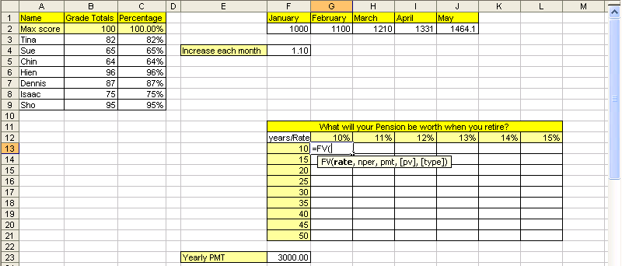

Figure 111
- Click on cell G12 (Figure 112):
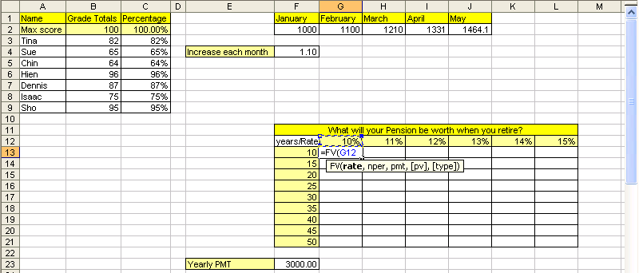

Figure 112
- Can you see in Figure 112 that we will need to use the 10% for all the formulas in column G? Can you also see that when we copy the formula over to column H we need to use the 11%? This means that we need the cell reference locked (absolute) when we are copying the formula down, or vertically, or across the rows: the row reference needs to be locked! However, when we copy the formula to column H the cell reference should not be locked (absolute) when we are copying the formula to the side, or horizontally, or across the columns. The column reference is not locked: it is relative.
- Because we want to lock (absolute) this cell reference when we copy the formula down, across the rows, we need the “$” sign in front of the number. Because we want this cell reference to move relatively as we copy the formula to the side, across the columns, we do not need the “$” sign in front of the letter. Cell reference = G$12 ➔ hit F4 twice (Figure 113):
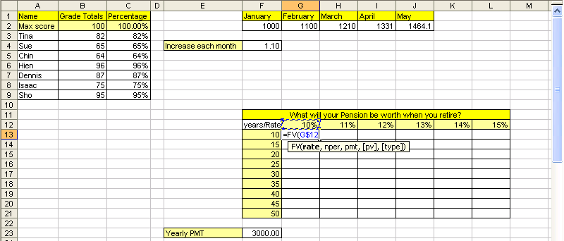

Figure 113
- Type a comma, click on F13, and hit F4 three times.
- We hit F4 three times because we want this cell reference to move relatively as we copy the formula down, across the rows, and we want the cell reference locked (absolute) as we copy the formula to the side, across the columns. Cell reference = $F13 ➔ (Figure 114):
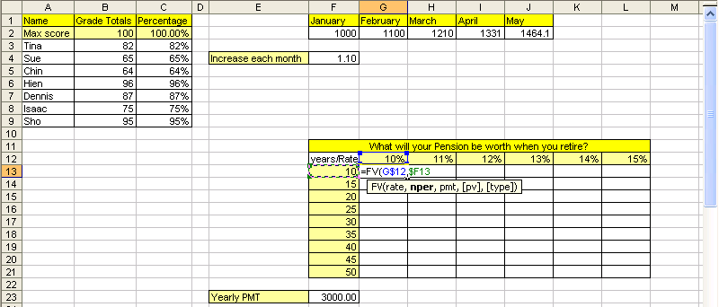

Figure 114
- Type a comma, type a minus sign, click on cell F23, and hit F4 once, type a close parenthesis.
- Because we want to use the cell reference F23 in every cell when we copy this formula, we want the cell reference locked in all directions. The dollar sign in front of the column reference “F” locks the cell reference when copying the formula to the side, across the columns. The dollar sign in front of the row reference “23” locks the cell reference when copying the formula down, across the rows. Cell reference = $F$23 ➔ (Figure 115):
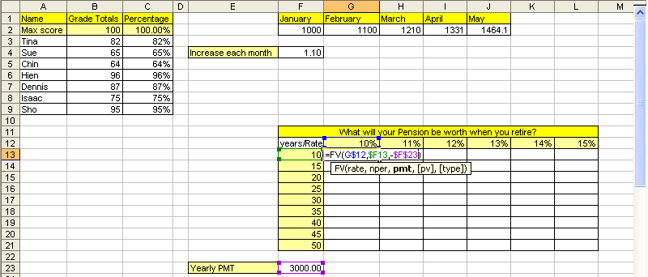

Figure 115
- Hold Ctrl, and then tap Enter. Point to the fill handle and click and drag formula down to cell G21 (Figure 116):
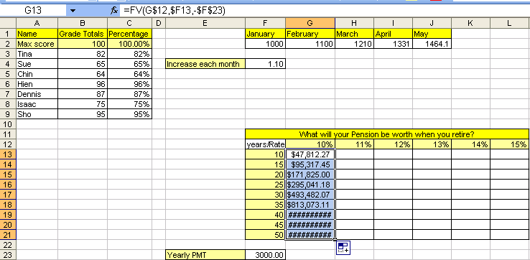

Figure 116
- Don’t be alarmed by the pound signs. They are just saying: “Please expand the column so this big number has room to show itself.” Point between the two column headings G and H and double click to expand the columns. You should see this (Figure 117):
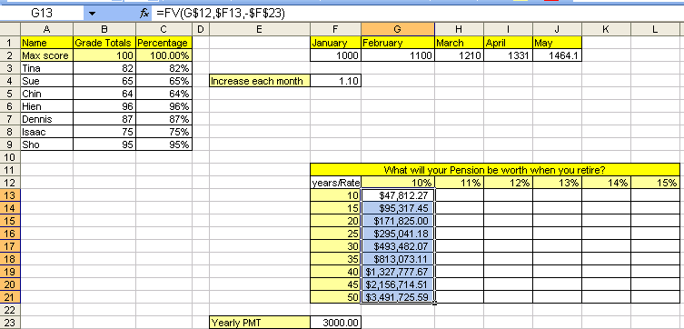

Figure 117
- Now point to the fill handle in the lower right corner for the entire range, then click and drag to L21. Notice that many pound signs appear. Highlight the column headings from H to L by clicking on the columns heading H and dragging to L. Then double-click between the column headings H and I to expand the columns (Figure 118):
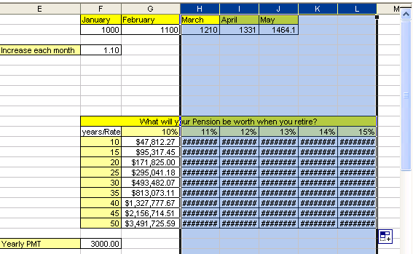

Figure 118
- Our result is that 54 formulas were created by enter just one formula, adding the correct cell references and then copying the formula in two-steps (first down, then over) (Figure 119):
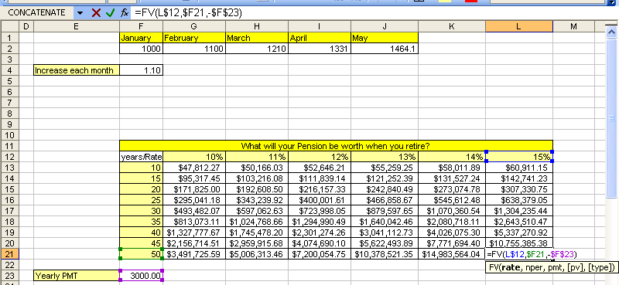

Figure 119
- For more practice with cell references, click on the sheet tab named “Multiplication Table and see if you can create 144 formulas by enter just one formula, adding the correct cell references and then copying the formula in two-steps.

Rule # 14 = Use of relative, absolute and mixed cell references reduces spreadsheet setup time, allows quick updating to setup structure, and will allow us to use many of Excel’s advanced features and tricks

Rule # 15 = When you use the fill handle to copy a formula across the rows and then across the columns, it is a two-step process. First copy it down, then let go of mouse, then copy it over (or visa-versa)

In the last few examples we saw what happens to cell references when we copy a formula that has cell references. Now we need to see what happens when we move a formula that contains cell references. Copy means copy the formula from a cell or range of cells, leave the formula in the original location, and then paste the formula in some other location. Move means cut the formula from a cell or range of cells, it will no longer be located in the original location, and then paste the formula in some other location.

Here are the steps to learn about the difference between copying and moving a formula with cell references.
- Click on the sheet tab named “Copy and Move.” Click in cell B6 and follow the instructions listed in cell B5 (Figure 120Error: Reference source not found):
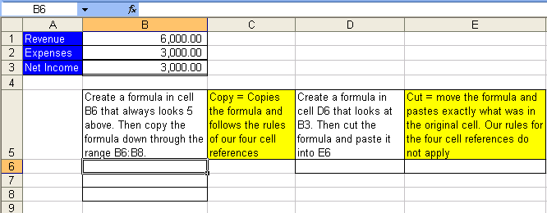

Figure 120

- , and illustrate that when you copy a cell reference that has a relative cell reference component, the cell reference changes relatively. In we see a formula that is looking into cell B1. In we see a formula that is looking into cell B3. When we copied the formula, the cell reference moved relatively – it actually did exactly what we told it to do, namely, “always look five above”.
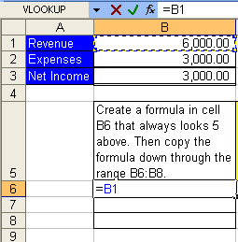

Figure 121
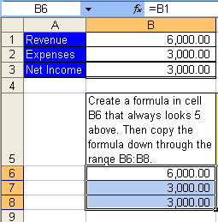

Figure 122
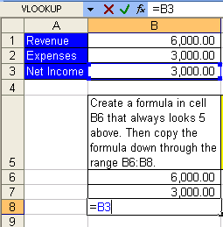

Figure 123
- Now let’s look at what happens when we cut a formula with a relative cell reference and paste it somewhere else.
- Click in cell D6 and create the formula “=B3” (Figure 124):

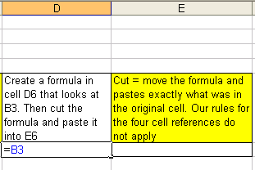

Figure 124
- Hold Ctrl, then tap Enter (Figure 125):

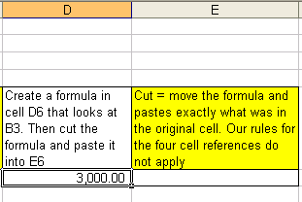

Figure 125
- Ctrl + X, hit Tab (Figure 126):
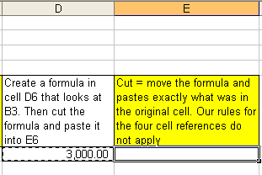

Figure 126
- Ctrl + V (Figure 127):
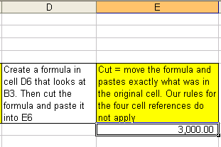

Figure 127
- Hit F2 (Figure 128Figure 127):
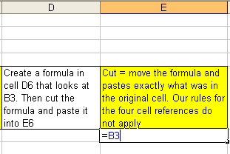

Figure 128
- Compare Figure 124 and Figure 128. When you cut a formula with a relative cell reference component and paste it into a new cell, the formula does not change – it actually moves the cell references exactly as they were in the original cell and pastes them in the new location. This is because when you move, you do not change anything; you simply put the formula, intact, in a new location.

Rule # 16 When you copy a formula that has a relative cell reference component, the relative cell reference changes relatively. When you cut a formula with relative cell references component, the relative cell reference does not change.
- Wow! Knowing the difference between moving and copying formulas is very helpful in our pursuit of efficient spreadsheet construction. Let’s practice copying a formula with relative cell references another time before we move on to the next topic ➔

- Navigate back to the sheet tab named “The Equal Sign” by holding the Ctrl key, and then tapping the PageUp key nine times (=SQRT(81) times in Excel speak). You should see this ():
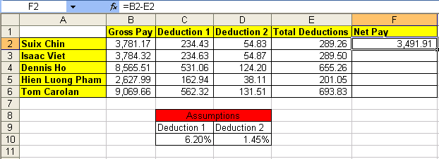

Figure 129
- Click in cell F2. Hit the F2 key (Figure 130). Look at the formula in cell F2. Can you say what type of cell references they are? Can you say what will happen to the formula when you copy it down from F2 to F6? The formula in cell F2, “=B2-E2”, uses relative cell references and so when you copy it down the cell references will move relatively. The formula actually reads: “always look four to the left and subtract one to the left”.
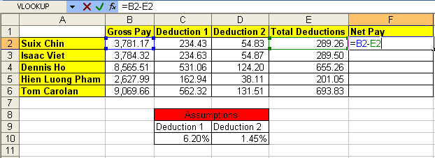

Figure 130
- Hold Ctrl, then tap the Enter key. Point to the fill handle and with your cross hair (angry rabbit), double click. The double click on the fill handle with your angry rabbit (cross hair), tells the formula to copy down as long as there is cell content in the cell directly to the left (Figure 131):
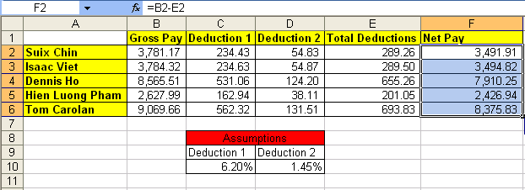

Figure 131
- Click in cell F6 and hit the F2 key (Figure 132). Because the cell references are relative and because we copied the formula, the formula, “=B6-E6”, looks different, but really it is the same formula, namely: “always look four to the left and subtract one to the left”.
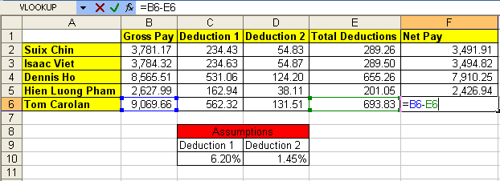

Figure 132
- Look at Figure 132. What is the word “Assumptions” across C8 and D8 mean?
- Click the Esc key to remove the range finder in cell F6. Click in cell C2 and then hit the F2 key (Figure 133). We can see in our formula that Deduction 1 is calculated by taking Suix Chin’s Gross Pay and multiplying it by the tax rate of 6.20%. Because the tax rate of 6.20% can change we have placed it in a cell and had our formula refer to it using a cell reference. We have assumed that our tax rate is 6.20% and thus have placed it into an assumption table. In our next section we will discuss the amazing power of assumption tables: when to use them, what to put in them and how to properly orientate them!
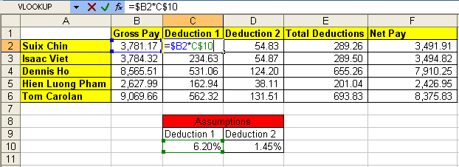

Figure 133

Assumption Tables/Sheets
Our golden rule for assumption tables is: All data that can vary (variable data) goes into a properly orientated assumption table. An example of data that can vary is a tax rate. An example of that data that will not vary is 12 months in a year. Remember: we don’t want to type data that can very into a formula for three reasons: 1) It is easier to edit or change our formula later if the variable data it is not typed into the formula (example: tax rate changes), 2) It is more polite for the spreadsheet user if the variable data can be seen on the face of the spreadsheet. (For example, even if we were to create a formula with variable data typed into the formula (such as “=$B2*.062”), when we came back tomorrow to use the worksheet, we as the creator might not even remember which formulas have variable data and/or what the variable data is). 3) what-if or scenario analysis is significantly easier when an assumption table is used. What-if/scenario analysis is simply when you change the variables to see different results.

In addition to the easy with which we can edit or locate variable data, assumption tables that are properly orientated can reduce the number of formula that we will be required to type into our spreadsheet. Proper orientation means the labels in the main table are orientated (horizontally or vertically) in the same way as the labels in the assumption table, and that there is at least one blank row or column between the main table and the assumption table. Also, you can format the assumption table differently to distinguish it from the main table.

In this section about assumption tables we will learn:
- When to use them
- What to put in them
- How it is easier to locate and edit variable data
- How to properly orientate them!
- See the ease with which we can conduct What-if/scenario analysis
- Bask in the amazing power of assumption tables!!

It will help if we work through an example ➔

Here are the steps to learn about assumption tables:
- Navigate to the sheet tab named “Assumptions” (Figure 134). This table will be used to calculate the Net take home pay for a number of employees. Notice that the calculated amounts for Commission on Sales, and Gross Pay have already been calculated. Our goal is to calculate the three payroll deductions (FICA, Medicare, and simplified Federal) and the Net Pay.
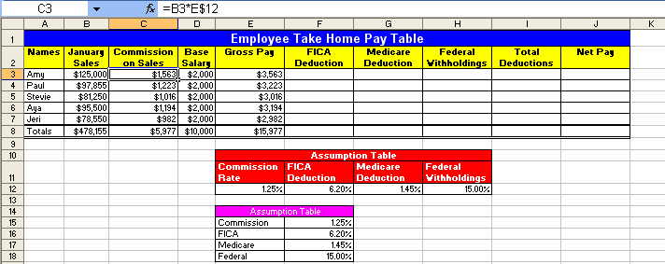

Figure 134
- Click in cell C3 and hit the F2 key. We can see the formula “=B3*E$12” ( Figure 135). Our first question we want to answer is: when do we use an assumption table? We use an assumption table when our formula contains variable data such as a tax rate. In cell E3 we are calculating the commission on sales that we pay each employee. Can this commission rate change? You bet!
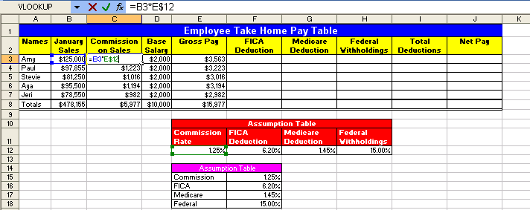

Figure 135
- Hit the Esc key. Click in cell E12. Our second question is: what do we put into an assumption table? We put the variable data that we need for our formula into an assumption table. In Figure 136 we can see that the commission rate of 1.25%, which we used in our formula, has been placed into an assumption table. This enables easy editing and formula updating later. Now, imagine that the boss just gave everyone a raise from 1.25% commission to 2% ➔
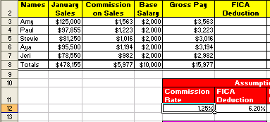

Figure 136
- Our third question is: How easy is it to locate and edit variable data? Very easy!
- Type 2, then hit Enter (because the cell was preformatted with the percent style, we did not have to type the % symbol). You should see the entire column of “Commission on Sales changes (Figure 137). THAT WAS EASY!! It is easier to change the variable data when it is on the face of the spreadsheet that it is to look for it, hidden underneath, inside a formula! I can already feel that vacation time adding up with all the time I will be saving!
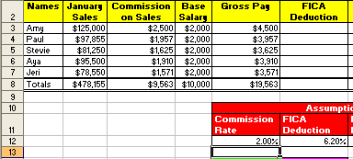

Figure 137
- Click in cell E12 and change the rate back to 1.25%. Our goal is still to calculate the deductions and calculate take home pay
- Click in cell F3 and create the formula for calculating the FICA deduction. But wait! Which assumption table should we use?
- Is the formula “=E3*F$16” (Figure 138) the one to use?
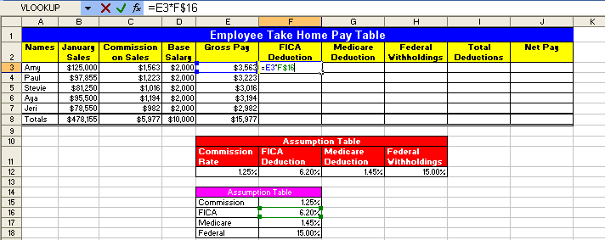

Figure 138
- Or is the formula “=$E3*F$12” the one to use?
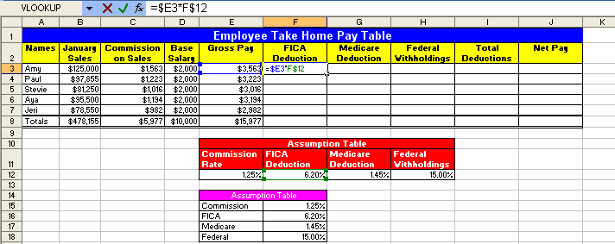

Figure 139
- The answer to which formula to use (which formula is more efficient) leads to the fourth question: what is the proper orientation for our assumption table? If we were to use the formula as seen in Figure 138, “=E3*F$16” we would have to create three separate formulas to make all our deduction calculations. If we were to use the formula as seen in Figure 139, “=$E3*F$12” we would have to create only one formula to make all our deduction calculations. This sort of efficiency is exactly what we are striving for. But why does the formula using the variable data from the assumption table that is orientated horizontally allow us to create only one formula that will work for all our deductions? To see this, let’s try both formula and see which works best.
- You should still have cell F3 highlighted. Create this formula: “=E3*F$16” (Figure 140):
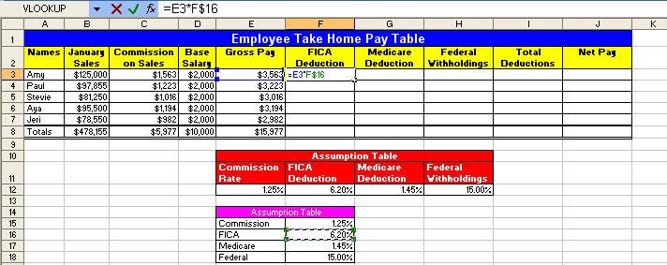

Figure 140
- Hold Ctrl, then tap Enter. Point to the fill handle, and with the Angry Rabbit cursor, copy the formula down through the range F3:F7. Then click in cell F7 and hit the F2 key (Figure 141). You can see that the formula worked when we copied it down.
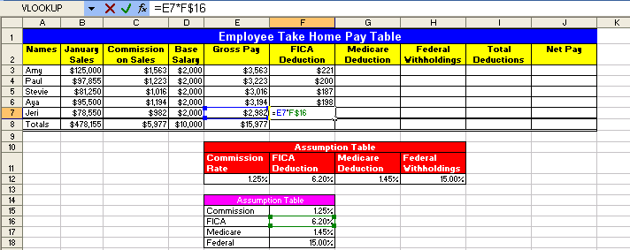

Figure 141
- Hit Esc. Click back into cell F3. Copy the formula to cell G3. Click in cell G3 and hit the F2 key to show the Range Finder. In Figure 142 we can see that the range finder shows that the cell reference for our tax rate moved and is now looking into the cell G16. Because the orientation of the assumption table is vertical (the labels for FICA, Medicare and Federal are located one on top of the other) and the orientation of our main table is horizontal, we would have to create three individual formulas in the cells F3, G3 and H3. Notice that in Figure 142 that the range finder moved to the right when we copied our formula to the right. This indicates that if we had used the horizontally orientated assumption table that formula would have calculated correctly ➔
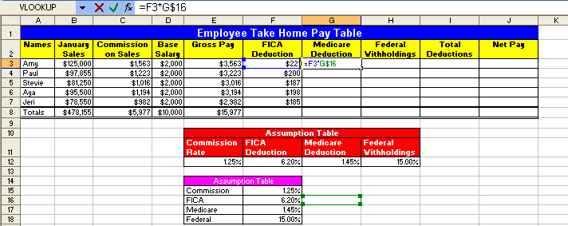

Figure 142
- Click Esc. Then Hold Ctrl, and tap the Z key three times (undo). Then create the formula “=$E3*F$12” in cell F3 (Figure 143):
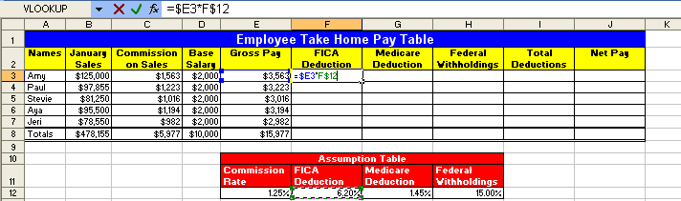

Figure 143
- Hold Ctrl, tap Enter. Ctrl + C (to copy formula). Hold Shift, then tap the Down Arrow key 4 times and the Right arrow key 2 times (highlights the range). Ctrl + V (pastes formula). Click in cell H7 and hit the F2 key. In Figure 144 we can see that because we orientated our assumption table correctly, it worked like MAGIC! We created the sea of formulas in the range F3:H7, 15 formulas, but we only had to type in one formula! This sort of efficiency is our goal!
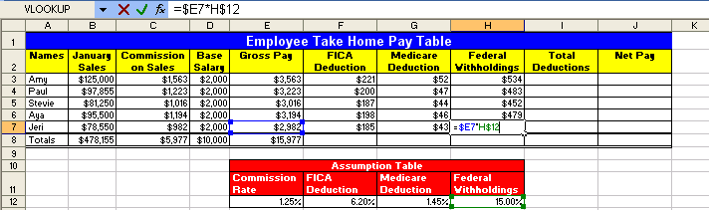

Figure 144
- Hit Esc. Highlight the range F3:I8. Hold Alt, and then tap the Equal sign key “=” (Alt + = is keyboard shortcut for AutoSum). As you can see in Figure 145, by highlighting a range of values and one blank row below and to the right, the Auto Sum feature knew what to add up. It doesn’t always add up the correct amount, so let’s check to be sure. After selecting cells with the AutoSum and verifying, the last cell we will check is cell I8 (Figure 145):
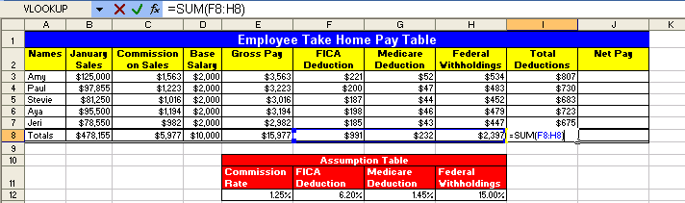

Figure 145
- Highlight the range J3:J8 (Figure 146). Notice that when you highlight a range that one of the cells is white and the rest are a light steel-blue color. The white cell is waiting for you to put a formula into it. If you put a formula into cell J3 and then hold Ctrl and tap Enter, you formula will go into all the cells highlighted ➔
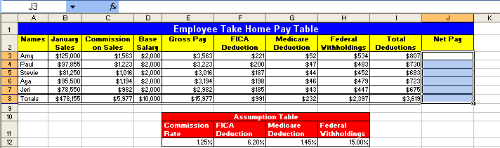

Figure 146
- Create the formula that will always take the value “five to the left and then subtract one to the left in cell J3. Type ‘=”, tap the left arrow key five times, Type “-“, tap the Arrow key once. You should see this (Figure 147):
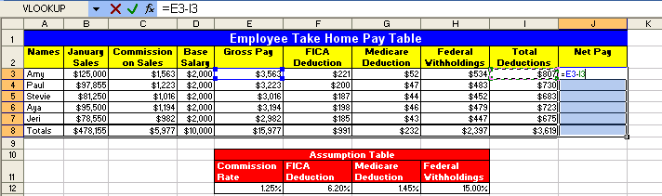

Figure 147
- Hold Ctrl, and then tap Enter. We see here that if you have a range highlighted and you place a formula into the white cell, when you hold Ctrl and tap Enter, the formula is placed into all the cells that are highlighted! You should see this (Figure 148):
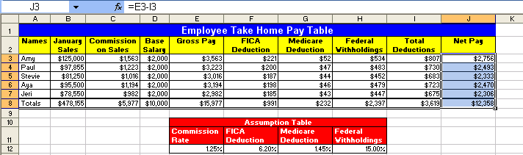

Figure 148
- Our fifth question is: How easy is what-if/scenario analysis when we use assumption tables?
- Click in cell E12 and change the Commission rate to 2%. Click in cell H12 and change the simplified Federal Withholding rate to 20%. Can you see how easy it is to say: “What if I changed this; what would happen to our calculations and our results?” (Figure 149):
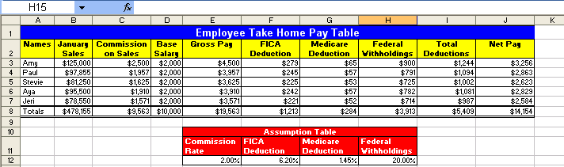

Figure 149
- is hidden underneath, inside a formula
- Our final question about assumption tables is how can we bask in the amazing power of assumption tables?
- Imagine your boss comes in and says: “we just added a new 2% deduction can you update our calculating table?” You look over your shoulder and say: “Oh you mean like this?!!” And with blistering speed you complete these steps ➔
- Click in column H, Click Alt, then tap I and then tap C (Figure 150):
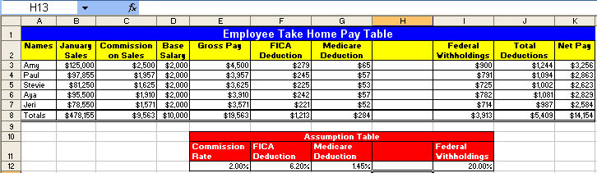

Figure 150
- Click in cell H11 and type Pension. Hit Enter, then type 2% (Figure 151):
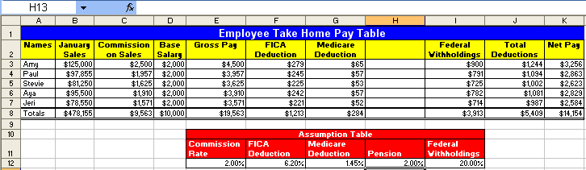

Figure 151
- Highlight the range G2:G8 and point to the fill handle in the lower right-corner. When you see your Angry Rabbit, click and drag one column to the right. You are done! 10 clicks and you have completely updated the table and you have amazed your boss (who then promptly gives you a promotion)! (Figure 152):
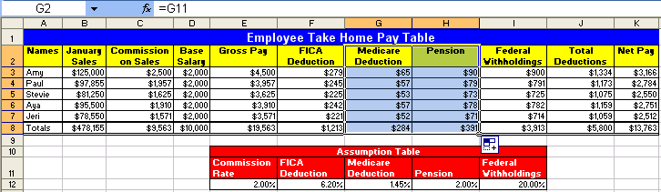

Figure 152
- In Figure 152 we can see that the deduction formulas updated because we used a properly orientated assumption table and mixed cell references; we can see that the SUM function for totals in row 8 updated because they were always looking to add the five above; and we can see that the totals for Total Deduction updated when we inserted a column because it utilized a range in its arguments! Wow, now we can have extra vacation time and bask in the amazing promotion we received – all because of efficient use of assumption tables, mixed cell references and range functions!

Rule #17: All data that can vary goes into a properly orientated assumption table that is at least one blank row/column away from the main table (it can also be placed on an entirely separate sheet). An example of data that can vary is a tax rate. An example of that data that will not vary is 12 months in a year. Although a properly orientated assumption table is not always possible, the idea is to have the labels in the table orientated (horizontally or vertically) in the same way as the assumption table If we do this, editing formulas, what-if analysis and formula creation is dramatically more efficient than if we do not utilize assumption tables.

Rule #18: Properly orientated assumption tables allow for mixed cell use and results in reduced time creating formulas
- Highlight the range K3:K8. Click the increase decimal button twice (Figure 153). Notice that the total Net Pay is $13,762.64.
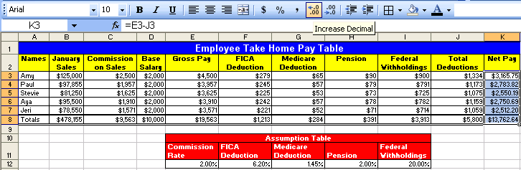

Figure 153
- Click in cell K8 and then hit the F2 key (Figure 154). There is no way that $19,563 - $5,800 = $13,762.64. What is going on here? This is one of the most common mistakes that people make in Excel. It is our job as Soon-To-Be Excel Efficiency Experts (EEE), to know that this is caused by formatting. What we often see in Excel is not actually what sits in the cell. 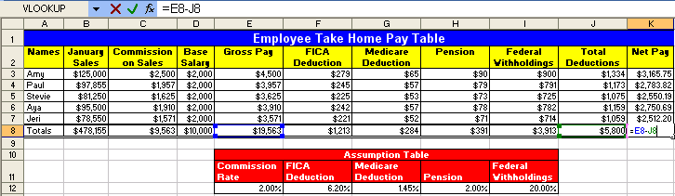

Figure 154
- To prove to ourselves that what is in the cell is different than what we are seeing on the surface of the spreadsheet, highlight the range B3:K8 and click the increase decimal button twice (Figure 155). We can see that what was really in the cell was numbers with more decimal places than we were allowed to see!
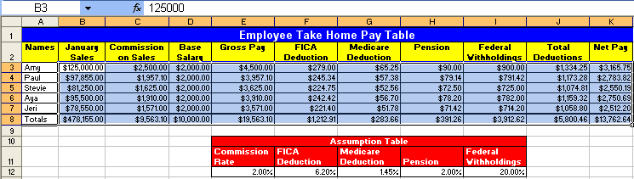

Figure 155
- As you learn to work with Excel you must be vigilant in the endeavor to always match the proper formatting with what actually sits in the cell. This leads us to our next section about formatting.

Cell Formatting
We format cells with color, number formats (such as currency), borders and other format so that we can better articulate our message to the viewer of our spreadsheet or printout of the spreadsheet. For example in Figure 156 we can see that formatting can help to communicate important information:
- The percentage format helps to communicate the number of parts for every 100 parts
- The accounting (similar to currency) format indicates that the Revenues, Expenses and Net Income are in USA dollars
- The double line under the Net Income communicates that this is the “bottom line”.
- The color helps to communicate that there are labels indicating what the numbers mean
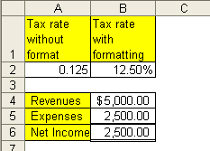

Figure 156
Here are the steps to learn how to apply cell formatting
- Navigate to the sheet named “Formatting (2)”. Click in cell E2. Hold Ctrl, then tap the “*” key on the number pad (this selects the table) (Figure 157):
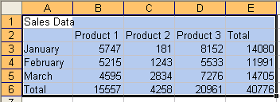

Figure 157
- Click the All Borders button on the Formatting Toolbar ():
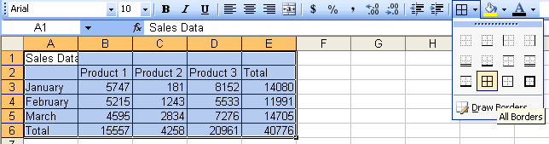

Figure 158

Figure 159
- Highlight the range A1:E1. Hold Ctrl key and tap “1” key (use the “1” below the F1 key not the “1” on the number pad). Ctrl + 1 opens the Format Cells dialog box (you could also right-click the highlighted range and point to Format Cells) Once you have the Format cells dialog box open click on the Alignment tab. See (Figure 160):
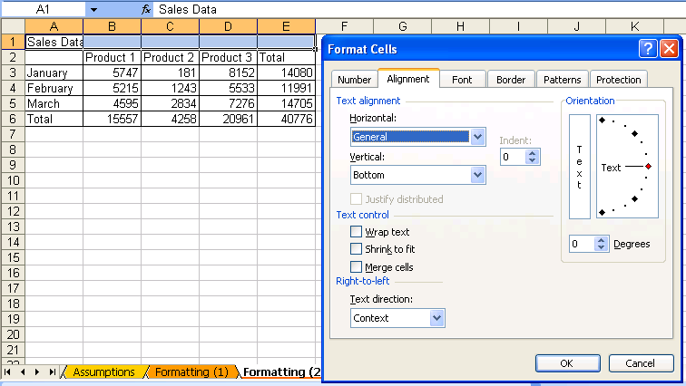

Figure 160

- With the Alignment tab selected, click the down arrow under Horizontal and select “Center Across Selection” ():
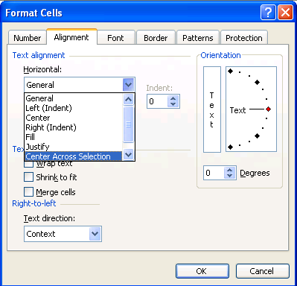

Figure 161
- We chose “Center Across Selection” instead of the more widely used “Merge and Center”. “Center Across Selection” allows move universal structural changes such as inserting columns/rows and moving, whereas the “Merge and Center” sometimes will disallow such actions.
- Click the Font tab. Select “Poor Richard” font (or some other font), Bold style, Size = 14, Color (of font) = White (Figure 162):
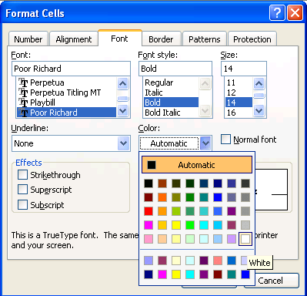

Figure 162
- Click on the Patterns tab and select Blue (Figure 163):
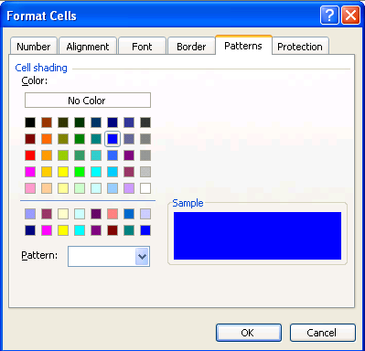

Figure 163
- Click OK (Figure 164):
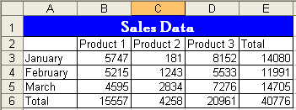

Figure 164
- Highlight the rangeB2:E2, Hold Ctrl, Highlight A3:A6. Click the yellow “Fill color button on the formatting toolbar (Figure 165):
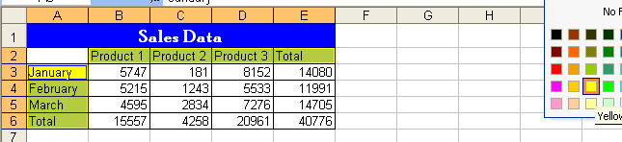

Figure 165
- Highlight the range B3:E6 (Figure 166)
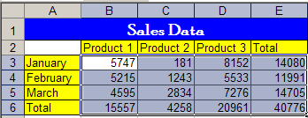

Figure 166

- Hold Ctrl and tap 1. Point to the Number tab. Select Accounting with no dollar sign, click OK (Figure 167):
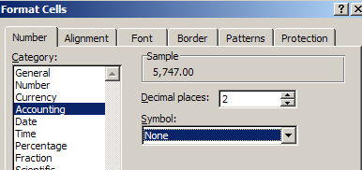

Figure 167
- Highlight A6:E6, Ctrl + 1, click the Borders tab. In the Line/Styles box, click the medium thick line (second column, fifth down) (Figure 168):
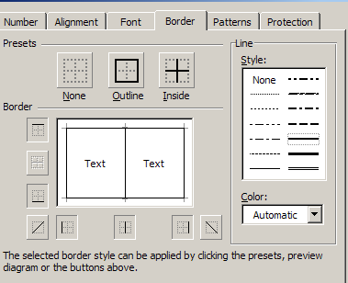

Figure 168
- Click the down arrow under color and select a color (Figure 169):
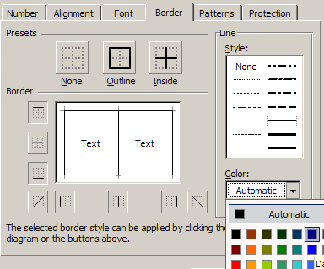

Figure 169

Figure 170
- Click the top line in the Border area (Figure 171):
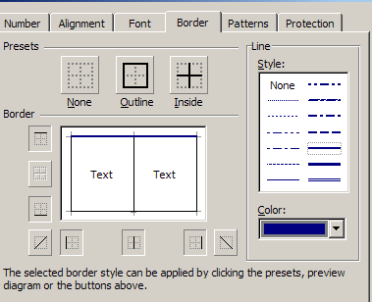

Figure 171
- The most important method that you must memorize to get this tab to work is this: ORDER MATTERS – you must click Line/Style FIRST, Color SECOND, and then draw your line the Border area THIRD!
- Now, use the method just discussed to add a Navy Blue Double line to the bottom border of our highlighted range (1):

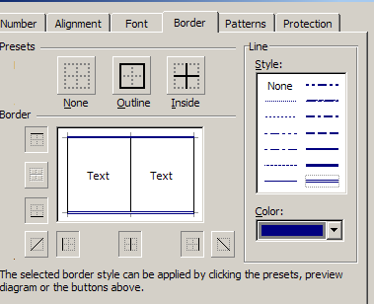

Figure 172

- Click OK, You should see (Figure 173):
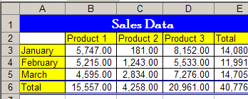

Figure 173
- Now that we have seen how to apply formatting, we need to look at how formatting can sometimes trick us. If we are to because efficient with Excel we need to be able match the proper formatting with what actually sits in the cell!

Cell Formatting is the façade that sits on top of data and formulas. What you see is not always what sits in the cell. For example:
- If you see 3.00%, Excel more than likely sees 0.03
- If you see $56.70, Excel may see 56.695
- If you see 07/26/2005, Excel more than likely sees 38559
- If you see 9:30 AM, Excel more than likely sees 0.395833333333333
Let’s look at an example ➔
Here are the steps to learn how to distinguish between formatting and actual cell content!!!!
- Navigate to the sheet named “Formatting (3)”. You should see what is in (Figure 174). Read the labels in column A and type in the number in column B. Column C tells you what is actually in the cell. The key strokes for typing the numbers in are as follows:
    - B2 ➔ 1, 3, :, 3, 9, Ctrl + Enter (that is to say: Type the number one, the number three, a colon, the number three, the number nine, and then hold Ctrl and then tap Enter)
      - Each time you hit Ctrl + Enter, look at what you see in the cell and compare that to what you see in the formula bar
    - B3 ➔ 1, 0, /, 2, 5, /, 2, 0, 0, 5, Ctrl + Enter
    - B4 ➔ 1, 0, Ctrl + Enter (Notice that you did not have to type in the dollar sign – the cell is preformatted)
    - B5 ➔ 1, 0, Ctrl + Enter
    - B6 ➔ 3, Ctrl + Enter
    - B7 ➔ 768, Ctrl + Enter
    - B8 ➔ 768, Ctrl + Enter
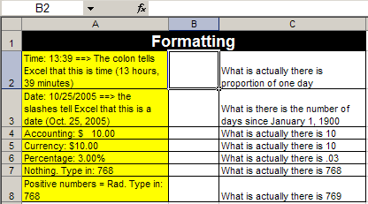

Figure 174
- When you are done you should see this (Figure 175):
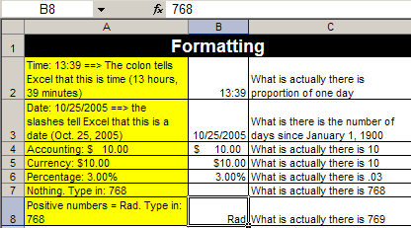

Figure 175
- Hold Ctrl and tap ~ key (Figure 176)
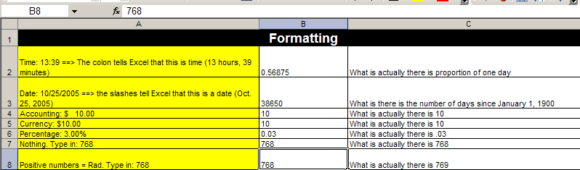

Figure 176
- What you see in Figure 175 is the façade. What you see in Figure 176 is what actually is in the cell and is what Excel will use for any formulas (whether calculating, text or other formulas)
- Ctrl + ~ to remove formula view. Then click on each cell in column B and using the Format Cells dialog box look at what Number format each cell is using
    - For Example in Figure 177 you can see that B2 has a time format
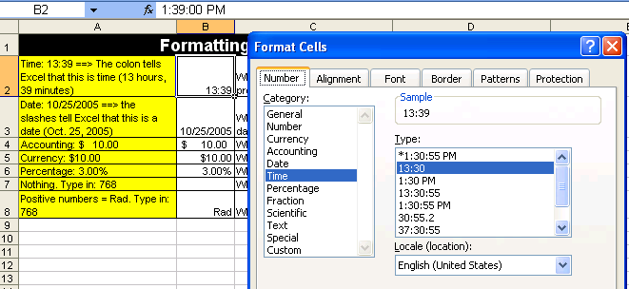

Figure 177
    - In Figure 178 you can see the custom format (discussed in another book):
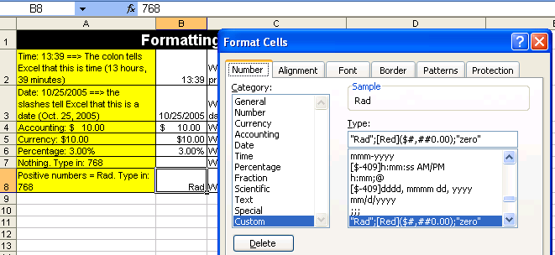

Figure 178
Rule #19: Cell Formatting is the façade that sits on top of data and formulas. What you see is not always what sits in the cell.

The next page reminds you that there are six tabs in the Formatting Cells dialog box. Two pages ahead we have an example of the formatting façade getting in the way of accurate calculations!

Make a note that there are six tabs in the Format Cells dialog box as seen below ():
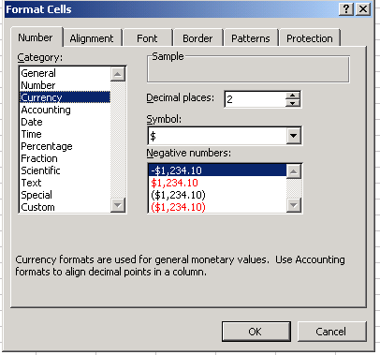
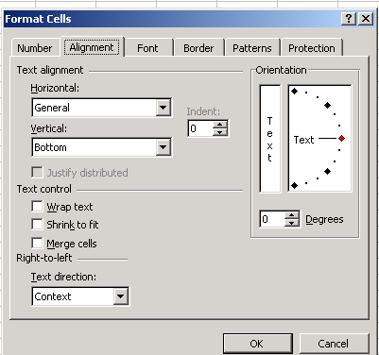
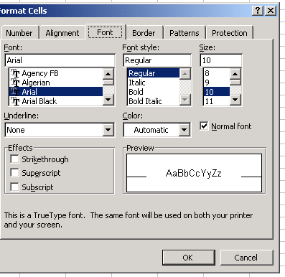
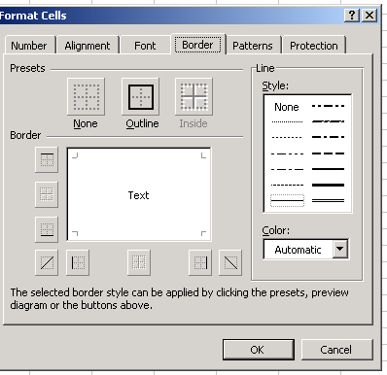
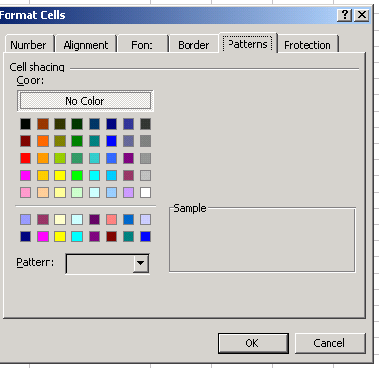
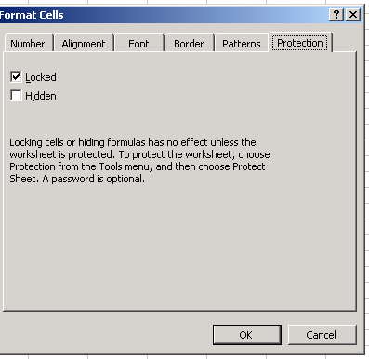

Figure 179

Here are the steps to learn how to use the ROUND Function in Excel to insure accurate payroll calculations when rounding to the penny is required
- Navigate to the sheet named “Round for Deduction”. Before you make any calculations on this sheet, follow the calculations in step 2 and make the deduction calculations by hand with a pencil.
- How to use a formula to calculate a tax deduction
  - Figure 180 shows the Taxable earnings and short description of how to calculate a deduction. Use Figure 181 to make a calculation by hand using a pencil, an eraser and the rules of rounding to a penny!
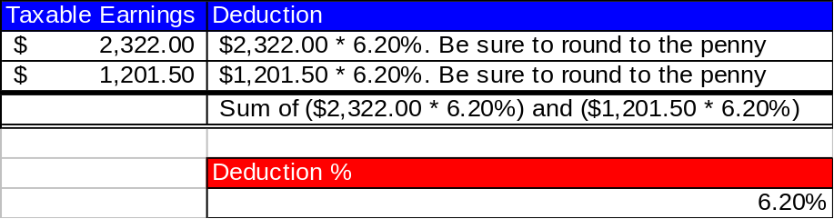

Figure 180
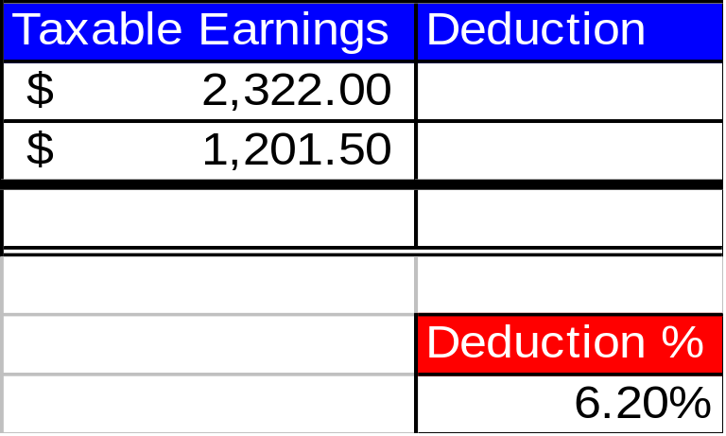

Figure 181
- Now we can try it in Excel
- How to use a formula to calculate a tax deduction
  - Before we create a formula to calculate the deduction, let’s look at the Accounting Number format already applied in the cell range B2:B4. Highlight the range and hold the Ctrl key, then tap the 1 key. You will see the Format Cells dialog box (Figure 182):
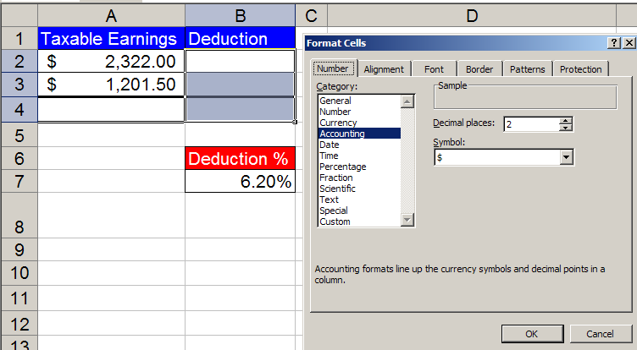

Figure 182
  - To begin a formula, type the equal sign (Figure 183):
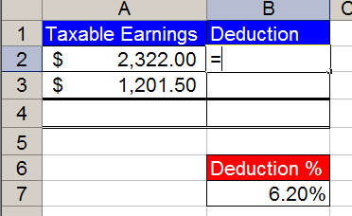

Figure 183
  - With the thick white cross cursor, click on cell A2 (The cell reference A2 will appear in the formula) (Figure 184):
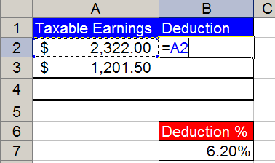

Figure 184
  - Type the multiplication symbol (Figure 185):
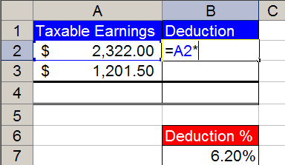

Figure 185
  - Click on the cell with the deduction % as seen below (Figure 186):
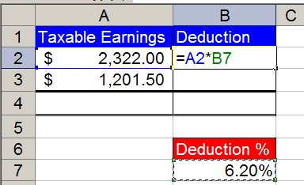

Figure 186
  - Click the F4 key twice to lock the percent (Figure 187):
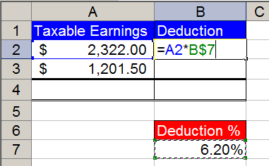

Figure 187
  - Hold the Ctrl key, then tap the Enter key to place the formula in the cell (Notice that you can still see the formula in the formula bar (Figure 188):
Name Box
Formula Bar
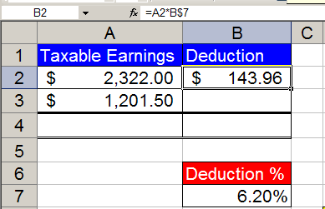

Figure 188
  - Point to the fill handle (Little black box in lower right corner of highlighted cell) (Figure 189):
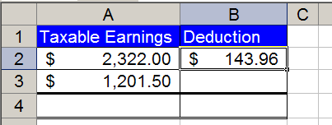
Fill Handle

Figure 189
  - With fill handle selected, copy formula from B2 to B3 (Figure 190):
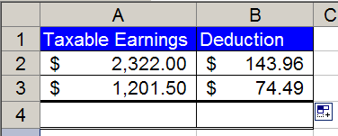

Figure 190
  - In cell B4 add a SUM function by holding the Alt key and tapping the equal sign. Verify that the SUM function selected the correct cells (Figure 191):
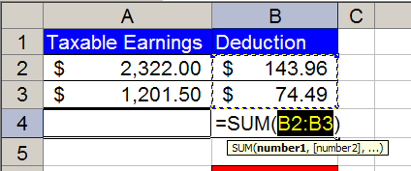

Figure 191
  - Hold Ctrl and tap Enter (Figure 192):
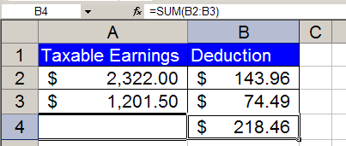

Figure 192
  - Go down to the area with the yellow instructions and verify that you entered the correct formula to calculate your payroll deductions. In cells E9 and E10 type what you see in cells B2 and B3, respectively (DO NOT USE CELL REFERENCES). Create a SUM function in cell E11 that adds the two cells above. (Figure 193):
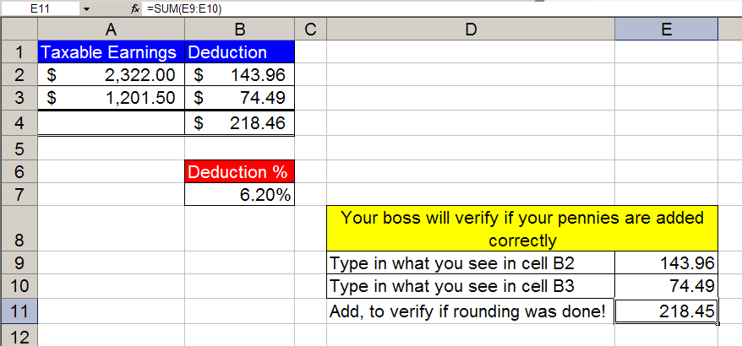

Figure 193
  - Question: What is the problem here???!!?
  - Answer: Excel did its part perfectly, but we did not! We forgot to make sure that the formatting and the calculating formulas are doing the same thing! To see how these are different, select the cell range B2:B4 and use the increase decimal button on the formatting toolbar to look at how the Accounting Number format formats the cells. You should see this after you click the increase decimal button once (Figure 194):
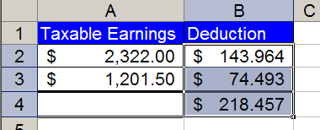

Figure 194
  - What has happened here? The formulas underneath have calculated without rounding, but the formatting on top has made it appear as if it has been rounded. The SUM function does not look at formatted numbers, but instead looks at the calculated unrounded numbers.
  - The solution is to make the format and the calculated numbers exactly the same by using the ROUND function.
  - Click the Decrease Decimal button to restore the format. You should see this (Figure 195):

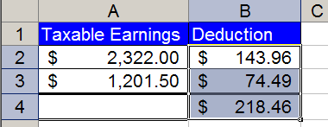

Figure 195
  - Add a ROUND function to our formula by clicking in cell B2. To edit the formula click the F2 keyboard button. You will see this (Figure 196):
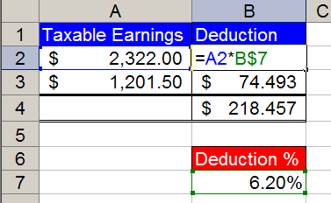

Figure 196
  - With your cursor point in between the equal sign and the letter “A” and click to insert your cursor into the formula. Then type the letters and characters “ROUND(“ as seen here (Figure 197):
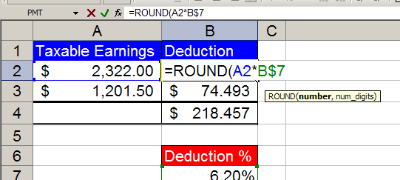

Figure 197
  - Then point your cursor to the formula bar and click at the end of the formula as seen here (Figure 198):
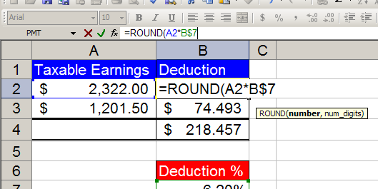

Figure 198
  - Type the characters and numbers: “,2)” as seen here (Figure 199):
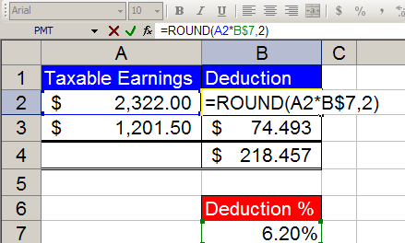

Figure 199
  - Hold the Ctrl key and then tap the Enter key. Then copy the formula to cell B3. Now you are done and you should see this (Figure 200):
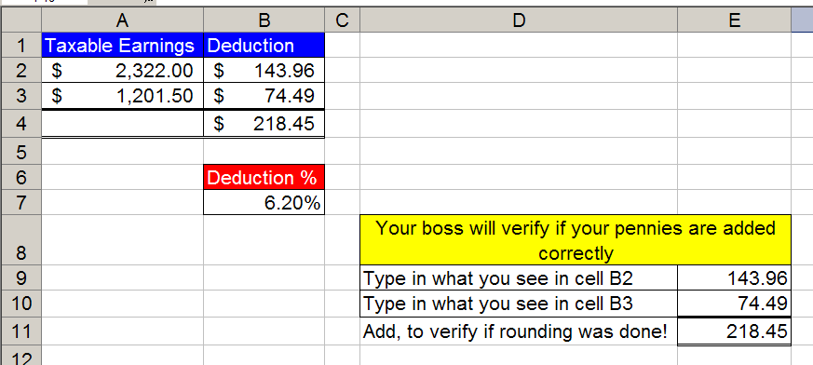

Figure 200
- Conclusions: because formatting (such as currency) is like a façade that sits on top of the number, when you have a formula that has the potential to yield more decimal places than the format displays, use the ROUND function.
  - For a payroll calculation that must be rounded to the penny, instead of =A2*B$7, use =ROUND(A2*B$7,2); where the second argument “2” means round to the second decimal.
2 means round to the penny (Payroll)
0 means round to the dollar (Income Taxes)
-3 means round to the thousands position. (Financial Statements)

Rule #20: Because formatting (such as currency) is like a façade that sits on top of the number, when you have a formula that has the potential to yield more decimal places than the format displays, use the ROUND function.

Next we will look at how to work with Date formatting.
With Date format, Excel sees the number of days since January 1, 1900 (inclusive). For example: January 1, 1900 is represented by the serial number 1; January 2, 1900 is represented by the serial number 2; and April 23, 2006 is represented by the serial number 38,830.

Here are the steps to learn how to understand the Date format and to make date calculations (Excel date math)
- Navigate to the sheet named “Date Math”. You should see this (Figure 201):
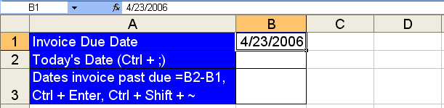

Figure 201
- Hold Ctrl and tap on the ~ key (this reveals what is actually in the cell; this is called formula view). You should see what is in Figure 202. Understanding the Date format requires that you know that when you type “4/23/2006” (Figure 201), Excel sees 38830 (Figure 202). The “4/23/2006” is the façade that we see. The 38830 is the serial number that Excel sees. This serial number is very useful for making date calculations…
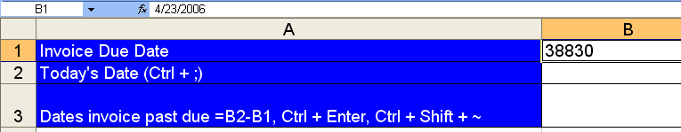

Figure 202
- Hold Ctrl and tap on the ~ key to remove formula view
- Select cell B2, Hold Ctrl and tap ; (semi colon) to put Today’s date in the cell (Figure 203). (Don’t worry if your day is different).
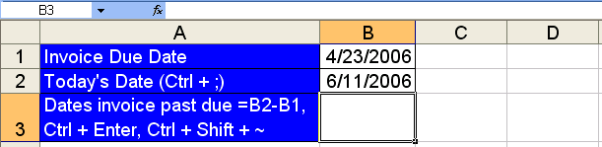

Figure 203
- Select cell B3, enter the formula “=B2-B3”, then hold Ctrl and tap Enter (Figure 204):
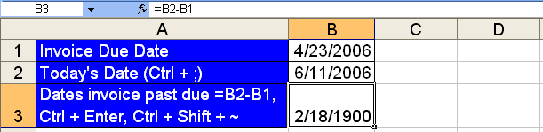

Figure 204
- What is going on here? Why is there a date in our cell instead of the number of days the invoice is past due? The answer is this: When you create a formula it brings the format from the cells that you have referenced to the cell you are creating a formula within.
- To bring the format back to the “General format, Hold Ctrl and Shift and tap ~ (Figure 205):
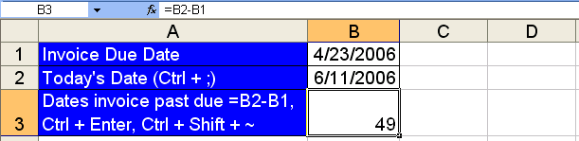

Figure 205
- Figure 205 reveals the beauty of the serial numbers that lie behind every date: it is easy to do date math! Whether you are calculating an overdue invoice, your own age, or an estimate of the number of days to complete a job, date math is amazing!
- One final note about Date format: Click in cell D1 and type the number 38830, then hold Ctrl and tap Enter (Figure 206):
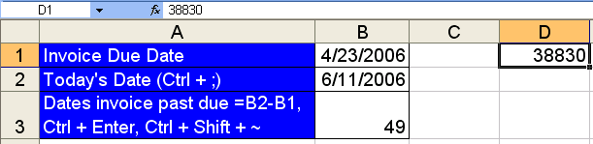

Figure 206
- Hold Ctrl and tap 1, click on the Number tab, click on Date (Figure 207):
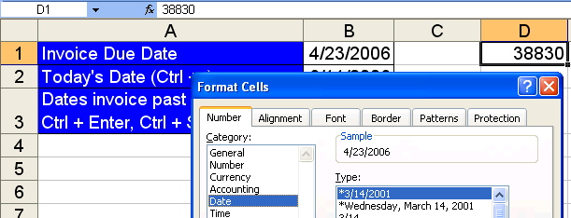

Figure 207
- Click OK. Figure 208 illustrates directly that the number 38830 has a façade on top of it for us Excel users to see. In this way, we understand that it is a date when we see it, but hidden underneath, Excel sees the serial number so it can make date calculations!
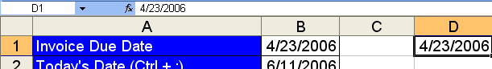

Figure 208
- For everyday Excel use, you can enter dates such as 4/23/2006, by typing the numbers and forward slashes – Excel automatically enters the serial number behind the scenes.

Rule #21: With Date format, Excel sees the number of days since January 1, 1900 (inclusive). This allows us to make date math calculations.

Now that we have studied the Date format façade and how to use it, we can look at the Time format façade and how to use it.
With Time format, Excel sees the proportion of one 24 hour day. For example: 8:00AM is represented by the decimal number (also known as serial number or time value) 0.333333333333333; 6:21AM is represented by the decimal number .264583333333333; and 5:15:15 PM is represented by the decimal number .718923611111111.

Here are the steps to learn how to understand the Time format and how to make time calculations (Excel time math)
- Navigate to the sheet named “Time Formatting (1)”. You should see this (Figure 209):
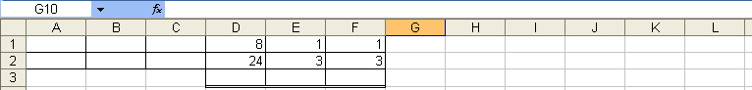

Figure 209
- When entering times into Excl, you can use the following conventions (Figure 210):
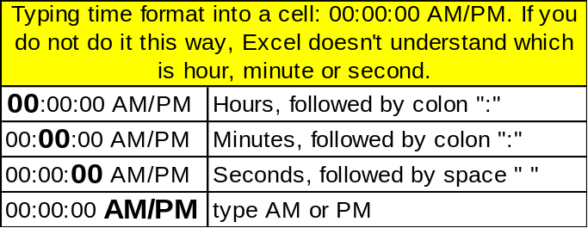

Figure 210
- Click in cell A1 and type: 8, :, 0, 0, (space), A, M (said another way: type 8:00 AM). Click in cell B1 and type 6:21 AM. Click in cell C1 and type 5:15:15 PM (Figure 211).
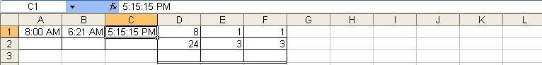

Figure 211
- Hold Ctrl and then tap ~ to see what Excel sees (Figure 212):
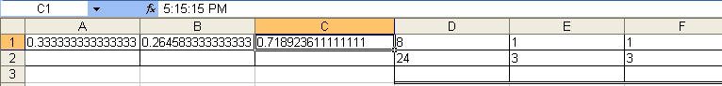

Figure 212
- In Figure 212, notice that the decimal number that represents 5:15:15 PM is greater than the decimal value that represents 8:00 AM. This insight will allow us to subtract the earlier time from the later time and get the proportion of one day that has elapsed between the two times.
- Hold Ctrl and then tap ~ to return to our normal view. In order to see that 8 hours does represent .333 or 1/3 of a 24 hour day, click in cell D3 and type the formula “two cells above divided by one cell above” (Figure 213):
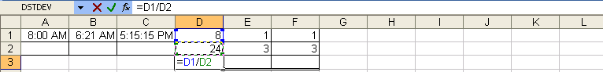

Figure 213
- Hold Ctrl and then tap enter. Point to the fill handle and drag the formula from cell D3 through F3 (Figure 214):
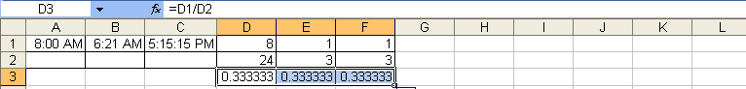

Figure 214
- Highlight the cells D3:E3, hold Ctrl and then tap 1, click on the number tab, click on the Time category (Figure 215):
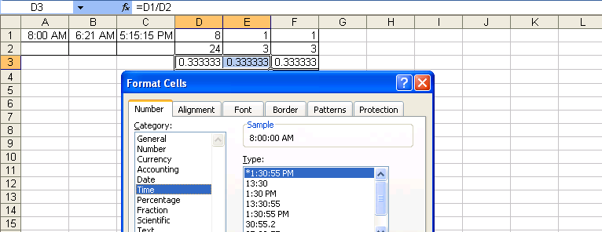

Figure 215
- Click OK. In Figure 216, we can see that 8/24 or 1/3 is .333333333333333, but when we apply a Time format, the Excel user sees 8:00 AM.
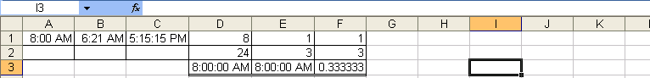

Figure 216
- As an extra bonus, click in cell F3 and apply the Fraction format. After you apply this format you should see this (Figure 217):
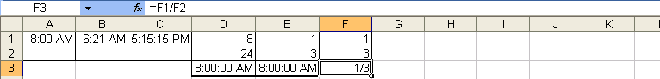

Figure 217
- With our new understanding of the Time format, we would like to make some time calculations in Excel.
- Navigate to the sheet tab named “Time Formatting (2)” You should see this (Figure 218):
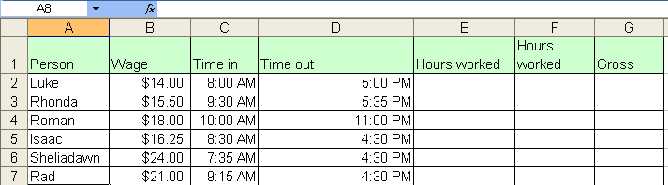

Figure 218
- We would like to use Excel to keep track of employees work hours and gross pay. Click in cell E2 and subtract the earlier time from the later time (“one to my left minus two to my left”) (Figure 219):
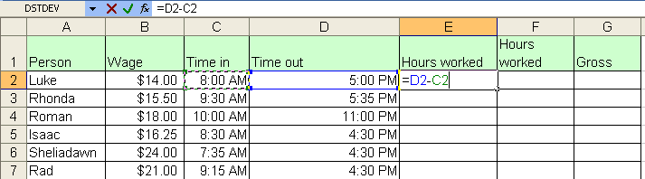

Figure 219
- Hold Ctrl and then tap Enter (Figure 220). We see is Figure 220 that the Time format has carried forward into our cell with the formula.
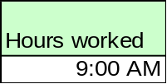

Figure 220
- Hold Ctrl and Shift and tap ~. In Figure 221 we see the proportion of the day that Luke ahs worked.
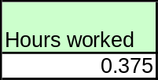

Figure 221
- Hold Ctrl and tap 1, select the Number tab, click on the Time category, click on the second time type in the list (Figure 222):
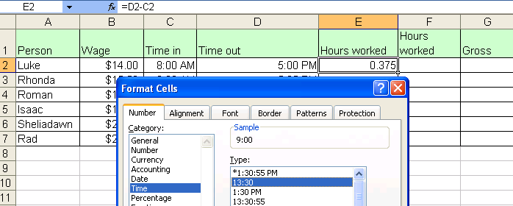

Figure 222
- Click in G2 and type the formula as seen in Figure 223:
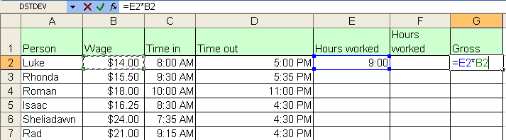

Figure 223
- Hold Ctrl and tap Enter. What is wrong with Figure 224? Nothing! If WE were trying to multiply 9 hours times $14.00, we did not accomplish this. We made the wrong calculation. Excel did not make the wrong calculation. The resultant answer, 5.25, is exactly what we asked Excel to calculate, namely: 375*14.
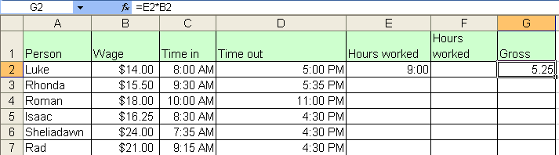

Figure 224
- Delete the contents of cell G2. In cell F2 type the formula “=(D2-C2)*24” (Figure 225). Notice that we had to know our order of operations (the subtraction is in parenthesis) and we had to know that 24 is a number that will not vary (thus it is OK to type into our formula).
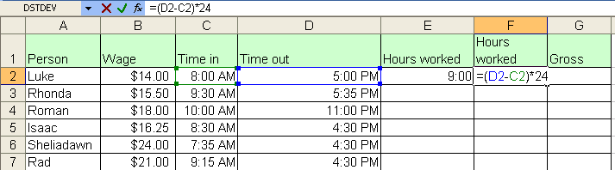

Figure 225
- Hit Tab. Type the formula “one to my left times four to my left” in cell G2, and then hold Ctrl and tap Enter. Then Hold Ctrl and Shift and tap the $ key (this is the keyboard shortcut for the Currency format). You should see this (Figure 226):
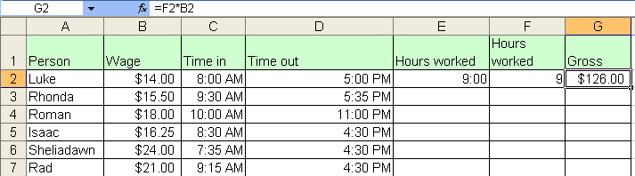

Figure 226
- Highlight the range E2:G2, point to the fill handle and with your angry rabbit, double click the fill handle to copy the formulas down (Figure 227):
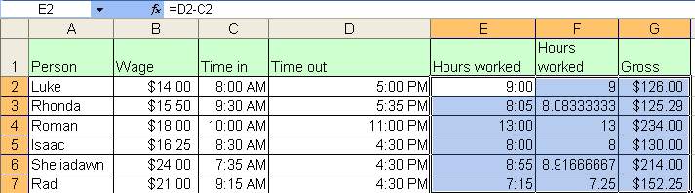

Figure 227
- With our knowledge of the Time format, order of operations and non-varying numbers, we have created formulas that we can use for timesheet calculations.

Rule #22: With Time format, Excel sees the proportion of one 24 hour day. This allows us to make time math calculations.

Next we will turn our attention to Excel’s Charting capabilities.
Charts
Charts and graphs are a means to visually articulation numerical data. There are times when a picture (chart or graph) tells a thousand words, or in our case, a thousand numbers. Charts and graphs can deliver a message in a more immediate way. Although a chart or graph lacks the detail of al the numbers, it quickly articulates its message in an effective way.

In Excel, you use the Chart Wizard to create your chart/graph. After highlighting your numerical data and labels, you click the Chart Wizard button on the Standard toolbar, or select “Charts…” from the Insert menu. There are many charts to choose from and choosing the correct one can sometimes be tricky. We will look at four chart types: Pie chart, Column chart with multiple series data, Column chart set up as a Histogram, and a XY (Scatter)/Line chart. If you would like to learn about more of the built in chart types, Click F1 (Microsoft Help) and type “chart types”. There is an article that will lead to the website: http://office.microsoft.com/en-us/assistance/HA010346071033.aspx.. There are four steps to the Charts Wizard. We will look at each step as we create our four different Charts:

Here are the steps for creating a Pie Chart
- Navigate to the sheet named “Charts (1)”. You should see this (Figure 228):
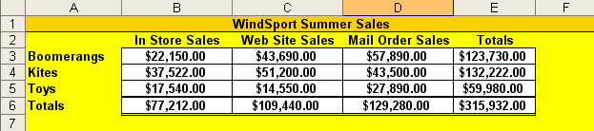

Figure 228
- Highlight the range A3:A5, Hold Ctrl, Select the range E3:E5, and then click the Chart Wizard button on the Standard toolbar (Figure 229). Figure 230 on the next page shows the dialog box that pops up.
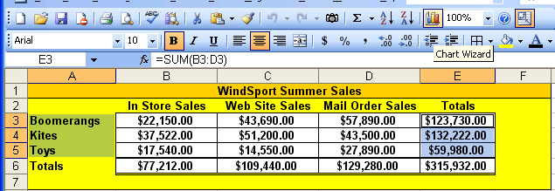

Figure 229
- Chart Wizard Step 1 = Chart Type ➔ What type of chart do you want? Notice in Figure 230 that by default the column chart is selected.
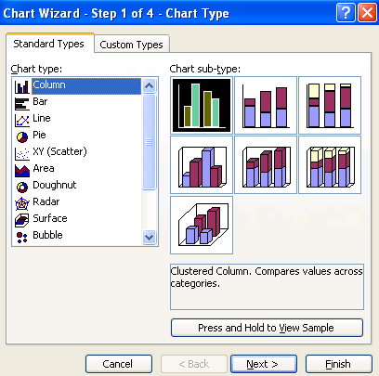

Figure 230
- You must memorize the 4 steps in the Chart Wizard. (In this way if you want to change a part of your chart, you already quickly know which step to access and change.)
- For our current chart we want a pie chart. Pie charts show the relationship of the parts to the whole. You will often see the words “proportion” or “percentage”. When you are required to make a pie chart. Figure 231 shows that data we are using for our pie chart. Notice that we never highlight the total: we only highlight the parts that make up the total.
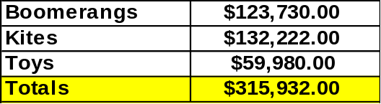

Figure 231
- In Step 1 of the Chart Wizard under Chart type, click on Pie (Figure 232). Notice the succinct description of what a pie chart is in the lower right hand corner. Also notice that there is a button to “View Sample” of your data with this chart.
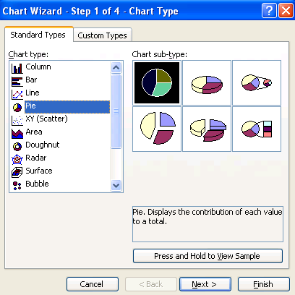

Figure 232
- Click Next.
- Chart Wizard Step 2 = Source Data ➔ Where is the source data located in the worksheet? (Figure 233). The Data Range tab reveals the cells in the worksheet that the Chart Wizard is looking to in order to make the chart. (Figure 233). Because the Chart is looking at cells in the worksheet, when you change the data in the cells, the chart will update!!
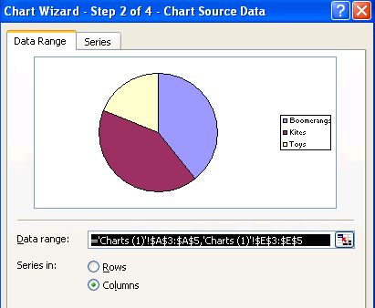

Figure 233
- Click on the Series tab. You will see this (Figure 234):
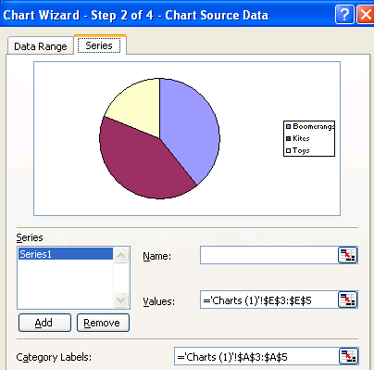

Figure 234
- Chart Wizard Step 2, Source Data, Series tab is perhaps the most important step while setting up your chart. Because the chart wizard does not always place your highlighted worksheet data into the correct parts of your chart, it is the series tab that will let you redirect or refine how the data is displayed in your chart. For our pie chart there is only one series. A series is simply a set of numbers and category labels. In addition, we can see that the “Values” are coming from the correct set of cells and our “Category Labels” are coming from the correct set of cells. For a Pie Chart, the “Name” textbox will add a title to our chart.
- Click in the “Name” textbox, then click in cell A1 in the worksheet, then hit the Tab key. You should see this (Figure 235):
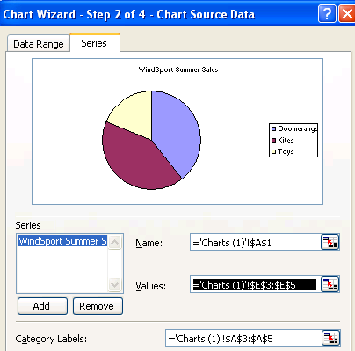

Figure 235
- Click Next
- Chart Wizard Step 3 = Chart Options ➔ What accessories would you like to add to your chart (titles, axis labels, percentage indicators, etc.)? (Figure 236):
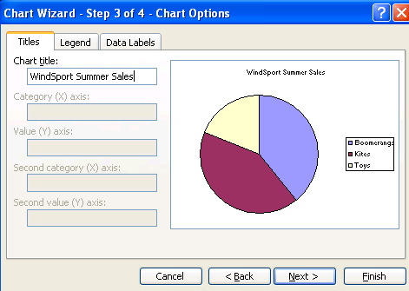

Figure 236
- Click on the Legend tab. Uncheck “Show legend”
- Click on the Data Labels tab. Check “Category name” and “Percentage”
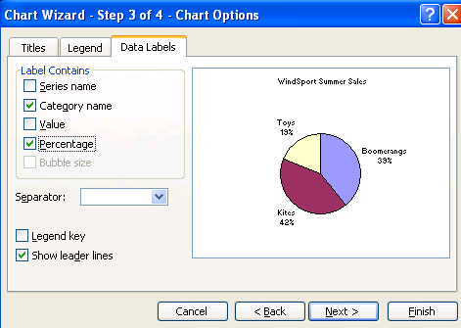

Figure 237
- Click Next.
- Chart Wizard Step 4 = Chart Location ➔ Do you want chart on top of worksheet, “As object in’, or do you want the chart to be placed as its own new sheet, “As new sheet”? (Figure 238)
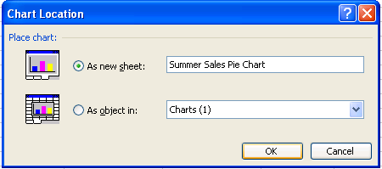

Figure 238
- As seen in Figure 238, select the dialog button “As new sheet”, click in the textbox for “As new sheet”, and type the chart sheet name: “Summer Sales Pie Chart”
- Click Finish. You should see this (Figure 239):
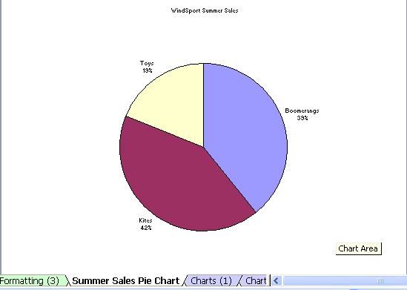

Figure 239
- Once you have created your chart, the # 1 rule for improving your visual message is: “Everything is right-clickable”. Each part of your chart can be edited and modifies by right-clicking that particular part.

- Right-click the title and point to “Format Chart Title” ():
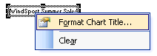

Figure 240
- After you click “Format Chart Title” and then click on the Font tab, select the settings as seen in Figure 241. Click OK.
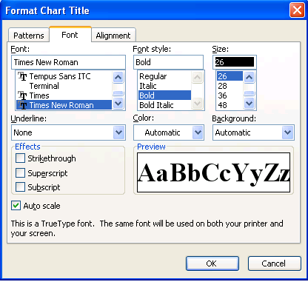

Figure 241
- Click one of the Category Names with Percentage labels. All three labels should be selected as seen in Figure 242. After you click on one label, you should see little black boxes on either side of each label – this indicates that all the labels have been selected and any action taken will apply to all labels.
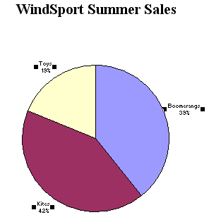

Figure 242
- After selecting all labels, right-click and point to Format Data Point (Figure 243):
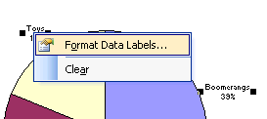

Figure 243
- Click the Font tab and select the items as seen in Figure 244
- 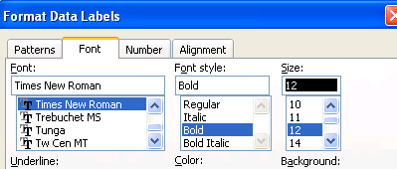

Figure 244
- Click the Number tab and select the items as seen in Figure 245:
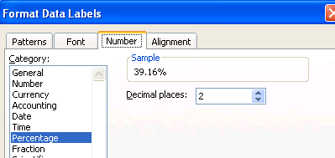

Figure 245
- Click OK. Then click one of the Category Names with Percentage labels (all three labels should be selected), wait two seconds, then click the same label a second time (this is called a S-L-O-W double-click). After this S-L-O-W double-click, only one label is selected. (This S-L-O-W double-click is the key to highlighting single data points that are part of a data series). The single selected label should look like this (Figure 246):
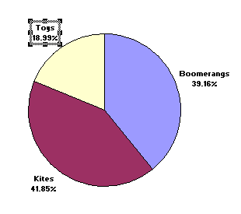

Figure 246
- In Figure 246 you can see the little black boxes with a gray square around the label. To move this label, slide your cursor close to the gray edge, and then click the gray edge to “grab” the label. Then you can move the label further out from the pie piece. After you have repeated the process for all the labels, you should see something like this (Figure 247):
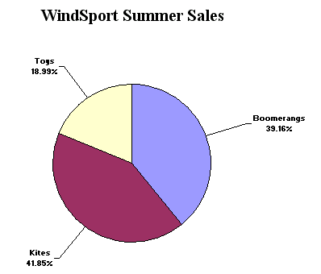

Figure 247
- Using the same S-L-O-W double-click technique, color each pie piece differently. Then right-click the background and change its color. You may get a chart that looks like this (Figure 248):
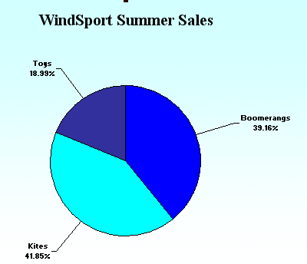

Figure 248
Here are the steps for creating a Column Chart with multiple series
- Navigate to the sheet named “Charts (1)” and highlight the range A2:D4 (Figure 249):
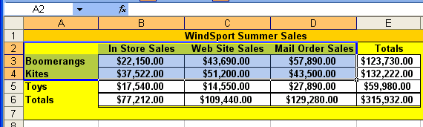

Figure 249
- Click the “secret automatic chart creating” button: F11. You should see a chart automatically created (as default chart type) and placed as a new sheet named Chart1 (Figure 250):
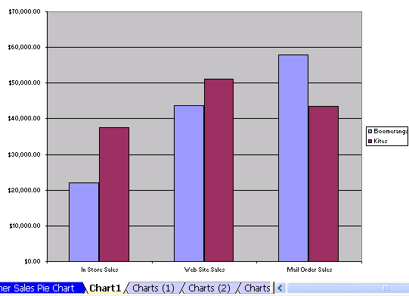

Figure 250
- Right-click the white area in the top-right corner and click on “Source Data” (Figure 251):
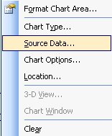

Figure 251
- After you click on “Source Data” you should see the tab for Step 2 of Chart Wizard (Figure 252). Notice the “multiple series”; there are two series to be exact: Boomerangs and Kites. Below the list of series there are buttons to “Remove” or “Add” series. In addition, you can see with multiple series that the “Name” shows the cells that supply the data for the Legend (but not chart title), the “Values” shows the cells that supply the data for the values, and the “Category labels” shows the cells that supply the data for the labels.
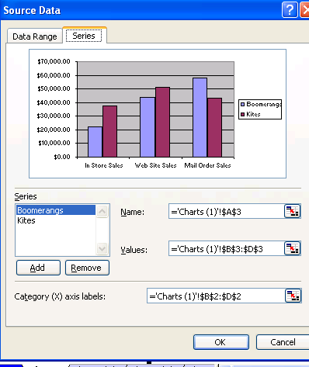

Figure 252
- Click OK. Right-click the white in the top-right corner and click on Location. You should see the tab for Step 4 of the Chart Wizard. Click the dialog button next to “As object in” and scroll down (you may have to scroll way down) and click on the sheet tab name “Charts (1)”(Figure 253). After you select the “Charts (1)” sheet, click OK.
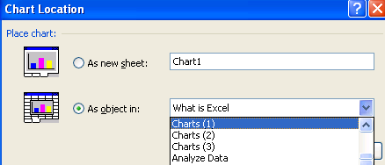

Figure 253
- After you click OK, the chart will be moved and placed as an object in the sheet named “Charts (1)” (Figure 254):
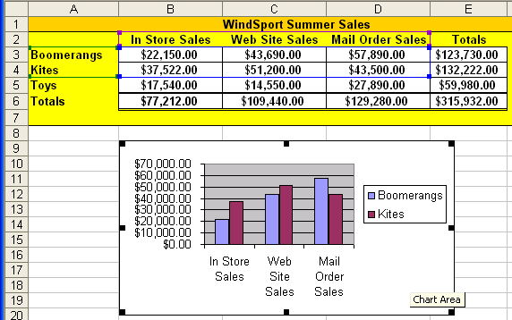

Figure 254
- Highlight the range A5:D5 and point to the edge of the highlight range (Figure 255):
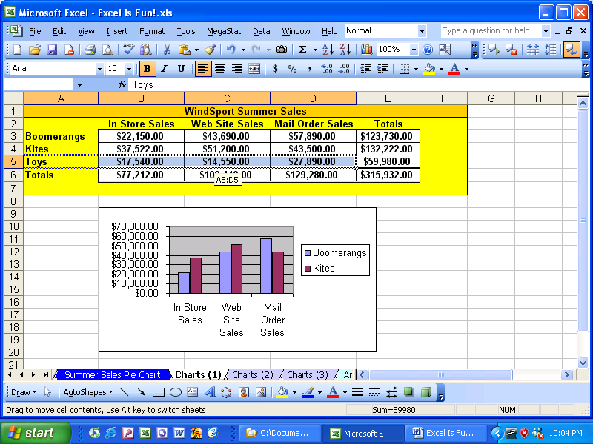

Figure 255
- When you see your “white-arrow with a thin four-way black-cross-arrow behind it” cursor, click and drag the range onto the chart. (You are not moving the range; you are actually dragging a new data series to the chart). You will know that you have successfully clicked and dragged the range when you see the gray thick border around the range. This gray border will move with your cursor as you drag the range. When you drag your cursor to the chart area, the gray border will surround the chart. At this point you let go of your mouse click and the new data series drops onto the chart. (Figure 256):
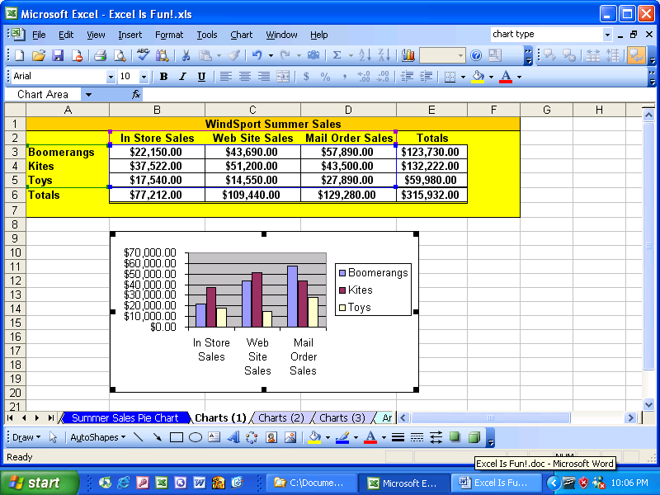

Figure 256
- If you want to change the default chart type, right-click any chart that has already been completed and point to Chart Type (this trick will not work inside Chart Wizard). After the Chart type dialog box appears there will be a button you can click to set that chart as the default chart (default charts are what gets created when you use the F11 key) (Figure 257):
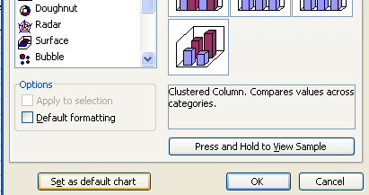

Figure 257
Here are the steps for creating a Column chart set up as a Histogram
- Navigate to the sheet named “Charts (2)”. Highlight the range D3:E10. Click the Chart Wizard button. In Step 1 of the Chart Wizard (Chart Type), accept the defaults and click the next button. In Step 2 (Source Data), click the Series tab. You should see this (Figure 258):
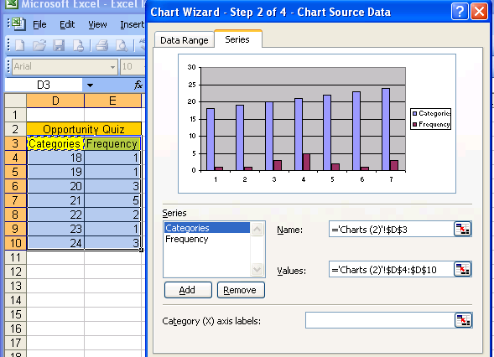

Figure 258
- Figure 258 illustrates how Chart Wizard can guess incorrectly. For our Histogram chart we need only one series and we will need Category labels. With the Categories Series highlighted, click the remove button. After the Category Series is removed, click in the Category (X) axis labels textbox, then highlight the range D4:D10. And finally, click in the Name textbox and then highlight cell D2. Your Series tab should look like this (Figure 259):
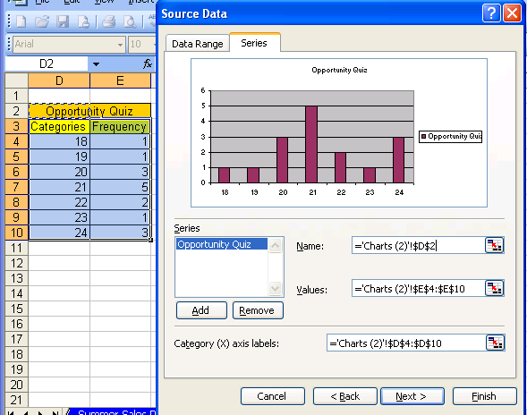

Figure 259

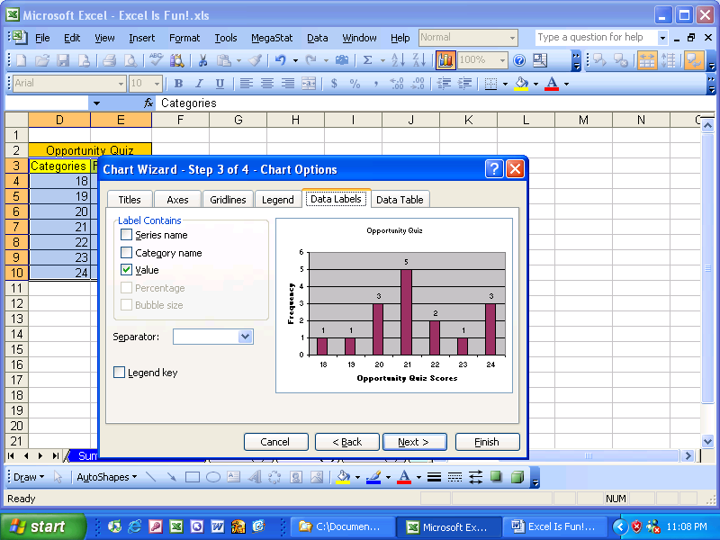

Figure 260
- In Figure 260 you can see that we have added titles and labels using the Titles tab, we got rid of the legend using the Legend tab, and we have added value labels using the Data Labels tab.
- Because we will place this chart as an object in this sheet, we don’t need to go through Step 4 (the default setting will get us what we want), so click Finish. You should see this chart:
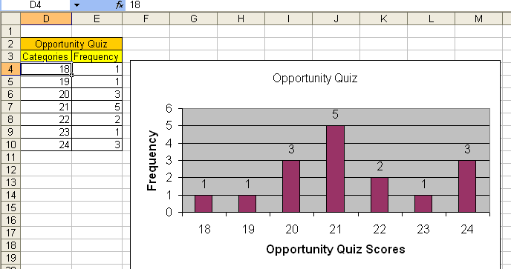

Figure 261
- With Histograms the columns should have no gaps between them. As a result we need to right-click one column and Format The Data Series (Figure 262):
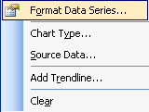

Figure 262
- Click on the Options tab and change the Gap width to zero (Figure 263). Once you click OK, your Histogram is completed.
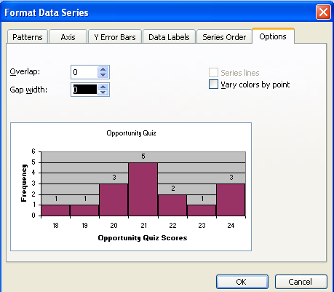

Figure 263

Here are the steps for creating a XY (Scatter) chart
- Navigate to the sheet tab named “Charts (3)” and highlight the range A1:B28 (Figure 264):
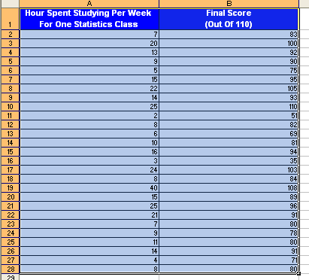

Figure 264
- Click the Chart Wizard button and in Step 1 under Chart type select “XY (Scatter)”. Click Next. Click NEXT again to get to step 3. Remove the Legend using the Legend tab. Click on the Titles tab and add the labels: X = “Hours Studying per Week for Stats Class” and Y = “Score on Final” (Figure 265):
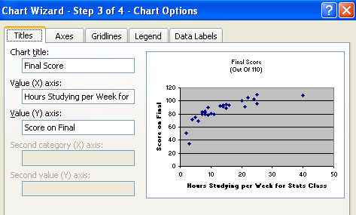

Figure 265
- Click Finish. You should see this chart (Figure 266):
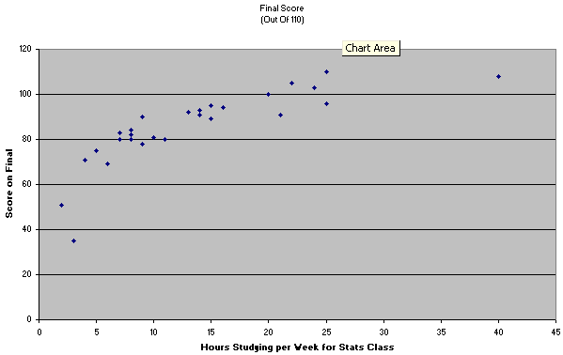

Figure 266
- Right-click one of the data points and click on “Add Trendline” (Figure 267):
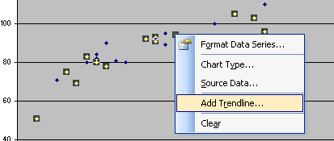

Figure 267
- After you click on Trendline, you should see this dialog box (Figure 268):
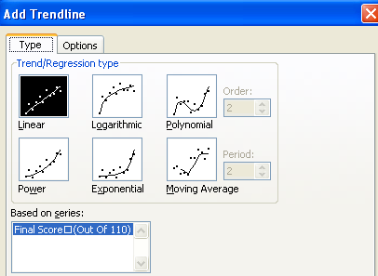

Figure 268
- Click on the Options tab and check “Display equation on chart” and “Display R-squared value on chart” (Figure 269)
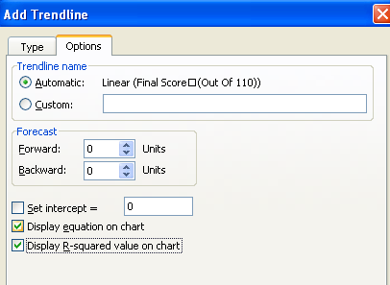

Figure 269
- Click OK. Figure 270 shows how easy creating charts for liner algebra can be. Figure 270 also has a number of items changed by right-clicking and changing. The labels and the equations have an increased font size and the vertical axis has the minimum value changed to 60.

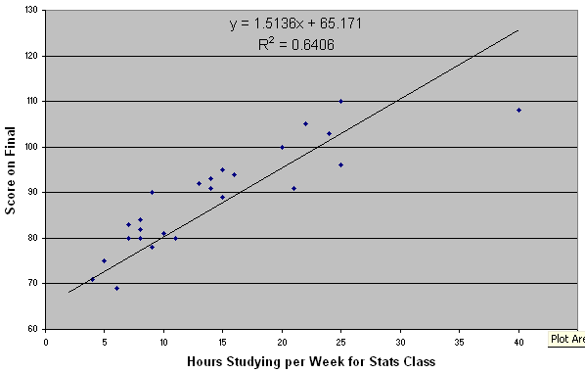

Figure 270
Wow! That is just a few of the tricks for charts. However, if you apply the theories learned and you remain creating, it is amazing what kind of charts you can make.

Rule #23: Chart Wizard: Step 1 = Chart Type, Step 2 = Source Data (Series tab gives you real power over Chart Wizard), Step 3 = Chart Options, Step 4 = Chart Location. After the chart is done, everything is right-clickable. Don’t know which chart to use? Type “Available chart types” into Help.

We just looked at charts, now let’s look at our next section about analyzing data!

Analyze Data
The essential beauty of Excel is that you can make calculations and analyze/manipulate data quickly and easily “on the fly!” What-if analysis is easy in Excel. You can Sort to see which Sales Rep had the greatest sales, create Subtotals by Region, and do complex data analysis such as summarizing on multiple criteria. (This section is only a brief look at Excel’s infinite Analyzing capabilities…). For this section we will look at Sorting, automatic Subtotals and a basic PivotTable.

The #1 MOST IMPORTANT THING TO REMEMBER WHEN YOU START TO USE EXCEL’S DATA ANALYSIS TOOLS IS:

Rule #24: Before you use Excel’s Data Analysis Tools: the data must be in proper Excel List Format: 1) First row has field names with bold and other formatting that is different from the rest of the data; 2) No blank field names; 3) Columns are Fields; 4) Rows are records; 5) No blank columns (fields); 6) No blank rows (records); 7) Blank rows and columns (or Excel’s column headers (A, B…) and row headers (1, 2…) must separate the Excel List from other data

Columns are called “Fields”. Fields are the variable data for each record. Rows are called “Records”. Records are individual collections of the fields. For example, navigate to the sheet tab named “Analyze Data”. You should see this (Figure 271):
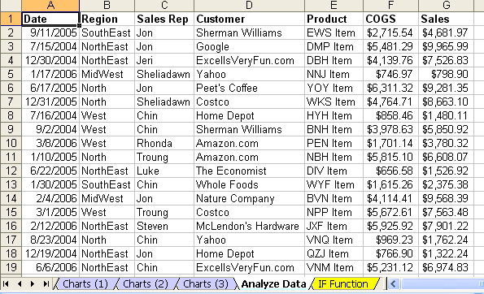

Figure 271
In Figure 271 we can see:
- Proper Excel List Format
- Each row represents one Sales Transaction
    - Each sales transaction is one new record
    - Each record is an individual collection of the seven fields
- The first seven columns represent fields
    - Each field is a variable
      - For each new transaction it can have a different date or different region or different sales rep
Steps to Sort to see which Sales Rep had the greatest Sales
- Click in the Sales column. Click in only one cell in the sales column (if you highlight more than one cell, you may sort just part of the data). Point to the Sort Z ➔ A button on the Standard toolbar (Figure 272):
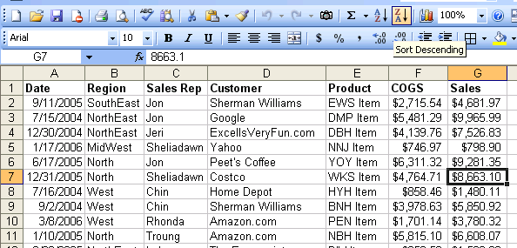

Figure 272
- Click the Sort button. Because our data is in Proper Excel List format, the entire 2000 row block of data is sorted by sales! (Figure 273):
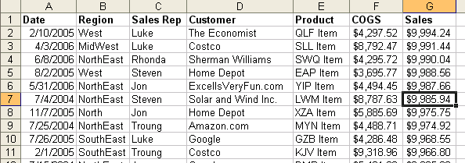

Figure 273
- Click in one cell in the Sales Rep field and then click the Sort A ➔ Z button on the Standard toolbar (Figure 274). Notice that the prior sort was retained. We can see that the Sales Rep has the Sales still sorted! Scroll down and see that all 2000 rows have been sorted!
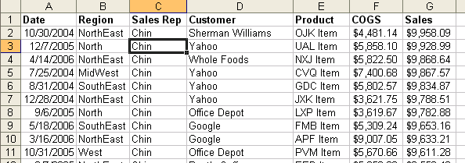

Figure 274
Rule #25: Before Sorting using the Sort button, make sure your block of data is in the Proper Excel List Format and highlight only one cell in the field you want to sort.
Steps to add automatic Subtotals
- Click on the Data menu, and then click on Subtotals (Alt + D + B). You should see Subtotal dialog box as seen in Figure 275. Notice that the whole table was highlighted when you invoked the Subtotals dialog box (this is because you have your data in Proper Excel List format). Using the drop-down arrow for the “At each change in” textbox, select the Sales Rep field. For the “Use function”, use the Sum function. For the “Add subtotals to: checkboxes check the Sales field.
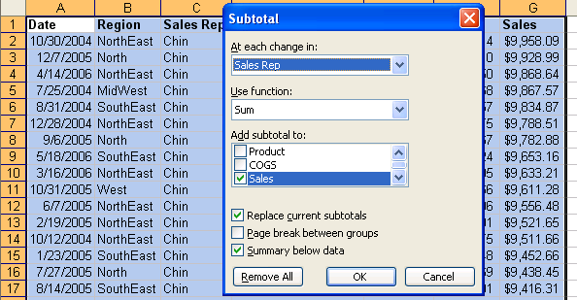

Figure 275
- Click OK. You should see something similar to Figure 276. On the left of your screen you should see three little blue-gray boxes with the numbers 1, 2, and 3 in them. These are called Outline buttons.
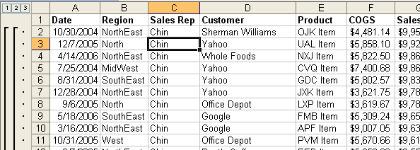

Figure 276
- Click the “2” Outline button and you should see subtotals similar to those as seen in Figure 277. The plus and minus symbols are collapse and expand symbols. You can use these to expose the data for a particular Sales Rep. You can also use the “3” Outline button to expose all the records.
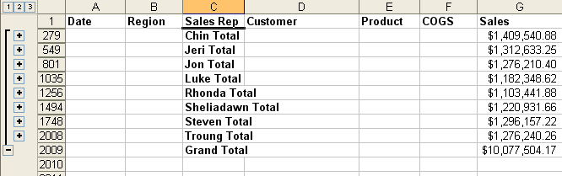

Figure 277
- To get rid of Subtotals click tap Alt + D + B + R. Click in one cell the Region column and click the Sort A ➔ Z button. You should see this (Figure 278):
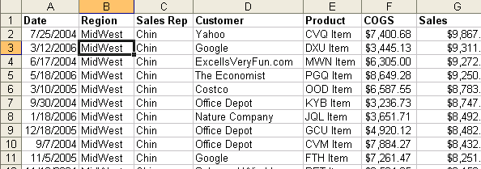

Figure 278
- Now we would like to create Subtotals by Region. Tap Alt + D + P and change the Subtotal parameters to the ones as seen in Figure 279:
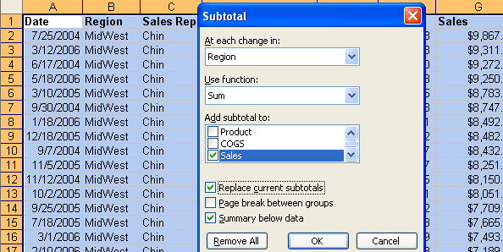

Figure 279
- Click OK. Click the “2” collapse button and you should see this(Figure 280):
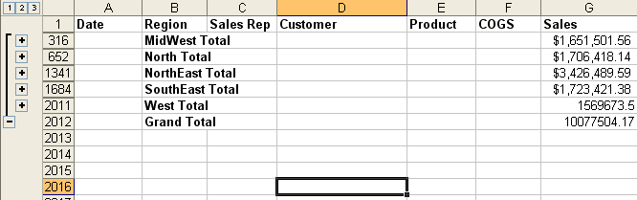

Figure 280
- It is possible to add another level of Subtotals. In order to add for the Sales Reps within each Region, tap Alt + D + B to view the Subtotals dialog box (Figure 281). The key to adding another Subtotal is to uncheck the “Replace current subtotals” check box, and be sure to change the field for the “At each change in” to Sales Rep.
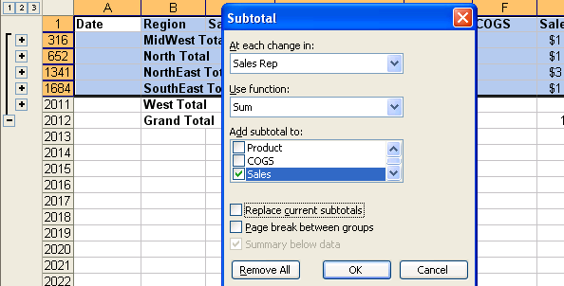

Figure 281
- Click OK. You should see this (Figure 282):
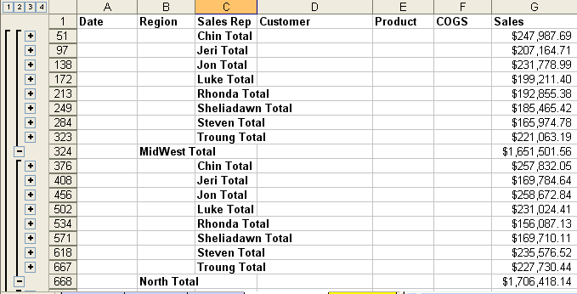

Figure 282
Rule #26: Before adding automatic Subtotals, sort your field. If you want to add a Subtotal to a Subtotal, Be sure to uncheck the “Replace current subtotals” check box.

- To get rid of your Subtotals, tap Alt + D + B + R + Enter.
Steps to create a basic PivotTable
- Make sure you have one cell in your data block selected (Proper Excel List Format). Point to the Data menu, click PivotTable and PivotChart Report (Figure 283):
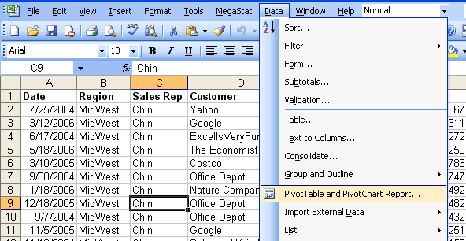

Figure 283
- Step 1, click Next (Figure 284):
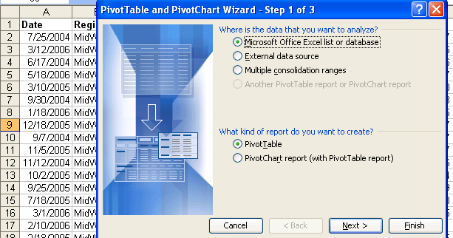

Figure 284
- Step 2, make sure that the data range is selected and then click Next (Figure 285):
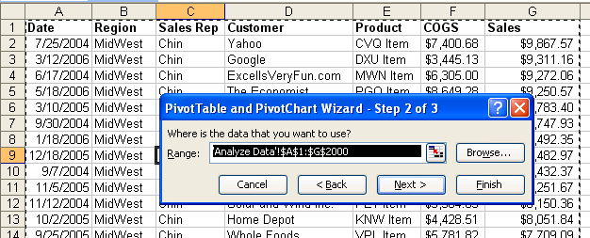

Figure 285
- Step 3, click Finish (Figure 286):
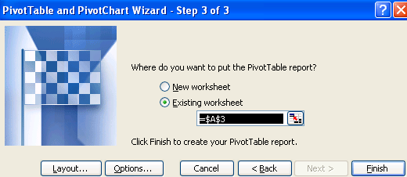

Figure 286
- After you click Finish you should see what is in Figure 287. The beauty of this is that you will use the Pivot Table Field List to send Fields to the “Drop Row Fields Here” area, “Drop Column Fields Here” or the “Drop Data Items Here” area. Don’t let this odd looking setup fool you, it’s just a table with variables along the left side (rows) and top (columns) with the intersection in the “Drop Data Items Here” area. So, if you want to quickly show how much each Sales Rep had in Sales by each Region you would just put the Sales Rep field in the “Drop Row Fields Here” area, Region field in the “Drop Column Fields Here” area, and the Sales in the “Drop Data Items Here” area.
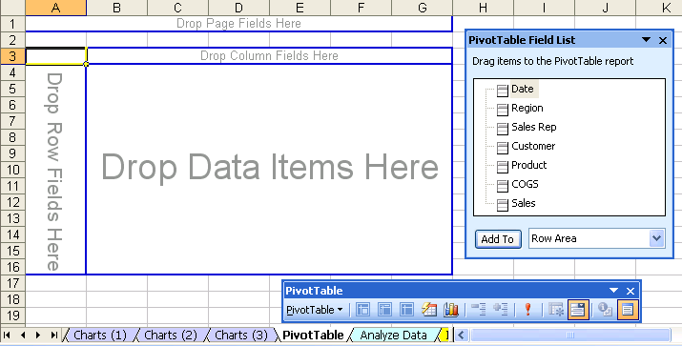

Figure 287
- In the Pivot Table Field List, select the Sales Rep field, next to the “Add To” button click the down-arrow and select Row Area, then click the “Add To” button (Figure 289):
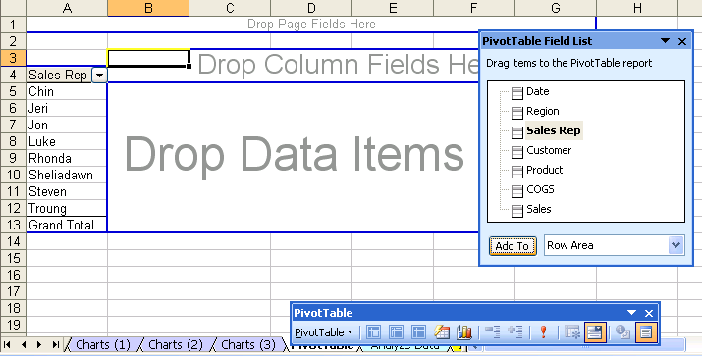

Figure 288

Figure 289
- In the Pivot Table Field List, select the Region field, next to the “Add To” button click the down-arrow and select Column Area, then click the “Add To” button (Figure 290):
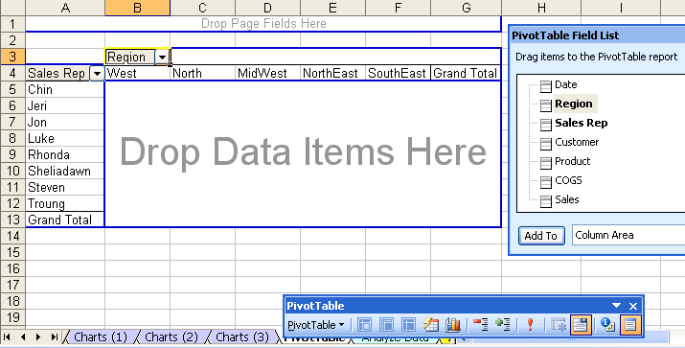

Figure 290
- In the Pivot Table Field List, select the Sales field, next to the “Add To” button click the down-arrow and select Data Area, then click the “Add To” button (Figure 291):
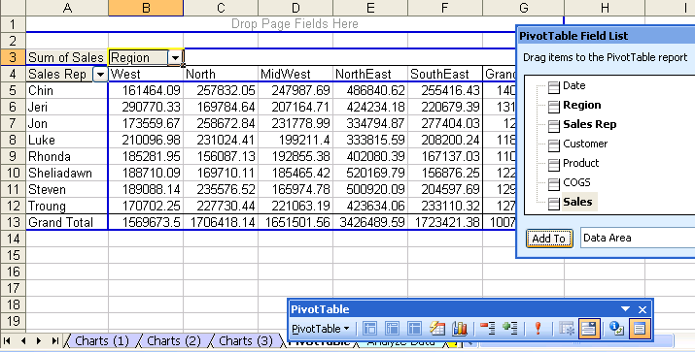

Figure 291
- Think about this: you just took 2000 rows of transactional data and within one minute, you created this summary table!
- PivotTables are the most powerful feature in Excel. During another class or book we can explore in great depth the magic of PivotTables…

Rule #27: When your data is in Proper Excel List Format, PivotTables are the most powerful tool in Excel. Don’t be afraid of them, there are just tables with variables on the left and top side and an intersecting calculation in the middle (such as summing)!

Conclusion:
This is just the beginning of what Excel can do for you. We have looked at the following topics:
- Introduction
- What Is Excel?
- Rows, Columns, Cells, Range Of Cells
- Worksheet, Sheet Tab, Workbook
- Menus And The Alt Key
- Toolbars
- Save As is different than Save
- Two Magic Symbols In Excel
- Math
- Formulas
- Functions
- Cell References
- Assumption Tables/Sheets
- Cell Formatting
- Charts
- Analyze Data
The key to learning Excel is to learn the theory of how to create Excel spreadsheets so that you can accomplish your tasks quickly and so that everything is updateable later. Inevitably, when we create a spreadsheet, later when we use the spreadsheet again, we need to change it to accommodate some new parameter that we had not initially considered. If you follow theses Efficient Spreadsheet Construction Guidelines, your setup, usage and edit time can be reduced significantly. In addition, you will have more fun with your job. Still further, you will become the Excel-master at your job and others will look to you for guidance! This is great because in this world of “Excel-Is-The-Default-Program-That-Everyone-Uses-Every-Day”, you will get promoted more quickly and have more time for vacations! Plus, this Excel stuff is just plain FUN!!

Efficient Spreadsheet Construction Guidelines:
Rule # 1: Learn Excel well so you can have fun working efficiently, gain promotions quickly, and have more vacation time 4
Rule # 2 = Always name your worksheets so that you can identify amongst the various worksheets 7
Rule # 3 = Always name your workbook and save it to a location that you will be able to find later 8
Rule # 4 = Learn key board shortcuts in order to save time 9
Rule # 5 = When the equal sign is placed as the first character in a cell that has not been pre-formatted as Text, it tells Excel to create a formula. 12
Rule # 6 = Do not type data that can vary into a formula. Instead place the data in a cell and refer to it using a cell reference. (A tax rate is a good example of a number that can vary; 12 months in a year is an example of data that will not change). 13
Rule #7 = Only use “Ctrl + Enter”, “Enter”, or “Tab” to enter a formula into a cell. 16
Rule #8 = We must learn the symbols that Excel uses for math and we must know the order of operations. 17
Rule #9 = By typing the numbers that can vary into cells and referring to them in our formulas using cell references, we gain the ability to edit formulas easily and check different scenarios without much effort. 24
Rule #10 = Using Excel’s built in Functions can simplify and shorten formula creation. 30
Rule #11 = Finding functions in Excel can be accomplished by reading the descriptions, searching for a common sense name in the list of functions, or by using the “Search” feature in the Insert Functions dialog box. (You can search Google or the mrexcel.com site also.) 30
Rule #12 = Figuring out what arguments to use for a given function can be accomplished by reading the descriptions, or by clicking the help button in the Argument dialog box. 30
Rule #13 = Using functions with ranges instead of a collection of individual cells allows structural updating to spreadsheets more easily. 33
Example: Use “=SUM(A13:A17)” instead of “= A13+A14+A15+A16+A17” 33
Rule # 14 = Use of relative, absolute and mixed cell references reduces spreadsheet setup time, allows quick updating to setup structure, and will allow us to use many of Excel’s advanced features and tricks 46
Rule # 15 = When you use the fill handle to copy a formula across the rows and then across the columns, it is a two-step process. First copy it down, then let go of mouse, then copy it over (or visa-versa) 46
Rule # 16 When you copy a formula that has a relative cell reference component, the relative cell reference changes relatively. When you cut a formula with relative cell references component, the relative cell reference does not change. 48
Rule #17: All data that can vary goes into a properly orientated assumption table that is at least one blank row/column away from the main table (it can also be placed on an entirely separate sheet). An example of data that can vary is a tax rate. An example of that data that will not vary is 12 months in a year. Although a properly orientated assumption table is not always possible, the idea is to have the labels in the table orientated (horizontally or vertically) in the same way as the assumption table If we do this, editing formulas, what-if analysis and formula creation is dramatically more efficient than if we do not utilize assumption tables. 59
Rule #18: Properly orientated assumption tables allow for mixed cell use and results in reduced time creating formulas 59
Rule #19: Cell Formatting is the façade that sits on top of data and formulas. What you see is not always what sits in the cell. 68
Rule #20: Because formatting (such as currency) is like a façade that sits on top of the number, when you have a formula that has the potential to yield more decimal places than the format displays, use the ROUND function. 77
Rule #21: With Date format, Excel sees the number of days since January 1, 1900 (inclusive). This allows us to make date math calculations. 79
Rule #22: With Time format, Excel sees the proportion of one 24 hour day. This allows us to make time math calculations. 84
Rule #23: Chart Wizard: Step 1 = Chart Type, Step 2 = Source Data (Series tab gives you real power over Chart Wizard), Step 3 = Chart Options, Step 4 = Chart Location. After the chart is done, everything is right-clickable. Don’t know which chart to use? Type “Available chart types” into Help. 94
Rule #24: Before you use Excel’s Data Analysis Tools: the data must be in proper Excel List Format: 1) First row has field names with bold and other formatting that is different from the rest of the data; 2) No blank field names; 3) Columns are Fields; 4) Rows are records; 5) No blank columns (fields); 6) No blank rows (records); 7) Blank rows and columns (or Excel’s column headers (A, B…) and row headers (1, 2…) must separate the Excel List from other data 95
Rule #25: Before Sorting using the Sort button, make sure your block of data is in the Proper Excel List Format and highlight only one cell in the field you want to sort. 96
Rule #26: Before adding automatic Subtotals, sort your field. If you want to add a Subtotal to a Subtotal, Be sure to uncheck the 99
Rule #27: When your data is in Proper Excel List Format, PivotTables are the most powerful tool in Excel. Don’t be afraid of them, there are just tables with variables on the left and top side and an intersecting calculation in the middle (such as summing)! 102

Keyboard shortcuts

Method of placing cell references in formula after you have placed an equal sign as the first character in the cell: 1) use mouse to click on cell, 2) use arrow keys to move to cell reference location

Keyboard shortcut: Shift + F3 = open Insert Function dialog box

Save As (Keyboard Shortcut = F12)
Page Setup = Alt + F + U
Save = Ctrl + S
Spelling = F7
Undo = Ctrl + Z

Copy = Ctrl + C

Cut = Ctrl + X

Paste = Ctrl + V

Select two cells and everything in-between = Click on first cell, hold Shift, Click on last cell

Select cell ranges that are not next to each other = click on cell or range of cells, Hold Ctrl, click on any number of other cells or range of cells

Ctrl + arrow key = move to end of range of data, or to beginning of next range of data
Cancel the formula in the middle of creating it (Shortcut key = Esc)
Formula is entered in the cell and the cell is selected (Shortcut key = hold Ctrl then tap Enter)
Ctrl + Page Up ➔ moves you up through the sheets
Ctrl + Page Down moves you down through the sheets
Keyboard shortcut for the SUM function is Alt + “=”
Keyboard shortcut for Range Finder = F2
Keyboard shortcut F4 key: Toggles between the four types of cell references
Keyboard shortcut Insert Row = Alt + I + R
Delete key = delete cell content but not format
If you have a range highlighted and you place a formula into the white cell, when you hold Ctrl and tap Enter, the formula is placed into all the cells that are highlighted
Click Alt, then tap I and then tap C = Insert Column
Hold Ctrl, then tap the “*” key on the number pad (this selects the table)
Ctrl + 1 opens the Format Cells dialog box
Hold Ctrl and tap ; (semi colon) to put Today’s date in the cell
To bring the format back to the “General format, Hold Ctrl and Shift and tap ~
Hold Ctrl and Shift and tap the $ key (this is the keyboard shortcut for the Currency format)

