Excel Is Fun!
Excel 2007

How to build efficient systems of spreadsheets to save time, get promoted and have extra time for vacation

An Excel book that takes you from the beginning theories of how to construct efficient systems of spreadsheets towards the Beautiful Excel infinity at the other end

By Michael “Excel Is Fun!” Girvin
Warning: because this book is free, I could not afford an editor. So you will have to put up with the occasional spelling/grammatical error. If you find any kind of error, please e-mail me at mgirvin@highline.edu.

Dedication:
This book is dedicated to Dennis “Big D” Ho, my step-son, because he loves books so much!
This book is also dedicated to Isaac “Big I” Girvin, my son, because he is so inquisitive!
Table of Contents
Introduction 4
What Is Excel? 5
Rows, Columns, Cells, Range Of Cells 7
Worksheet, Sheet Tab, Workbook 8
Save As is different than Save 10
There are no more Menus or Toolbars in Excel 2007. We now have “Ribbons”, the “Orb” and the “QAT” toolbar. 11
Ribbons 13
Quick Access Toolbar (QAT) 21
Scroll Bars and Selecting Cells 24
Keyboard Shortcuts and the Alt Key 27
Two Magic Characters In Excel 32
Math 38
Formulas 42
Functions 47
Cell References 57
Assumption Tables/Sheets 72
Cell Formatting 82
Charts 105
Page Setup 115
Analyze Data: Sort, Filter, Subtotals, PivotTables 121
IF function 135
Conclusion: 140

Introduction
Excel is Fun! Why? Because your efficient use of Excel can turn a three hour payroll calculating chore or a five hour reporting task into a five minute breeze. Efficient use of Excel will save a lot of time. That time adds up to extra time for your more enjoyable endeavors in life such as vacations! In addition, your bosses and employees will notice that you are efficient and can produce professional looking reports that impress. This of course leads to promotion more quickly. Still, further, your knowledgeable and efficient use of Excel can land you a job during an interview. Employers are like dry sponges ready to soak up any job candidate that can make their entity more efficient with Excel skills! Save time?, get promoted?, get the job?, and have more time for vacation? – That sounds like a great skill to have!

In the working world, almost everyone is required to use Excel. Amongst the people who are required to use it, very few know how to use it well; and even amongst the people who know it well, very few of those people know how to use it efficiently to the point where grace and beauty can be seen in a simple spreadsheet!

This book will take you from the very beginning basics of Excel and then straight into a simple set of efficiency rules that will lead you towards Excel excellence.

Rule # 1: Learn Excel well so you can have fun working efficiently, gain promotions quickly, and have more vacation time

What Is Excel?
You use Word to create letters, flyers, books and mail merges. You use PowerPoint to create visual, audio and text presentations. You use Google to research a topic and find the local pizza restaurant. You use Excel to make Calculations, Analyze Data and Create Charts. Although databases (such as Access) are the proper place to store data and create routine calculating queries, many people around the planet earth use Excel to complete these tasks. Excel’s row and column format and ready ability to store data and make calculations make it easy to use when compared to a database program. However, Excel’s essential beauty is that you can make calculations and analyze/manipulate data quickly and easily “on the fly!” This easy to use, planet-earth “default” program must be learned if you want to succeed in today’s working world.

Open up the Excel file named “Excel 2007 Is Fun!.xlsm” and with your mouse, click on the “What is Excel” sheet tab.

Here is an example of how Excel can make payroll Calculations quickly and with fewer errors than doing it by hand (Figure 1) (Your sheet will not appear as large as the one in Figure 1):
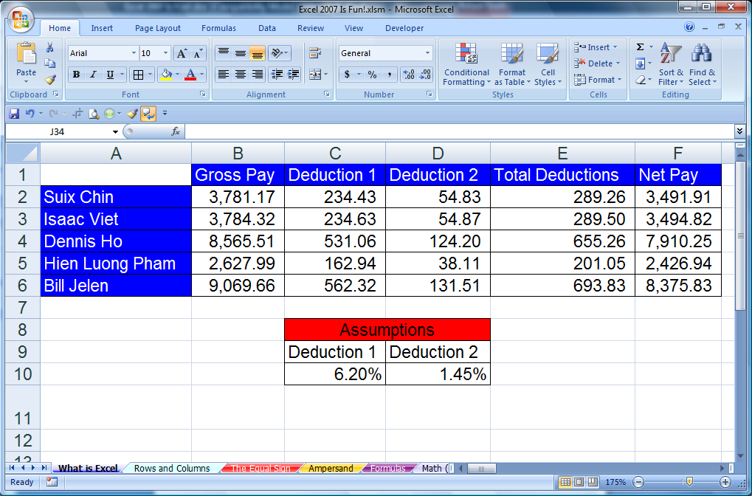
Sheet tab “What is Excel?”

Figure 1
Here is an example of how Excel can Analyze Data (sorting by time) quickly and with fewer errors than doing it by hand (Figure 2 and Figure 3):

Before Sort:
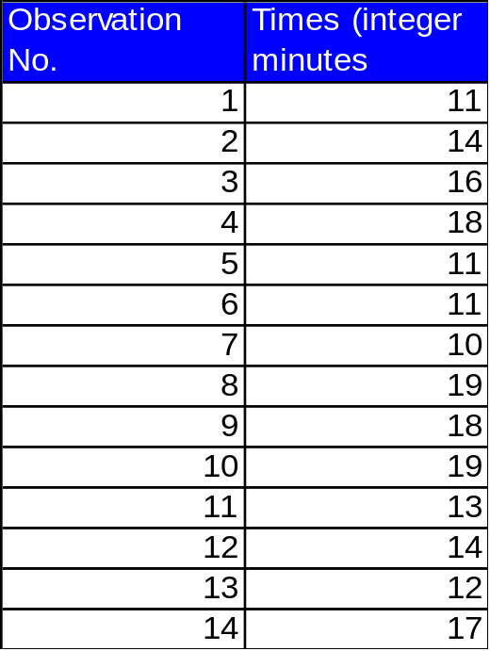

Figure 2

After Sort:
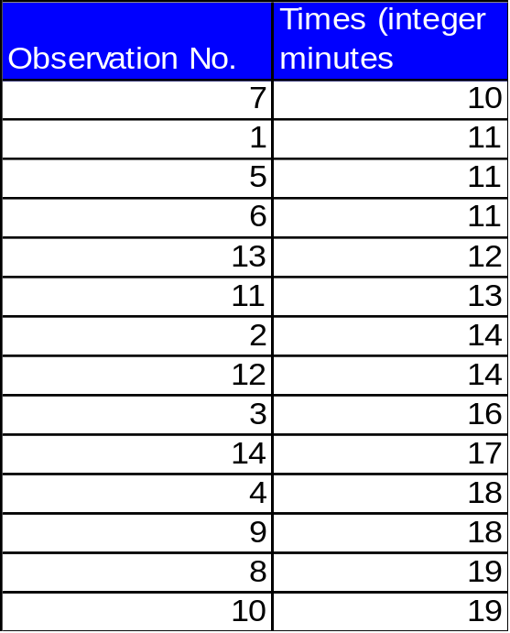

Figure 3

Rows, Columns, Cells, Range Of Cells
With your mouse, click on the “Rows and Columns” sheet tab.
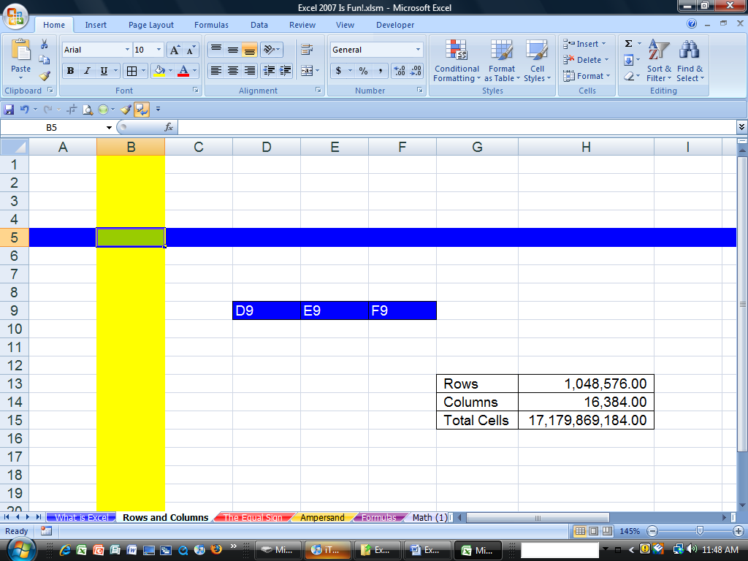
Sheet tab “Rows and Columns”
Name Box

Figure 4
Rows are horizontal and are represented by numbers. In our example (Figure 4) the color blue has been added to show row 5.
Columns are vertical and represented by letters. In our example (Figure 4) the color yellow has been added to show Column B.
A cell is an intersection of a row and a column. In our example the color green has been added to show cell B5. In our example column B and row 5 can be detected because the column and row headers are highlighted in a light-orange color (Figure 4) (color may vary by computer). In addition, you can see that the name box shows that cell B5 is selected (Figure 4 and Figure 5).
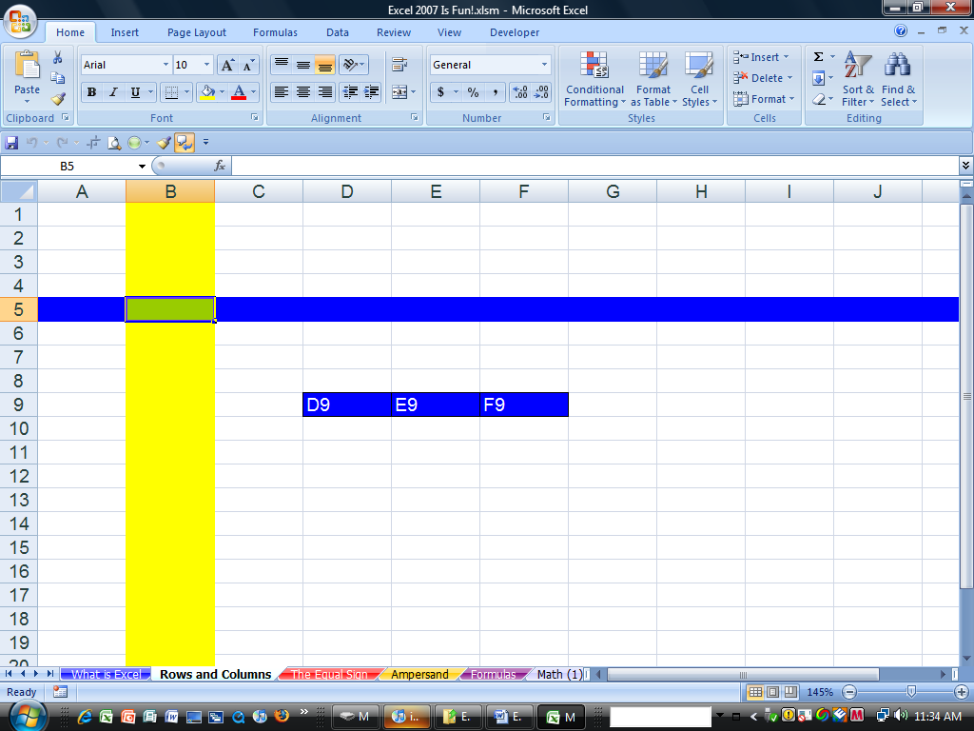

Figure 5
B5 is the name of this cell. It can be thought of as the address for this cell. It is like the intersection of two streets. If we wanted to hang out at the corner of Column B Street and Row 5 Street, we would be hanging out at the cell address B5.
Later when we make calculations in Excel (making formulas), B5 will be called a cell reference.
A range of cells is two or more cells that are adjacent. For example you can see three blue cells D9, E9, and F9. This range would properly be expressed as D9:F9, where the colon means from cell D9 all the way to cell F9.

Worksheet, Sheet Tab, Workbook

Figure 6
A worksheet is all the cells (1,048,576 rows, 16,384 columns worth of cells). A worksheet is commonly referred to as “sheet.”
The sheet tab is the name of the sheet. By default they are listed as Sheet1, Sheet2. In our example (Figure 6), the sheet we are viewing is named “Rows and Columns.” You can see other worksheets that have been given names in our example. Can you see what they are?

Rule # 2 = Always name your worksheets so that you can identify amongst the various worksheets
Naming your sheets helps you to keep track of things in a methodical way. Navigating through a workbook, understanding formulas and creating headers/footers is greatly enhanced when you name sheets. To name your sheet, double-click the sheet tab (this highlights the sheet tab name) and type a logical name that describes the purpose of the sheet. You can also, right-click a sheet tab and point to Rename in order to give the sheet a new name.
A workbook is all the sheets (over 8000 worksheets possible – limited my computer’s memory). To name a new workbook that has not been saved or named, use Save As (Keyboard Shortcut = F12).

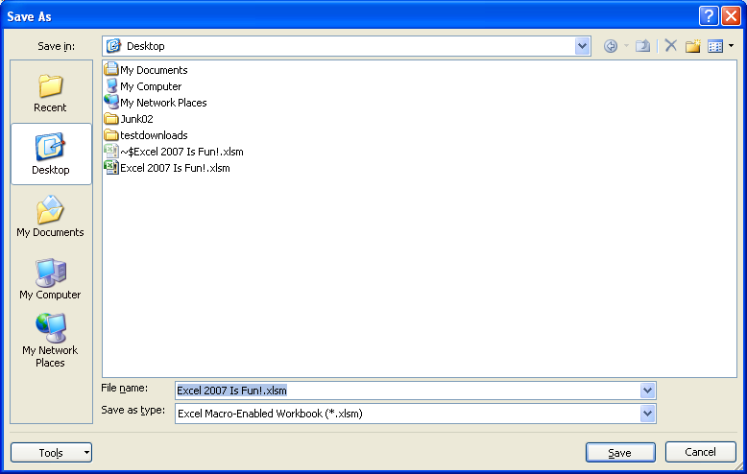

Figure 7

Figure 7 shows the Save As dialog box:

Save in = Where do you want to save it?
File name = What do you want to call it?
Save as type = What type of file is it? (.xlsm? or .xlsx or .xls or .htm? or .xltm or .xlt?)

See notes on next page about the new Excel 2007 “Save as types”.

Rule # 3 = Always name your workbook and save it to a location that you will be able to find later
Some of the Excel 2007 “Save as type” or “extension type” or “file format”:
- xlsm
  - 2007 workbook that allows Macros (Macros = custom code that you can put in workbook (VBA))
  - This file format is called XML (Extensible Markup Language). XML is efficient because:
    - Most any program can read it
    - It is less corruptible
      - Lose a few lines in BIFF and you can lose the whole file, lose a few lines in XML and you can easily recover the file
  - This new file format is different than XML in 2003 (2003 XML did not support VBA, Charts, and other embedded images), it now supports all Excel elements.
  - These files are actually zipped files!!!!
      - Saves space
- xlsx
  - This is the same as the description for .xlsm except that does not allow Macros (Macros = custom code that you can put in workbook(VBA))
- .xls
  - 1997 – 2003 file format
    - Use this if you are going to let other people use your file that do not have Excel 2007
- .htm
  - Saves worksheet or workbook as html (web site)
- .xltm
  - 2007 Excel Template that allows Macros
    - Templates automatically save to the Microsoft Template folder so that your template will show up in the Templates window
- .xlt
  - 1997 – 2003 file format for Templates
- .xlsb
  - This file type is called BIFF (Binary Interchange File Format)
    - BIFF5 (Excel 95)
    - BIFF8 (Excel 97-2003)
    - BIFF12 ➔.xlsb
      - BIFF cannot be read by many applications
      - But it saves and loads more quickly than XML

Save As is different than Save
Once you have saved your workbook for the first time, subsequent saves will replace the stored file with the most recent changes. Save As gives you the power to: 1) Save the file to a new location 2) save file with a new name 3) change the file type. In this way the Save As dialog box is very powerful.

There are no more Menus or Toolbars in Excel 2007. We now have “Ribbons”, the “Orb” and the “QAT” toolbar.
The menus and toolbars from earlier versions of Excel are gone. In their place are “Ribbons” and the “Quick Access Toolbar” (QAT). The Ribbons contain icons and words that let you click on a particular icon to take a particular action such as changing the font size or changing the number of decimals showing for a number. The icons and words are grouped into categories to help the user find similar items. These categories are called “Groups”. There are 26 total different Ribbons. You can only view one Ribbon at a time. The “Orb” or “Office Button” (located in the upper left corner of the screen, to the left of the Home Ribbon and slightly on top of the title bar) shows a “Microsoft Office” icon inside a glowing circle. If you click on the Orb a drop-down menu appears (similar to the old File menu) that has icons and words that let you click on a particular icon to take a particular action such as Save As or Excel Options. The QAT contains the icons for save, undo and redo by default and then any other additional icons that you add yourself. There is only one QAT. The QAT is always visible and available for use, either above the Ribbons or below the Ribbons depending on where you place it.
The Ribbons change appearance depending on the size of your screen and/or your computers screen resolution (screen resolution can be changed in Display Properties). The QAT changes appearance depending on how you customize it. Figure 8 shows the Home Ribbon on a large screen (or high screen resolution) and with a QAT that has five additional icons beyond the three default icons. Figure 9 shows the Home Ribbon on a small screen (or low screen resolution) and with a QAT that has 23 additional icons beyond the three default icons.

Figure 8
Edit Group

Title Bar
Change Decimals
Quick Access Toolbar (QAT)

Font Size
Font Group
Home Ribbon
Orb
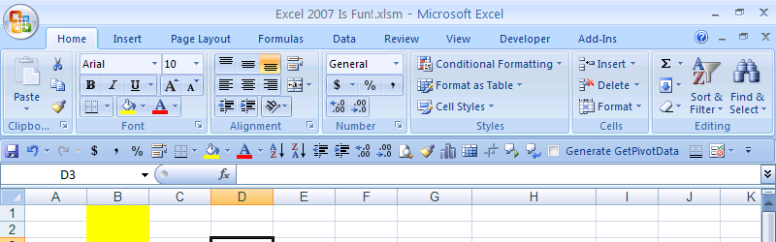

Figure 9
Figure 10 Shows the Orb drop-down menu and the Excel Options button. You can see the icons and words such as Save As, the list of recent Documents that have been used and are accessible here to re-open, and the Excel Options button in the lower right corner.
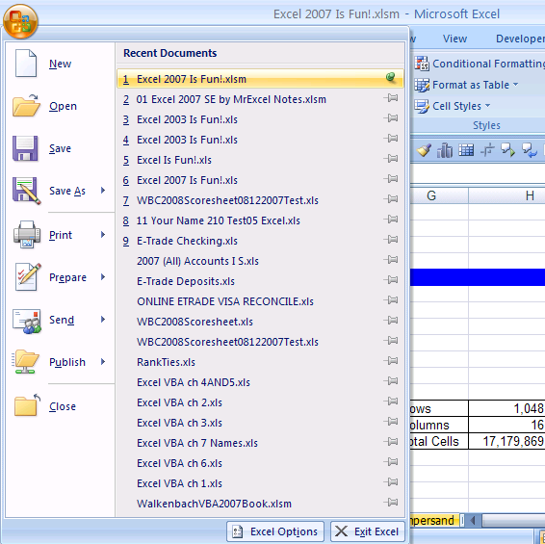

Figure 10: Orb drop-down menu and Excel Options button that appear after you click the Orb.

Ribbons
Now we would like to talk about the Ribbons in more detail.

Each Ribbon has a tab that sticks out above the Ribbon and contains the name of the Ribbon. There are seven standard Ribbons (Home, Insert, Page Layout, Formulas, Data, Review) and 18 additional Ribbons. Some of the addition Ribbons you can add in the Excel Options Area and some of the additional Ribbons are “Context-Sensitive Ribbons” (also known as “Contextual Ribbons”) that show up depending on where the cursor is located (for example, if a chart is selected, the context sensitive Ribbons for charts appear). To move between the visible Ribbons you can click on any tab name to access that particular Ribbon. If you want to temporarily hide the Ribbons because of space requirements, use the keyboard Shortcut Ctrl + F1 (This is a toggle that will successively hide and unhide the Ribbons). The seven standard Ribbons, one additional Ribbon added in Excel Options and one context sensitive Ribbon are shown below in figures: Figure 11 to Figure 20.

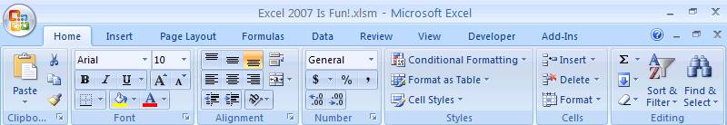

Figure 11: Home Ribbon: Contains items such as Copy, Paste, stylistic (Font/Color) formatting, Number Formatting, Conditional Formatting, Insert Row/Column, Insert Function, Clear All, Clear Format, Sorting, Find, Replace, Select, Go To, Go To Special, and more….
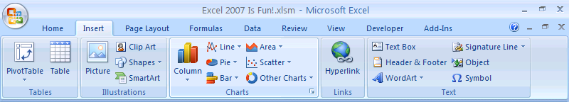

Figure 12: Insert Ribbon: Insert items such as: PivotTable, Table, Pictures, Clip Art, Shapes, Charts, Hyperlinks, Text Box, Header and Footer, Word Art, Object, or Symbol.
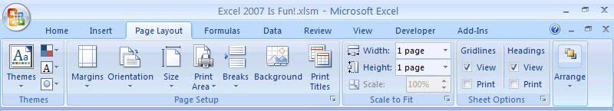

Figure 13: Page Layout Ribbon: Add Themes (coordinated Color, Font, Effects), various page layout for printing.
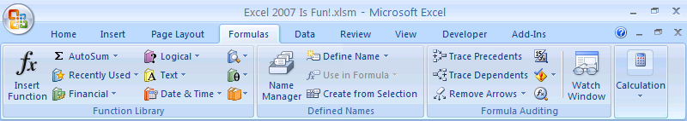

Figure 14: Formulas Ribbon: Contains items such as Insert Functions, Insert Functions Categories, items associated with Names, items associated with Formula Auditing, and Calculation.
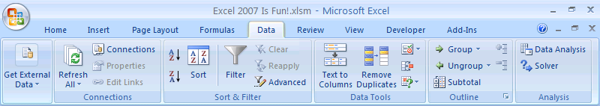

Figure 15: Data Ribbon: Get External Data, Refresh (External Data or PivotTable), Sorting and Filtering, Text to Columns, Data Validation, Consolidate, Scenario Manager, Goal Seek, Data Table, Grouping, Subtotals, and the Add-ins Data Analysis (statistics) and Solver (linear algebra) if you add them using Add-ins in the Excel Options area.
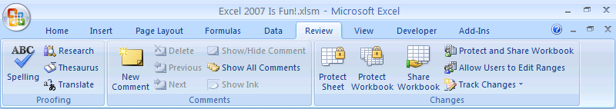

Figure 16: Review Ribbon: Contains items such as Spell Check, Comments, Protect Worksheet or Workbook, Share Workbook and Track Changes.
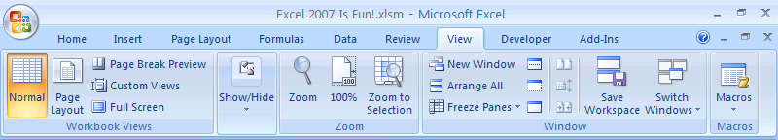

Figure 17: View Ribbon: Contains items such as Normal view, Page Layout view, Page Break Preview view, Show/Hide Formula Bar, Show/Hide Gridlines, Zoom view, New Window (opens a second view of the same Workbook), Arranges All (arranges all open Workbooks), Freeze Panes (always show a certain part of the Worksheet), Hide Window (which means hide Workbook), Unhide Window (which means unhide Workbook), Save Workspace, Macros (Macro means Excel computer code that you can write Excel).
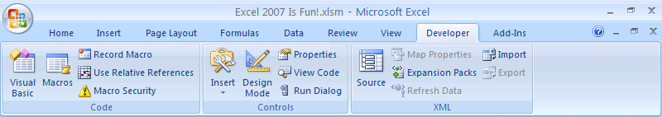

Figure 18: Developer Ribbon that was added in the Excel Options area.
To add the Developer Ribbon you would use the keyboard shortcut to get to Excel Options as follows: Alt + F + I (Tap the Alt key, then tap the “F” key, then tap the “I” key). Excel Options is also accessible by clicking on the Orb and then click on the Excel Options button. After you open the Excel Options dialog box, you would check the “Show Developer tab in the Ribbon” checkbox and then click the OK button and the lower right corner. See Figure 19:
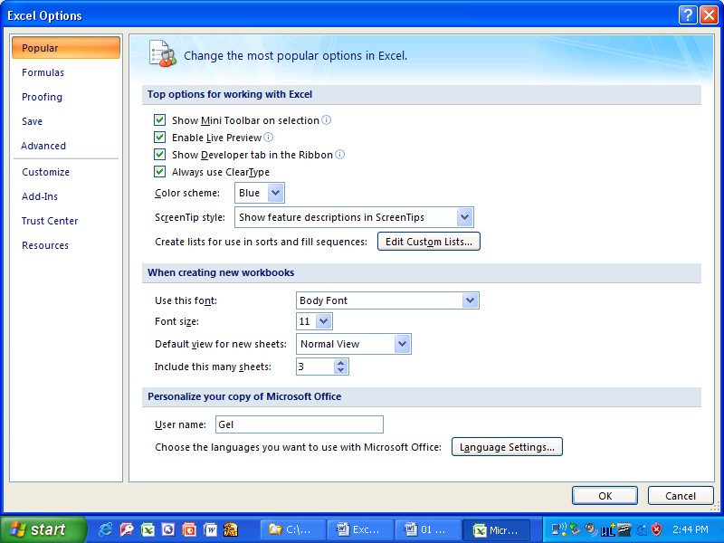

Figure 19: Excel Options
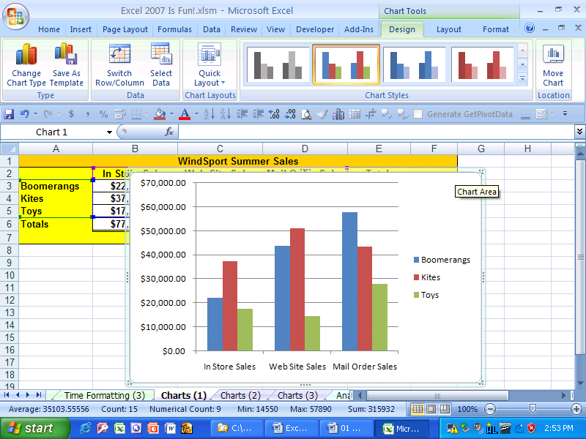

Figure 20: Because a Chart is selected, the Title Bar shows “Chart Tools” and there are three context sensitive chart Ribbons after the last “always-available” Ribbon. The three Chart Ribbons are: Design, Layout, Format.
As seen in Figure 21 and Figure 22, some of the elements of the Ribbons are:
- Tabs (Page Layout)
- Groups (Page Setup Group)
- Icons (Orientation)
- Drop-down arrows (Orientation: Portrait or Landscape)
- Check Boxes (Toggle to view or not view Excel Gridlines)
- Dialog Launchers (Small grey boxes with diagonal arrows that, when clicked, launch the 1997-2003-type dialog boxes – you can see the Page Setup Dialog launcher on the right-side of the Page Setup Group Label)
- “See More Selections” Arrows (Figure 22 shows More Chart Styles)
1) Tabs
3) Icons
5) Check Boxes

Figure 21
2) Groups
4) Drop-down arrows
7) “See More Selections” Arrow
6) Dialog Launcher

Figure 22
The Ribbon elements can be seen in further detail in the figures .

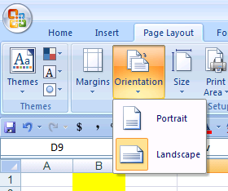

Figure 23: If you click on the Orientation drop-down arrows you can see the two options for printing your worksheet: Portrait or Landscape. The shaded box means that the current selection is Landscape. If you clicked on Portrait, you would change the printing orientation to Portrait.
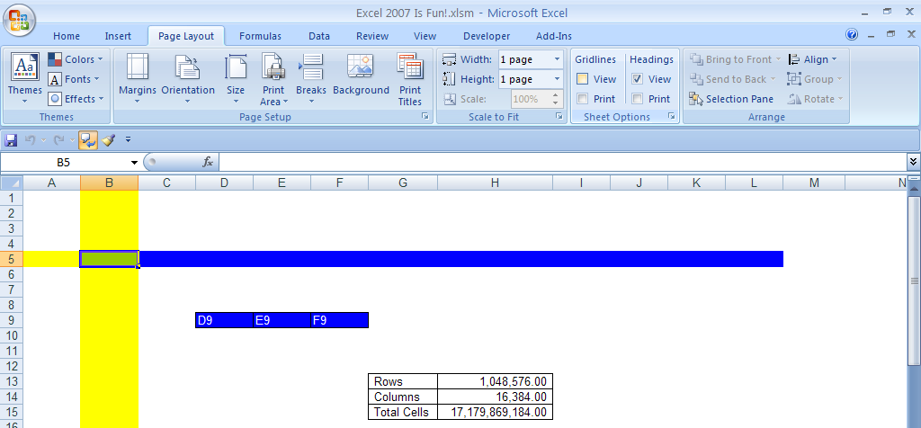

Figure 24: The check box for View Gridlines in the Sheet Options Group has been unchecked. The result is that the default Excel Gridlines cannot be seen on the screen and they will not be printed. Compare this to Figure 6. In Figure 6 you can see the Gridlines. The Check Boxes are “Toggles” that will alternate between viewing the Excel Gridlines and not viewing the Excel Gridlines. Notice that the black lines around the Row and Column count are still viewable. This is because these lines were added using the borders button in the Font Group on the Home Ribbon.
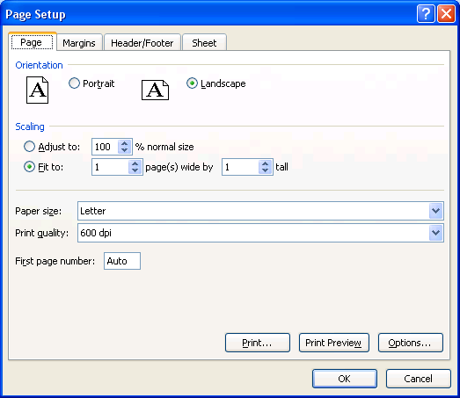

Figure 25: If you click the Page Setup Dialog Launcher on the right-side of the Page Setup Group Label this dialog box will show up. This is the Excel 1997-2003 Page Setup dialog box.
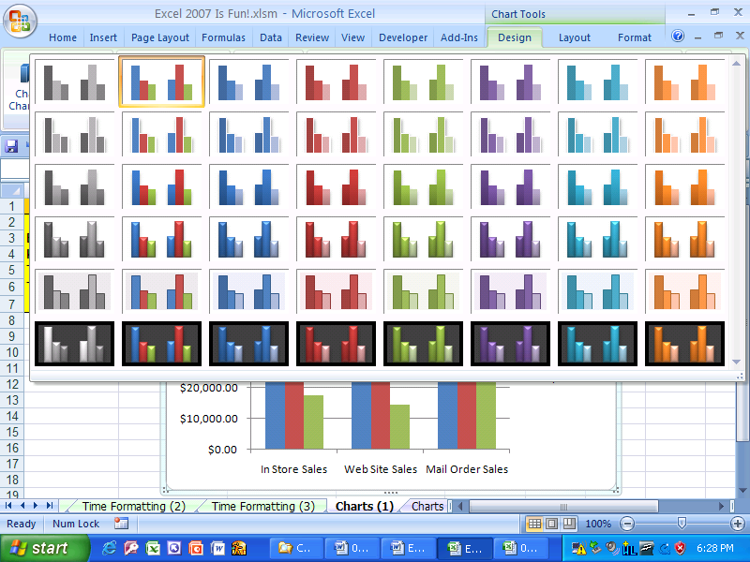

Figure 26: If you click the “See More Selections” Arrow in the Chart Styles Group in the Chart Tools Design Ribbon you will see more selections for Chart Design.

The last important trick regarding the Ribbons is that you can hide them. This is convenient because they take up a lot of room on the screen. The keyboard shortcut for toggling the Ribbons on and off is Ctrl + F1 (Hold Ctrl and then tap the F1 key (the F1 key is in the top row of keys on the keyboard and all the way to the left, but to the right of the Esc key)). See figures Figure 27 and Figure 28 for examples of the Ribbons toggled off and toggled on.

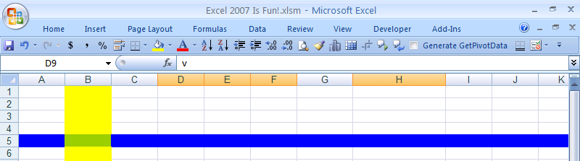

Figure 27: Ctrl + F1 hides the Ribbons, but the QAT is still visible!
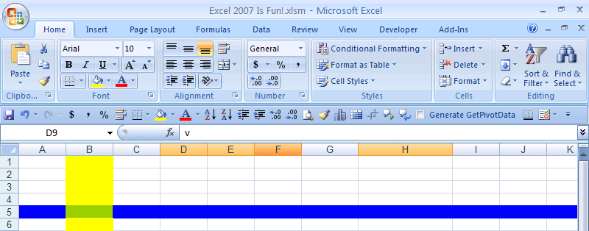

Figure 28: Ctrl + F1 a second time, toggles the Ribbon on again.

Quick Access Toolbar (QAT)
Now we would like to talk about the Quick Access Toolbar (QAT) in more detail.

No matter what Ribbon you have showing, or whether or not the Ribbons are toggled on or off, the QAT is always visible and available for use! This is great because sometimes it is quicker to click on the QAT than it is to click on the Ribbon and then click on the icon you want. Not only that, but there are actions, dialog boxes and Task Panes from Excel 1997-2003 that are not anywhere in the Ribbons! So if you have a particular action that you used to do in earlier versions of Excel and it is not in the Ribbons, you can add it to the QAT. Also, you can easily show your QAT above or below the Ribbon. First let’s see two great ways to add icon buttons to the QAT.

The first way to add icon buttons to the QAT is to find an icon or an item from a drop-down arrow list in the Ribbons, and then right-click that item. If the right-click drop-down menu says “Add to Quick Access Toolbar”, then you are allowed to add that icon to the QAT. If you do not see “Add to Quick Access Toolbar”, then that item is not available to be added to the QAT (Some items are not available). In Figure 29 I have right-clicked the Fill icon (it is the picture of a tipping paint bucket – it is the icon button that fills the cell with color) and you can see the right-click drop-down menu. After I click on the “Add to Quick Access Toolbar”, the icon button will automatically be added to the QAT (Figure 30).

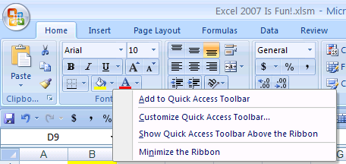

Figure 29: Right-click a Ribbon icon to add it to the QAT.
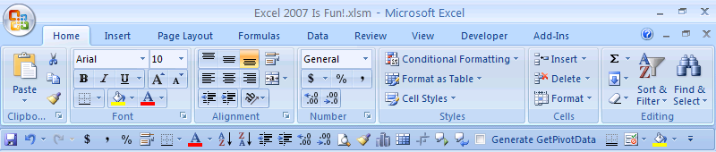

Figure 30: The Fill icon has been added to the end of the QAT.
The second way to add icon buttons to the QAT is to go to the Customize section in the Excel Options area. This is the best method because you can see a list with all the icon buttons that can be added. In the Figures Figure 31 to Figure 34 the process of adding icon buttons from the Customize section in the Excel Options area is illustrated.
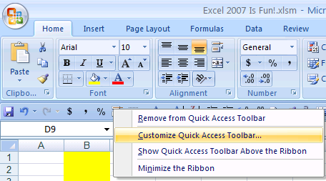

Figure 31: Right-click the QAT and click on the “Customize Quick Access Toolbar…” item in the drop-down menu.
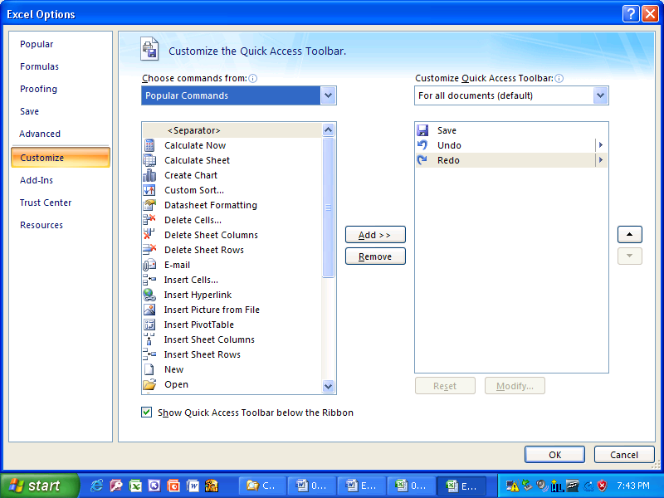

Figure 32: By right-clicking the QAT and click on the “Customize Quick Access Toolbar…” item in the drop-down menu, you will automatically go to the Customize section in the Excel Options area.
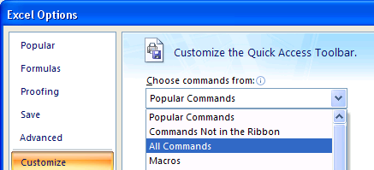

Figure 33: Click on “All Commands” from the “Choose commands from” drop-down list
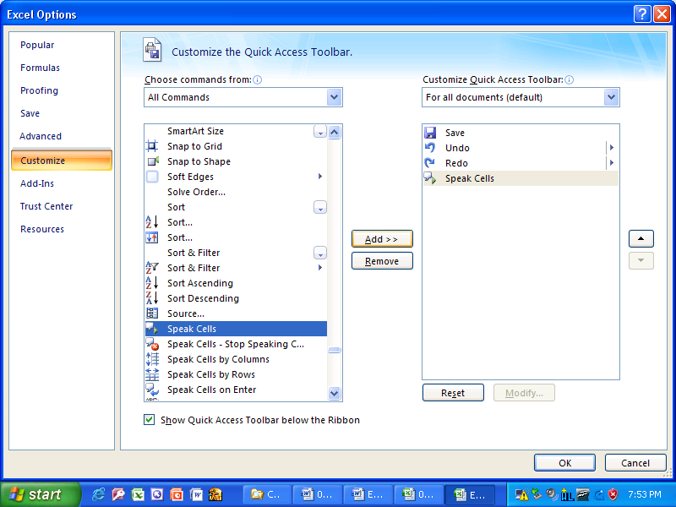

Figure 34: Use the Scroll Bar to find the icon that you want, click on the icon, and then click the add button. The Icon will appear on the right. When you have added all the buttons that you want, click the OK button.
1) Scroll Bar
2) Click on the icon
3) Click the add button
4) Icon will appear on the right
5) Click the OK button

The last trick we want to see regarding the QAT is how to move it above or below the Ribbons. This is easily done. Simply right-click the QAT and look in the drop-down menu for the command you would like.

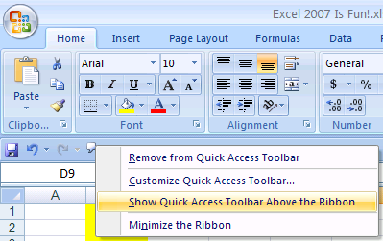

Figure 35: If the QAT is below the Ribbon and you want to move it above.

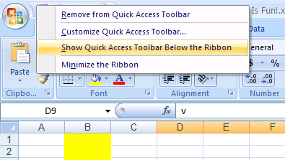

Figure 36: If the QAT is above the Ribbon and you want to move it below.

Scroll Bars and Selecting Cells
In Excel there are Horizontal and Vertical Scroll Bars that let you move the worksheet so that you can see rows, columns and cells that are not in view. In addition, for the Horizontal Scroll Bar, you can change the size of it by clicking on the front edge of the Horizontal Scroll Bar and dragging. In Figure 37 you can see that I have labeled the Scroll Bars as Vertical Scroll Bar and Horizontal Scroll Bar, but technically the whole thing is called the Scroll Bar, the part that you click on with your mouse and drag is called a “Scroll Box”, and the arrows (that allow you to move only one row or column at a time) are called “Scroll Arrows.” Nevertheless, I will refer to the “Scroll Box” as the “Scroll Bar” because is common language that is the custom.
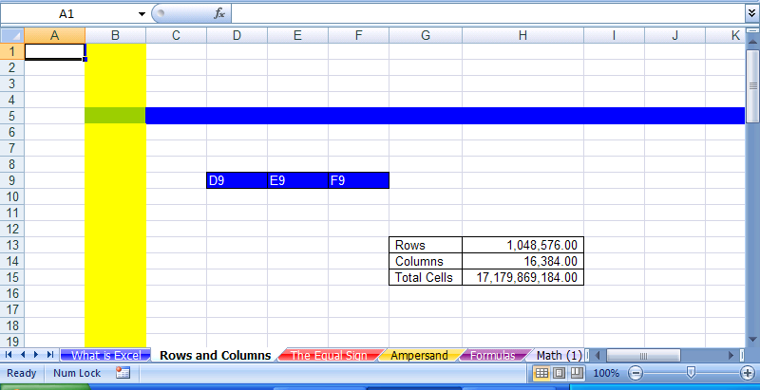
Vertical Scroll Bar
Horizontal Scroll Bar
Front edge of the Horizontal Scroll Bar
Technically, this is a Scroll Box, but I will refer to it as the “Scroll Bar”

Figure 37
To see how the Scroll Bars work, click on the Vertical Scroll Bar and drag it down until you can see Row 26. Notice how the first row now visible is Row 8 (Figure 38):
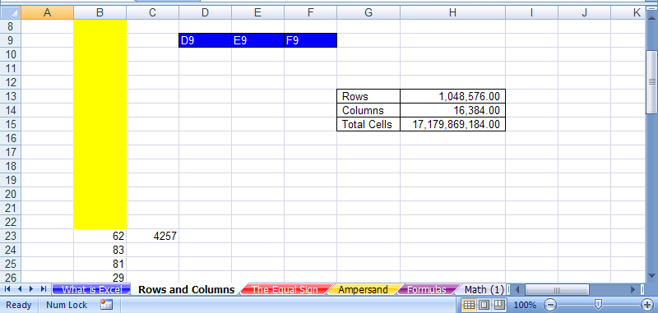
Vertical Scroll Bar
First row now visible is Row 8
Row 26
Small gap means that there are more rows above that are not visible

Figure 38
Now use the Horizontal Scroll Bar to move the sheet back so that you can see Row 1 again (Figure 39):
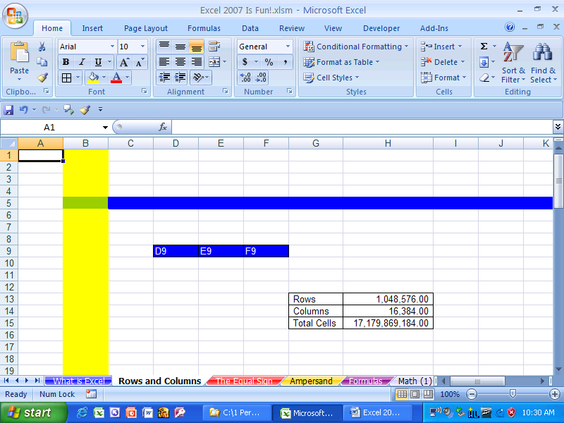

Figure 39
To change the size of the Horizontal Scroll Bar so that the Horizontal Scroll Bar begins after the Sheet Tab named “The Equal Sign”, click and drag front edge of the Horizontal Scroll Bar (Figure 40):
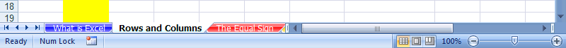

Figure 40
Now move it back (Figure 41):

Figure 41
Try moving the sheet with the Horizontal Scroll Bar, and then move it back.

Next, we want to talk about selecting cells.
Although many of us know how to select something and click something with your mouse, we will discuss it here so that we are all on the same page. When you move your mouse in Excel the cursor on the screen moves. However, the cursor changes depending on what item or element your mouse is hovering over. To see how this works, make sure you are located on the sheet tab “Rows and Columns” and then move your mouse over the cell A1 without clicking in cell A1. You will see a thick-white-cross cursor with a black outline and a black shadow. Now click in cell A1 and type the number 1. Now when you hover over cell A1 without clicking in the cell, your cursor is shaped like a thin capital letter I. Now hit the Enter key and you will see this (Figure 42):

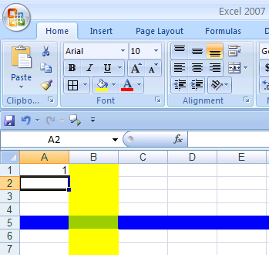

Figure 42
Now take your mouse and move the thick-white-cross cursor over cell A2, click, hold the click, drag the thick-white-cross cursor to cell A6, and then let go of your cursor. In Figure 43 you can see that you just have selected the range of cells A2:A6.
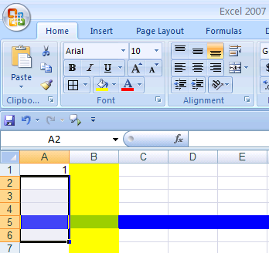

Figure 43

Next, in order to add some color to the selected range, click the down-arrow next to the Fill icon on the Home Ribbon and select the color red as seen in Figure 44

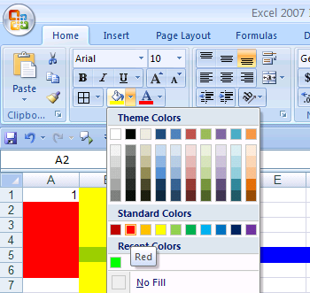

Figure 44
That is how to select cells with the mouse and cursor. However, there are sometimes when using the mouse to select cells is not efficient. In our next section, we will see how to use the keyboard to select cells and how to do many other tasks.

Keyboard Shortcuts and the Alt Key
Now we are about to learn the best trick in all of Excel! Yes, this is the one trick that will guarantee you extra vacation time and instant success in the eyes of your bosses and co-workers. The one trick is… well it’s not just one trick, it is many. Are you ready for this?

The best trick in Excel is:

Learn keyboard short cuts!!!!

Keyboard shortcuts are the best way to save time and become efficient. Let’s look at a few examples here, and then throughout the book, we will see many more keyboard shortcuts

To see these keyboard shortcuts, make sure you are located on the sheet tab “Rows and Columns”. Click in the cell C1, type the number 4, and then hold the Ctrl key and tap Enter. The result is that you have entered the number 4 in cell C1 and kept your cursor in cell C1 as seen in Figure 45:

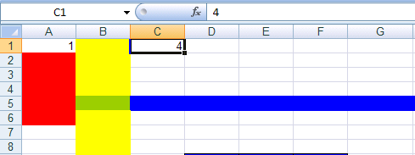

Figure 45
With cell C1 still selected, Hold the Ctrl key and Tap the ‘C” key (this is the keyboard shortcut for copy). After you copy cell C1, you will see a moving dotted line around the copied cell. Next, to move three cells to the right and Paste your copied item, Tap the Tab key three times and then hold Ctrl and tap the “V” key (this is the keyboard shortcut for paste).See Figure 46:

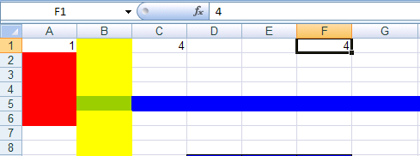

Figure 46
The other benefit to the keyboard shortcuts for Copy and Paste (besides that they are faster than going up to the Home Ribbon) is that they work in almost all programs and web sites in the world!

The best example of how keyboard shortcuts can save time is to show you how to use it when adding. Now we haven’t learned how to make formulas or use functions yet, but I am going to show you this next keyboard shortcut for add many numbers in a formula that uses the SUM function before we even learn about formulas and functions. Why? Because this trick is sooooo much faster than using a mouse, that it illustrates the beauty of keyboard shortcuts better than any other trick. Ready? OK. Click in cell B1 (Figure 47):

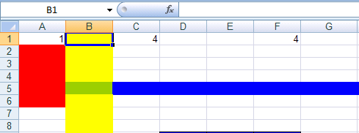

Figure 47
Then hold Ctrl and tap the drown arrow (the arrow keys are on the right side of your keyboard. Ctrl + down-arrow jumps you to the next section of data (it skips all the blanks and jumps to the first cell that has a character). See Figure 48 on the next page:

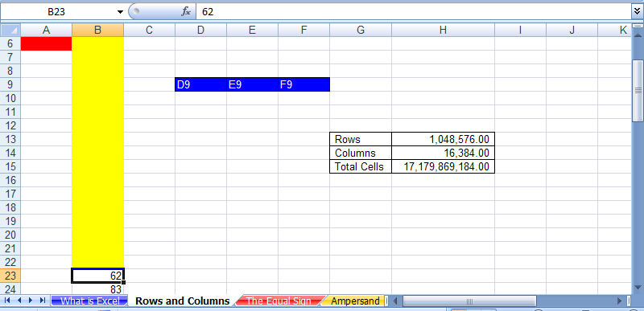
Scroll Bar

Figure 48: Ctrl + down arrow jumps to the next section with data, and it also moves the scroll bar so that row 6 is the first row that we can see.
This also moved the scroll bar so that row 6 is the first row that we can see (rows 1 to 5 are still in the worksheet, they are just not visible. Next, hit the Tab key so that your cursor is in cell C23 (Figure 49):

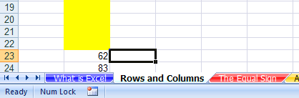

Figure 49
Next, to automatically add a formula that will add, Hold the Alt key and tap the “=” sign (“=” sign key is to the left of the Backspace key). Atl + = is the keyboard shortcut for the Auto Sum Function Formula. You should see this (Figure 50):

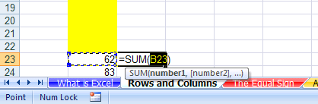

Figure 50
Next, hold the Ctrl key and hold the Shift key at the same time, and then tap the down arrow key (this selects the entire range of numbers below cell B23). You should see this (Figure 51):

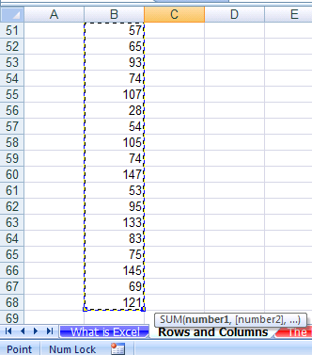

Figure 51
Next tap the Enter key, and the up arrow key five times (the Enter is to put the formula in the cell and the up arrow keys are to move the screen down so you can see what you did). You should see this (Figure 52):

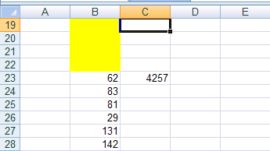

Figure 52
Next, hit the down arrow key four times to select cell C23. In the formula bar you can see the amazing formula that you created with the keyboard shortcut Alt + =, then Ctrl + Shift + down-arrow, then Enter. The formula bar shows that you used the SUM function and selected 46 rows of numbers without ever using your mouse!!! You should see this (Figure 53):

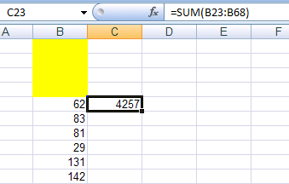
Formula Bar

Figure 53
Next, to navigate quickly to cell A1, hold Ctrl and tap the “Home” key (the Home key is to the right of the Backspace key and above the arrow keys). Your cursor should be in cell A1 (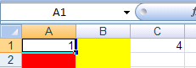Figure 54):

Figure 54
Here are some common keyboard shortcuts:

Copy = Ctrl + C

Cut = Ctrl + X

Paste = Ctrl + V

Save = Ctrl + S

Spell Check = F7

Undo = Ctrl + Z.

Redo = Ctrl + Y

Go to cell A1 = Ctrl + Home

Add bold to cell content = Ctrl + B

Add Underline to cell content = Ctrl + U

Add Italic to cell content = Ctrl + I

Select two cells and everything in-between = Click on first cell, hold Shift, Click on last cell

Select cell ranges that are not next to each other = click on cell or range of cells, Hold Ctrl, click on any number of other cells or range of cells

Ctrl + arrow key = move to end of range of data, or to beginning of next range of data
Next we want to look at the keyboard shorts using the Alt key. The Alt key is a special keyboard shortcut key because when you tap the Alt key, all the elements in the Ribbon and QAT show little messages called “Screen tips” or “ToolTips”. To illustrate, tap the Alt key once and you should see this (Figure 55):

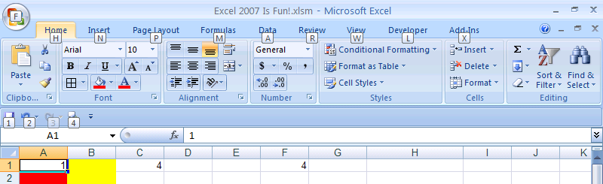

Figure 55: After you tap the Alt key, the Ribbon Tabs show tool tips and the QAT shows tool tips after the first Alt tap.
If you tap the Alt key once the Ribbon Tabs show tool tips and the QAT shows tool tips, but none of the other elements of the Ribbon show screen tips. However, if you tap one of the keys for the letters or numbers that you see in the tool tips that activates the next level of tool tips. For example if you hit the “H” key after you taped the Alt key, you would see this (Figure 56):

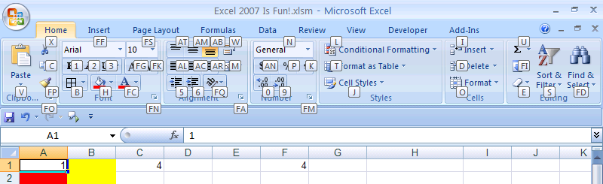

Figure 56: After you hit Alt + H, you can see the next level of tool tips for the Home Ribbon.
After you hit Alt + H, you can see the next level of tool tips for the Home Ribbon. If you then tap the 0 key (zero key), you would have increased the decimals showing by one position. Thus, the keyboard shortcut for increasing the decimals showing by one position is Alt + H + 0 (Figure 57):

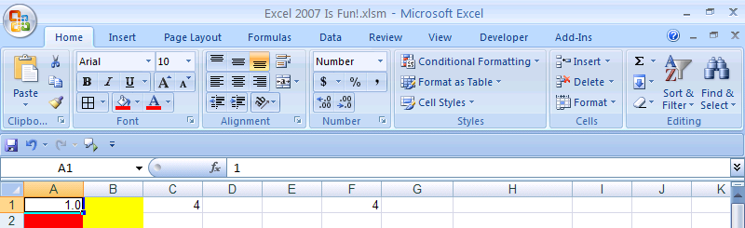

Figure 57
This is an amazing aspect to Excel 2007. Every Ribbon and QAT element has a keyboard shortcut. And your goal to achieve efficiency is not to memorize all the keyboard shortcuts, but it is to memorize the keyboard shortcuts that you use all the time. In addition, if you memorized some of the Excel 1997-2003 Alt key keyboard shortcuts, they all still work, except for the Alt keyboard shortcuts that started with the letter “F” – this is because the Alt “F” is used by the Orb is Excel 2007.

Rule # 4 = Learn keyboard shortcuts in order to save time

Two Magic Characters In Excel
For this next section, click on the sheet tab named “The Equal Sign”.

The equal sign, “=,” and the join-operator (ampersand), “&,” are two magic characters in Excel. We will look at the equal sign first.
The equal sign tells Excel to create a formula in a cell. For example, in Figure 58, if you would like to calculate the net pay for Suix Chin in cell F2, what would you need to do? You would need to take the net pay and subtract from it the total deductions. In order to make this calculation in cell F2, you must first tell Excel that you want to make a calculation by typing an equal sign: “=”.
Here are the steps to make your first calculation in Excel:
- Using your “thick, white-cross” cursor (it also has a black shadow) click in cell F2 in order to highlight the cell. See Figure 58. Make sure that the name box shows F2.
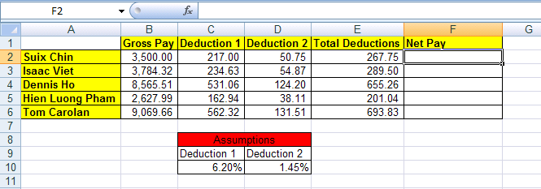

Figure 58
- Type an equal sign. See Figure 59:
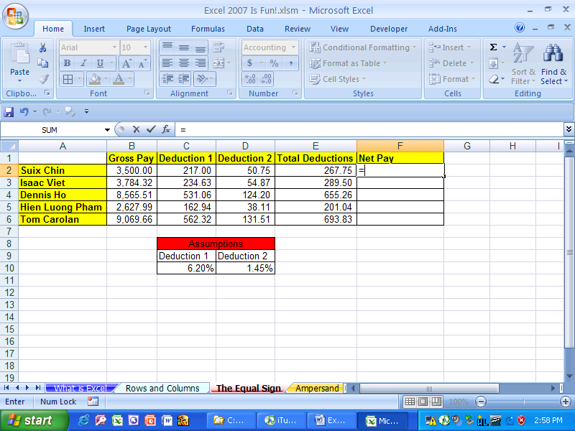

Figure 59
- Notice the equal sign in the formula bar as seen in Figure 60. (Don’t be alarmed that the name box has converted to an “Insert Function” dropdown arrow with the SUM function showing– we’ll talk about this later).

Figure 60: The Formula Bar. The f_{x} is a symbol from algebra that means “f of x”, or function, or formula
- Next, using your “thick- white-cross” cursor, click in cell four to the left of F2 (cell B2). Like magic, Excel inserts the proper CELL REFERENCE after the equal sign (see Figure 61). In addition, Excel shines the blue and yellow flashlight around the cell B2 (these are the colorful marching ants that march around the cell telling you that you have placed the CELL REFERENCE B2 behind the equal sign).
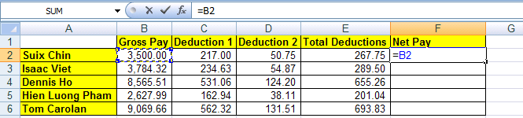

Figure 61
- The formula is now looking at a cell that is four cells to the left of F2 – looking at the cell named B2 which holds Suix Chin’s Gross Pay. Because our goal is to calculate Net Pay, we still have to subtract the Total Deductions.
- Type a minus sign, then using your “thick-white-cross” cursor, click in cell E2, which is one cell to the left of F2. You should see this (Figure 62):
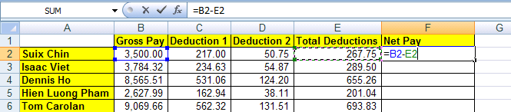

Figure 62
- Hold the Ctrl key, and then tap the Enter key once. This is what you should see (Figure 63):
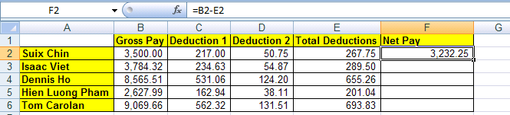

Figure 63
- You have just created your first calculating formula in Excel by using the equal sign as the first character in a cell. Although the cell F2 displays the take home pay of 3,232.25, what is actually in the cell can be seen in the formula bar. Our formula reads: please look at Suix Chin’s Gross Pay (four cells to the left in B2) then subtract the Total Deductions (one cell to the left in E2).
- We have creating our first calculation in Excel, and what we actually created is called a formula. Because the equal sign is the first character in the cell we told Excel to create a formula. If there was no equal sign, there would be no formula. In addition, we used CELL REFERENCES. CELL REFERENCES are our way of telling our formula to look into a different cell and use that value in our formula!

Rule # 5 = When the equal sign is placed as the first character in a cell that has not been pre-formatted as Text, it tells Excel to create a formula.
- What would have happened if you did not place an equal sign in the cell as the first character but you still typed the rest of the formula (Figure 64)? Excel would obey you and not create a formula, but instead place the typed text “B2-E2” in the cell.
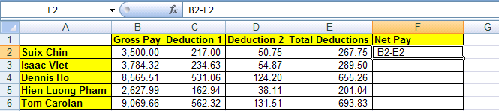

Figure 64

- What would happen if you type the number for gross pay and the number for total deductions in the formula instead of the cell references? Here is an example of this situation, however, please burn this image into you brain as something you should NEVER do (Figure 65):
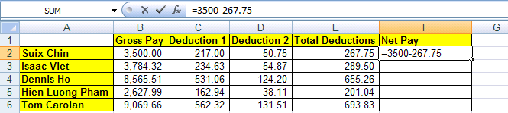

Figure 65

- In Figure 65 Excel will obey you and calculate an answer. However, if you want to become even moderately efficient with using Excel, NEVER TYPE NUMBERS THAT CAN VARY INTO A FORMULA. When you enter numbers that can change (or text) into formulas instead of references to other cells:
    - Editing the formulas later on can become nearly impossible
    - What-if or scenario analysis becomes cumbersome
    - The true magic of Excel is greatly dimmed, as if a magnificent rainbow that fills the sky with refreshing color is suddenly all one color of grey.
- Numbers such as the number 12 that represents months is OK to type into a formula. Similar numbers would be things like 7 days in a week, 24 hours in a day.

Rule # 6 = Do not type data that can vary into a formula. Instead place the data in a cell and refer to it using a cell reference. (A tax rate is a good example of a number that can vary; 12 months in a year is an example of data that will not change).
The second magic character in Excel is the Ampersand (more commonly known as the “and” character) “&”. This character joins the content from two or more cells and places them all into one cell. To see an example, click on the sheet tab named “Ampersand”.
Here are the steps to join the words “Your” and “Name” and place them into one cell.

- In cell A1 type “Y o u r” (letters Y, o, u, r, space). You should see this (Figure 66):
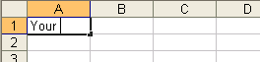

Figure 66
- Hit Tab. In cell B1 type “N a m e” (letters N , a, m, e), and then Tab. You should see (Figure 67):
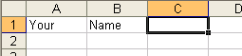

Figure 67
- In cell C1 type the an equal sign (Figure 68):
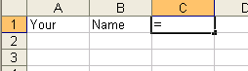

Figure 68
- Hit the left arrow key twice (Figure 69):
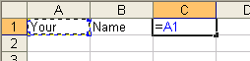

Figure 69
- Type the Ampersand (Shift + 7) (Figure 70):
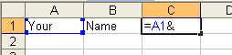

Figure 70
- Hit the left arrow key once (Figure 71):
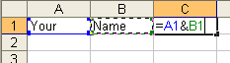

Figure 71
- Hit Ctrl + Enter (Figure 72):
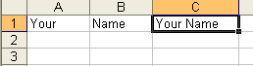

Figure 72
- In cell A1 type “Isaac ” and in cell B1 type “Newton” (Figure 73):
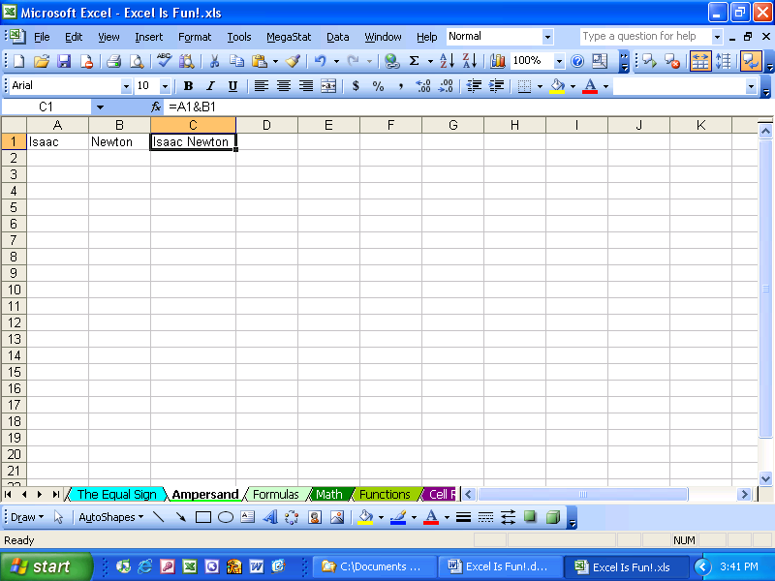

Figure 73
- Now try your own joining using the “&” (Figure 74):
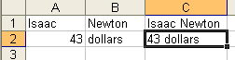

Figure 74
Note about the Ampersand (&)“join” character: When you join two or more items using the “&” in a formula, Excel treats the result as Text (in computer programming language it is referred to as a “text string”). In other words, Excel thinks that the formula result is a word, not a number. This becomes important later when we need to distinguish between text and numbers.

Keyboard shortcut Note:

Method of placing cell references in formula after you have placed an equal sign as the first character in the cell: 1) use mouse to click on cell, 2) use arrow keys to move to cell reference location, 3) type the cell reference (higher probability of error)

Here are the steps to calculate a monthly interest rate on a loan
- Click on the sheet tab named “Formulas”
- As seen in Figure 75, click in cell B2 and type an equal sign. By typing the equal sign, you are telling Excel that you are creating a formula in cell B2.
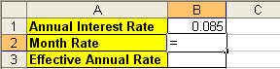

Figure 75
- Click the up arrow key (in between the letter keys and the number keys). By typing the up arrow, you are telling Excel that you would like the formula to look into the cell “one above” B2 and get the annual rate of .085. You should see what is in Figure 76:
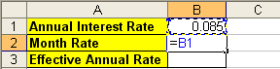

Figure 76
- Notice that by using the arrow key to select a cell reference, you save the time it would take you to grab the mouse and click on cell B1.
- Type the division symbol “/” and the number 12 (12 months in a year does not vary so that fact that this is a number does not violate Rule #6). See Figure 77:
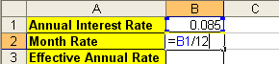

Figure 77
- Tap Enter. Taping the Enter key puts the formula in the cell and moves the cursor one cell below B2 to the cell B3. The monthly rate displayed in the cell can be seen in Figure 78:
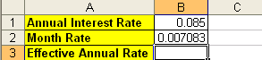

Figure 78
So far we have seen two keystrokes that tell Excel that the formula is completed and we would like to have Excel show us the result. The keystrokes “Ctrl + Enter” and “Enter” will officially enter the formula into the cell. There are two other keystrokes that will officially enter the formula into the cell: the “Tab” key will do it and Shift + Enter (Shift + Enter) enters the formula and moves the cursor up – we will not use this one in this book). These four keystrokes are the safest methods for putting the formula into the cell. There are other keystrokes that work some of the time, but not all the time. For safety and efficient formula creation we will only use Ctrl + Enter, Enter, Tab or Shift + Enter to enter formulas into cells. If we use only four keystrokes to place formulas in cells we can avoid unintended cell reference insertion that can cause our formula to be inaccurate.

To enter a formula into a cell:
- Use “Ctrl + Enter” to place the formula in the cell and select the cell with the formula
- Use Enter to place the formula in the cell and select the cell directly below the cell with the formula
- Use Shift + Enter to place the formula in the cell and select the cell directly above the cell with the formula
- Use Tab to place the formula in the cell and select the cell one to the right

Rule #7 = Use “Enter”, “Ctrl + Enter”, “Shift + Enter”, or “Tab” to enter a formula into a cell.

- In Cell B3, type: “=(1+”, as seen in Figure 79:
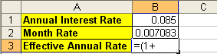

Figure 79
- Click the up arrow once, then type: “)^12-1” as seen in Figure 80 ( ^ symbol = Shift + 6):
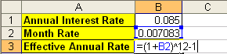

Figure 80

- We do not violate rule # 6 (DO NOT TYPE DATA THAT CAN VARY INTO A FORMULA) by typing the 1, 12, and 1 into these formulas. For calculating the annual effective rate from a month rate these numbers do not vary!
- Click Tab. You should see this (Figure 81):
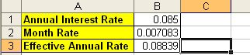

Figure 81
- But what is that “^” symbol mean? See the arrows in Figure 82 on the next page.

Math
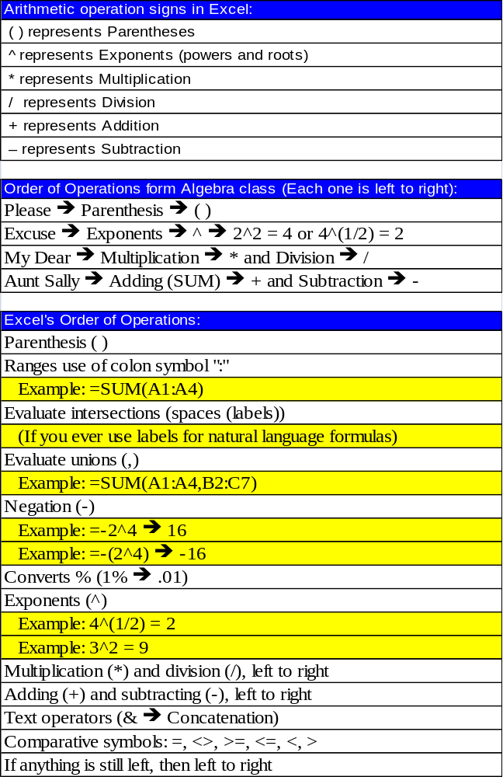

Figure 82
As seen in Figure 82, we will have to learn the Arithmetic operation signs in Excel. In addition, we will have to learn the order of operations in order to avoid analysis mistakes. For example, what is the answer to 3 + 3 * 2? Is it 12 or is it 9? Because Excel knows the order of operations, we must also know the order of operations so we can calculate correctly. For a refresher in the order of operations, read Figure 82.

Rule #8 = We must learn the symbols that Excel uses for math and we must know the order of operations.
Here are the steps to practice math and the order of operations:
- Click on the sheet tab named “Math (2)”. You should see this (Figure 83):
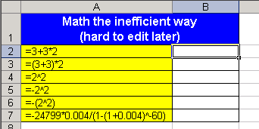

Figure 83
- Click in cell B2 and type the formula “=3+3*2”. You should see this (Figure 84):
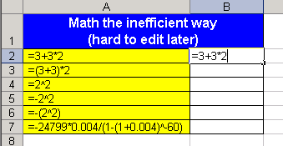

Figure 84
- Looking at the examples of formulas in column A, create the remaining formulas in column B. When you are done you should have these results (Figure 85):
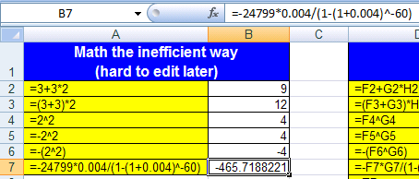

Figure 85
- The problem with what you just did (Figure 83, Figure 84, Figure 85), is that editing the formulas later is inefficient when compared to a method that employs cell references. Our next example will employ cell references.
- Click in cell E2 and type an equal sign “=” (Figure 86).
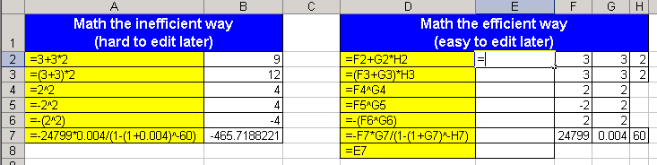

Figure 86

- Click the right arrow key, as seen in Figure 87:
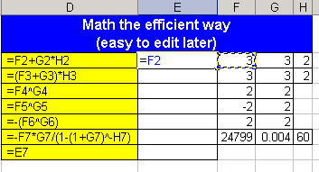

Figure 87
- Type “+”, as seen in Figure 88:
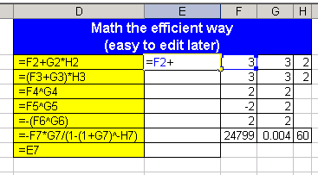

Figure 88
- Click the right arrow key twice, as seen in Figure 89:
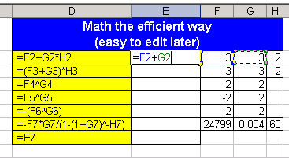

Figure 89
- Type the “*”, as seen in Figure 90:
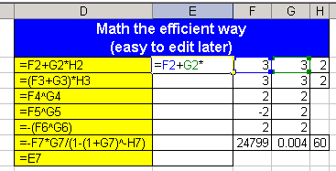

Figure 90
- Click the right arrow three times, (Figure 91):
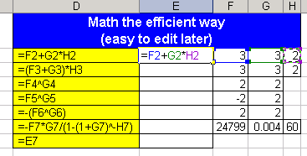

Figure 91
- Hit Enter. The answer should be 9.

- In Figure 92 the heading says “Math the efficient way”. The efficiency comes from the fact that it is easy to edit these formulas because you have utilized cell reference that point to numbers typed into cells. Change the number in cell F3 to 12 and watch your formula change (Figure 92):
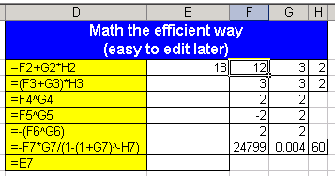

Figure 92
- Look at the formulas in column D) and create the corresponding formulas in column E. When you are done you should see this (Figure 93):
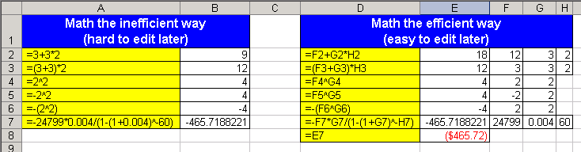

Figure 93
- But what is going on in cell E8? How come when cell E8 looks at cell E7 it shows us a dollar figure? The answer comes from formatting. We will talk about formatting later (this is exciting foreshadowing)…. For the time being we have been taking about the equal sign, ampersand sign, numbers, cell references and math operators: these are all components of formulas. We will now formally define a formula in Excel ➔.

Formulas
Definition of a formula: Anything in a cell when the first character is an equal sign.
(The long version: anything in a cell or formula textbox when the first character is an equal sign and the cell is not preformatted as Text.)
Advantages of a formula: You are telling Excel to do calculations, look into another cell, create text strings, or deliver a range
How to create a formula: Type “=,” followed by:
  - Cell references (also: names and sheet references)
  - Operation signs
  - Functions
  - Text that is in quotes (ex: “For The Month Ended”)
  - Ampersand symbol: &
    - To combine information from different cells, text in quotes, or functions use the ampersand: &
      - Example: ="For The Month Ended "&B5
  - Numbers
    - The only numbers that ever go in a formula are numbers that will never change (such as the number of months in a year)
  - Arrays (example: {1,”Sioux”;2,”Chin”;3,”Fred”}
How to enter a formula into a cell: hit one of the following:
  - ENTER (Active Cell goes down)
  - Ctrl + Enter (Active Cell remains the same)
  - Tab(Active Cell goes left)
  - Shift + Tab (Active Cell goes right)
  - Shift + Enter(Active Cell goes up)
Here are the steps to create five formulas:
- You are currently looking at the sheet tab named “Math (2)”. Make sure that you are in this sheet
- To use a keyboard shortcut to move two sheets up (back toward the first sheet), hold down Ctrl, then tap the “Page Up” key twice (the “Page Up” and “Page Down” keys are near the Home key).
Ctrl + Page Up ➔ moves you up through the sheets (toward the first sheet)
Ctrl + Page Down moves you down through the sheets (away from the first sheet)
- You should now be located in the sheet tab named “Formulas”
- Create the following formula (as seen in Figure 94). Efficient key strokes are: “=”, up arrow twice, “-“, up arrow once.
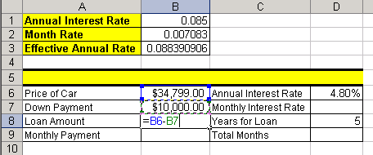

Figure 94
- Hit Tab twice, Arrow up and create this formula in D7 (Figure 95):
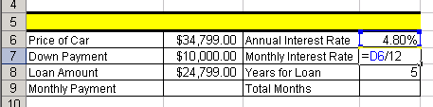

Figure 95
- The 12 represents months in a year and does not change and so it is efficient to type this number into a formula
- Hit Enter twice and create this formula in D9 (Figure 96):
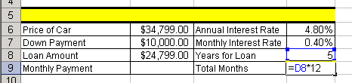

Figure 96
- Click in cell B9 and create the formula as seen in Figure 97. After you create it, hold Ctrl, then tap Enter.
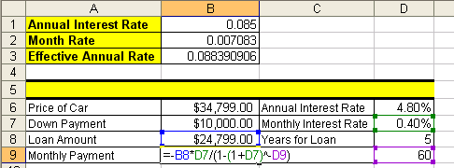

Figure 97
- Click in cell A5. The cell is merged and centered and so the formula will be created in the middle of the range. Create the following formula as seen in Figure 98:
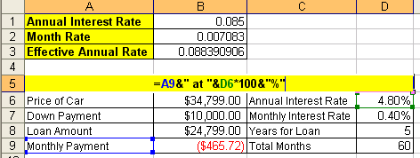

Figure 98
- This formula combines cell references, text in quotes and a calculation all joined together with the Ampersand “&”. The resulting label for our calculations can be seen in Figure 99:
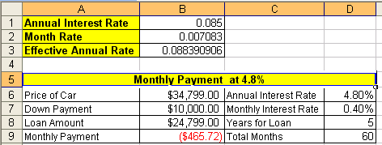

Figure 99
- The efficiency and beauty of building a spreadsheet in this manner is revealed when we change the source data and then watch our formulas change automatically.
- Click in cell B6 and change the price of the car to 50,000 (type 50000), then hit Tab twice. (Figure 100):
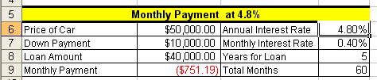

Figure 100
- Notice that the preformatted cells formatted the “50000” to appear as “$50,000.00”. Also notice that our formulas for Loan Amount and Monthly Payment updated.
- Verify that you are in cell D6 and then type “6” and then hit Enter (Figure 101):
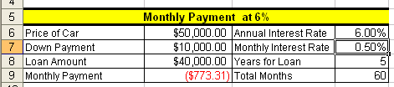

Figure 101
- Notice that the three formulas that were dependent on the Annual Interest Rate all updated when we changed the rate. This ability to check different scenarios without much effort is at the heart of using Excel efficiently. We always want to strive to build our spreadsheets efficiently so that they are easily edit-customizable at any time! By typing the numbers that can vary into cells and referring to them using cell references in our formulas we have accomplished Excel efficiency and fun!

Rule #9 = By typing the numbers that can vary into cells and referring to them in our formulas using cell references, we gain the ability to edit formulas easily and check different scenarios without much effort.

- Look in the lower left corner of Figure 102 and find the scroll arrow for sheet tabs. The little black triangle turned on its side means show me one more sheet tab. The little black triangle turned on its side with an extra vertical line means take me all the way to the last and/or first sheet tab.

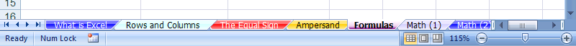
Scroll arrow that reveals more sheet tabs

Figure 102
- Click the sheet tab scroll arrow twice as seen in Figure 103:
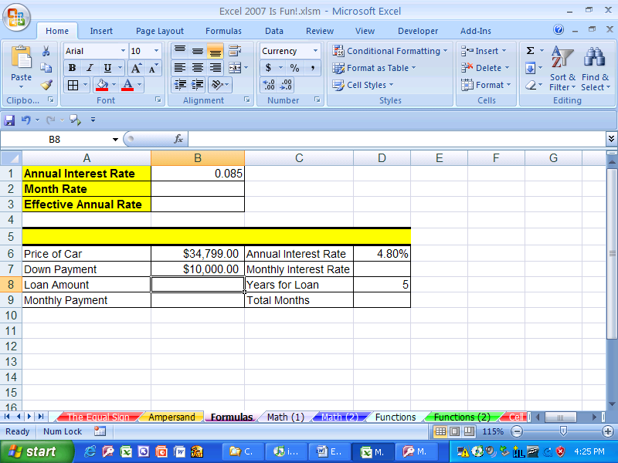

Figure 103
- You should see a few more sheet tabs exposed. The sheet tab “Formulas” is still selected, even though we see a few more sheets exposed (Figure 104):
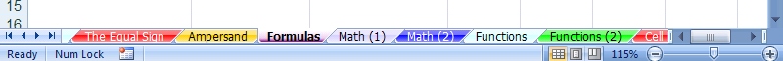

Figure 104
- Move to the sheet tab named “Functions” by either clicking on the sheet tab named “Functions”, or by Holding Ctrl, then tapping the “Page Down” key three times. You should see this (Figure 105):
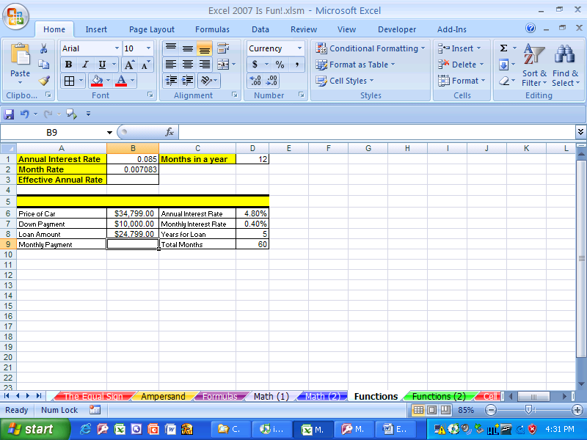

Figure 105
- Click in cell B9. What if we want to calculate the monthly payment for our car loan, but we do not know that math formula? Luckily there are built in “Functions” that know how to do this – as long as we can tell the Function what the monthly rate, number of months and present value of our loan is, the function will do the rest!

Functions
What are functions? Built in code that will do complicated math (and other tasks) for you after you tell it which cells to look in
Examples:
SUM function (adds)
AVERAGE function (arithmetic mean)
PMT function (calculate loan payment)
COUNT function (counts numeric values)
COUNTA function (counts non-blank cells)
COUNTIF function (counts based on a condition)
ROUND function (round a number to a specified digit)
IF function (Puts one of two items into cell depending on whether the condition evaluates to true or false)
Here the steps to practice with many new Functions:
- Click in cell B9 and then click the f_{x} button (Insert function button) in the formula bar (Figure 106). (Keyboard shortcut: Shift + F3 = Open Insert Function dialog box)
Formula bar: from here to here
f_{x} button ➔ the insert function button

Figure 106
- The Insert Function dialog box looks like this (Figure 107):
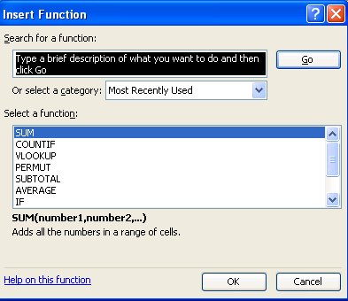

Figure 107
- There are five key parts to the Insert Function dialog box:
  - Search
  - Category
  - Select function
  - Description of selected function
  - Help
- Click in the search for a function text box and type “monthly car payment” then hit Enter (Figure 108):
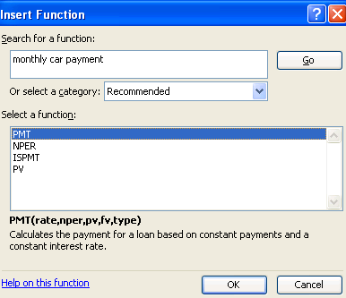

Figure 108
- In the select a function list the first function selected is “PMT”
- Below the list is the description: “Calculates the payment for a loan based on constant payments and a constant interest rate.” This sounds perfect for our need. But let’s check the others to make sure that there is not something even better. Click on “NPER.” Figure 109 shows the description of this function:
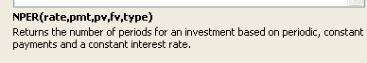

Figure 109
- After looking at each function, click back on the PMT function because, amongst the four options, it fulfills our goal most satisfactorily. Descriptions are the key to the Insert Function dialog box. You can find the most amazing functions that will do all the calculating for you if you just spend a little time “hunting” (looking through the list of functions).
- Because “hunting for the right function is the key to learning about all the wonderful built-in functions, another way is to “hunt” using the “All” category.
- Click the down-arrow next to “Select a category” and point to All (Figure 110):
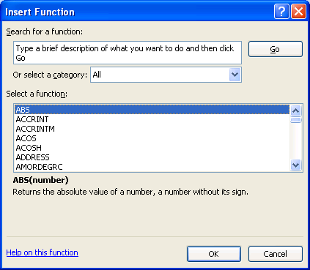

Figure 110
- Most of the functions have common sense names. See if you can find a function that will calculate “Absolute value”, “Geometric mean”, “Average”, “Straight-line depreciation”. All four of these can be found by hunting for those words in the list.

- Absolute value (Figure 111):
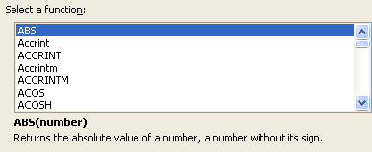

Figure 111
- Geometric mean (Figure 112):
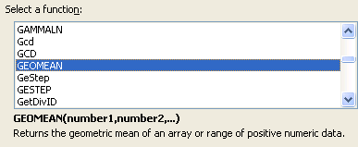

Figure 112
- Average (Figure 113):
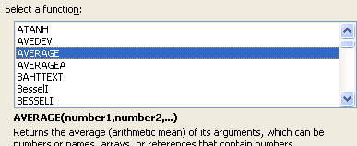

Figure 113
- Straight-line depreciation (Figure 114):
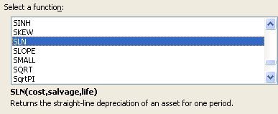

Figure 114
- Now, find the PMT function again. (Figure 115):
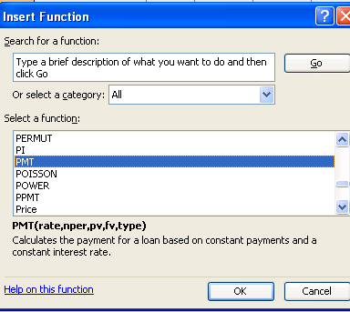

Figure 115

- Double click the highlighted PMT function to open the Functions Arguments dialog box (Figure 116):
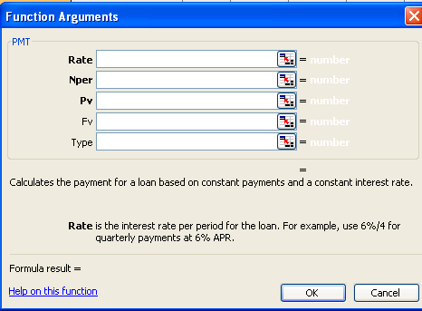

Figure 116
- The arguments “Rate” “Nper” and “Pv” are in bold and the most commonly used variables for this function and are required for the function to give you a result. The “Fv” and the “Type” are not in bold and are not required. There is a description for each argument that will help you figure out how to use the function. In addition, “Help on this function” (bottom lower left corner of Figure 116) is amazing! If you click that link it will give you a full description and example of how to use this function. The help looks similar to this (Figure 117):
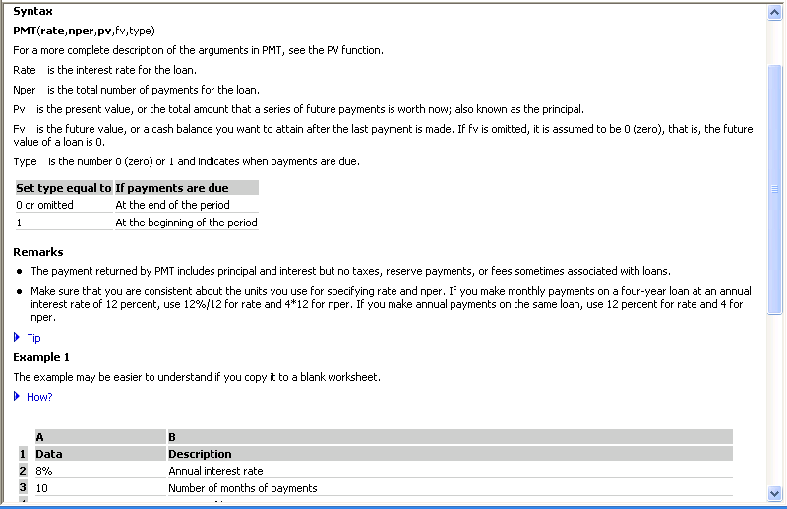

Figure 117
- If you opened up the help, close it. Make sure your curser is in the argument box for Rate, then click in cell D7 (Figure 118):
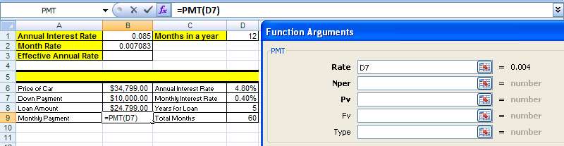

Figure 118
- Notice that when you click on cell D7 the value is shown to the right side of the argument box.
- Hit Tab to move to the next argument box, click in cell D9, Hit Tab, Click in cell B8 (Figure 119):
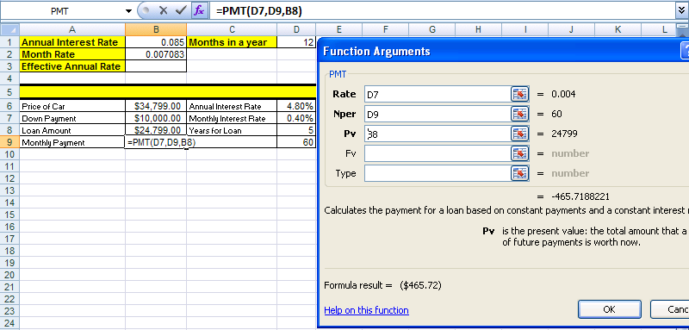

Figure 119
- In Figure 119 notice:
- Each argument box has a cell reference (this makes it easy to edit later)
- To the right of each argument box that the variable amount is shown
- The formula result is shown in two different locations (can you see both?)
- The formula bar shows that Excel has placed an equal sign in the cell for you, that the name of the function is in the formula and that the three cell references (arguments) are separated with commas.
- Click OK. The result is the same as when we made our calculations before without the use of an Excel function. (Figure 120):
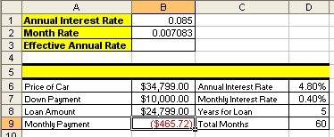

Figure 120

Rule #10 = Using Excel’s built in Functions can simplify and shorten formula creation.

Rule #11 = Finding functions in Excel can be accomplished by reading the descriptions, searching for a common sense name in the list of functions, or by using the “Search” feature in the Insert Functions dialog box. (You can search Google or the mrexcel.com site also.)

Rule #12 = Figuring out what arguments to use for a given function can be accomplished by reading the descriptions, or by clicking the help button in the Argument dialog box.
- Click in cell B3, hold the Shift key and tap the F3 key and then use the Insert Function dialog box to find a formula for calculating the Effective Annual Rate. The result should look like this (Figure 121):
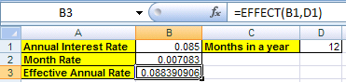

Figure 121
- Click in cell A5 and then hold the Shift key and tap the F3 key. In the Search for a function text box type “join text” (Figure 122):
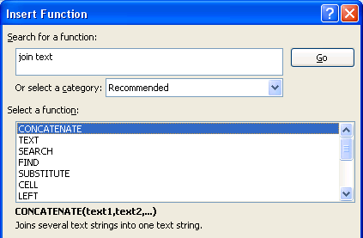

Figure 122
- Create the label for the Monthly Payment table (be sure to pay attention to the spaces before and after the word “ at “) using the CONCATENATE function (Figure 123):
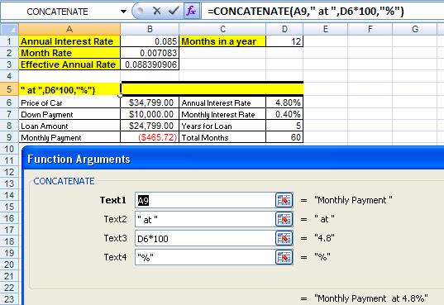

Figure 123
- The result looks like this (Figure 124):
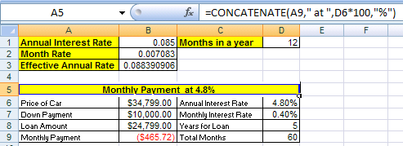

Figure 124

- Type the number “1” into cell A13 and the number “2” into cell A14. Then highlight the two cells (Figure 125):
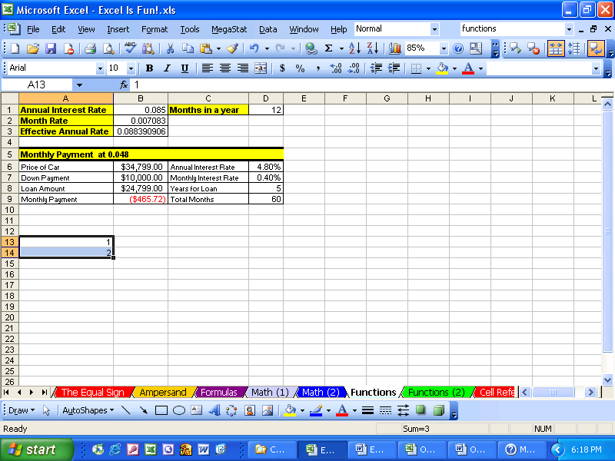

Figure 125
- Look at Figure 125. What is that little black box in the lower right corner of the highlighted range? It is called the fill handle. It is magic. Take your cursor and point to it until you see a cross hair (angry rabbit). (Figure 126):

Figure 126
- Click and drag the angry rabbit down to A17. Just like magic Excel assumes you want to add by 1 because the pattern of the number 1 and 2 is to always add 1. (Figure 127):
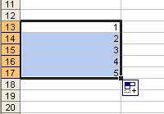

Figure 127
- Click in Cell A18. We are going to add all the numbers by using a SUM function. The keyboard shortcut for the SUM function is Alt + “=”.
- Hold the Alt key, then tap “=” (Figure 128):
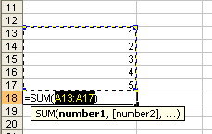

Figure 128
- In Figure 128 we see that the SUM function tries to guess what data we want to sum (it does not always guess correctly). It guessed correctly this time and so we hit Ctrl + Enter (or if we are still holding the Alt key we would tap “=” a second time. (Figure 129):
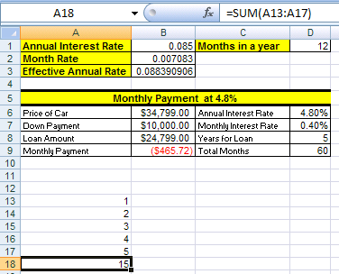

Figure 129
- It is much more efficient to use the SUM function, “=SUM(A13:A17)”, than it is to type in “=A13+A14+A15+A16+A17”. In addition there is an added bonus to using a function that uses a range such as A13:A17. Let’s take a look ➔
- Point to the row heading 15 and click to highlight the whole row (Figure 130):
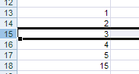

Figure 130
- With the row highlighted click on the Home Ribbon and point to Insert icon in the Cells Group without clicking (Figure 131):
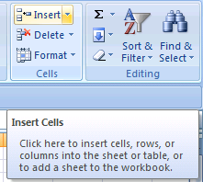
Screen Tip

Figure 131
- Notice that a screen tip pops up to tell you what this icon button does.
- Click the Insert icon button and then click the Insert Sheet Rows button (Figure 132):
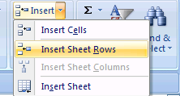

Figure 132
- The result is that you have inserted a row (Figure 133):
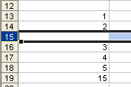

Figure 133

Note:

2007 Keyboard shortcut Insert Row = Alt H + I + R

2003 Keyboard shortcut Insert Row = Alt I + R
If you want, use the 2003 version because it is shorter.
- Click in cell A15 and type the number “100” and hit enter (Figure 134):
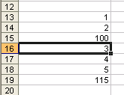

Figure 134
- Notice that the sum function updated
- Click in cell A19 and click the F2 key (Figure 135).

Keyboard shortcut for “Range Finder” = F2
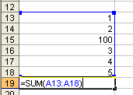

Figure 135
- Range Finder allows us to audit a formula after it is created. Look at the range we have in Figure 135 (A13:A18). Now look at the range in Figure 129. Our conclusion: by using a function with a range our formula will update when we insert rows or columns. If we had used the formula “= A13 + A14 + A15 + A16 + A17”, it would not have updated when we inserted a row.

Rule #13 = Using functions with ranges instead of a collection of individual cells allows structural updating to spreadsheets more easily.

Example of Rule #13: Use “=SUM(A13:A17)” instead of “= A13+A14+A15+A16+A17”

- For more practice with Functions go to the sheet tab named “Functions (2)”
- Hover your “thick, white-cross” cursor over cell A2, then click in cell A2, hold the click, and drag your cursor to cell J9. This is how you highlight a range. The range you have highlighted is A2:J9. (Figure 136):
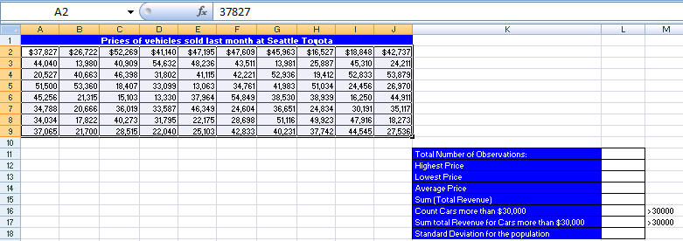

Figure 136
- Click in the Name Box (Figure 137):
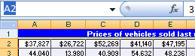

Figure 137
- After you click in the name box it will highlight the cell A2.
- Type over “A2” and replace it with “sd” (“sd” will stand for sales data). (Figure 138):
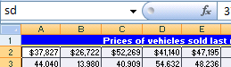

Figure 138
- Then hit Enter to register the newly named cell range. The cell range A2:J9 now has the name “sd” When we create functions that look at that range we can now simply type in “sd” instead of highlighting the range A2:J9
- Click in cell L11 and see if you can find a function that can count the number of cars that were sold last month at Seattle Toyota. When you find it, your formula result should look like this (Figure 139):
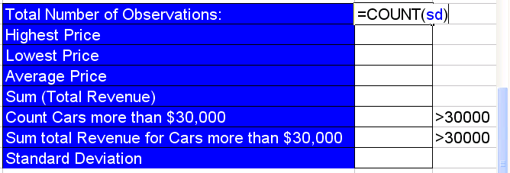

Figure 139
- See if you can find the remaining functions using your new “function hunting skills”
- When you are done you should see the same results that you see in column L in Figure 140 by using the formulas that you see in column N in Figure 140.
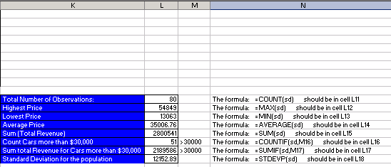

Figure 140
- We have been using cell references so often, that it is now time to investigate the different types of cell references ➔

Cell References
When we copy formulas that contain cell references to other cells, then we need to understand that there are four types of cell references:
- Relative
- Absolute
- “Mixed Cell Reference with Column Locked” also known as “Column Absolute, Row Relative”
- “Mixed Cell Reference with Row Locked” also known as “Row Absolute, Column Relative”

It will only be possible to understand these if we look at a few examples. Nevertheless, here are the crucial facts about cell references:

- Relative Cell References Example: A1
No dollar signs
Moves relatively throughout copy action
“Relatively” means that if the formula is looking at a cell reference that is three cells to the left, when you copy the formula to any other cell, the cell reference will still be looking three cells to the left.
- Absolute Cell References Example: $A$1
Dollar signs before both:
Column designation = A
Row designation = 1
“Absolute” means that if the formula is looking at a particular cell reference, when you copy the formula to any other cell, the cell reference will still be looking at that particular cell reference.
If the Absolute Cell reference is $A$1, the formula will always look at cell A1. It is as if the formula is locked on the cell A1 throughout copy action
“Locks cell reference when copying it horizontally and vertically”
- “Mixed Cell Reference with Column Locked” Example: $A1
Dollar sign before column designation
Remains absolute or locked when copying across columns
Remains relative when copying across rows
“Locks cell reference when copying it horizontally, but not vertically”
- “Mixed Cell Reference with Row Locked” Example: A$1
Dollar sign before row designation
Remains absolute or locked when copying across rows
Remains relative when copying across columns
“Locks cell reference when copying it vertically, but not horizontally”
Keyboard shortcut F4 key: Toggles between the four types of cell references

When creating formulas with cell references, ask two questions of every cell reference in formula:
Q1: What do you want it to do when you copy it horizontally?
Is it a relative reference? OR
Is it an absolute or locked reference?
Q2: What do you want it to do when you copy it vertically?
Is it a relative reference? OR
Is it an absolute or locked reference?
Here are the steps to learn about the four cell references:
- Go to the sheet tab named “Cell References” and click in cell C3 and create the formula shown in Figure 141. The formula calculates a proportion or percentage of the whole (depending on how it is formatted). In our example we are comparing Tina’s score (82 parts of the 100 whole) and comparing it to the total possible points (100 points – the whole). If you look ahead to creating the formulas for Sue and Chin and Hien, all their “parts” will have to be compared to the “whole”.
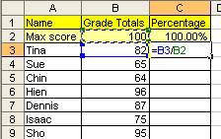

Figure 141
- Hold Ctrl, then tap Enter. You should see that the proportion of points that Tina earned is .82 (Figure 142):
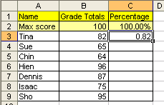

Figure 142
- To format the number “.82” as a percentage, highlight cell C3, click the Home Ribbon and then click the % icon button in the Number Group. (Figure 143). Remember 82% is not a number. Underneath in Excel’s code (just like any other calculator), Excel sees the number “.82” even though it is formatted with a % symbol and even though what we see in the spreadsheet is 82%:
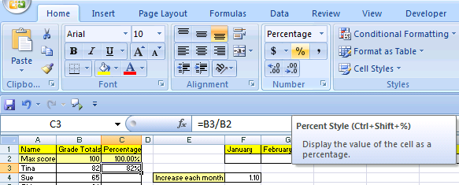

Figure 143: Notice the Screen Tip that let’s us know the keyboard shortcut for this format.
- Highlight the range C4:C9 and then use the keyboard shortcut to add the % style (Ctrl + Shift + %): this pre-formats the cells with the percentage format (Figure 144):
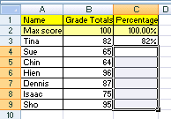

Figure 144
- Click in C4 and create the formula for calculating Sues’ percentage grade (Figure 145):
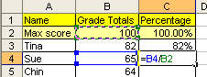

Figure 145
- Continue until you have created the percentage grades (Figure 146):
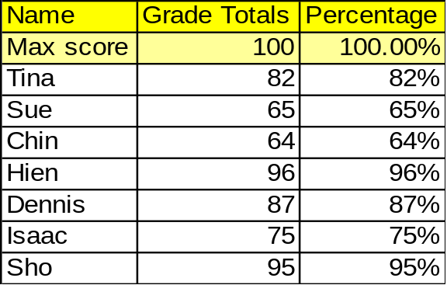

Figure 146
- What we just completed did not require that we know anything about the four different cell references. However, what we did was inefficient. There is a way to create all those formulas by just creating one formula in cell C2 and then copying it down through our range. We will have to learn how to “LOCK” or make “ABSOLUTE” some of our cell references. If we can learn how to do this, it will make tasks such as this easier to complete and will result in few errors. In addition, many of the most advanced Excel Features and tricks are only possible if we learn about these four cell references.
- Highlight the range C2:C9 and then hit the delete key (Keyboard short cut: Delete key = delete cell content but not format) (Figure 147):
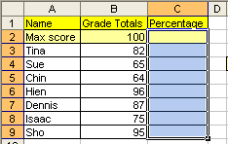

Figure 147
- Click in cell C2 and create the following formula (Figure 148):
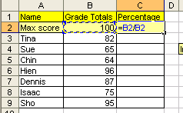

Figure 148
- Figure 148 shows a fraction B2/B2. For clarification of terms: Numerator means the top of the fraction and Denominator means the bottom of the fraction.
- Now think about this: the numerator B2 needs to always look one cell to my left and the denominator B2 always needs to be locked on B2. We have to let Excel know that the two B2s are different.
The numerator B2 needs to always look one cell to my left
    - This is called a relative cell reference
    - Relative to the cell the formula sits in, the cell reference always needs to look one cell to the left
    - For our example the “one-to-the-left” B2 will be entered into the formula as B2
The denominator B2 always needs to be locked on B2
    - This is called a locked or absolute cell reference
    - The secret code we need to put into our cell reference to let Excel know that the cell is locked in the “$” sign. Why the dollar sign? No reason – just think of it as the secret code).
    - But where do we put the secret code? The answer depends on which direction you will be copying the formula. In our case we will be copying up-and-down (vertical direction), across the rows (and rows are numbers), so the secret code goes in front of the Number 5.
    - For our example the “LOCKED” B2 will be entered into the formula as B$2
- Very carefully, place your cursor in the middle of the denominator B2 and click the F4 key twice. The first tap of the F4 key will put two dollar signs into the cell reference, then the second tap of the F4 key will toggle to the next cell reference which has only one dollar sign in front of the number 2. See Figure 149:
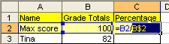

Figure 149
- Hold Ctrl, then tap Enter. You should see this (Figure 150):
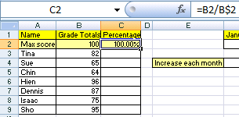

Figure 150
- Point to the fill handle and with your angry rabbit, double-click the fill handle to copy the formula down to cell C9 (Figure 151):
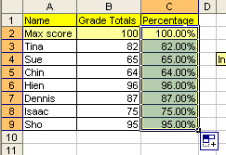

Figure 151
- In Figure 151, notice that it copied the yellow cell fill color formatting down with the formula. Take you cursor and click on the blue smart tag, then click on Fill Without Formatting (this great feature copies only the formula) (Figure 152):
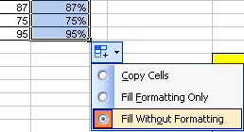
These are called Smart Tags and appear only until you perform a new action.

Figure 152

- Click in cell C9 and audit the formula (F2 key) to make sure that you actuality did create 8 formulas, but only had to create one formula which you then copied down (Figure 153):
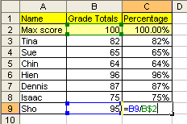

Figure 153
- Click in cell G2 and create the formula seen in Figure 154. Because the January 1000 amount will be increased by 10% each month, we need to multiply (1 + .10) or 1.10 by each previous month’s amount. But notice that the cell reference F2 is actually always going to be looking at the cell “one-to-the-left” (relative cell reference = F2) and the cell reference F4 will always be “locked” on F4 when copying it side-to-side, across the columns (columns are letters), so the secret code goes in front of the letter (locked copying it across the columns = $F4)
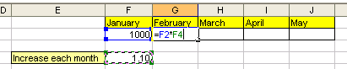
Don’t confuse these cell references (F2 and F4) with the keyboard buttons F2 key and F4 key.

Figure 154
- Very carefully, place your cursor in the middle of the F4 and click the F4 key three times (Figure 155):
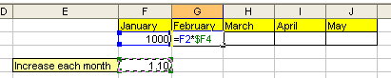

Figure 155
- Hit Ctrl + Enter. Point to the fill handle and copy to formula to J2 (Figure 156):
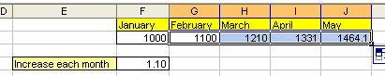

Figure 156
- Click in cell J2 to audit the formula with the F2 key (Figure 157):
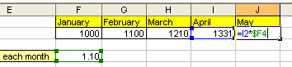

Figure 157
- Look in Figure 158 at the table titled “What will your Pension be worth when you retire?” We would like to estimate what our pension will be depending on the annual rate that we earn and how many years we save for retirement. The trick here is that we don’t want to type 54 formulas. We would like to create the whole “sea of formulas”, G13 to L21, by creating only one formula in cell G13 and then copying it to the remaining cells.
- Click in cell G13 and type “=FV(“. The screen tip will come up to help you with the arguments for this function. To calculate our retirement funds we will need to assume an annual rate “rate”, the number of years that we deposit money “nper” and a yearly deposit amount “pmt” (Figure 158):
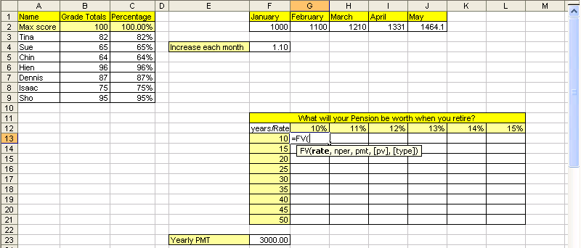

Figure 158
- Click on cell G12 (Figure 159):
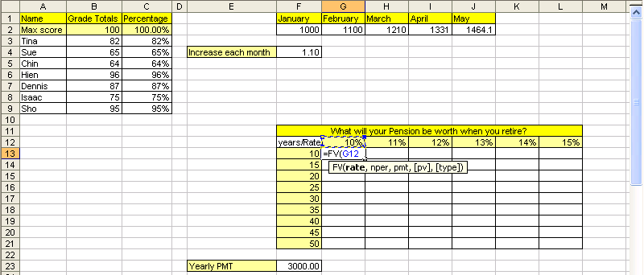

Figure 159
- Can you see in Figure 159 that we will need to use the 10% for all the formulas in column G? Can you also see that when we copy the formula over to column H we need to use the 11%? This means that we need the cell reference locked (absolute) when we are copying the formula down, or vertically, or across the rows: the row reference needs to be locked! However, when we copy the formula to column H the cell reference should not be locked (absolute) when we are copying the formula to the side, or horizontally, or across the columns. The column reference is not locked: it is relative.
- Because we want to lock (absolute) this cell reference when we copy the formula down, across the rows, we need the “$” sign in front of the number. Because we want this cell reference to move relatively as we copy the formula to the side, across the columns, we do not need the “$” sign in front of the letter. Cell reference = G$12 ➔ hit F4 twice (Figure 160):
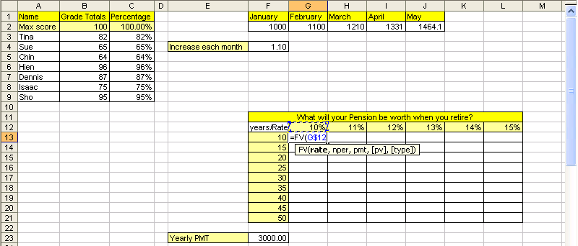

Figure 160
- Type a comma, click on F13, and hit F4 three times.
- We hit F4 three times because we want this cell reference to move relatively as we copy the formula down, across the rows, and we want the cell reference locked (absolute) as we copy the formula to the side, across the columns. Cell reference = $F13 ➔ (Figure 161):
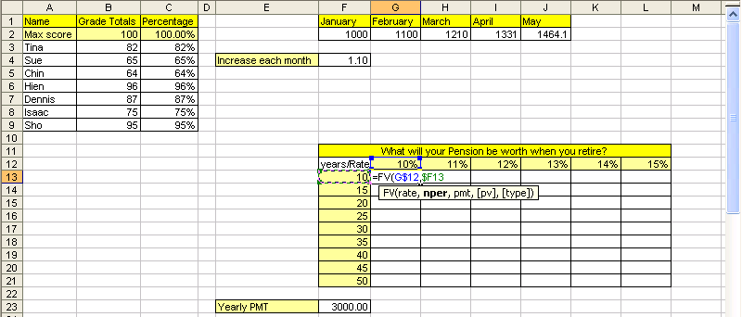

Figure 161
- Type a comma, type a minus sign, click on cell F23, and hit F4 once, type a close parenthesis.
- Because we want to use the cell reference F23 in every cell when we copy this formula, we want the cell reference locked in all directions. The dollar sign in front of the column reference “F” locks the cell reference when copying the formula to the side, across the columns. The dollar sign in front of the row reference “23” locks the cell reference when copying the formula down, across the rows. Cell reference = $F$23 ➔ (Figure 162):
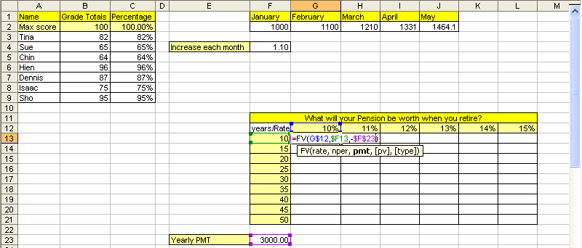

Figure 162
- Hold Ctrl, and then tap Enter. Point to the fill handle and double-click the fill handle to copy the formula down to cell G21 (Figure 163):
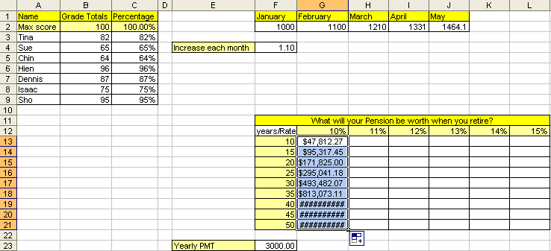

Figure 163
- Don’t be alarmed by the pound signs. They are just saying: “Please expand the column so this big number has room to show itself.” Point between the two column headings G and H and double click to expand the columns. You should see this (Figure 164):
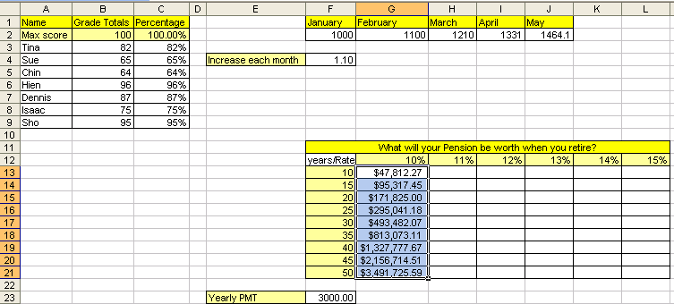

Figure 164
- Now point to the fill handle in the lower right corner for the entire range, then click and drag to L21. Notice that many pound signs appear. Highlight the column headings from H to L by clicking on the columns heading H and dragging to L. Then double-click between the column headings H and I to expand the columns (Figure 165):
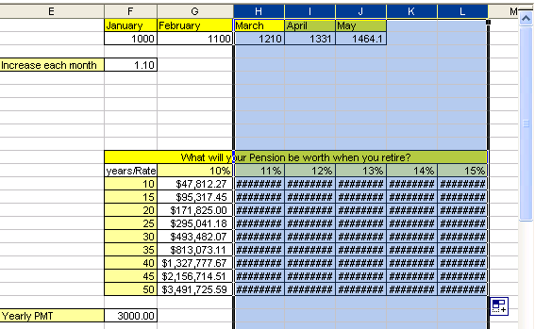

Figure 165
- Our result is that 54 formulas were created by enter just one formula, adding the correct cell references and then copying the formula in two-steps (first down, then over) (Figure 166):
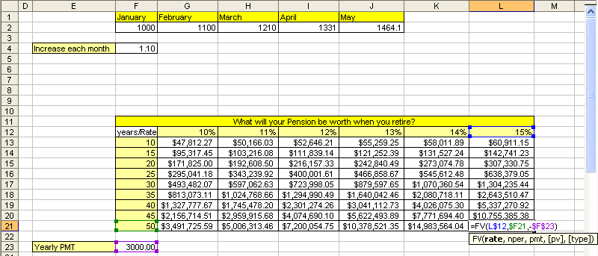

Figure 166
- For more practice with cell references, click on the sheet tab named “Multiplication Table and see if you can create 144 formulas by enter just one formula, adding the correct cell references and then copying the formula in two-steps.

Rule # 14 = Use of relative, absolute and mixed cell references reduces spreadsheet setup time, allows quick updating to setup structure, and will allow us to use many of Excel’s advanced features and tricks

Rule # 15 = When you use the fill handle to copy a formula across the rows and then across the columns, it is a two-step process. First copy it down, then let go of mouse, then copy it over (or visa-versa)

In the last few examples we saw what happens to cell references when we copy a formula that has cell references. Now we need to see what happens when we move a formula that contains cell references. Copy means copy the formula from a cell or range of cells, leave the formula in the original location, and then paste the formula in some other location. Move means cut the formula from a cell or range of cells, it will no longer be located in the original location, and then paste the formula in some other location.

Here are the steps to learn about the difference between copying and moving a formula with cell references.
- Click on the sheet tab named “Copy and Move.” Click in cell B6 and follow the instructions listed in cell B5 (Figure 167):
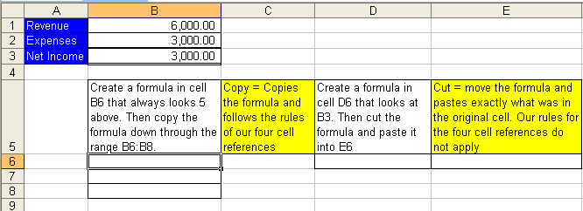

Figure 167

- Figure 168, Figure 169 and Figure 170 illustrate that when you copy a cell reference that has a relative cell reference component, the cell reference changes relatively. In Figure 168 we see a formula that is looking into cell B1. In Figure 170 we see a formula that is looking into cell B3. When we copied the formula, the cell reference moved relatively – it actually did exactly what we told it to do, namely, “always look five above”.
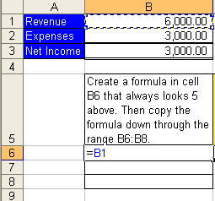

Figure 168
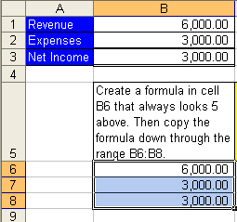

Figure 169
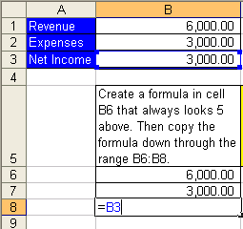

Figure 170
- Now let’s look at what happens when we cut a formula with a relative cell reference and paste it somewhere else.
- Click in cell D6 and create the formula “=B3” (Figure 171):

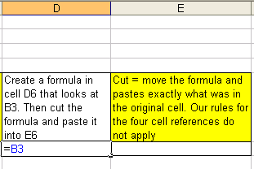

Figure 171
- Hold Ctrl, then tap Enter (Figure 172):

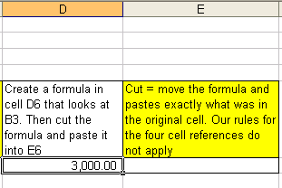

Figure 172
- Ctrl + X (keyboard shortcut for Cut), hit Tab (Figure 173):
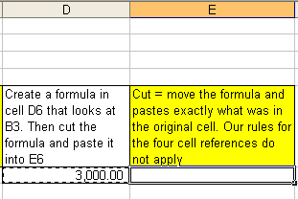

Figure 173
- Ctrl + V (Figure 174):
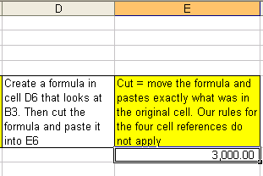

Figure 174
- Hit F2 (Figure 175Figure 174):
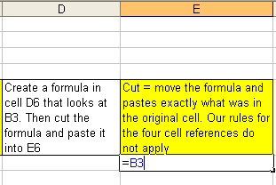

Figure 175
- Compare Figure 171 and Figure 175. When you cut a formula with a relative cell reference component and paste it into a new cell, the formula does not change – it actually moves the cell references exactly as they were in the original cell and pastes them in the new location. This is because when you move, you do not change anything; you simply put the formula, intact, in a new location.

Rule # 16 When you copy a formula that has a relative cell reference component, the relative cell reference changes relatively. When you cut a formula with relative cell references component, the relative cell reference does not change.
- Wow! Knowing the difference between moving and copying formulas is very helpful in our pursuit of efficient spreadsheet construction. Let’s practice copying a formula with relative cell references another time before we move on to the next topic ➔

- Navigate back to the sheet tab named “The Equal Sign” by holding the Ctrl key, and then tapping the Page Up key nine times. You should see this (Figure 176):
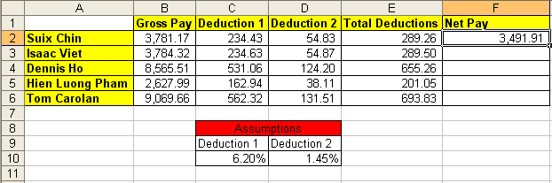

Figure 176
- Click in cell F2. Hit the F2 key (Figure 177). Look at the formula in cell F2. Can you say what type of cell references they are? Can you say what will happen to the formula when you copy it down from F2 to F6? The formula in cell F2, “=B2-E2”, uses relative cell references and so when you copy it down the cell references will move relatively. The formula actually reads: “always look four to the left and subtract one to the left”.
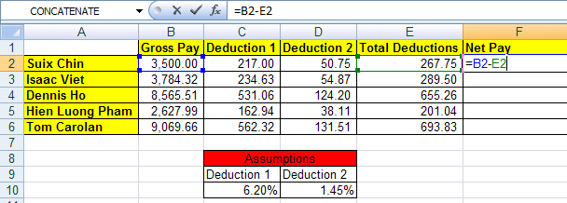

Figure 177
- Hold Ctrl, then tap the Enter key. Point to the fill handle and with your cross hair (angry rabbit) and then double click the fill handle. The double click on the fill handle tells the formula to copy down as long as there is cell content in the cell directly to the left (Figure 178):
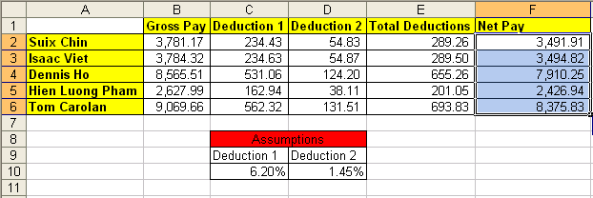

Figure 178
- Click in cell F6 and hit the F2 key (Figure 179). Because the cell references are relative and because we copied the formula, the formula, “=B6-E6”, looks different, but really it is the same formula, namely: “always look four to the left and subtract one to the left”.
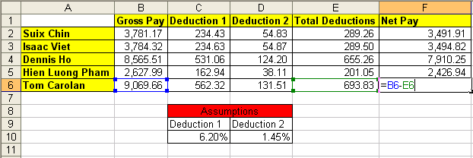

Figure 179
- Look at Figure 179. What is the word “Assumptions” across C8 and D8 mean?
- Click the Esc key to remove the range finder in cell F6. Click in cell C2 and then hit the F2 key (Figure 180). We can see in our formula that Deduction 1 is calculated by taking Suix Chin’s Gross Pay and multiplying it by the tax rate of 6.20%. Because the tax rate of 6.20% can change we have placed it in a cell and had our formula refer to it using a cell reference. We have assumed that our tax rate is 6.20% and thus have placed it into an assumption table. In our next section we will discuss the amazing power of assumption tables: when you should use them, what to put in them, and how to properly orientate them!

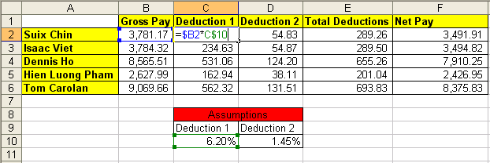

Figure 180

Assumption Tables/Sheets
Our golden rule for assumption tables is: All data that can vary (variable data) goes into a properly orientated assumption table. An example of data that can vary is a tax rate. An example of that data that will not vary is 12 months in a year. Remember: we don’t want to type data that can very into a formula for three reasons:
- It is easier to edit or change our formula later if the variable data it is not typed into the formula (example: tax rate changes)
- It is more polite for the spreadsheet user if the variable data can be seen on the face of the spreadsheet. (For example, even if we were to create a formula with variable data typed into the formula (such as “=$B2*.062”), when we came back tomorrow to use the worksheet, we as the creator might not even remember which formulas have variable data and/or what the variable data is)
- What-if or scenario analysis is significantly easier when an assumption table is used. What-if/scenario analysis is simply when you change the variables to see different formula results.
In addition to the ease with which we can edit or locate variable data, assumption tables that are properly orientated can reduce the number of formula that we will be required to type into our spreadsheet. Proper orientation means the labels in the main table are orientated (horizontally or vertically) in the same way as the labels in the assumption table (horizontally or vertically), and that there is at least one blank row or column between the main table and the assumption table. Also, you can format the assumption table differently to distinguish it from the main table.
In this section about assumption tables we will learn:
- When to use them
- What to put in them
- How it is easier to locate and edit variable data
- How to properly orientate them!
- How to conduct What-if/scenario analysis easily
- How to bask in the amazing power of assumption tables!!
It will help if we work through an example ➔
Here are the steps to learn about assumption tables:
- Navigate to the sheet tab named “Assumptions” (Figure 181). This table will be used to calculate the Net take home pay for a number of employees. Notice that the calculated amounts for Commission on Sales, and Gross Pay have already been calculated. Our goal is to calculate the three payroll deductions (FICA, Medicare, and simplified Federal) and the Net Pay.
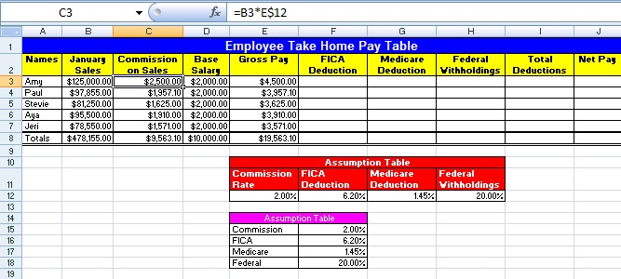

Figure 181
- Click in cell C3 and hit the F2 key. We can see the formula “=B3*E$12” ( Figure 182). Our first question we want to answer is: when do we use an assumption table? We use an assumption table when our formula contains variable data such as a commission rate or tax rate. In cell E3 we are calculating the commission on sales that we pay each employee. Can this commission rate change? You bet!
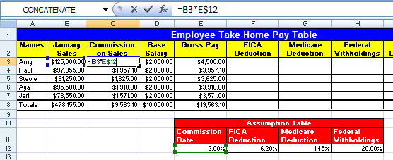

Figure 182
- Hit the Esc key. Click in cell E12. Our second question is: what do we put into an assumption table? We put the variable data that we need for our formulas into an assumption table. In Figure 183 we can see that the commission rate of 1.25%, which we used in our formula, has been placed into an assumption table. This enables easy editing and formula updating later.
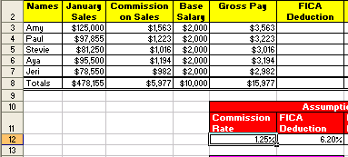

Figure 183
- Now, imagine that the boss just gave everyone a raise from 1.25% commission to 2%! This leads to our third question: How easy is it to locate and edit variable data? Very easy!
- Type 2, then hit Enter (because the cell was preformatted with the percent style, we did not have to type the % symbol). You should see the entire column of “Commission on Sales changes (Figure 184). THAT WAS EASY!! It is easier to change the variable data when it is on the face of the spreadsheet that it is to look for it, hidden underneath, inside a formula! I can already feel that vacation time adding up with all the time I will be saving!
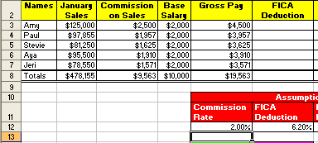

Figure 184
- Click in cell E12 and change the rate back to 1.25%. Our goal is still to calculate the deductions and calculate take home pay
- Click in cell F3 and create the formula for calculating the FICA deduction. But wait! Which assumption table should we use?
- Is the formula “=E3*F$16” (Figure 185) the one to use?
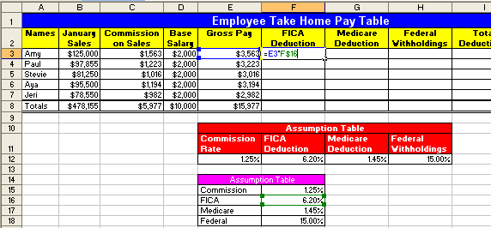

Figure 185
- Or is the formula “=$E3*F$12” the one to use?
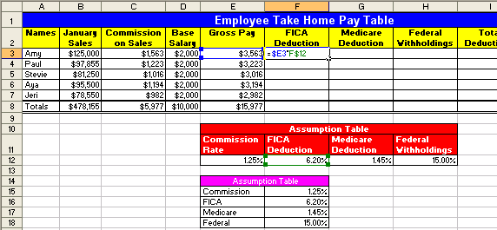

Figure 186
- The answer to which formula to use (which formula is more efficient) leads to the fourth question: what is the proper orientation for our assumption table? If we were to use the formula as seen in Figure 185, “=E3*F$16” we would have to create three separate formulas to make all our deduction calculations. If we were to use the formula as seen in Figure 186, “=$E3*F$12” we would have to create only one formula to make all our deduction calculations. This sort of efficiency is exactly what we are striving for. But why does the formula using the variable data from the assumption table that is orientated horizontally allow us to create only one formula that will work for all our deductions? To see this, let’s try both formula and see which works best.
- You should still have cell F3 highlighted. Create this formula: “=E3*F$16” (Figure 187):
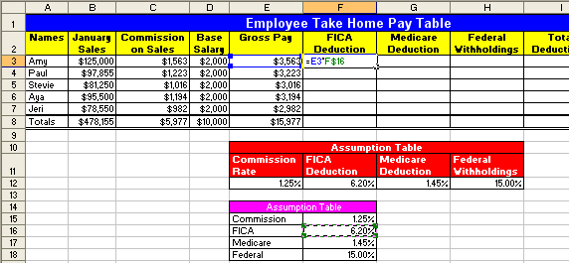

Figure 187
- Hold Ctrl, then tap Enter. Point to the fill handle, and with the Angry Rabbit cursor, copy the formula down through the range F3:F7. Then click in cell F7 and hit the F2 key (Figure 188). You can see that the formula worked when we copied it down.
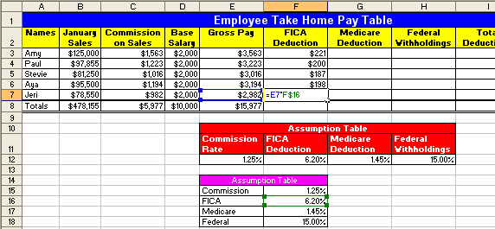

Figure 188
- Hit Esc. Click back into cell F3. Copy the formula to cell G3. Click in cell G3 and hit the F2 key to show the Range Finder. In Figure 189 we can see that the range finder shows that the cell reference for our tax rate moved and is now looking into the cell G16. Because the orientation of the assumption table is vertical (the labels for FICA, Medicare and Federal are located one on top of the other) and the orientation of our main table is horizontal, we would have to create three individual formulas in the cells F3, G3 and H3. Notice that in Figure 189 that the range finder moved to the right when we copied our formula to the right. This indicates that if we had used the horizontally orientated assumption table that formula would have calculated correctly ➔
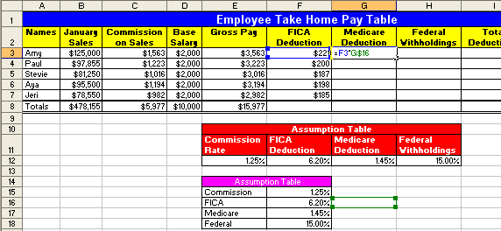

Figure 189
- Click Esc. Then Hold Ctrl, and tap the Z key three times (undo). Then create the formula “=$E3*F$12” in cell F3 (Figure 190):
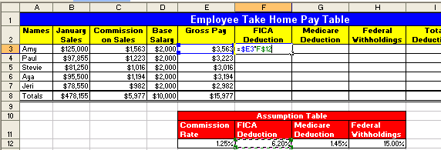

Figure 190
- Hold Ctrl, tap Enter. Ctrl + C (to copy formula). Hold Shift, then tap the Down Arrow key 4 times and the Right arrow key 2 times (highlights the range). Ctrl + V (pastes formula). Click in cell H7 and hit the F2 key. In Figure 191 we can see that because we orientated our assumption table correctly, it worked like MAGIC! We created the sea of formulas in the range F3:H7, 15 formulas, but we only had to type in one formula! This sort of efficiency is our goal!
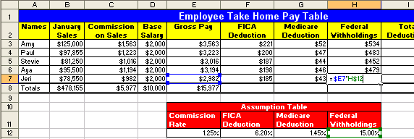

Figure 191
- Hit Esc. Highlight the range F3:I8 (Figure 192):
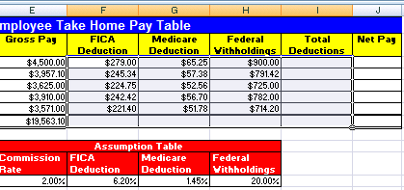

Figure 192
- Hold Alt, and then tap the Equal sign key “=” (Alt + = is keyboard shortcut for AutoSum). As you can see in Figure 193, by highlighting a range of values and one blank row below and to the right, the Auto Sum feature knew what to add up. It doesn’t always add up the correct amount, so let’s check to be sure. After selecting cells with the AutoSum and verifying, the last cell we will check is cell I8 (Figure 193):
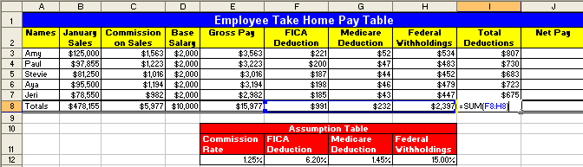

Figure 193
- Highlight the range J3:J8 (Figure 194). Notice that when you highlight a range that one of the cells is white and the rest are a light steel-blue color. The white cell is waiting for you to put a formula into it. If you put a formula into cell J3 and then hold Ctrl and tap Enter, you formula will go into all the cells highlighted ➔
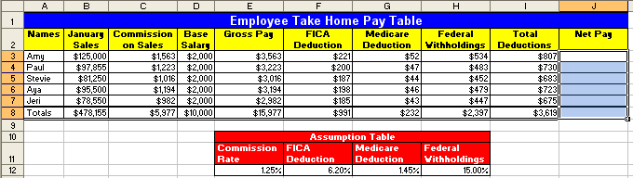

Figure 194
- Create the formula that will always take the value “five to the left and then subtract one to the left in cell J3. Type ‘=”, tap the left arrow key five times, Type “-“, tap the Arrow key once. You should see this (Figure 195):
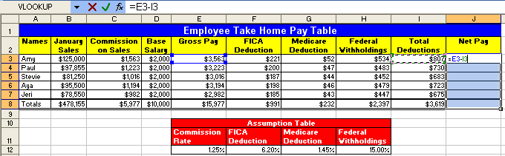

Figure 195
- Hold Ctrl, and then tap Enter. We see here that if you have a range highlighted and you place a formula into the white cell, when you hold Ctrl and tap Enter, the formula is placed into all the cells that are highlighted! You should see this (Figure 196):
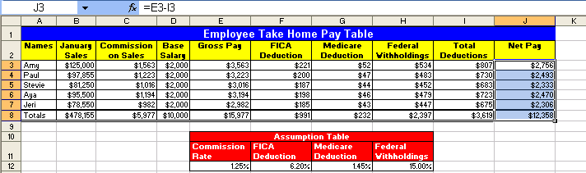

Figure 196
- Our fifth question is: How easy is what-if/scenario analysis when we use assumption tables?
- Click in cell E12 and change the Commission rate to 2%. Click in cell H12 and change the simplified Federal Withholding rate to 20%. Can you see how easy it is to say: “What if I changed this; what would happen to our calculations and our results?” (Figure 197):
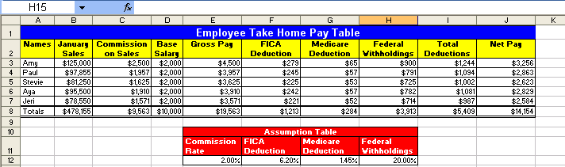

Figure 197
- Our final question about assumption tables is how can we bask in the amazing power of assumption tables?
- Imagine your boss comes in and says: “we just added a new 2% deduction can you update our calculating table?” You look over your shoulder and say: “Oh you mean like this?!!” And with blistering speed you complete these steps ➔
- Click in any cell in column H, Tap Alt, then tap I and then tap C (Alt + I + C is the keyboard shortcut for Insert Column) (Figure 198):
New column was inserted
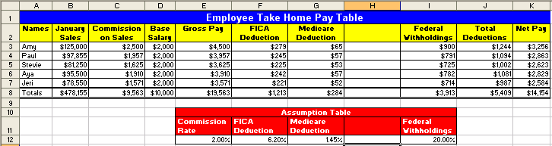

Figure 198: Alt + I + C is the keyboard shortcut for inserting a column
- Click in cell H11 and type Pension. Hit Enter, then type 2% (Figure 199):
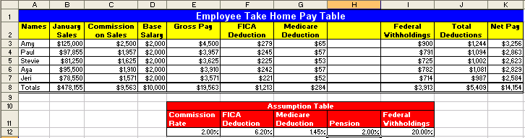

Figure 199
- Highlight the range G2:G8 and point to the fill handle in the lower right-corner. When you see your Angry Rabbit, click and drag one column to the right. You are done! 10 clicks and you have completely updated the table and you have amazed your boss (who then promptly gives you a promotion)! (Figure 200):
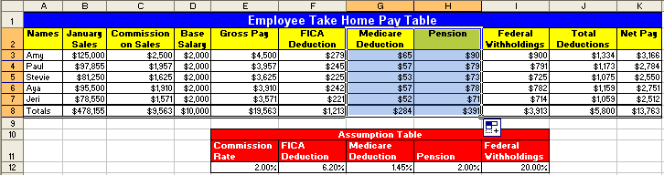

Figure 200
- In Figure 200 we can see that the deduction formulas updated because we used a properly orientated assumption table and mixed cell references; we can see that the SUM function for totals in row 8 updated because they were always looking to add the five above; and we can see that the totals for Total Deduction updated when we inserted a column because it utilized a range in its arguments! Wow, now we can have extra vacation time and bask in the amazing promotion we received – all because of efficient use of assumption tables, mixed cell references and range functions!

Rule #17: All data that can vary goes into a properly orientated assumption table that is at least one blank row/column away from the main table (it can also be placed on an entirely separate sheet). An example of data that can vary is a tax rate. An example of that data that will not vary is 12 months in a year. Although a properly orientated assumption table is not always possible, the idea is to have the labels in the table orientated (horizontally or vertically) in the same way as the assumption table If we do this, editing formulas, what-if analysis and formula creation is dramatically more efficient than if we do not utilize assumption tables.

Rule #18: Properly orientated assumption tables allow for mixed cell use and results in reduced time creating formulas
- Highlight the range K3:K8. To Increase the decimals, click on the Increase Decimal icon in the Number Group on the Home Ribbon, or use the key board shortcut Alt + H + 0 twice. (Figure 201). Notice that the total Net Pay is $13,762.64.
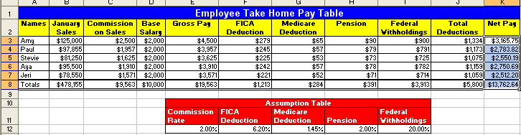

Figure 201
- Click in cell K8 and then hit the F2 key (Figure 202). There is no way that $19,563 - $5,800 = $13,762.64. What is going on here? This is one of the most common mistakes that people make in Excel. It is our job as Soon-To-Be Excel Efficiency Experts (EEE), to know that this is caused by formatting. What we often see in Excel is not actually what sits in the cell. We must investigate further….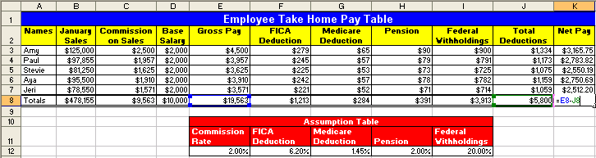

Figure 202
- To prove to ourselves that what is in the cell is different than what we are seeing on the surface of the spreadsheet, highlight the range B3:K8 and increase the decimals so that we see the decimals to the penny (Figure 203). We can see that what was really in the cell was numbers with more decimal places than we were allowed to see!
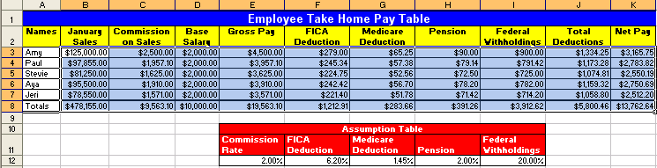

Figure 203
- As you learn to work with Excel you must be vigilant in the endeavor to always match the proper formatting with what actually sits in the cell. This leads us to our next section about formatting.

Cell Formatting
We format cells with color, number formats (such as currency), borders and other format so that we can better articulate the message of our spreadsheet or printout of the spreadsheet. For example in Figure 204 we can see that formatting can help to communicate important information:
- The percentage format helps to communicate the number of parts for every 100 parts
- The accounting (similar to currency) format indicates that the Revenues, Expenses and Net Income are in USA dollars
- The double line under the Net Income communicates that this is the “bottom line”.
- The color helps to communicate that there are labels indicating what the numbers mean
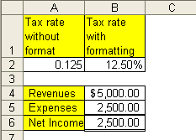

Figure 204
Here are the steps to learn how to apply cell formatting
- Navigate to the sheet named “Formatting (2)”. Click in cell E2. Hold Ctrl, then tap the “*” key on the number pad (this selects the table) (Figure 205):
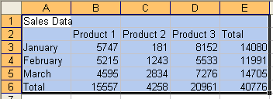

Figure 205
- Click the drop-down arrow to the right of the Border icon button in the Font Group on the Home Ribbon. Then select the “All Borders icon from the drop-down list (Figure 206):
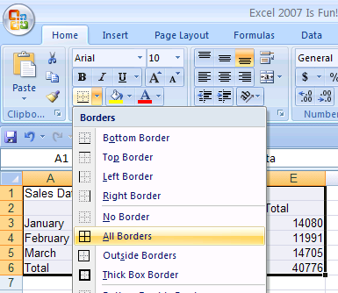

Figure 206
- Highlight the range A1:E1. Hold Ctrl key and tap “1” key (use the “1” below the F1 key not the “1” on the number pad). Ctrl + 1 opens the Format Cells dialog box (you could also right-click the highlighted range and point to Format Cells) Once you have the Format cells dialog box open click on the Alignment tab. See (Figure 207):
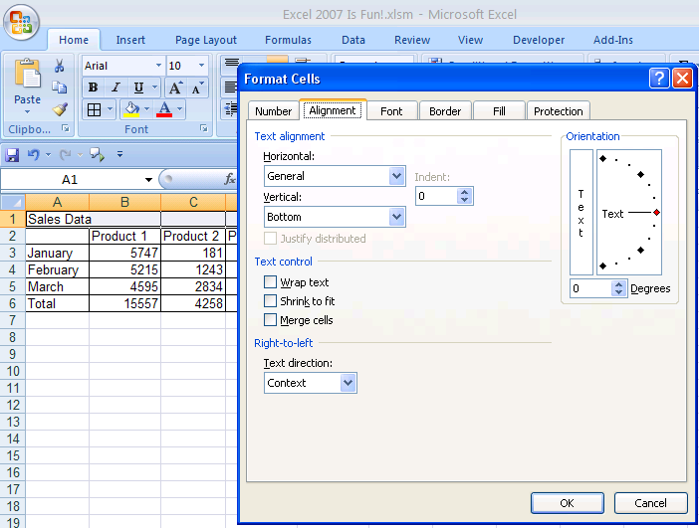

Figure 207

- With the Alignment tab selected, click the down arrow under Horizontal and select “Center Across Selection” (Figure 208):
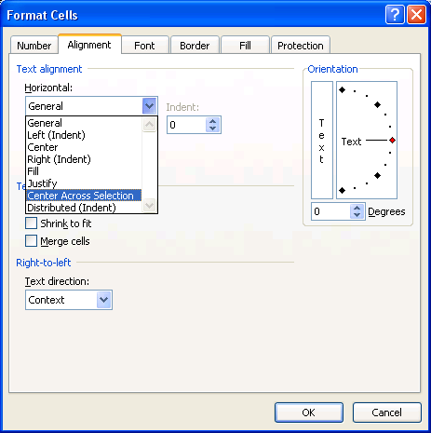

Figure 208
- We chose “Center Across Selection” instead of the more widely used “Merge and Center”. “Center Across Selection” allows move universal structural changes such as inserting columns/rows and moving, whereas the “Merge and Center” sometimes will disallow such actions.
- Click the Font tab. Select “Poor Richard” font (or some other font), Bold style, Size = 14, Color (of font) = White (Figure 209):
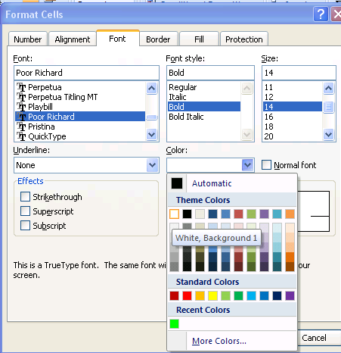

Figure 209
- Click on the Patterns tab and select a dark blue (Figure 210):
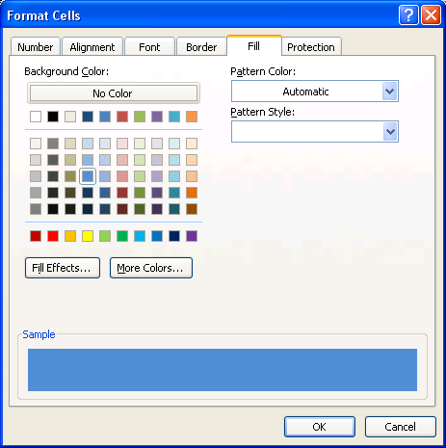

Figure 210
- Click OK (Figure 211):
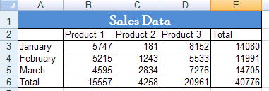

Figure 211
- Highlight the rangeB2:E2, Hold Ctrl, Highlight A3:A6 (By holding the Ctrl key you can select cells that are non-adjacent. Click the Fill color button in the Font Group on the Home Ribbon (Figure 212):
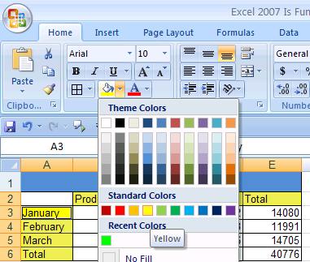

Figure 212
- Highlight the range B3:E6 (Figure 213)
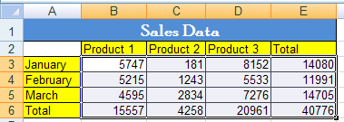

Figure 213
- Hold Ctrl and tap 1. Point to the Number tab. Select Accounting with no dollar sign, click OK (Figure 214):
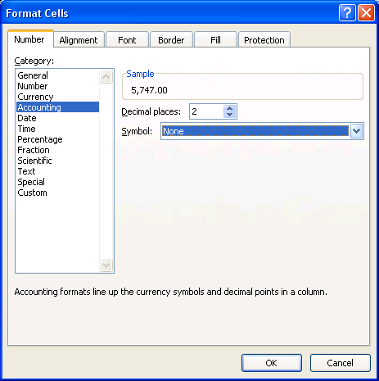

Figure 214
- Highlight A6:E6, Ctrl + 1, click the Borders tab. In the Line/Styles box, click the medium thick line (second column, fifth down) (Figure 215):
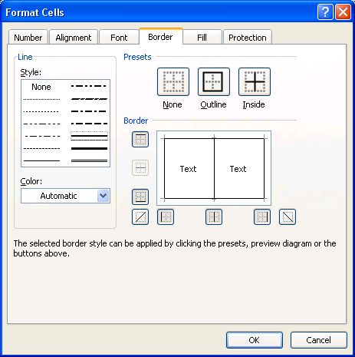

Figure 215
- Click the down arrow under color and select a color (Figure 216):
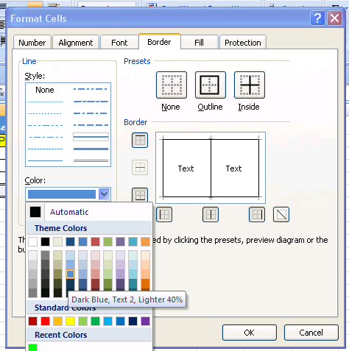

Figure 216
- Click the top line in the Border area (“Preview Diagram” area) (Figure 217): 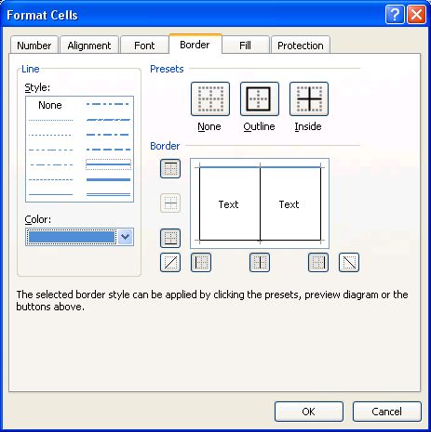

Figure 217
- The most important point that you must memorize to get this tab to work is this: ORDER MATTERS – you must click Line/Style FIRST, Color SECOND, and then draw your line in the Border area THIRD!
- Now, use the method just discussed to add a Dark Blue Double line to the bottom border of our highlighted range (Figure 218):
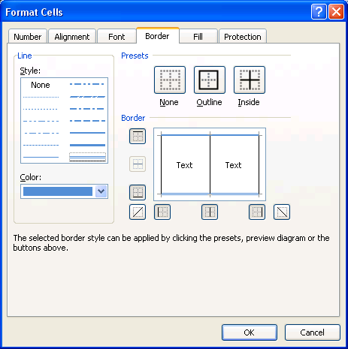

Figure 218

- Click OK, You should see (Figure 219):
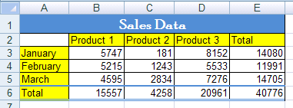

Figure 219
- Now that we have seen how to apply formatting, we need to look at how formatting can sometimes trick us. If we are to become efficient with Excel we need to be able to match the proper formatting with what actually sits in the cell!

Cell Number Formatting is the façade that sits on top of data and formulas. What you see is not always what sits in the cell. For example:
- If you see 3.00%, Excel more than likely sees 0.03
- If you see $56.70, Excel may see 56.695
- If you see 07/26/2005, Excel more than likely sees 38559
- If you see 9:30 AM, Excel more than likely sees 0.395833333333333
Let’s look at an example ➔
Here are the steps to learn how to distinguish between Number Formatting and actual cell content!!!!
- Navigate to the sheet named “Formatting (3)”. You should see what is in (Figure 220). Read the labels in column A and type in the number in column B. Column C tells you what is actually in the cell. The key strokes for typing the numbers in are as follows:
    - B2 ➔ 1, 3, :, 3, 9, Ctrl + Enter (that is to say: Type the number one, the number three, a colon, the number three, the number nine, and then hold Ctrl and then tap Enter)
      - Each time you hit Ctrl + Enter, look at what you see in the cell and compare that to what you see in the formula bar
    - B3 ➔ 1, 0, /, 2, 5, /, 2, 0, 0, 5, Ctrl + Enter
    - B4 ➔ 1, 0, Ctrl + Enter (Notice that you did not have to type in the dollar sign – the cell is preformatted)
    - B5 ➔ 1, 0, Ctrl + Enter
    - B6 ➔ 3, Ctrl + Enter
    - B7 ➔ 768, Ctrl + Enter
    - B8 ➔ 768, Ctrl + Enter
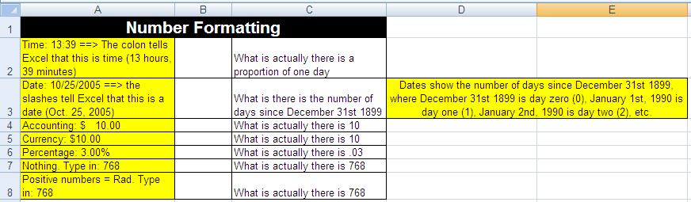

Figure 220
- When you are done you should see this (Figure 221):
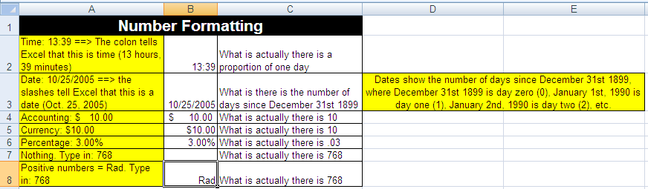

Figure 221: Notice that although we see the word “Rad”, the formula bar shows us that the number 768 actually sits in the cell.
- The keyboard shortcut to see the worksheet in “formula view” is Ctrl + ~ (The ~ key is to the left of the “1” key and above the Tab key). Formula view shows you what is actually in the cells, whether it is data, formulas. Hold Ctrl and tap ~ key (Figure 222):
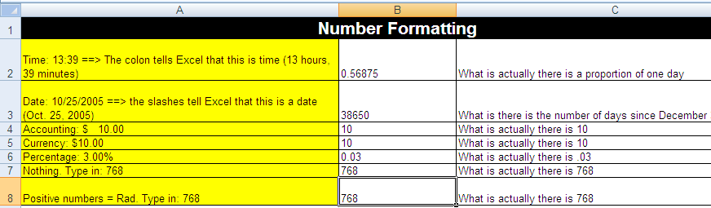

Figure 222
- What you see in Figure 221 is the façade. What you see in Figure 222 is what actually is in the cells. In addition, what is actually there in the cell is what Excel will use for any formulas (whether calculating, text or other formulas).
- Ctrl + ~ to remove formula view (Ctrl + ~ is a toggle that switches between Formula view and Normal view). Then click on each cell in column B and using the Format Cells dialog box look at what Number format each cell is using
For Example in Figure 223 you can see that B2 has a time format
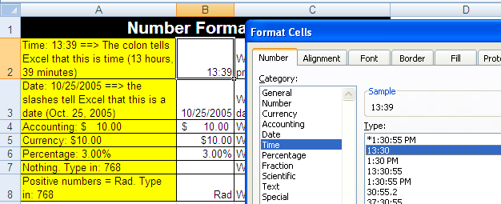

Figure 223
    - In Figure 224 you can see the custom format (Custom formatting is not a topic that is book addresses):
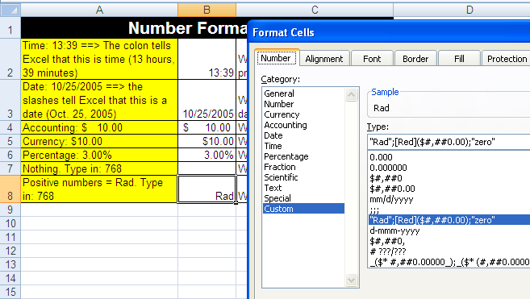

Figure 224
Rule #19: Cell Formatting is the façade that sits on top of data and formulas. What you see is not always what sits in the cell.

The next page reminds you that there are six tabs in the Formatting Cells dialog box. Two pages ahead we have an example of the formatting façade getting in the way of accurate calculations!

Make a note that there are six tabs in the Format Cells dialog box as seen below (Figure 225):
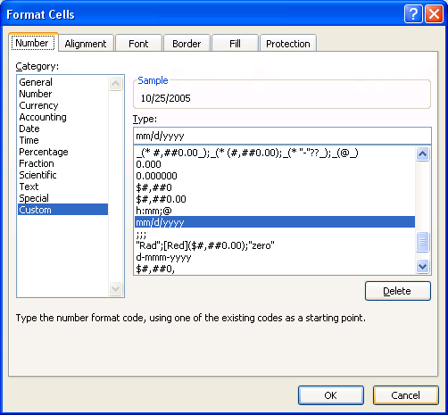
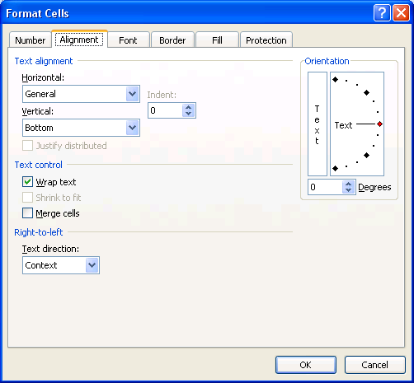
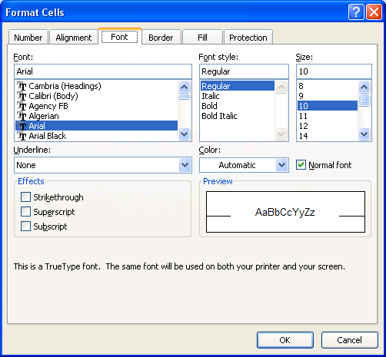
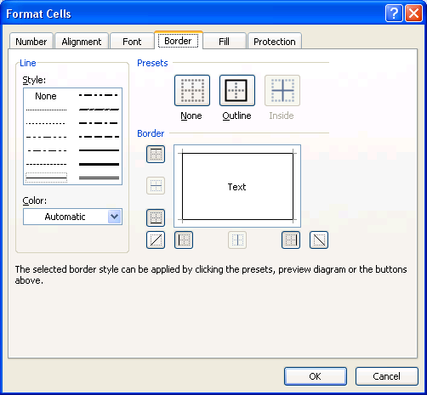
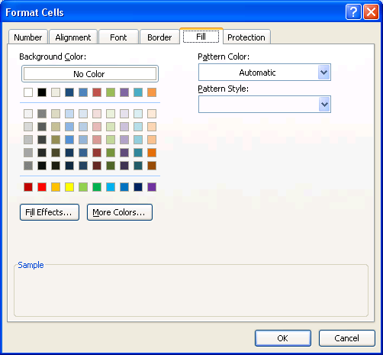
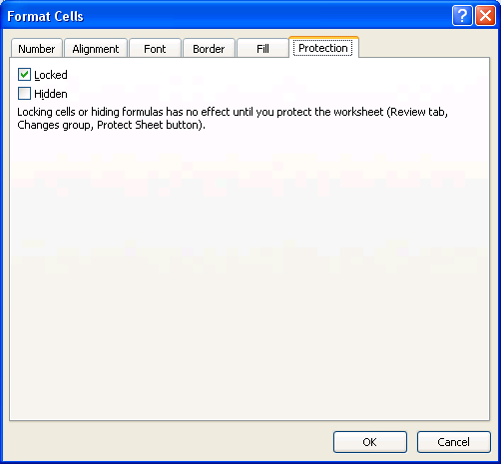

Figure 225

Here are the steps to learn how to use the ROUND Function in Excel to insure accurate payroll calculations when rounding to the penny is required
- Navigate to the sheet named “Round for Deduction”. Before you make any calculations on this sheet, follow the calculations in step 2 and make the deduction calculations by hand with a pencil.
- How to use a formula to calculate a tax deduction
  - Figure 226 shows the Taxable earnings and short description of how to calculate a deduction. Use Figure 227 to make a calculation by hand using a pencil, an eraser and the rules of rounding to a penny!
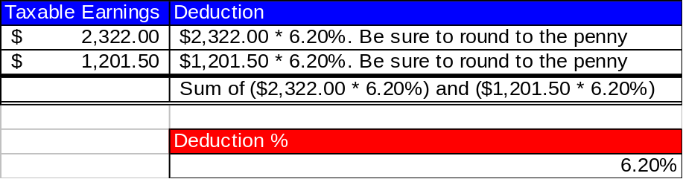

Figure 226
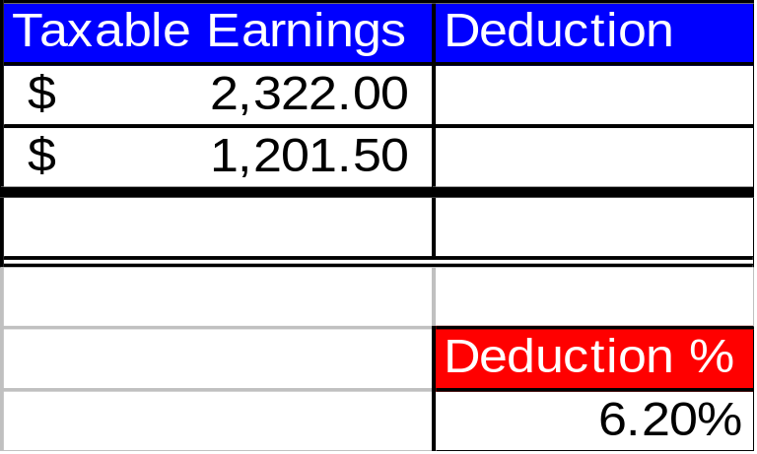

Figure 227
- Now we can try it in Excel
- How to use a formula to calculate a tax deduction
  - Before we create a formula to calculate the deduction, let’s look at the Accounting Number format already applied in the cell range B2:B4. Highlight the range and hold the Ctrl key, then tap the 1 key. You will see the Format Cells dialog box (Figure 228):
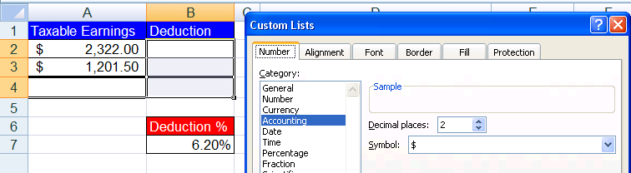

Figure 228
  - To begin a formula, type the equal sign (Figure 229):
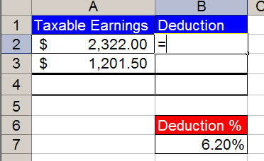

Figure 229
  - With the thick white cross cursor, click on cell A2 (The cell reference A2 will appear in the formula) (Figure 230):
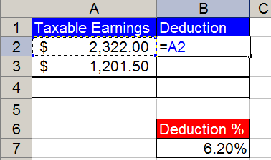

Figure 230
  - Type the multiplication symbol (Figure 231):
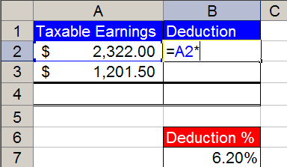

Figure 231
  - Click on the cell with the deduction % as seen below (Figure 232):
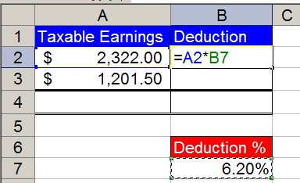

Figure 232
  - Click the F4 key twice to lock the percent (Figure 233):
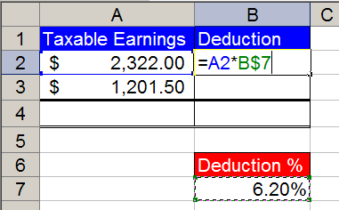

Figure 233
  - Hold the Ctrl key, then tap the Enter key to place the formula in the cell (Notice that you can still see the formula in the formula bar (Figure 234):
Name Box
Formula Bar
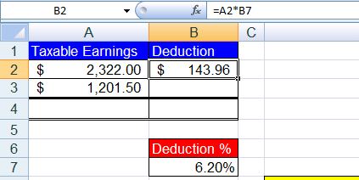

Figure 234
  - Point to the fill handle (Little black box in lower right corner of highlighted cell) (Figure 235):
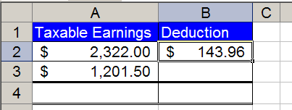
Fill Handle

Figure 235
  - With fill handle selected, copy formula from B2 to B3 (Figure 236):
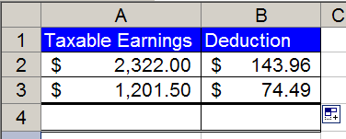

Figure 236
  - In cell B4 add a SUM function by holding the Alt key and tapping the equal sign. Verify that the SUM function selected the correct cells (Figure 237):
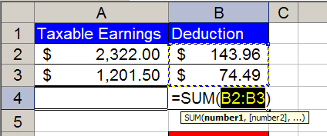

Figure 237
  - Hold Ctrl and tap Enter (Figure 238):
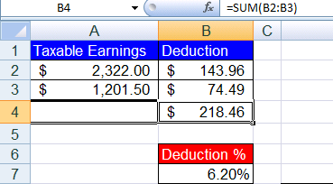

Figure 238
  - Go down to the area with the yellow instructions and verify that you entered the correct formula to calculate your payroll deductions. In cells E9 and E10 type what you see in cells B2 and B3, respectively (DO NOT USE CELL REFERENCES). Create a SUM function in cell E11 that adds the two cells above. (Figure 239):
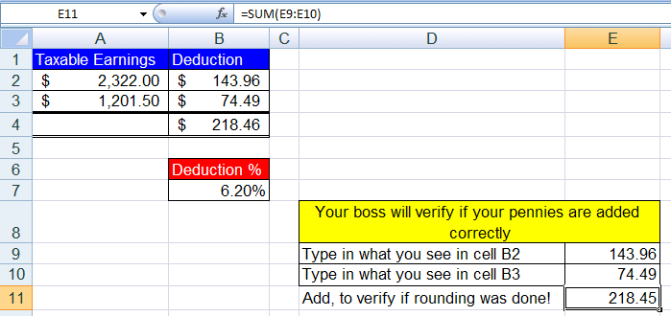

Figure 239
  - Question: What is the problem here???!!?
  - Answer: Excel did its part perfectly, but we did not! We forgot to make sure that the formatting and the calculating formulas are doing the same thing! To see how these are different, select the cell range B2:B4 and increase the decimals to three places. The Accounting Number format was only allowing us to see two decimals, but what was actually in the cells was more than just two decimals. You should see this after you increased the decimals to three places (Figure 240):
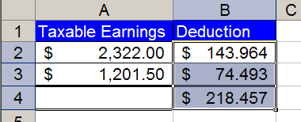

Figure 240
  - What has happened here? The formulas underneath have calculated without rounding, but the formatting on top has made it appear as if it has been rounded. The SUM function does not look at formatted numbers, but instead looks at the unrounded numbers.
  - The solution is to make the format and the calculated numbers exactly the same by using the ROUND function.
  - Decrease the decimals to two places to restore the format to its original state. You should see this (Figure 241):

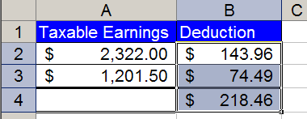

Figure 241
  - Add a ROUND function to our formula by clicking in cell B2. To edit the formula click the F2 keyboard button. You will see this (Figure 242):
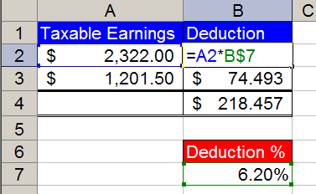

Figure 242
  - With your cursor point in between the equal sign and the letter “A” and click to insert your cursor into the formula. Then type the letters and characters “ROUND(“ as seen here (Figure 243):
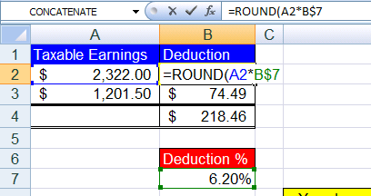

Figure 243
  - Then point your cursor to the formula bar and click at the end of the formula as seen here (Figure 244):
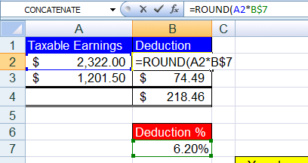

Figure 244
  - Type the characters and numbers: “,2)” as seen here (Figure 245):
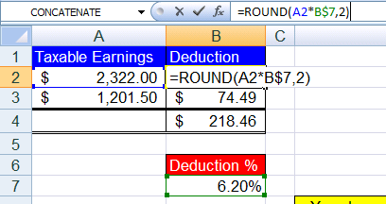

Figure 245
  - Hold the Ctrl key and then tap the Enter key. Then copy the formula to cell B3. Now you are done and you should see this (Figure 246):
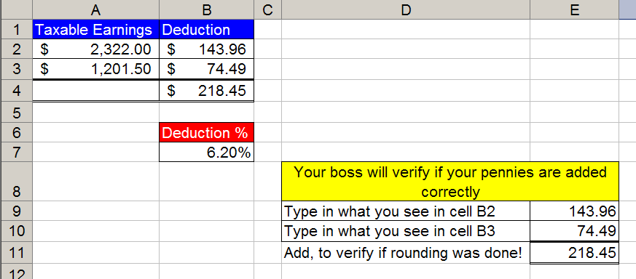

Figure 246
- Conclusions: because formatting (such as currency) is like a façade that sits on top of the number, when you have a formula that has the potential to yield more decimal places than the format displays, use the ROUND function.
  - For a payroll calculation that must be rounded to the penny, instead of =A2*B$7, use =ROUND(A2*B$7,2); where the second argument “2” means round to the second decimal.
2 means round to the penny (Payroll)
0 means round to the dollar (Income Taxes)
-3 means round to the thousands position. (Financial Statements)

Rule #20: Because formatting (such as currency) is like a façade that sits on top of the number, when you have a formula that has the potential to yield more decimal places than the format displays, use the ROUND function.

Next we will look at how to work with Date formatting.
With Date number format, dates show the number of days since December 31st 1899, where December 31st 1899 is day zero (0), January 1st, 1990 is day one (1), January 2nd, 1990 is day two (2), etc. For example: January 1, 1900 is represented by the serial number 1; January 2, 1900 is represented by the serial number 2; and April 23, 2006 is represented by the serial number 38,830.

Here are the steps to learn how to understand the Date number format and to make date calculations (Excel date math)
- Navigate to the sheet named “Date Math”. You should see this (Figure 247):
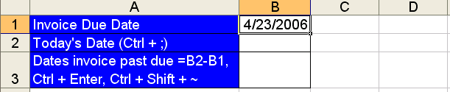

Figure 247
- Hold Ctrl and tap on the ~ key (this reveals what is actually in the cell; this is called formula view). You should see what is in Figure 248. Understanding the Date format requires that you know that when you type “4/23/2006” (Figure 247), Excel sees 38830 (Figure 248). The “4/23/2006” is the façade that we see. The 38830 is the serial number that Excel sees. This serial number is very useful for making date calculations…
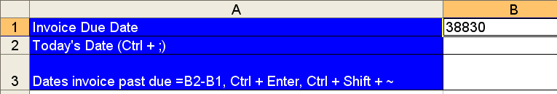

Figure 248
- Hold Ctrl and tap on the ~ key to remove formula view
- Select cell B2, Hold Ctrl and tap ; (semi colon) to put Today’s date in the cell (Figure 249). (Don’t worry if your day is different).
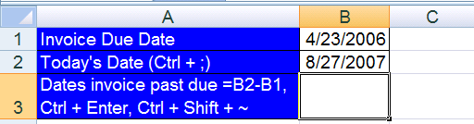

Figure 249
- Select cell B3, enter the formula “=B2-B1”, then hold Ctrl and tap Enter (Figure 250):
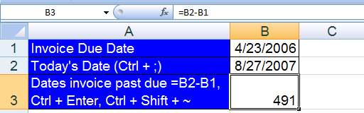
Figure 250
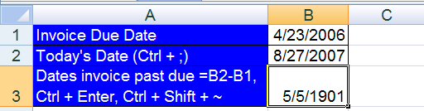

Figure 251
- If you see the formula result of 491 days (Figure 250), everything is working fine and accurate.
- But if you see a formula result that is date formatted (Figure 251) You must be asking yourself What is going on here? Why is there a date in our cell instead of the number of days the invoice is past due? The answer is this: When you create a formula sometimes it brings the format from the cells that you have referenced to the cell you are creating a formula within.
- To bring the format back to the “General format, Hold Ctrl and Shift and tap ~ (Figure 252):

Figure 252
- Figure 252 reveals the beauty of the serial numbers that lie behind every date: it is easy to do date math! Whether you are calculating an overdue invoice, your own age, or an estimate of the number of days to complete a job, date math is amazing!
- One final note about Date format: Click in cell D1 and type the number 38830, then hold Ctrl and tap Enter (Figure 253):
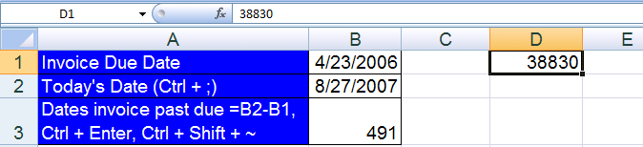

Figure 253
- Hold Ctrl and tap 1, click on the Number tab, click on Date (Figure 254):
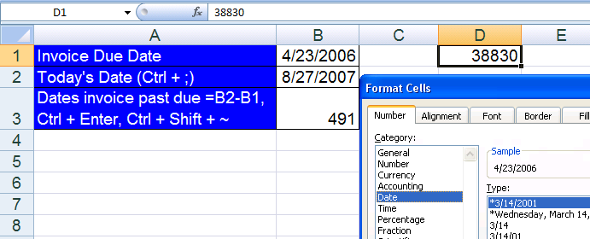

Figure 254
- Click OK. Figure 255 illustrates directly that the number 38830 has a façade on top of it for us Excel users to see. In this way, we understand that it is a date when we see it, but hidden underneath, Excel sees the serial number so it can make date calculations!
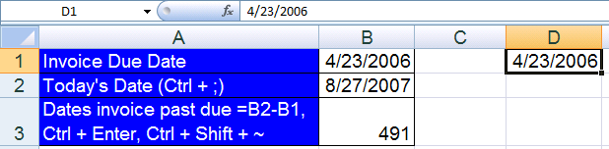

Figure 255
- For everyday Excel use, you can enter dates such as 4/23/2006, by typing the numbers and forward slashes – Excel automatically enters the serial number behind the scenes.

Rule #21: With Date number format, Excel sees the number of days since December 31st 1899 (or January 1, 1900 (inclusive)). This allows us to make date math calculations.

Now that we have studied the Date number format façade and how to use it, we can look at the Time number format façade and how to use it.

With Time number format, Excel sees the proportion of one 24 hour day. For example: 8:00AM is represented by the decimal number (also known as serial number or time value) 0.333333333333333; 6:21AM is represented by the decimal number .264583333333333; and 5:15:15 PM is represented by the decimal number .718923611111111.

Here are the steps to learn how to understand the Time number format and how to make time calculations (Excel time math)
- Navigate to the sheet named “Time Formatting (1)”. You should see this (Figure 256):
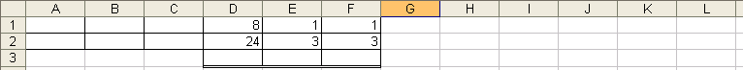

Figure 256
- When entering times into Excl, you can use the following conventions (Figure 257):
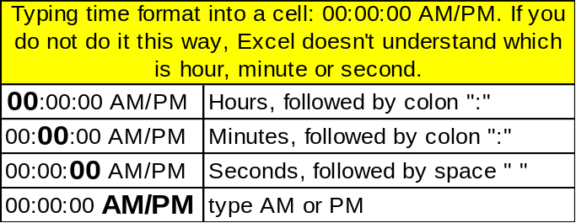

Figure 257
- Click in cell A1 and type: 8, :, 0, 0, (space), A, M (said another way: type 8:00 AM). Click in cell B1 and type 6:21 AM. Click in cell C1 and type 5:15:15 PM (Figure 258).
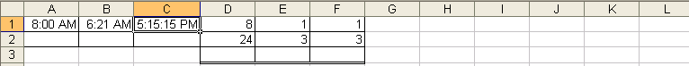

Figure 258
- Hold Ctrl and then tap ~ to see what Excel sees (Figure 259):
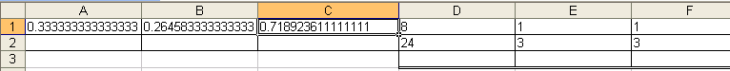

Figure 259
- In Figure 259, notice that the decimal number that represents 5:15:15 PM is greater than the decimal value that represents 8:00 AM. This insight will allow us to subtract the earlier time from the later time and get the proportion of one day that has elapsed between the two times.
- Hold Ctrl and then tap ~ to return to our normal view. In order to see that 8 hours does represent .333 or 1/3 of a 24 hour day, click in cell D3 and type the formula “two cells above divided by one cell above” (Figure 260):
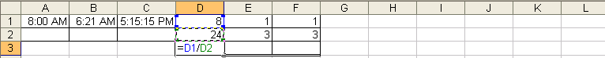

Figure 260
- Hold Ctrl and then tap enter. Point to the fill handle and drag the formula from cell D3 through F3 (Figure 261):
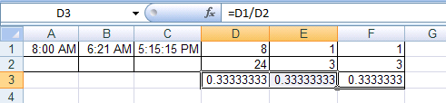

Figure 261
- Highlight the cells D3:E3, hold Ctrl and then tap 1, click on the number tab, click on the Time category (Figure 262):
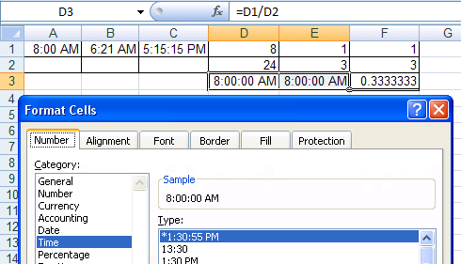

Figure 262
- Click OK. In Figure 263, we can see that 8/24 or 1/3 is .333333333333333, but when we apply a Time format, the Excel user sees 8:00 AM.
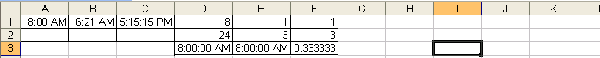

Figure 263
- As an extra bonus, click in cell F3 and apply the Fraction format. After you apply this format you should see this (Figure 264):
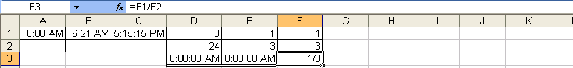

Figure 264
- With our new understanding of the Time format, we would like to make some time calculations in Excel.
- Navigate to the sheet tab named “Time Formatting (2)” You should see this (Figure 265):
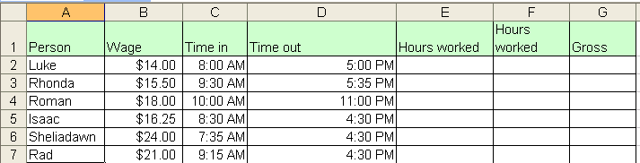

Figure 265
- We would like to use Excel to keep track of employees work hours and gross pay. Click in cell E2 and subtract the earlier time from the later time (“one to my left minus two to my left”) (Figure 266):
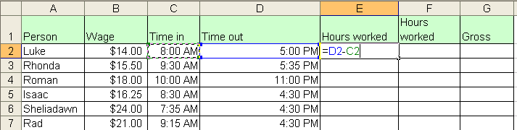

Figure 266
- Hold Ctrl and then tap Enter (Figure 267). We see is Figure 267 that the Time format has carried forward into our cell with the formula.
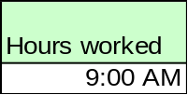

Figure 267
- Hold Ctrl and Shift and tap ~. In(Figure 268). we see the proportion of the day that Luke has worked.
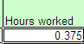

Figure 268
- Hold Ctrl and tap 1, select the Number tab, click on the Time category, click on the second time type in the list (Figure 269):
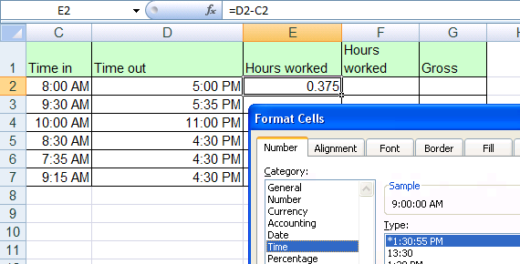

Figure 269
- Click in G2 and type the formula as seen in Figure 270:
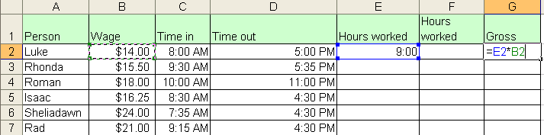

Figure 270
- Hold Ctrl and tap Enter. What is wrong with Figure 271? Nothing! If WE were trying to multiply 9 hours times $14.00, we did not accomplish this. We made the wrong calculation. Excel did not make the wrong calculation. The resultant answer, 5.25, is exactly what we asked Excel to calculate, namely: 0.375*14.
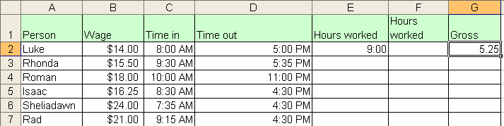

Figure 271
- Delete the contents of cell G2. In cell F2 type the formula “=(D2-C2)*24” (Figure 272). Notice that we had to know our order of operations (the subtraction is in parenthesis) and we had to know that 24 is a number that will not vary (thus it is OK to type into our formula).
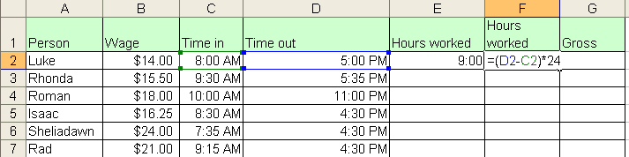

Figure 272
- Hit Tab. Type the formula “one to my left times four to my left” in cell G2, and then hold Ctrl and tap Enter. Then Hold Ctrl and Shift and tap the $ key (this is the keyboard shortcut for the Currency format). You should see this (Figure 273):
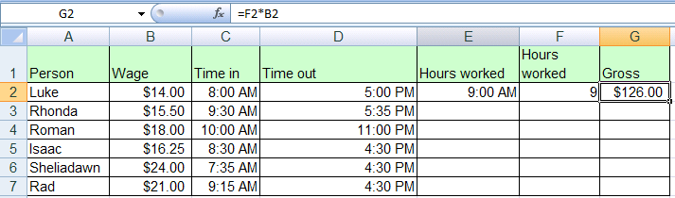

Figure 273
- Highlight the range E2:G2, point to the fill handle and with your angry rabbit, double click the fill handle to copy the formulas down (Figure 274):
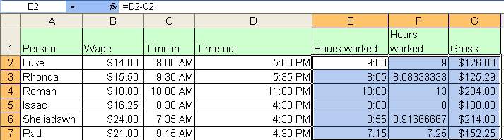

Figure 274
- With our knowledge of the Time format, order of operations and non-varying numbers, we have created formulas that we can use for timesheet calculations.

Rule #22: With Time number format, Excel sees the proportion of one 24 hour day. This allows us to make time math calculations.

Next we will turn our attention to Excel’s Charting capabilities.
Charts
Charts and graphs are a means to visually articulation numerical data. There are times when a picture (chart or graph) tells a thousand words. Charts and graphs can deliver a message in a more immediate way. Although a chart or graph lacks the detail of all the numbers, it quickly articulates its message in an effective way.

Navigate to the sheet tab named “Charts (1)”.

In Excel, after highlighting your numerical data and labels, you can initiate chart creation from the Chart Group on the Insert Ribbon. (Figure 275):
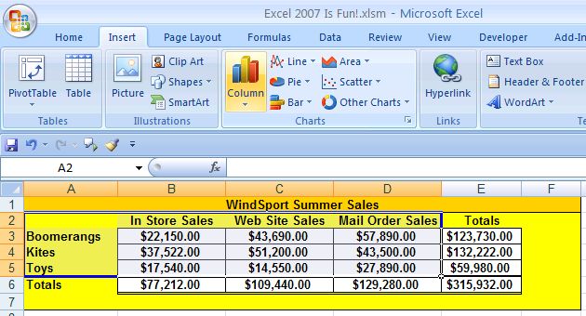

Figure 275
After you initially create your Chart from the Chart Group on the Insert Ribbon, you can use the three Context-Sensitive Ribbons for Charts or you can right-click the different elements of the Chart. (Figure 276):
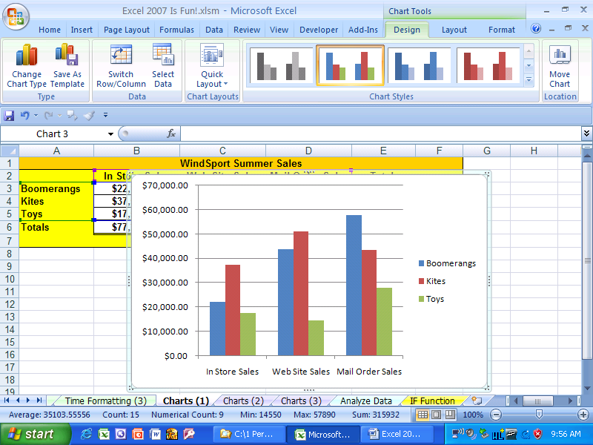

Figure 276
In Figure 276 we can see a “Column” chart type. However, there are many charts to choose from and choosing the correct one can sometimes be tricky. We will look at two chart types: Pie chart and a Column chart with multiple series data. If you would like to learn about more of the built in chart types, Click F1 (Microsoft Help) and type “Available chart types”. There is an article that gives an excellent example of each chart type.

Here are the steps for creating a Pie chart
- Navigate to the sheet named “Charts (1)”. You should see this (Figure 277):
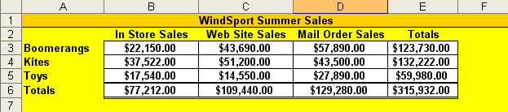

Figure 277
- In Figure 277 we can see that WindSports Sales are broken apart into categories. Vertically, in Column A, we can see that WindSport has categorized the sales according to the products that they sell: boomerangs, kites and toys. Horizontally, in Row 2, we can see that WindSport has categorized the sales according to the sales channels that they use for selling: In Store, Web Site and Mail Order. In addition, they have listed totals for each category and an overall total in the lower-right corner.
- For our first Chart we would like to show how each product total contributes to the overall total. This means that we are comparing three “parts” (boomerangs, kites, toys) to the overall total to see what proportion or percentage that each contributes to the whole. Anytime you have this situation (comparing parts to the overall total), a Pie chart type is an excellent choice.
- Highlight the range A3:A5, Hold Ctrl, Select the range E3:E5 (you are selecting two ranges of cells that are not adjacent to each other), and then point to the Pie chart icon button in the Charts Group on the Insert Ribbon (Figure 278).
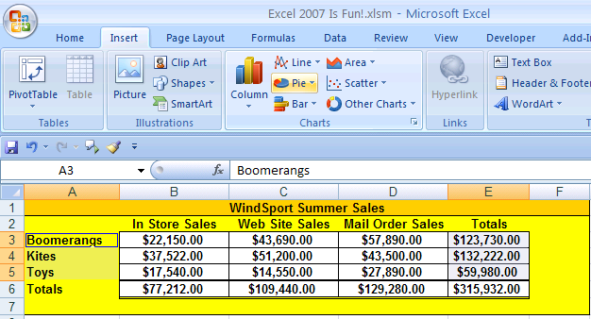

Figure 278
- Click on the Pie chart icon button and then point to the first option. As you can see in (Figure 279)., Excel gives you a description of what the chart should be used for. As you learn how to make charts, you can read these as you are trying to decide which chart is best for your message.
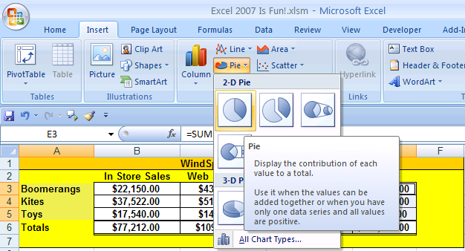

Figure 279
- Click on this first option to create your Pie chart. In Figure 280 you can see that it placed a pie chart on top of the worksheet and opened the three context-sensitive Ribbons for charts.
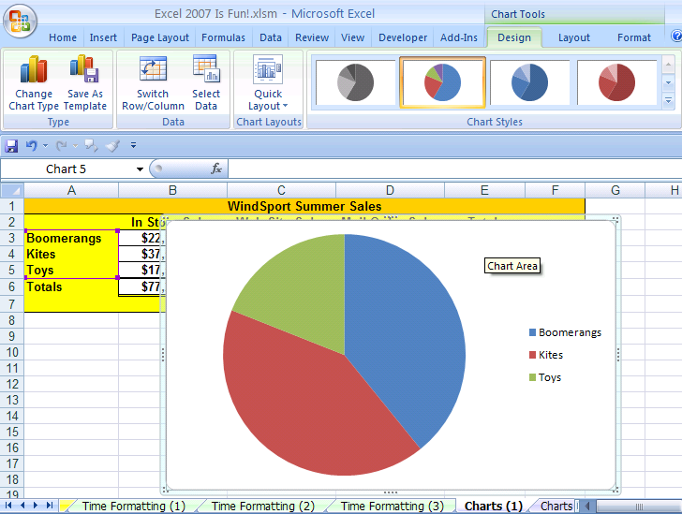
Upper left corner

Figure 280
Context-Sensitive Ribbons
- To change the size of the chart, hold the Shift Key and point to the upper left corner of the chart and when you see a diagonally pointing black arrow, click and drag inward. You should change the size to about the same size as seen in Figure 281:
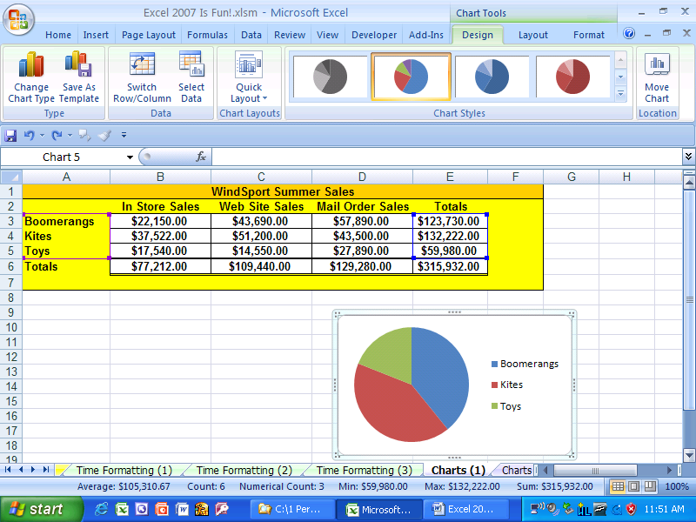

Figure 281
- Click on the “Quick Layout” icon button on the Chart Tools Design Ribbon and point to the “Layout 1” option (Figure 282):
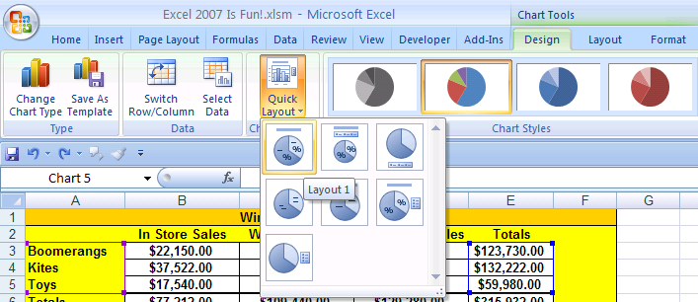

Figure 282:
- In Figure 283 you should see that the Quick Layout added a Chart Title, and the category names with percentages that convey how much each part contributes to the whole.
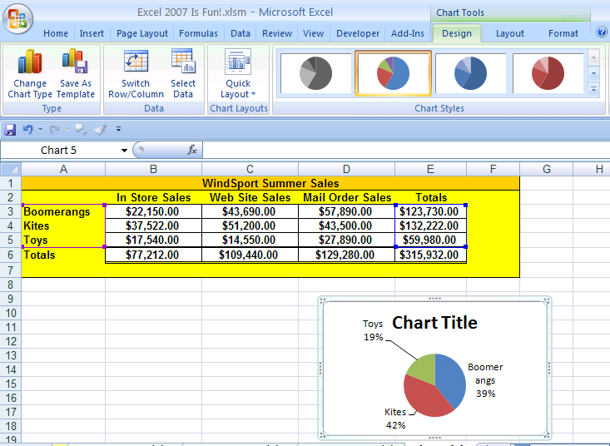

Figure 283

- Click on the “See More Selections” Arrow in the Chart Styles Group (Figure 284):
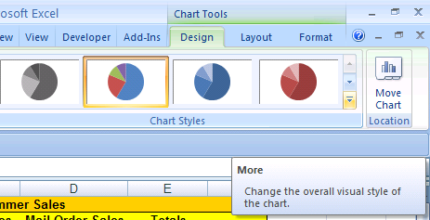

Figure 284
- After you click on the “See More Selections” Arrow, choose “Style 10” as seen in Figure 285:
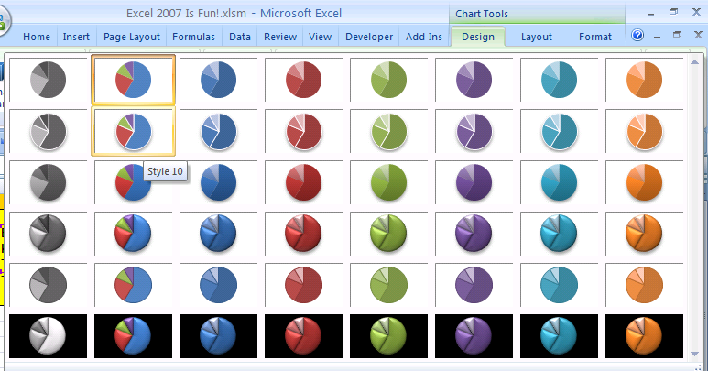

Figure 285
- After clicking on Style 10 you should see this (Figure 286):
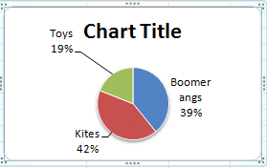

Figure 286
- Now we need to Change the Chart Title. Click once on the Chart Title, then click a second time so that an I-beam cursor is flashing in the Chart Title(Figure 287):
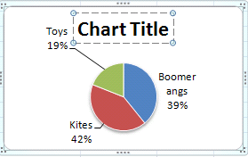

Figure 287
- Hold Ctrl and tap the “A” key (keyboard shortcut for Select All) (Figure 288):
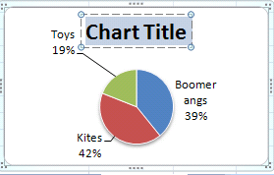

Figure 288
- Type “Summer Sales.” And then click on the outer edge of the Chart to register the “Summer Sales” Title. (Figure 289):
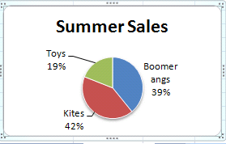

Figure 289
- To change the size of the chart, hold the Shift Key and point to the upper left corner of the chart and when you see a diagonally pointing black arrow, click and drag outward. You should change the size to about the same size as seen in Figure 290:
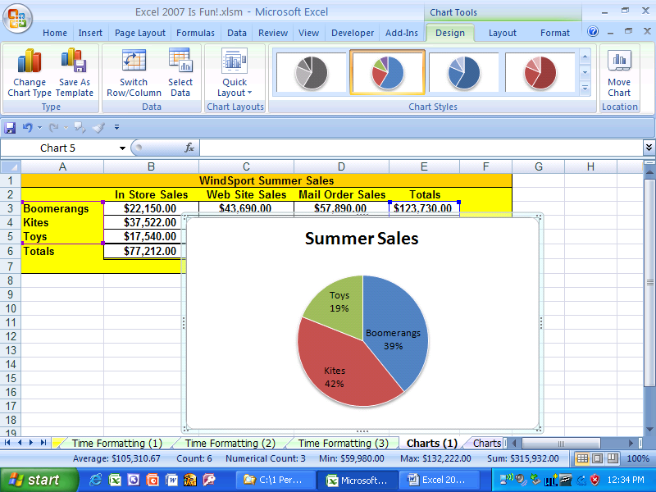

Figure 290

- To move that chart to below the Sales Table, Hold Ctrl and Click on the Chart (This selects the chart so that you can move it). Then click and drag your Pie chart as seen in Figure 291. Then Hold Ctrl and tap the F1 key to hide the Ribbons.
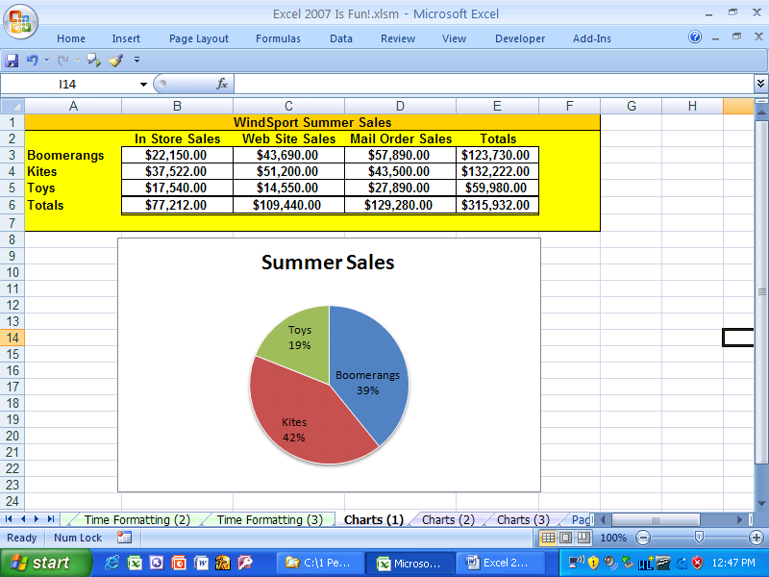

Figure 291
- In Figure 291 we can see that we have created an appropriate chart that shows how much each product contributed to the overall total sales. We can clearly see that the Toy products contribution the smallest amount to the overall total as compared to the other two products.
- For our next chart, Navigate to the sheet tab named “Charts (2)”.
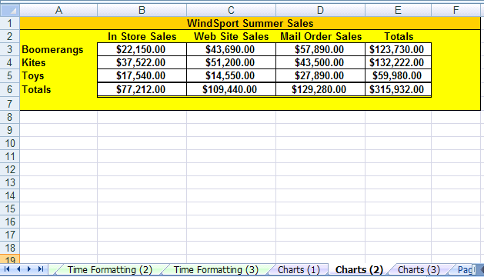

Figure 292
Here are the steps for creating a Column chart with multiple series data
- The first Pie chart we made showed the product categories, but we only looked at the totals. Next we would like see how each of the three product categories compares in each sales channel. Now we could make three different Pie charts, but there is a better way than that. If we use a Column chart we can see the three products compared across the sales channel categories (Column chart with multiple series data). In Figure 292 we can see that there are three product categories and each one of those categories has a sales number for each sales channel. For example, for Toys we have the numbers $17,540.00, $14,550.00, $27,890.00. These three numbers are called a “data series” in Excel. There is a data series for each product and a data series for each sales channel. For example, the data series for the In Store sales channel would be $22,150.00, $37,522.00, $17,540.00.
- Highlight the range A1:D5 and click on the Column icon button in the Chart Group on the Insert Ribbon (Figure 293).
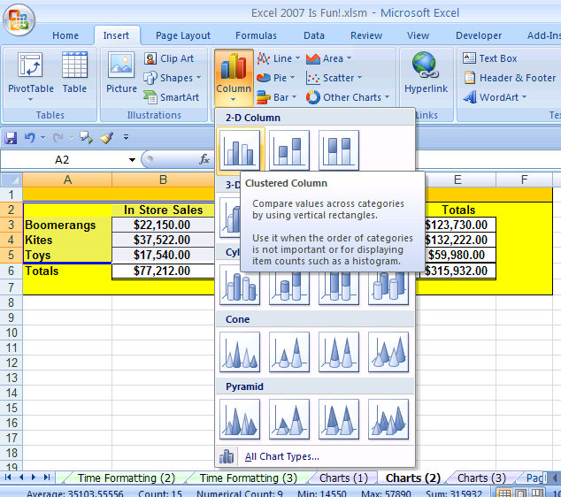

Figure 293
Clustered Column
- As seen in Figure 293, click on the first option in the drop-down icon list named “Clustered Column” The result can bee seen in Figure 294:
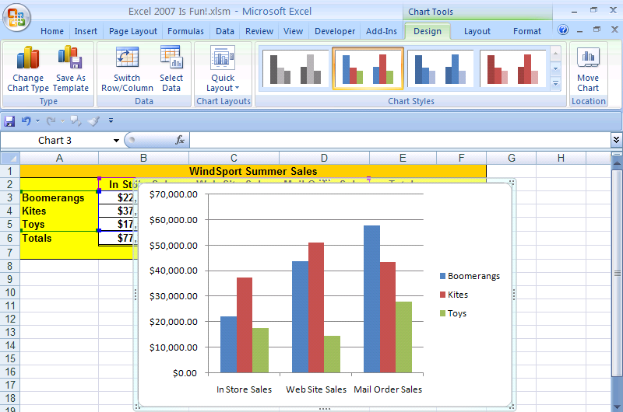

Figure 294
- An excellent aspect of this chart is that you can quickly change the orientation of a Clustered Column chart by clicking on the Switch Rows/Columns icon button in the Data Group on the Chart Tools Design Ribbon. Figure 294 shows the icon button to click. Figure 295 shows the “switched” Chart.
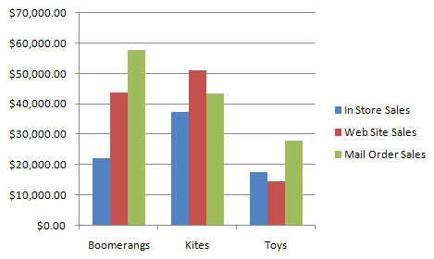

Figure 295
- Click the Switch Rows/Columns icon button again to switch back. Then click on the Charts Tools Layout Ribbon (Figure 296):
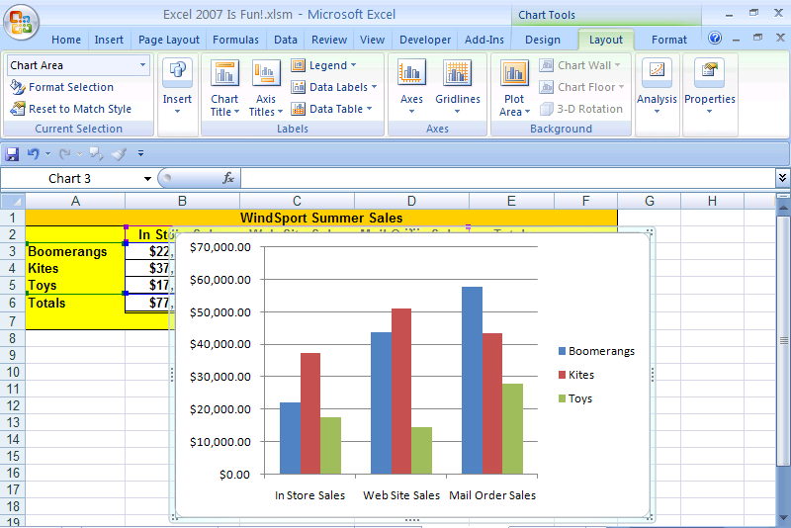

Figure 296
- As seen in Figure 296, the Layout Ribbon has many chart elements that you can add. Let’s add a Chart Title. Click on the Chart Title icon button in the Labels Group on the Chart Tools Layout Ribbon. Then as seem in Figure 297, click on the “Above Chart” item on the icon drop-down list.
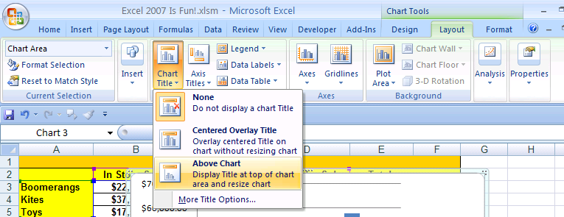

Figure 297
- When the Chart Title appears, highlight the words and type “Product Sales for Each Sales Channel” (Figure 298):
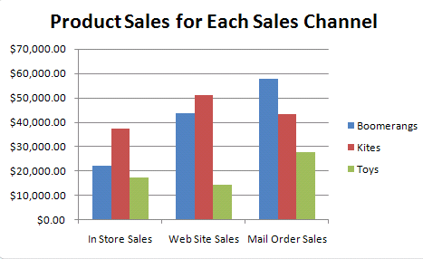

Figure 298
- As seen in Figure 299, we next want to click on the Chart Tools Format Ribbon. The Chart Tools Format Ribbon allows you to format any of the chart elements after you have selected the element that you want to format. An alternative to using this Ribbon is to select the Chart Element and then right-click the element. Let’s try this. Click on the vertical axis (also known as the y-axis). When you click on the vertical axis, a thin black outline will appear that let’s you know that you have selected it (Figure 300).
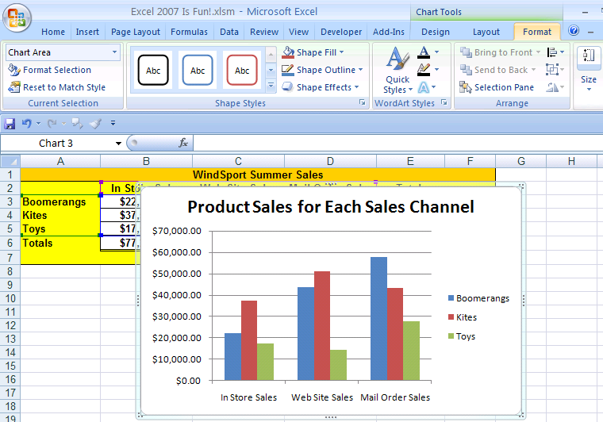

Figure 299
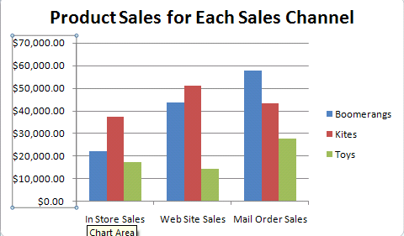

Figure 300
- Once you have the element selected that you want to format, use the keyboard shortcut for the Formatting Chart Element dialog box =: Ctrl + 1 (Figure 301):
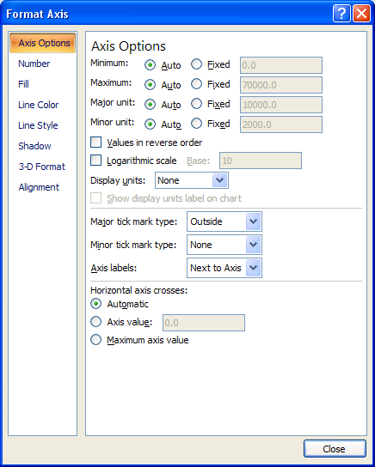

Figure 301
- On the Left side of the Format Axis dialog box, click on “Number”. Make sure that the Currency Number format is selected, change the decimals to 0, and click Close (Figure 302):
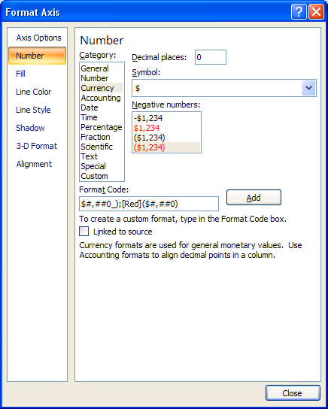

Figure 302

- The Chart should look like this (Figure 303):
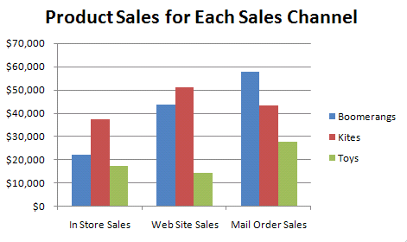

Figure 303
- In Figure 303 we can see how each of the three product categories compares in each sales channel. The smallest sales for a product are the sales for Toys sold through the web site.

In our nest section, we want to talk about Page Setup. Navigate to the sheet tab names “Page Setup”.

Page Setup
To see how Page Setup works, click on the “Page Layout” Ribbon. In Figure 304 you can see that there is a Payroll sheet. Imagine that your boss asked you to print out this report. To see what it would look like before you print it out, click on the Orb.
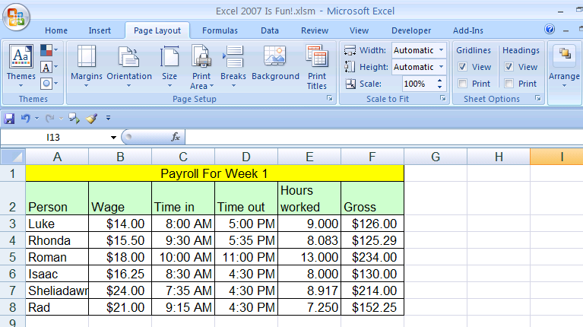

Figure 304
After you click on the Orb, point to the Print icon and then to the Print Preview icon. Notice in Figure 305 that a screen tip pops up and let’s us know that there is a faster way to see Print Preview: the keyboard shortcut for Print Preview is Ctrl + F2. Click the Esc key (upper left corner) twice. Then use you newly discovered keyboard shortcut Ctrl + F2 to open up Print Preview.
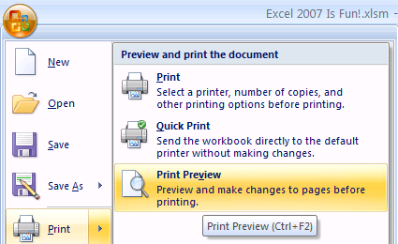

Figure 305
Ctrl + F2 opens up Print Preview. As we can see from Figure 306, the sheet will print out in the upper left corner. This does not look like a professional payroll report. We need to fix it! Click the Esc key to get back to Normal View.
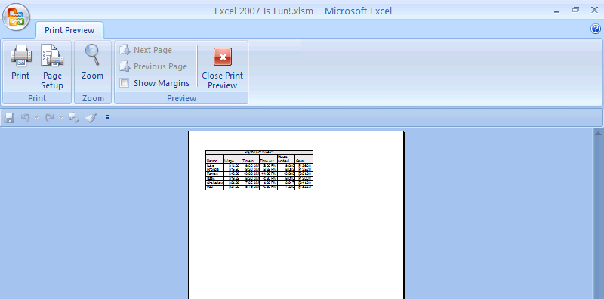

Figure 306
Here are the steps for setting up your sheet for printing
- After you click the Esc key you are back in Normal view. As seen in Figure 307, click on the Page Setup Dialog Launcher in the lower right corner of the Page Setup Group on the Page Layout Ribbon.
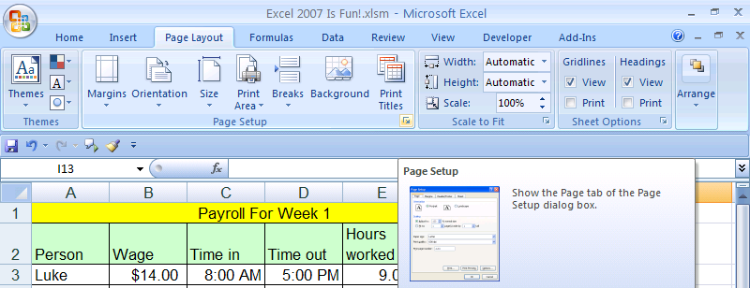

Figure 307

- After you click the Page Setup Dialog Launcher, you should see this (Figure 308):
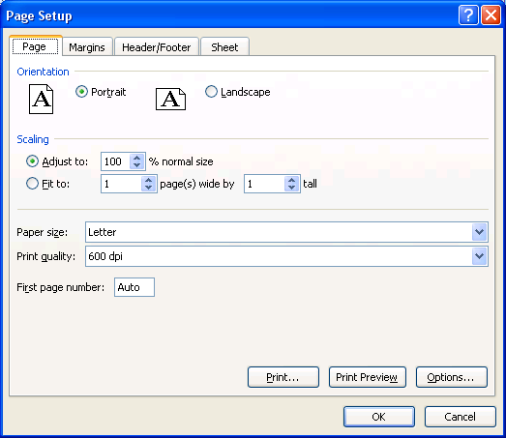

Figure 308
- The advantage of using the Page Setup dialog box is that you do not need to keep going up to the Ribbon to launch the dialog box. For example, click on the “Sheet tab” (as seen in Figure 309) that contains two parts in the Ribbon all in one dialog box. As seen in Figure 310, the Print Titles icon button in the Page Setup Group on the Page Layout Ribbon launches the Page Setup dialog box with the Sheet tab showing. As seen in Figure 311, the Sheets Options Dialog Launcher on the Page Layout Ribbon launches the Page Setup dialog box with the Sheet tab showing also. However, with all this said about the advantages of the Page Setup dialog box, the reason Microsoft allows users different options for the various elements in Excel is because users have different preferences. So ultimately you get to decide which method you like better. However, in the long-run, it is not disputed that the fastest and most efficient way to accomplish things is Excel is to use as many keyboard shortcuts as possible.
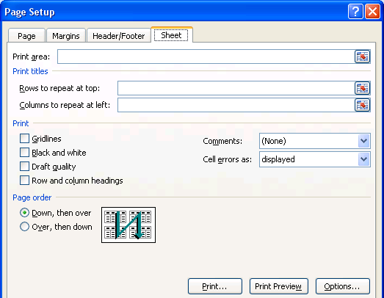

Figure 309
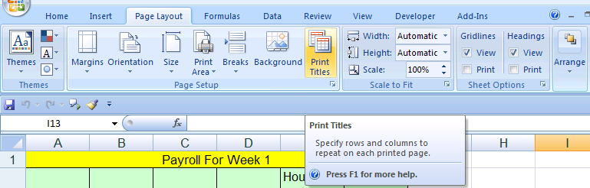

Figure 310
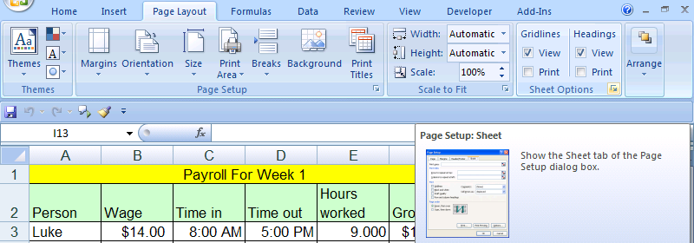

Figure 311
- Click the Esc key. Then use the keyboard shortcut for Page Setup: Alt + P + S + P (Tap each key in succession). You should see the Page Setup dialog box. As seen in Figure 312, click the dialog buttons for Landscape and “Fit to: 1 page(s) wide by 1 tall.” This will orientate the printed page in the same fashion as the Payroll table: wider than it is tall. Also, the “Fit to: 1 page(s) wide by 1 tall.” will assure that if the Payroll table is bigger than the page Excel will automatically shrink it to fit on one page!
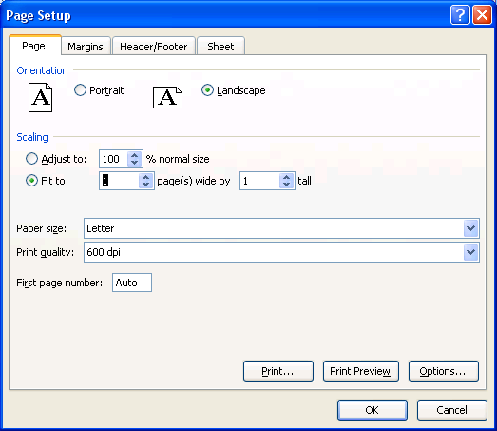

Figure 312
- Next, click on the Margins tab and then click the Horizontal checkbox in the Center on page area as seen in Figure 313. This will center it on the page horizontally for a professional look. Do you know what Margins do? Margins are how far in from the edge of the paper the worksheet content can be printed. For example, if we did not center the Payroll table, the left edge of the Payroll table would be printed .7 inches from the left side of the piece of paper. Also in Figure 313 you can see that you have the option to change any of the page margins (left, right, top, and bottom) and also you can change the location that Headers and Footers are printed. In Figure 313 you can see that the Headers and Footers will be printed .3 inches from the top and bottom of the page. In our next step we will add Headers and Footers.
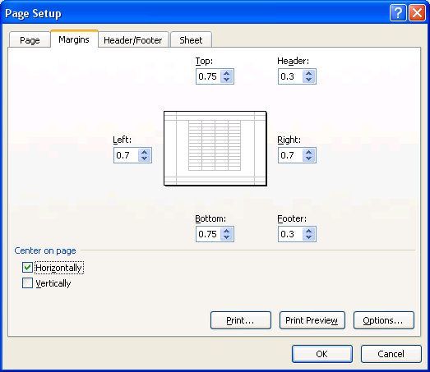

Figure 313

- As seen in Figure 314 click on the Header/Footer tab.
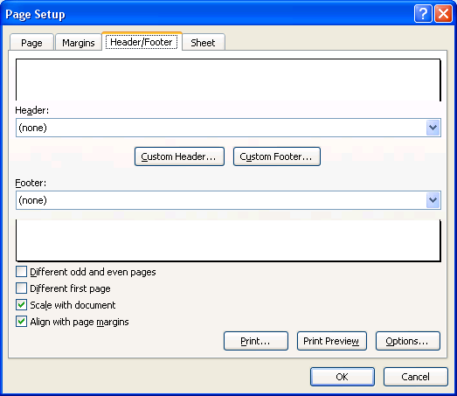
Header
Preview
Drop-down for built-in Headers
Button to build Custom Header
Footer
Preview
Drop-down for built-in Footers
Button to build Custom Footers

Figure 314
Note: there is a good alternative for creating Headers and Footers. If you choose the Header & Footer in the Text Group on the Insert Ribbon, you can create Headers and Footers. (Keyboard shortcut for Headers and Footers is Alt + N + H (this puts you into Page Layout View with the Headers enacted), and the keyboard shortcut to get out of Page Layout View is Alt W + L (this puts you back in Normal View). If you are only adding Headers and Footers this is the better method. However, if you are adding many Page Setup elements all at once, then the Page Setup dialog box is more efficient.
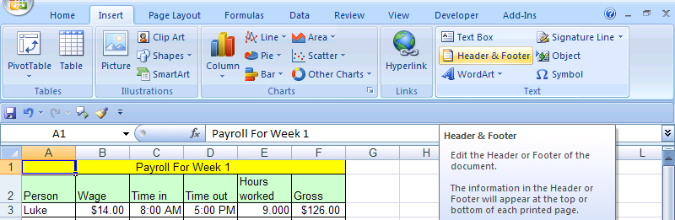

Figure 315
- While still viewing the Header/Footer tab in the Page Setup dialog box, click the drop-down arrow for built-in Footers and select “Page 1 of ?” as seen in Figure 316. This is Excel Code that will automatically put the correct page numbers on each page that prints out. (In our case we have only one page.)
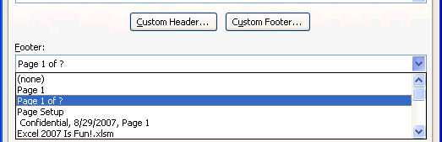

Figure 316
- Next, click on the Button to build Custom Headers. A new dialog box pops up on top of the Page Setup dialog box (Figure 317):
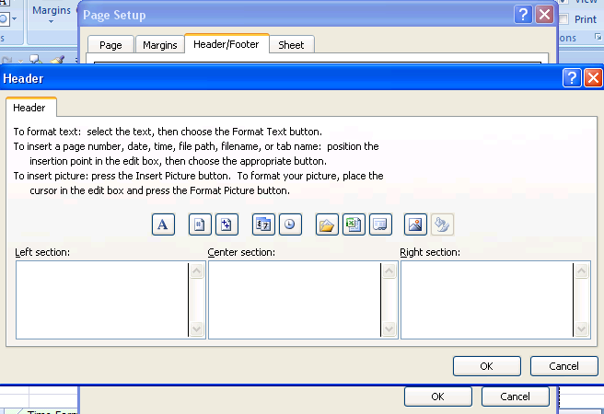
Header dialog box is on top of the Page Setup dialog box

Figure 317
- As seen in Figure 318, click in the left section and click on the Insert File Name (this inserts the code that automatically puts the file name in your header – even if you change the file name, your header will automatically update).
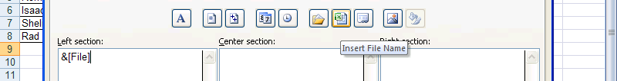

Figure 318
- As seen in Figure 319, click in the center section and click on the Insert Sheet Name (this inserts the code that automatically puts the sheet name in your header – even if you change the sheet name, your header will automatically update).
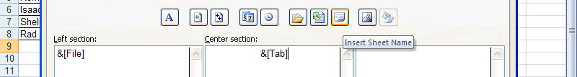

Figure 319
- As seen in Figure 320, click in the right section and click on the Insert Date (this inserts the code that automatically puts today’s date in your header – if you print it out at a later date, your header will automatically update).
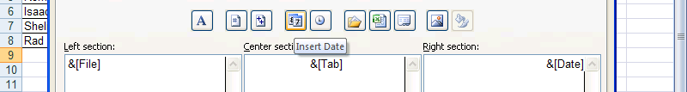

Figure 320
- As seen in Figure 321, click OK in the Header dialog box:
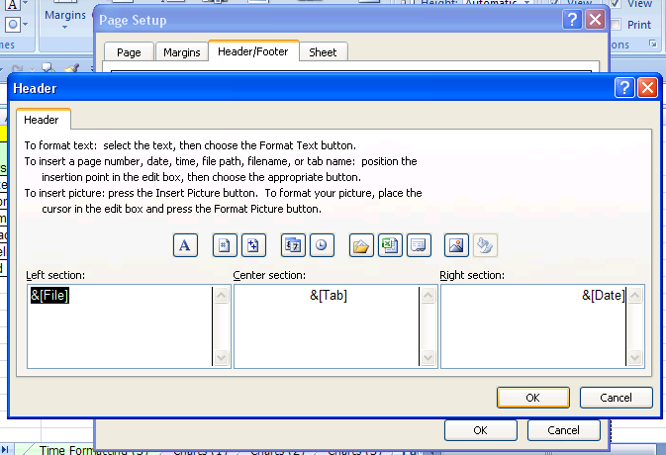

Figure 321
- As seen in Figure 322Figure 321, click OK in the Page Setup dialog box:
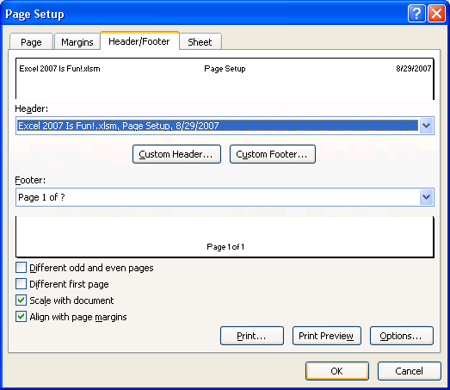

Figure 322
- To see a preview of your Page Setup before you print, Hold the Ctrl key and tap the F2 key (Figure 323):
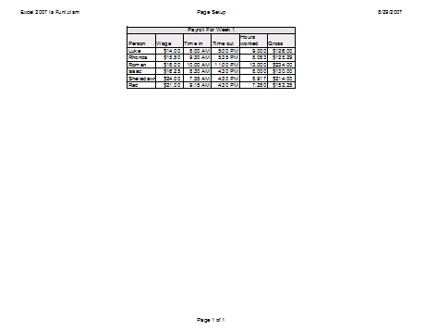

Figure 323
- The print preview that we see in Figure 323 is much better than the one we saw in Figure 306. Not only that, but with the ability to do Page Setup, you will be the heroine or hero in many office setting (because usually people can’t figure out how to print their sheet correctly!
- In our next section, we want to take about data analysis topics such as sorting, subtotals and PivotTables.

Analyze Data: Sort, Filter, Subtotals, PivotTables
The essential beauty of Excel is that you can make calculations and analyze/manipulate data quickly and easily “on the fly!” What-if analysis is easy in Excel. You can Sort to see which Sales Rep had the greatest sales, create Subtotals by Region, and do complex data analysis such as summarizing on multiple criteria (PivotTables). (This section is only a brief look at Excel’s infinite Analyzing capabilities…). For this section we will look at Sorting, Filtering, automatic Subtotals and a basic PivotTable.

The #1 MOST IMPORTANT THING TO REMEMBER WHEN YOU START TO USE EXCEL’S DATA ANALYSIS TOOLS IS:

Rule #24: Before you use Excel’s Data Analysis Tools: the data must be in proper Excel “List” or “Table” Format. This format is as follows: 1) First row has field names with formatting that is different from the rest of the data; 2) No blank field names; 3) Columns are called Fields; 4) Rows are called records; 5) No blank columns (fields); 6) No blank rows (records); 7) Blank rows and columns and/or Excel’s column headers (A, B…) and/or row headers (1, 2…) must separate the Excel List from other data

Columns are called “Fields”. Fields are the variable data for each record. Rows are called “Records”. Records are individual collections of the fields. For example, navigate to the sheet tab named “Analyze Data”, click on the Data Ribbon. You should see this (Figure 324): Note: your data may not be in the same order as the picture.
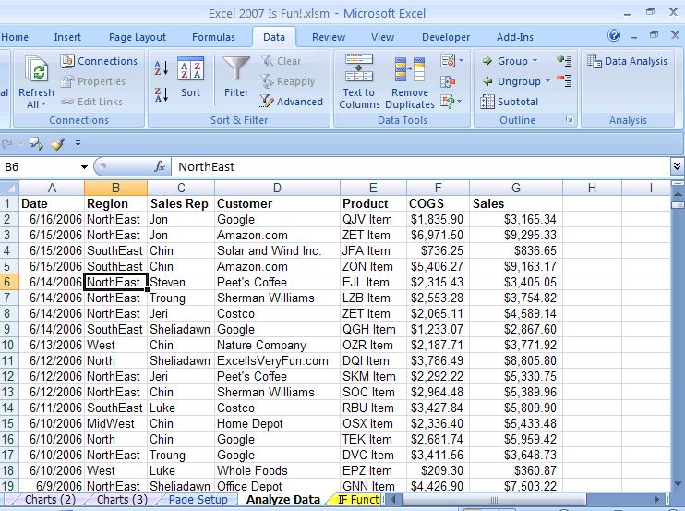

Figure 324
In Figure 324 we can see:
- Proper Excel “List” or “Table” Format, which will refer to as “Excel’s List/Table format” (this is because in Excel 2003 it was called “List” and in Excel 2007 it is called “Table”)
- Each row represents one Sales Transaction
    - Each sales transaction is one new record
    - Each record is an individual collection of the seven fields
- The first seven columns represent fields
    - Each field is a variable
      - For each new transaction it can have a different date or different region or different sales rep, etc.
Steps to Sort on various criteria
- The method of sorting we will look at involves turning on the “Filter” with the keyboard shortcut for Filter: hold Ctrl and Shift, then tap the “L” key. In Figure 325 you can see that that keyboard short cut added drop-down arrows at the top of each field and turned on the Filter button in the Sort and Filter Group on the Data Ribbon.
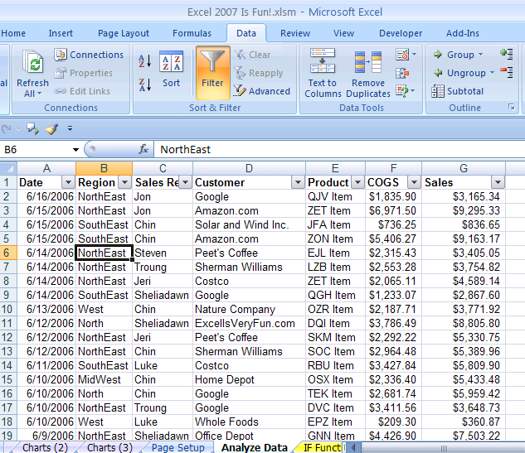

Figure 325
- Point to the drop-down arrow for the Sales field and point to “Sort Largest to Smallest” (Figure 326):
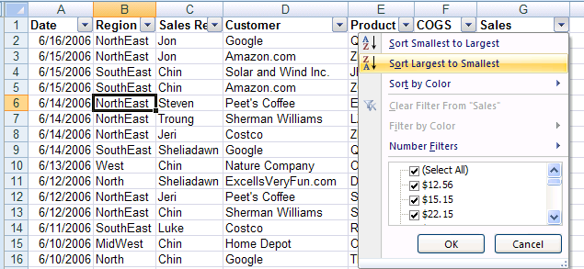

Figure 326
- As seen in Figure 327, instantly, the whole table is sorted by the sales numbers in the Sales field. We can easily see that Sales Rep Luke had the two largest sales.
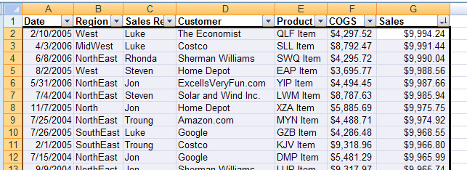

Figure 327
- Next click on the drop-down arrow for the Sales Rep field and click on the “Sort A to Z” from the drop-down list (Figure 328)
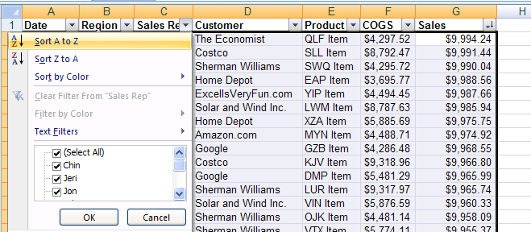

Figure 328
- As seen in Figure 329, instantly, the whole table is sorted by the names in the Sales Rep field, with Chin at the top.
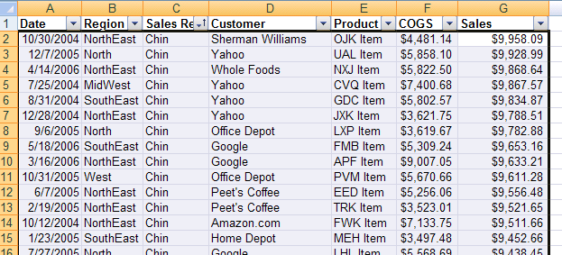

Figure 329
- To see how to sort without the Filter turned on, turn off the Filter with the keyboard shortcut Ctrl + Shift + L, then click in cell B6 (Figure 330):
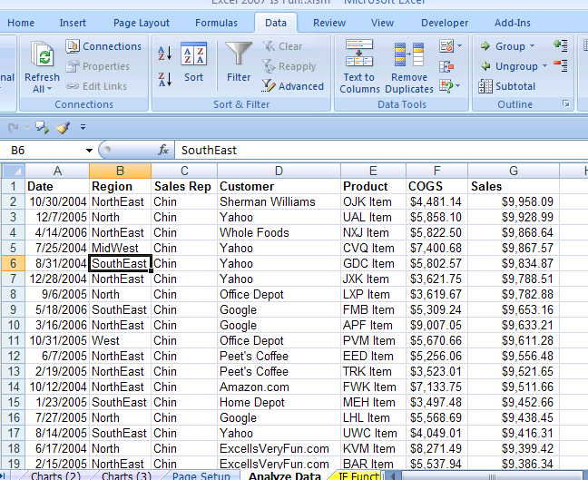

Figure 330
- With only one cell selected in the Region field column, click the “A ➔ Z” icon button in the Sort & Filter Group on the Data Ribbon (Figure 330)
- As seen in Figure 331, the whole table was sorted by the region names in the Region field column.
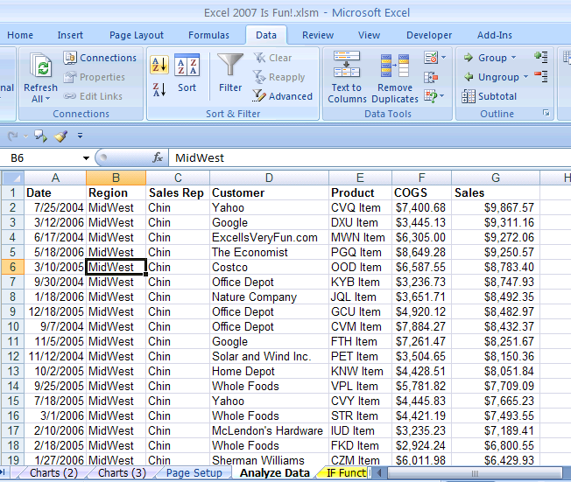

Figure 331

Rule #25: Before click the “A ➔ Z” icon button in the Sort & Filter Group on the Data Ribbon, make sure your block of data is in the Proper Excel List/Table Format and highlight only one cell in the field you want to sort.
Steps to Filter your data
- Navigate to the sheet named “Filter”. You can use this keyboard shortcut to move down two sheets: Hold Ctrl and then tap the Page Down key twice. You should see the data as seen in Figure 332. Then, turn on the Filter using the keyboard shortcut: Ctrl + Shift + L
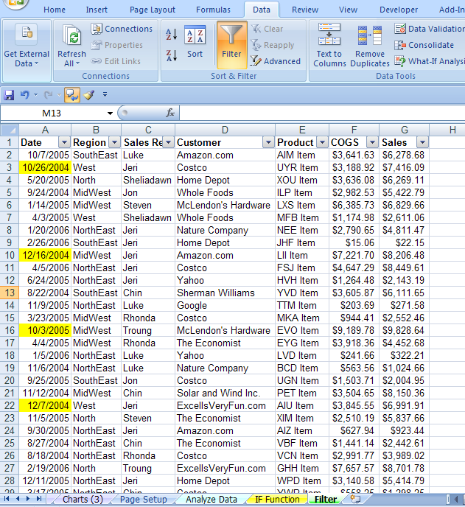
Hold Ctrl and Shift at the same time and then tap “L” to turn on the Filter

Figure 332

- To see the Sales that are Above Average, click the drop-down arrow at the top of the Sales field and in the drop down list point to Number Filters and then point and click on Above Average (Figure 333).
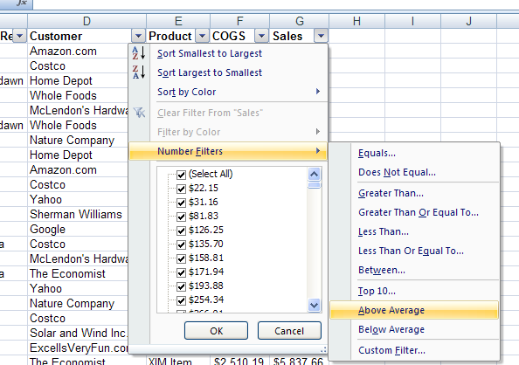

Figure 333
- As you can see in Figure 334 Excel quickly shows us the results. Notice two things: 1) the drop-down arrow at the top of the Sales field contains a “Filter” icon to let us know that the field has been filtered; 2) the row numbers are the color blue to let you know that the rows with records that are not above average have been hidden. For example, you can see in Figure 334 that rows 7, 8, 9, and 10 are hidden.
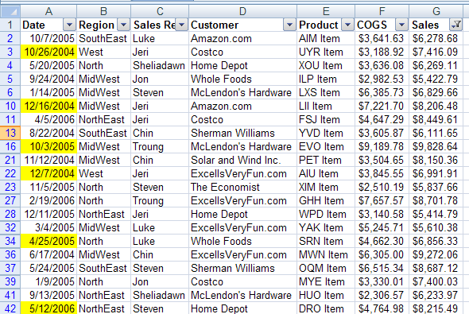

Figure 334
- To clear the filter, click on the drop-down arrow at the top of the Sales field and click on the item “Clear Filter From Sales”.
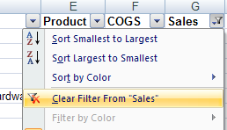

Figure 335
- To see a brief example of the options available for filtering words, click on the drop-down arrow at the top of the Customers fields and point to Text Filters (Figure 336). Notice that you can uncheck any customers you would like if you only want to see a selection of Customers. In addition, you can see the Text Filters available.
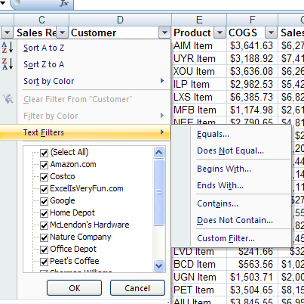

Figure 336
- Next we want to see how to sort by color. Notice in Figure 337 that the color yellow is added to some of the dates. This color was to tag those records for auditing. Instead of scrolling down and seeing each record one at a time, we can sort by color.
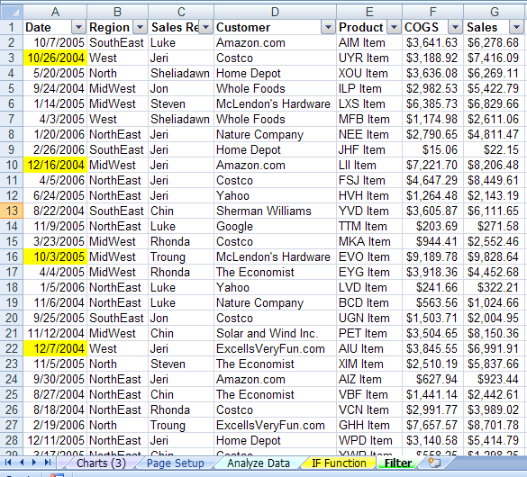

Figure 337
- Click on the drop-down arrow at the top of the Date fields and point to Sort by Color and then click on the color yellow (Figure 338):
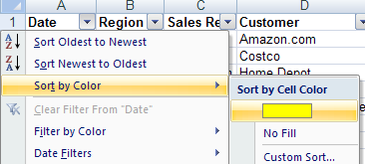

Figure 338
- In Figure 339 we can see that very quickly our records that we need for auditing are sorted to the top.
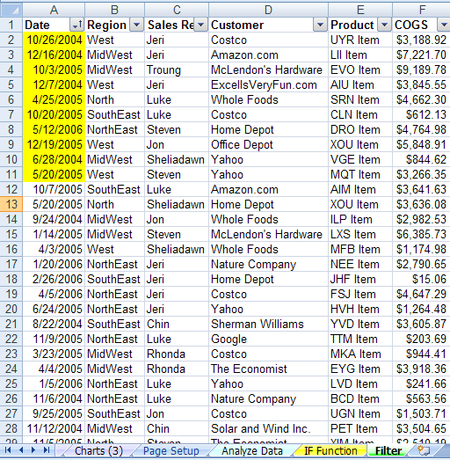

Figure 339
- As you can see to our brief introduction to Sorting and Filtering, it allows us to do data analysis efficiently. In addition, you can also see from some of the drop down menus that we only looked at a small fraction of the possibilities!
- In our next section, we will look at another data analysis tool: Subtotals.

Rule #26: Using the Sorting or Filtering features in Excel can save a tremendous amount of time as compared to accomplishing the same sorting or filtering tasks manually.

Steps to add automatic Subtotals
- Before we look at Subtotals, navigate back to the sheet tab named “Data Analysis” (Figure 341):
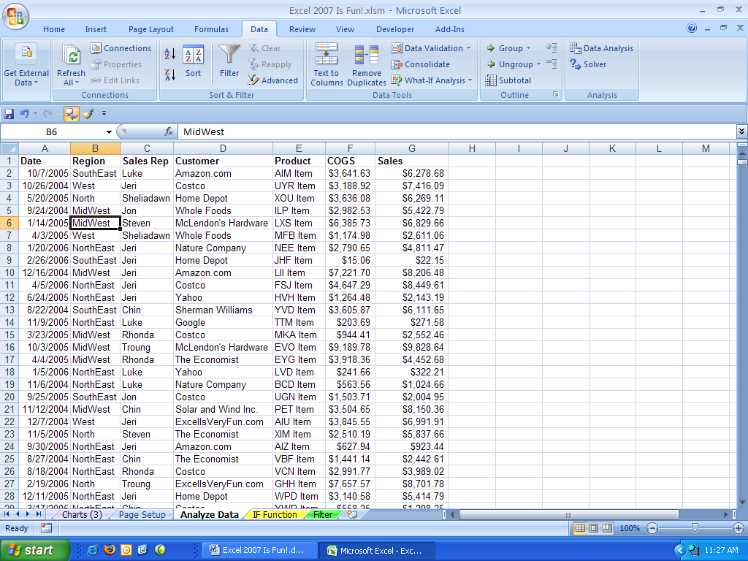

Figure 340
- Subtotals are one of the greatest tricks in Excel because using the Subtotal feature quickly goes through the whole table and inserts rows and adds totals for the column that you specify. In our case, we will be able to very quickly add totals for all the regions and Sales Reps!
- An important point to make here is this: DON’T USE THE SUBTOTALS FEATURE FOR A PARTICULAR FIELD UNTIL YOU HAVE SORTED THAT FIELD.
- We have already sorted the region and the Sales Rep fields so that we can use the Subtotal feature.
- As seen in Figure 341, click on the Subtotals icon button in the Outline Group on the Data Ribbon.
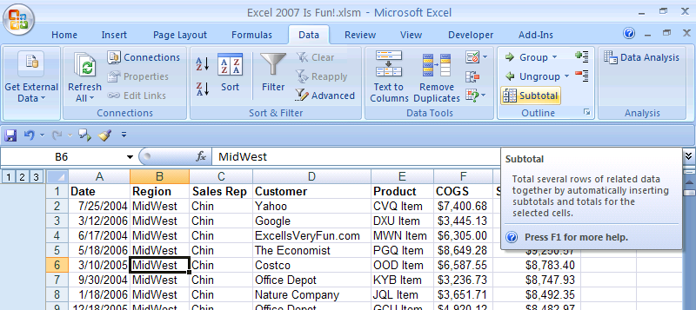

Figure 341
- You should see Subtotal dialog box as seen in Figure 342. . Notice that the whole table was highlighted when you invoked the Subtotals dialog box (this is because you have your data in proper Excel List/Table format). Using the drop-down arrow for the “At each change in” textbox, select the Region field. For the “Use function:”, use the Sum function. For the “Add subtotals to:” checkboxes check the Sales field.
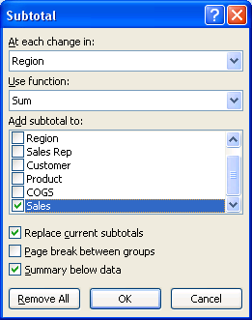

Figure 342
- Click OK. You should see something similar to Figure 343. On the left of your screen you should see three little blue-gray boxes with the numbers 1, 2, and 3 in them. These are called Outline buttons.
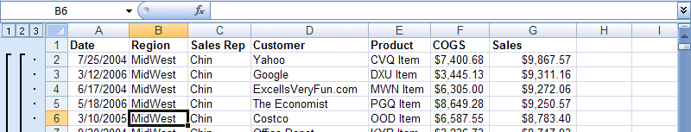

Figure 343
- Click the “2” Outline button and you should see subtotals similar to those as seen in Figure 344. The plus and minus symbols are collapse and expand symbols. You can use these to expose the data for a particular Region. You can also use the “3” Outline button to expose all the records. Before you click on the “3” Outline button, notice that there are 200 rows of sales transaction data that the Subtotals feature traversed in less than a second! This is an amazingly efficient feature in Excel!
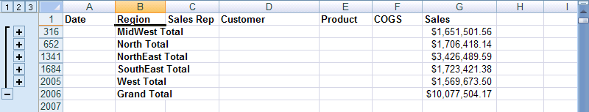
The Subtotal feature works through 200 rows of data quickly

Figure 344
- Click on the “3” Outline button to show all the records again (Figure 345):

Figure 345

- Open the Subtotals dialog box with the keyboard shortcut: Alt + A + B. As seen in Figure 346, use the drop-down arrow next to the “At each change in” textbox to select the Sales Rep field. For the “Use function:”, use the Sum function. For the “Add subtotals to:” checkboxes check the Sales field. Finally (this is the most important step when adding a second Subtotal), un-check the “Replace current subtotals” checkbox and then click OK.
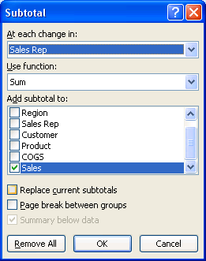

Figure 346

- As seen in Figure 347, a fourth Outline Level has been added.
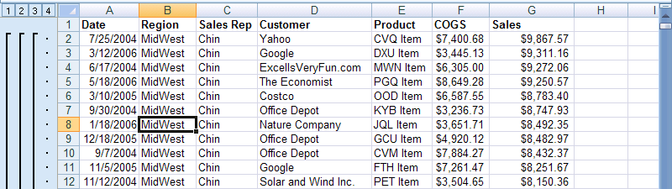

Figure 347
- Click on the “3” Outline button. As seen in Figure 348, Subtotals have been added for both the Region and Sales Rep fields. With this Subtotal Data Analysis, we can easily pick how each Sales Rep did in each Region.
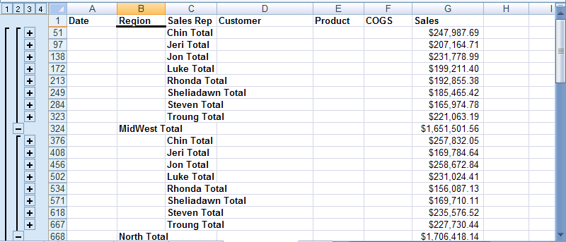

Figure 348
- To get rid of the Subtotals, use the keyboard shortcut to open the Subtotals dialog box: Alt + A + B and then click the “Remove All” Button
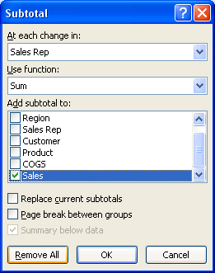
- In our next section we will talk about the most powerful toll in Excel, the PivotTable.

Rule #27: Before adding automatic Subtotals, sort your field. If you want to add a Subtotal to a Subtotal, Be sure to uncheck the “Replace current subtotals” check box.
Steps to create a basic PivotTable
- What is a PivotTable? It is a quick way to analyze data such as summing up data in a rectangular table shape when you have more than one category to summarize upon. Figure 349 shows us an example of what would like to accomplish from our data. As you can see we have two categories (Sales Rep and Region) and we have a rectangular table shape. To create this without using the PivotTable feature, but instead to use functions, would be very time consuming.
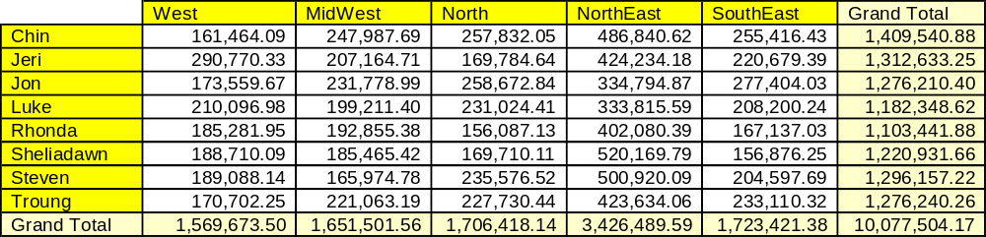

Figure 349
- To create something similar to what we see in Figure 349, make sure you have one cell in your data table selected and that your data is in proper Excel List/Table format, then click on the PivotTable icon button in the Table group on the Insert Ribbon (Figure 350):
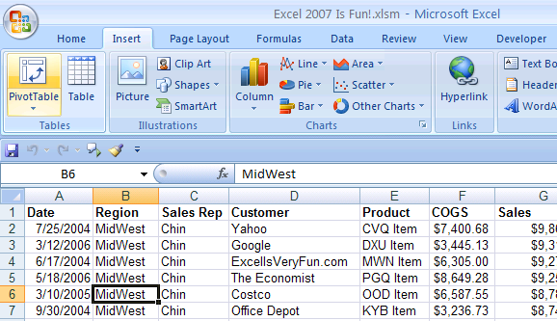

Figure 350
- Notice that because we are using proper Excel List/Table format and we had selected one cell in the middle of our data, all the data was automatically selected. As we can see in Figure 351 Create PivotTable dialog box opens and we can see that the range A1:G2000 is selected. In addition, we want to create our PivotTable on a new sheet and so we will accept the defaults and then click the OK button.
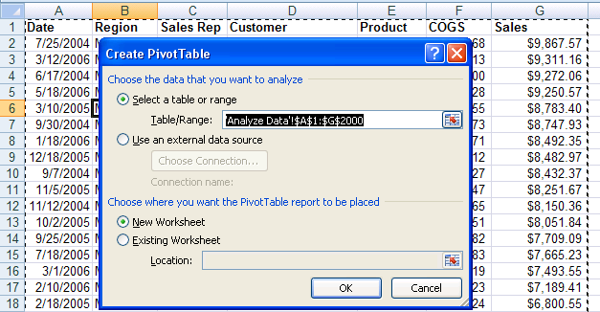

Figure 351
- In Figure 352 we can see that the PivotTable Field List Task Pane pops up and a new sheet is added to the workbook. All we have to do in order to create a table with the two categories Sales Rep and Region is to click on the checkboxes for those two fields (after all this is just field list).
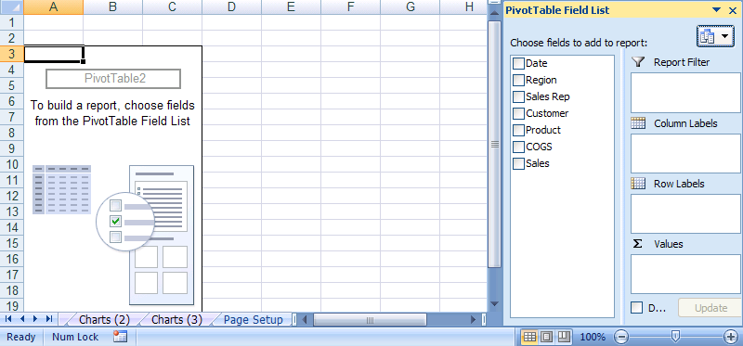
PivotTable Field List Task Pane

Figure 352

- As seen in Figure 353, by checking the two fields, both were added as Row Labels.
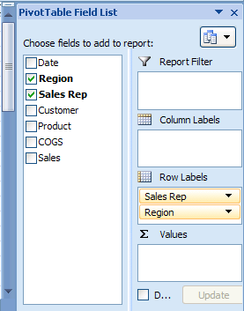
Click on the Region field and drag it to the Column Labels’ area

Figure 353
- As seen in Figure 353, because we want the Sales Rep field as a Row Label and our Region as a Column Label, we will click on the Region field in the Row Labels’ area, hold the click, and drag it to the Column Labels’ area
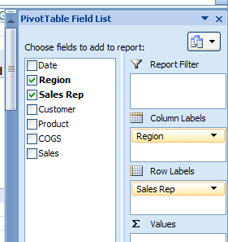

Figure 354
- As seen in Figure 354, we have our two category labels

- As seen in Figure 355, we can see our PivotTable taking shape. We can see that the Sales Rep labels and the Region labels in our worksheet. We can see that two context-sensitive Ribbons for the PivotTable have appeared (PivotTable Tools Options and Design Ribbons).
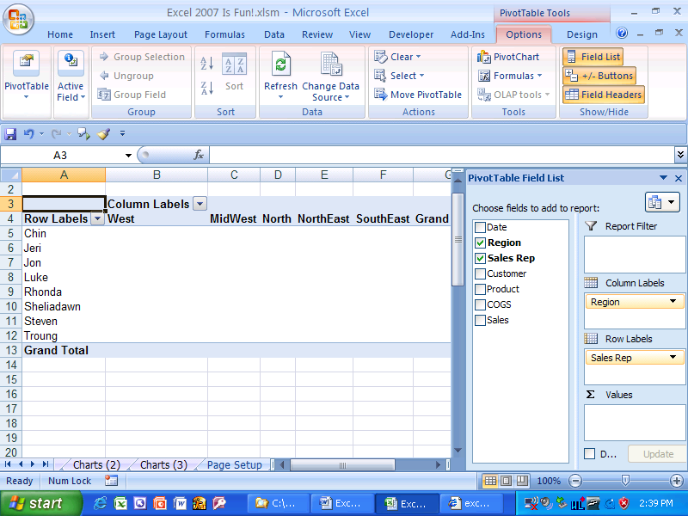
We can see that the Sales Rep labels and the Region labels in our worksheet.
We can see that two context-sensitive Ribbons for the PivotTable have appeared.

Figure 355
- Because we cannot see the whole PivotTable, Zoom slider in the Status Bar to move down to 90% view. As seen in Figure 356, click the “Zoom Out button (minus sign) to move to 90% view.
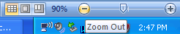

Figure 356
- As seen in Figure 357, we can now see the whole PivotTable.
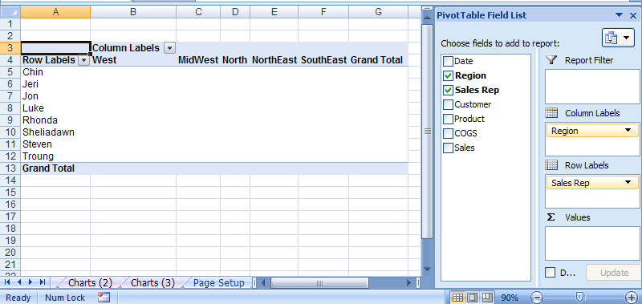

Figure 357
- Next, as seen in Figure 358, click on the Sales field in the PivotTable Field List Task Pane – this adds the Sales field to the Values area. PivotTables use the Sum Function by default, which is what we wanted in our case. To see how to change the function and to format the Sales numbers, click the close “x” button in the top right corner of the PivotTable Field List Task Pane and then click in cell A3.
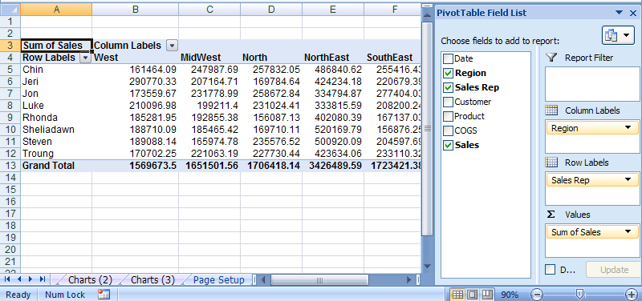

Figure 358
- With your cursor in cell A3, right-click and point to “Value Field Settings” (Figure 359):
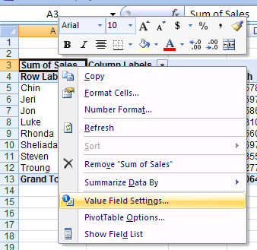

Figure 359
- As seen in Figure 360, the Value Field Settings dialog box should appear: If you were to change the function, you could do so in the “Summarize value field by” function list. Because we want to change the Number formatting, we will click the Number Format button.
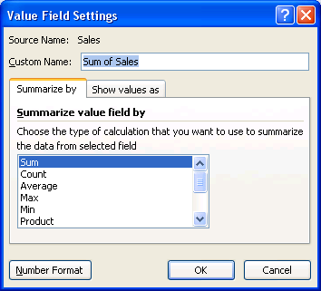
If you were to change the function, you could do so in the “Summarize value field by” function list.
Number Formatting

Figure 360
- This is another one of those situations when two dialog boxes are opened. When the Format Cells dialog box appears, select the Currency Number format. Then click the OK button on the Format Cells dialog box. Then click the OK button on the Value Field Settings dialog box. (Figure 361):
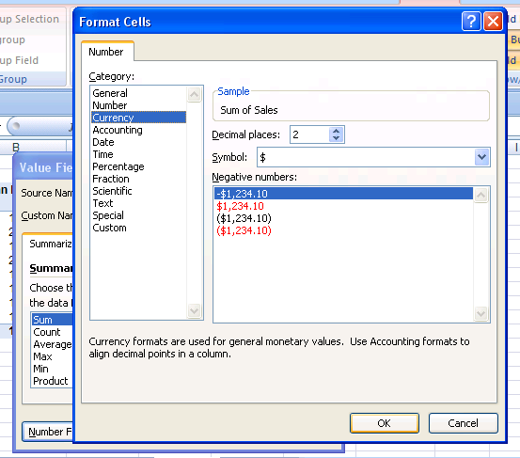

Figure 361
- With only a few clicks, the PivotTable is done. Even better than with Subtotals, we can easily see how each Sales Rep did in each Region (Figure 362):
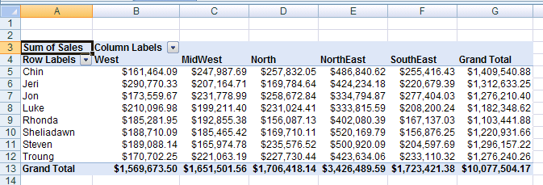

Figure 362

Rule #28: When your data is in Proper Excel List Format, PivotTables are the most powerful tool in Excel. Don’t be afraid of them, there are just tables with variables on the left (Row) and top (Column) side and an intersecting calculation in the middle (such as summing)!

IF function
In this next section we will talk about a built-in Excel function called the IF function. The IF function is great for when you need to put one of two things into a cell. For example, when you are calculating whether or not you get a bonus at work, you would say something like, “If I make sales over or equal to $5,000, I get a $100 bonus, otherwise I get no bonus.” Notice that the words that we use to describe whether or not we get a bonus start with the word “If”! This is why Excel named the function “IF”.

In our case the logical test would be: “Sales >=$5,000” (in words: “If I make sales over or equal to $5,000”). This logical test will either be TRUE or FALSE. If the logical test is TRUE, then we get our bonus of $100. If the logical test is FALSE, then we get a bonus of $0 (we did not exceed or equal the sales hurdle of $5,000).

The built-in Excel IF function will automatically tell you whether or not you earned a bonus! All you have to do is tell the IF function three things:
- What the logical test is
- What the bonus amount is (Value to put in the cell if the logical test turns out to be TRUE)
- What the amount is if we don’t make the sales hurdle. (Value to put in the cell if the logical test turns out to be FALSE)
In Excel language (and math language) the three things are called “arguments”. So our three arguments for the IF function will be:
- Logical test
- Value if TRUE
- Value if FALSE
The function will look like this:
=IF(logical_test,[value_if_true],[value_if_false])
The great thing about the IF function is that whenever you have one of two things to put in a cell that depend of a logical test that comes out to be TRUE or FALSE, you can use the IF function. In addition, the two things that you want to put in a cell that depend on a logical test can be numbers, text, cell references, or other formulas.

Steps to see four examples of the IF function:
- Navigate to the sheet named “IF function”. As seen in Figure 363, there are four screen tips that I have added to show you the formulas that will help you see the different ways the IF function can be used. We will go step by step through the first one and then you can try the remaining ones on your own (there are even two more very complicated IF examples if you scroll down further in the sheet).
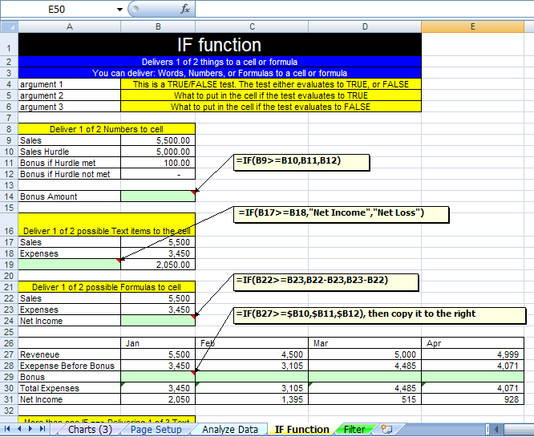

Figure 363
- Click in cell B14 and type the beginning few characters of our formula: “=IF(“. In Figure 364 you can see the beginning characters of our formula in the cell B14 and in the formula bar. You can also see a function screen tip that gives you a hint of what arguments are required.
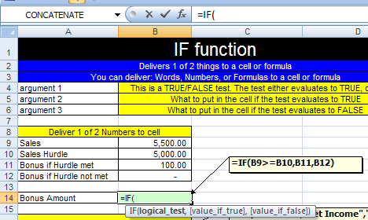
Function Screen Tip
=IF(

Figure 364
- Type the logical test (Figure 365). This logical test says “If Sales are greater than or equal to the Sales Hurdle”. This logical test will come out to be TRUE or FALSE.
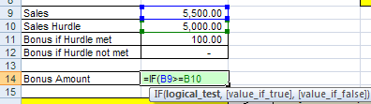

Figure 365
- Next, we type a comma. As seen in Figure 366, the screen tip highlights with bold the next argument that is needed. We can see that we must tell the IF function what to put in the cell if the logical test comes out to be TRUE.
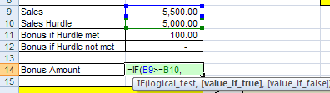

Figure 366
- As seen in Figure 367, in order to tell the function what value goes into the cell if the logical test is TRUE, we click on the cell with the $100 bonus, cell B11.
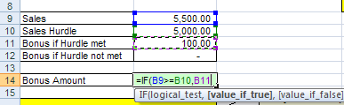

Figure 367
- As seen in Figure 368, we complete the formula by adding the last argument and ending parenthesis to our IF function. This last argument tells the IF function what to put in the cell if the logical test is FALSE.
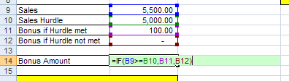

Figure 368
- Hit control + Enter to enter our formula into the cell. As seen in Figure 369, the IF function delivers the $100 bonus to the cell because our Sales number, $5,500, is above the Sales Hurdle number, $5,000. But what if our mean boss changed the Sales Hurdle number to $6,000? What would happen to our $100 Bonus?
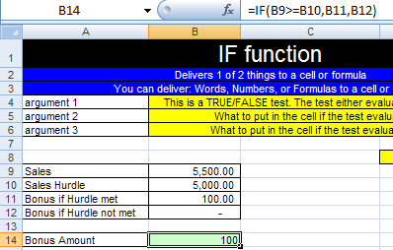

Figure 369
- To see the IF function in action, pretend you are the mean boss and change the Sales Hurdle value in cell B10 to the value $6,000 (which is above your Sales number. As seen in Figure 370, the IF function looked at the logical test Sales>=$6,000 ($5,5000>=$6,000), came to a FALSE conclusion, and then put the $0 amount in cell B14.
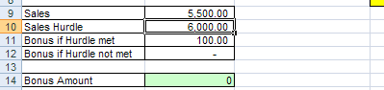

Figure 370
- Now change your Sales number to $6,000. As seen in Figure 371, because the logical test Sales>=$6,000 ($6,000>=$6,000) was TRUE, the TRUE amount of $100 was put into cell B14.
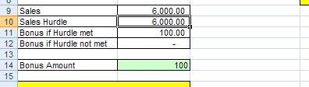

Figure 371
- Before you try the remaining IF functions on your own, let’s look at the completed IF function formula in cell A19 in our formula bar in Figure 372. Here we can see that the logical test is whether or not Sales are greater than Expenses (Sales>=Expenses), if this is TRUE, we want out label to read “Net Income”, otherwise if it is FALSE, we want our label to read “Net Loss”.
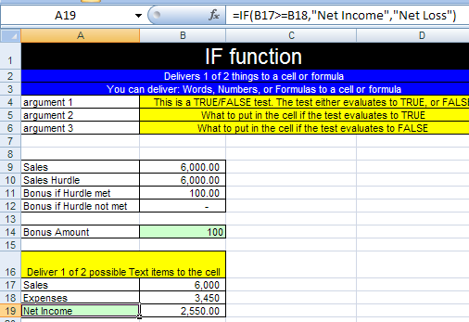

Figure 372
- In Figure 373 , we can see that if we were to change or Expenses to be $7,000, the labels updates because the IF function formula puts the words “Net Loss” in the cell because the logical test evaluates to FALSE.
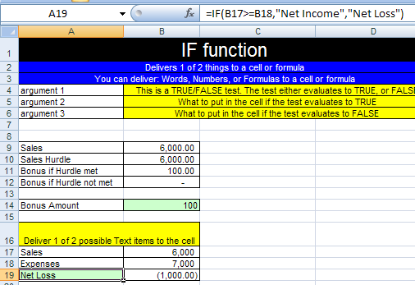

Figure 373

Conclusion:
This is just the beginning of what Excel can do for you. We have looked at the following topics:
- What Is Excel?
- Rows, Columns, Cells, Range Of Cells
- Worksheet, Sheet Tab, Workbook
- Save As is different than Save
- Ribbons
- Quick Access Toolbar (QAT)
- Scroll Bars and Selecting Cells
- Keyboard Shortcuts and the Alt Key
- Two Magic Characters In Excel
- Math
- Formulas
- Functions
- Cell References
- Assumption Tables/Sheets
- Cell Formatting
- Charts
- Page Setup
- Analyze Data: Sort, Filter, Subtotals, PivotTables
- IF function

The key to learning Excel is to learn the theory of how to create Excel spreadsheets so that you can accomplish your tasks quickly and so that everything is updateable later. Inevitably, when we create a spreadsheet, later when we use the spreadsheet again, we need to change it to accommodate some new parameter that we had not initially considered. If you follow theses Efficient Spreadsheet Construction Guidelines, your setup, usage and edit time can be reduced significantly. In addition, you will have more fun with your job. Still further, you will become the Excel-master at your job and others will look to you for guidance! This is great because in this world of “Excel-Is-The-Default-Program-That-Everyone-Uses-Every-Day”, you will get promoted more quickly and have more time for vacations! Plus, this Excel stuff is just plain FUN!!

Efficient Spreadsheet Construction Guidelines:
Rule # 1: Learn Excel well so you can have fun working efficiently, gain promotions quickly, and have more vacation time 4
Rule # 2 = Always name your worksheets so that you can identify amongst the various worksheets 8
Rule # 3 = Always name your workbook and save it to a location that you will be able to find later 9
Rule # 4 = Learn keyboard shortcuts in order to save time 31
Rule # 5 = When the equal sign is placed as the first character in a cell that has not been pre-formatted as Text, it tells Excel to create a formula. 33
Rule # 6 = Do not type data that can vary into a formula. Instead place the data in a cell and refer to it using a cell reference. (A tax rate is a good example of a number that can vary; 12 months in a year is an example of data that will not change). 34
Rule #7 = Use “Enter”, “Ctrl + Enter”, “Shift + Enter”, or “Tab” to enter a formula into a cell. 37
Rule #8 = We must learn the symbols that Excel uses for math and we must know the order of operations. 38
Rule #9 = By typing the numbers that can vary into cells and referring to them in our formulas using cell references, we gain the ability to edit formulas easily and check different scenarios without much effort. 45
Rule #10 = Using Excel’s built in Functions can simplify and shorten formula creation. 51
Rule #11 = Finding functions in Excel can be accomplished by reading the descriptions, searching for a common sense name in the list of functions, or by using the “Search” feature in the Insert Functions dialog box. (You can search Google or the mrexcel.com site also.) 51
Rule #12 = Figuring out what arguments to use for a given function can be accomplished by reading the descriptions, or by clicking the help button in the Argument dialog box. 51
Rule #13 = Using functions with ranges instead of a collection of individual cells allows structural updating to spreadsheets more easily. 54
Example of Rule #13: Use “=SUM(A13:A17)” instead of “= A13+A14+A15+A16+A17” 54
Rule # 14 = Use of relative, absolute and mixed cell references reduces spreadsheet setup time, allows quick updating to setup structure, and will allow us to use many of Excel’s advanced features and tricks 67
Rule # 15 = When you use the fill handle to copy a formula across the rows and then across the columns, it is a two-step process. First copy it down, then let go of mouse, then copy it over (or visa-versa) 67
Rule # 16 When you copy a formula that has a relative cell reference component, the relative cell reference changes relatively. When you cut a formula with relative cell references component, the relative cell reference does not change. 69
Rule #17: All data that can vary goes into a properly orientated assumption table that is at least one blank row/column away from the main table (it can also be placed on an entirely separate sheet). An example of data that can vary is a tax rate. An example of that data that will not vary is 12 months in a year. Although a properly orientated assumption table is not always possible, the idea is to have the labels in the table orientated (horizontally or vertically) in the same way as the assumption table If we do this, editing formulas, what-if analysis and formula creation is dramatically more efficient than if we do not utilize assumption tables. 80
Rule #18: Properly orientated assumption tables allow for mixed cell use and results in reduced time creating formulas 80
Rule #19: Cell Formatting is the façade that sits on top of data and formulas. What you see is not always what sits in the cell. 89
Rule #20: Because formatting (such as currency) is like a façade that sits on top of the number, when you have a formula that has the potential to yield more decimal places than the format displays, use the ROUND function. 97
Rule #21: With Date number format, Excel sees the number of days since 100
Rule #22: With Time number format, Excel sees the proportion of one 24 hour day. This allows us to make time math calculations. 104
Rule #24: Before you use Excel’s Data Analysis Tools: the data must be in proper Excel “List” or “Table” Format. This format is as follows: 1) First row has field names with formatting that is different from the rest of the data; 2) No blank field names; 3) Columns are called Fields; 4) Rows are called records; 5) No blank columns (fields); 6) No blank rows (records); 7) Blank rows and columns and/or Excel’s column headers (A, B…) and/or row headers (1, 2…) must separate the Excel List from other data 121
Rule #25: Before click the “A ➔ Z” icon button in the Sort & Filter Group on the Data Ribbon, make sure your block of data is in the Proper Excel List/Table Format and highlight only one cell in the field you want to sort. 124
Rule #26: Using the Sorting or Filtering features in Excel can save a tremendous amount of time as compared to accomplishing the same sorting or filtering tasks manually. 126
Rule #27: Before adding automatic Subtotals, sort your field. If you want to add a Subtotal to a Subtotal, Be sure to uncheck the 129
Rule #28: When your data is in Proper Excel List Format, PivotTables are the most powerful tool in Excel. Don’t be afraid of them, there are just tables with variables on the left (Row) and top (Column) side and an intersecting calculation in the middle (such as summing)! 134

Keyboard shortcuts

Excel Options Area (Keyboard Shortcut Alt F + I)

Ctrl + F1 (This is a toggle that will hide and unhide the Ribbons)

Save As (Keyboard Shortcut = F12)
Save = Ctrl + S
Spelling = F7
Undo = Ctrl + Z

Copy = Ctrl + C

Cut = Ctrl + X

Paste = Ctrl + V

Go to cell A1 = Ctrl + Home

Select two cells and everything in-between = Click on first cell, hold Shift, Click on last cell

Select cell ranges that are not next to each other = click on cell or range of cells, Hold Ctrl, click on any number of other cells or range of cells

Ctrl + arrow key = move to end of range of data, or to beginning of next range of data

Method of placing cell references in formula after you have placed an equal sign as the first character in the cell: 1) use mouse to click on cell, 2) use arrow keys to move to cell reference location

Keyboard shortcut: Shift + F3 = open Insert Function dialog box
Cancel the formula in the middle of creating it (Shortcut key = Esc)
Formula is entered in the cell and the cell is selected (Shortcut key = hold Ctrl then tap Enter)
Ctrl + Page Up ➔ moves you up through the sheets
Ctrl + Page Down moves you down through the sheets
Keyboard shortcut for the SUM function is Alt + “=”
Keyboard shortcut for Range Finder = F2
Keyboard shortcut F4 key: Toggles between the four types of cell references
Keyboard shortcut Insert Row = Alt + I + R
Delete key = delete cell content but not format
If you have a range highlighted and you place a formula into the white cell, when you hold Ctrl and tap Enter, the formula is placed into all the cells that are highlighted
Tap Alt, then tap I and then tap C (Alt + I + C is the keyboard shortcut for Insert Column)
Hold Ctrl, then tap the “*” key on the number pad (this selects the table)
Ctrl + 1 opens the Format Cells dialog box
Hold Ctrl and tap ; (semi colon) to put Today’s date in the cell
To bring the format back to the “General format, Hold Ctrl and Shift and tap ~
Hold Ctrl and Shift and tap the $ key (this is the keyboard shortcut for the Currency format)
Hold Ctrl and tap the “A” key (keyboard shortcut for Select All)
Hold Ctrl and Click on the Chart (This selects the chart so that you can move it).
Keyboard shortcut for the Formatting Chart Element dialog box =: Ctrl + 1
Keyboard shortcut for Page Setup: Alt + P + S + P (Tap each key in succession)
(Keyboard shortcut for Headers and Footers is Alt + N + H (this puts you into Page Layout View with the Headers enacted), and the keyboard shortcut to get out of Page Layout View is Alt W + L (this puts you back in Normal View)
Keyboard shortcut for Filter: hold Ctrl and Shift, then tap the “L” key
Open the Subtotals dialog box with the keyboard shortcut: Alt + A + B

