Video #16 Homework
- Download and unzip the folder “CityTextFiles”.
- Here is a picture of the “.csv” files:
  - 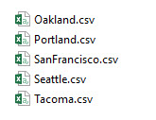
- Examine the City “.csv” files to see what Fact Date data is in each file. A picture of one of the tables look like this:
  - 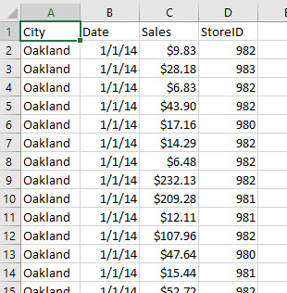
- Open a blank Power BI Desktop file.
- Save Power BI File.
- Using Power Query import the “.csv” files into a single Fact Table.
- During the Fact import and transformation, using Power Query (and what we learned earlier in our class) extract and create a City Dimension Table. The Finished Fact Table and City Table should look like picture below:
  - Hints:
    - In the Fact Table create a new column to create the CityID (First Letter of City Name & StoreID)
    - Do not delete City & StoreID columns until later).
    - Duplicate Fact Table Query.
    - Now go back and delete City & StoreID columns.
    - For City Table, delete Date and Sales columns, then Remove Duplicates.
    - Close and Load to Data Model.
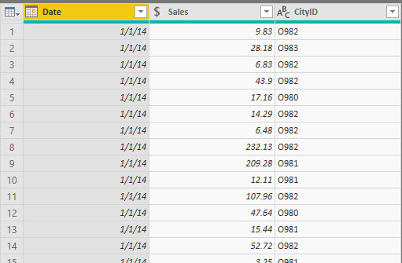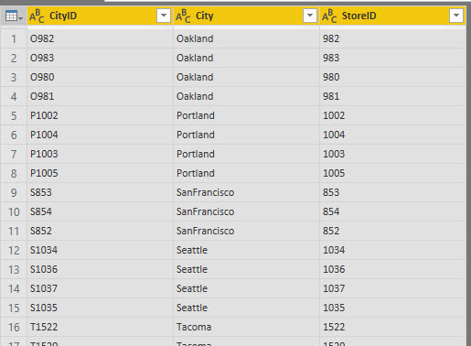
Fact Table
City Table
- Create a Date Table using DAX Formulas. The start date for the Fiscal Year is July 1.
- The Date Table should look like this:
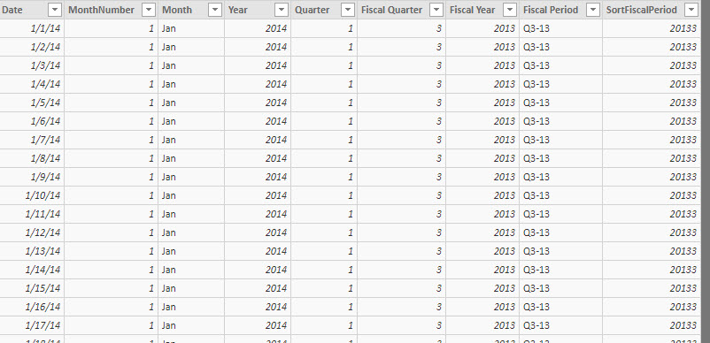
- The Relationships should look like this:
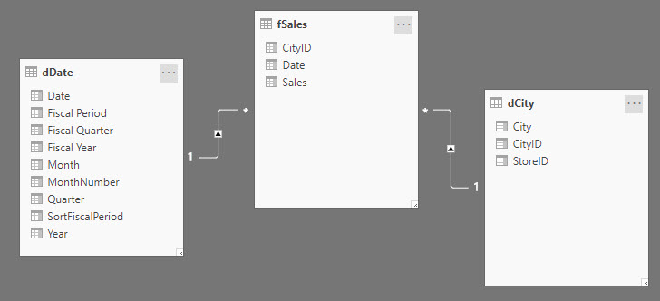
- Create Measures for Total Sales, Average Transactional Sales, Average Daily Sales, and a Rolling 12-month Average for Transactional Sales.
- Create a Measure to count the number of Transactions for a given set of criteria with the DAX formula =COUNTROWS(fSales)
- Create a Hierarchy for StoreID and City.
- Hide any columns you do not need in report view.

- Data Model should look something like:
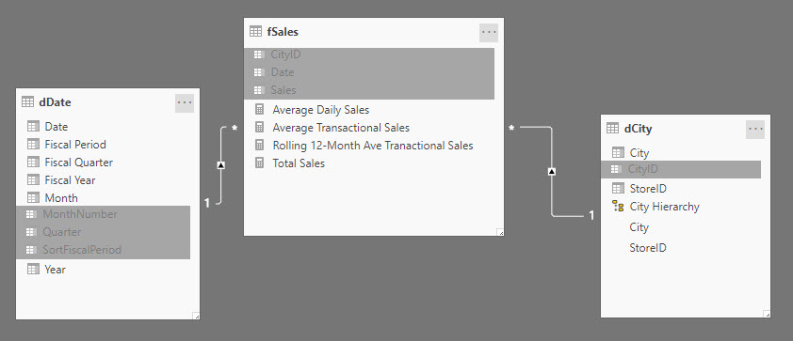

- Create a Dashboard that shows:
  - The three averages in a Line chart by Fiscal period
  - A column chart that shows Total Sales by the Hierarchy City and Store.
  - Bar Chart that shows the Number of Transactions by the Hierarchy City and Store.
  - Add a slicer for City. The Slicer should only control the Bar Chart.
- The picture of the dashboard is here:
