Steps to Importing Excel Data Model into Power BI Desktop File for E-Dab Video #10:
- Download the files:
  - “E-DAB-10-ExcelFileSourceTables.xlsx”.
  - “E-DAB-10-ExcelFileWithDataAndReports.xlsx”.
  - “E-DAB-10-PowerBIDesktop-Start.pbix”.
- Open the “E-DAB-10-PowerBIDesktop-Start.pbix” file.
- To import the Data Model from the Excel file “E-DAB-10-ExcelFileWithDataAndReports.xlsx” into the Power BI File, in the Power BI Desktop file , go to the File Menu, then click on Import, then click on “Power Query, Power Pivot, Power View”, as seen here:
  - 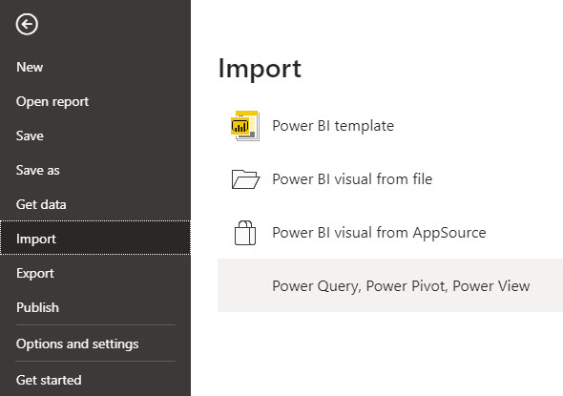
- Find and select your file in your location on your computer named “E-DAB-10-ExcelFileWithDataAndReports.xlsx”, as seen here:
  - 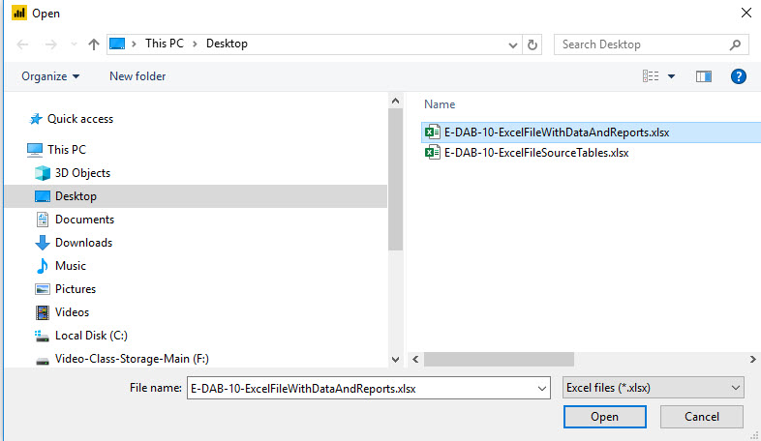

- In the next window click “Start”, as seen here:
  - 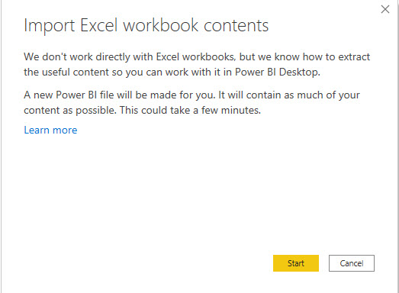
- In the next Window, lick “Close”, as seen here:
  - 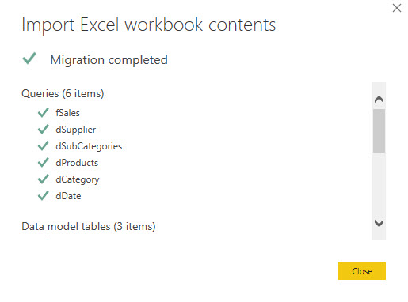
- Then in the Power BI Desktop Home Ribbon Tab, Queries group, click the drop-down arrow for “Transform data”, then from the drop down click the “Data source settings”, as seen here:
  - 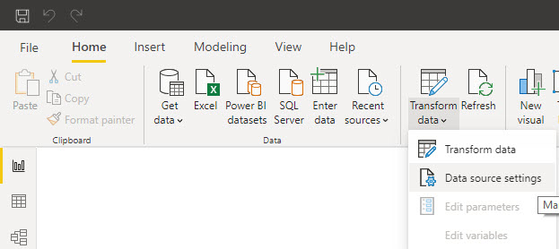

- In the next window: 1) Select the data source location (this is the location of the Excel files that has the tables we are using) and 2) Click the “Change Source” button, as seen below:
  - 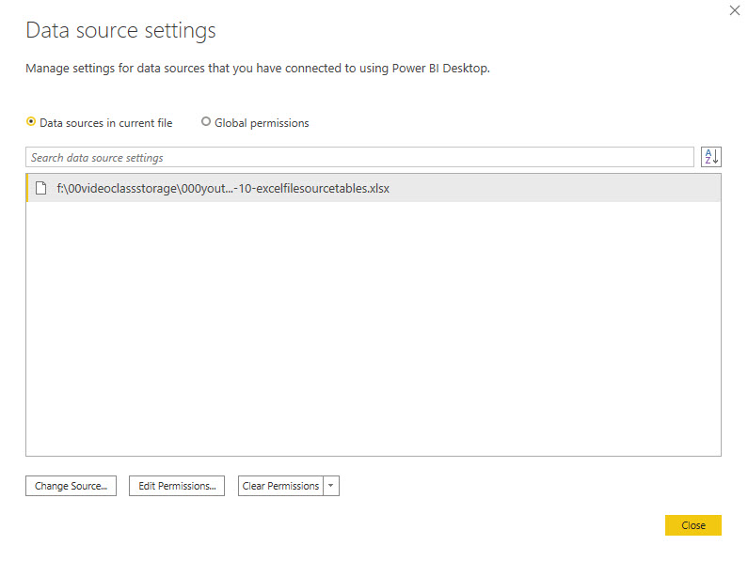
1
2
- In the next dialog box, click “Browse”, as seen here:
  - 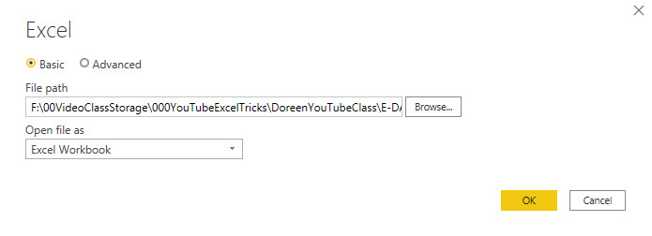
- Find and select your file in your location on your computer named “E-DAB-10-ExcelFileSourceTables.xlsx”, as seen here (This step allows the Power BI File to see the location of the data source, the Excel Tables in the Excel file):
  - 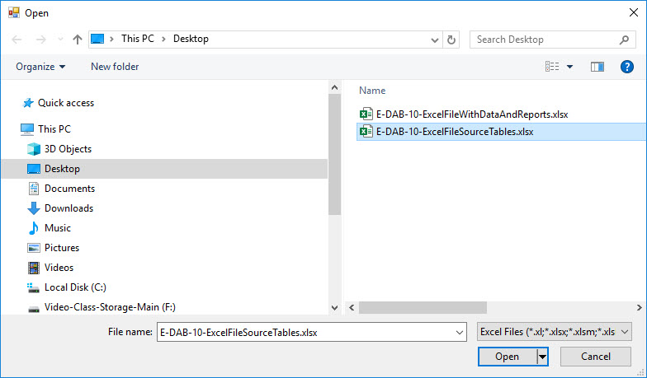
- Click OK in the next step.
  - 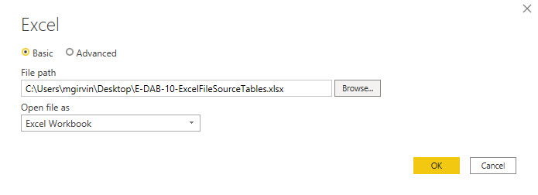
- Click Close in the next step.
  - 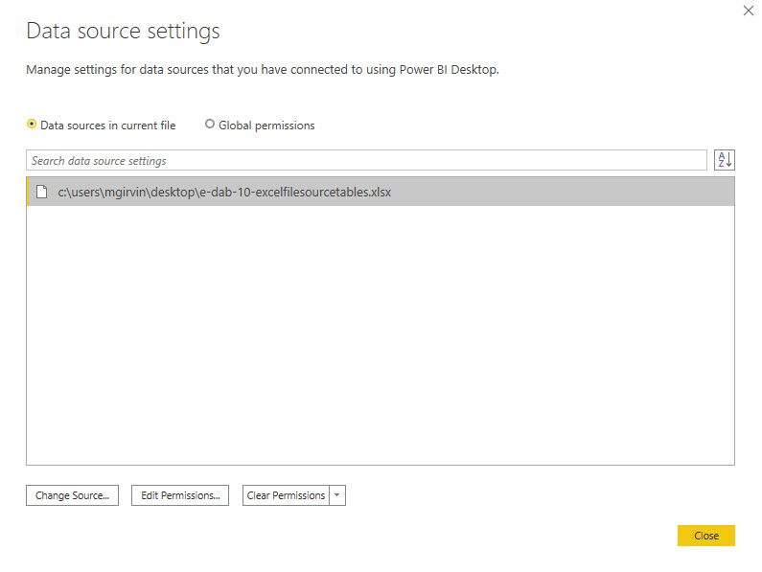
- In the Power BI Desktop File, click the “Apply Changes” button in the yellow area (This allows the Power BI File to update the data based on the new Data Source Location).
  - 