Video #18 Homework
- Problem #1
  - Download the file named “018-MSPTDA-HomeworkFile01Start.pbix”.
  - In this file there is a Measure named “Ave Transactional Revenue”. This Measure calculates the incorrect answer. Fix the Measure so it calculates the correct answer.
- Problem #2
  - Use the file from the video named “018-MSPTDA-BigDataStart.pbix”.
  - In this file create the following measures and then time them using DAX Studio:
    - 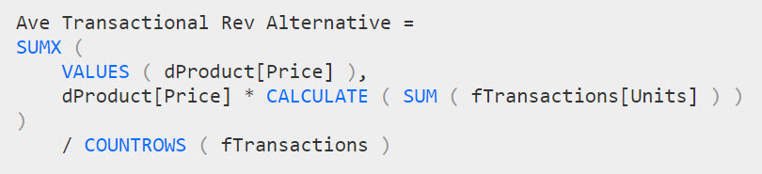
  - In this file create a Measure that calculates the Average Monthly Revenue.

