Our Project in Access:



1. Code for Input Mask Properties:  
     
   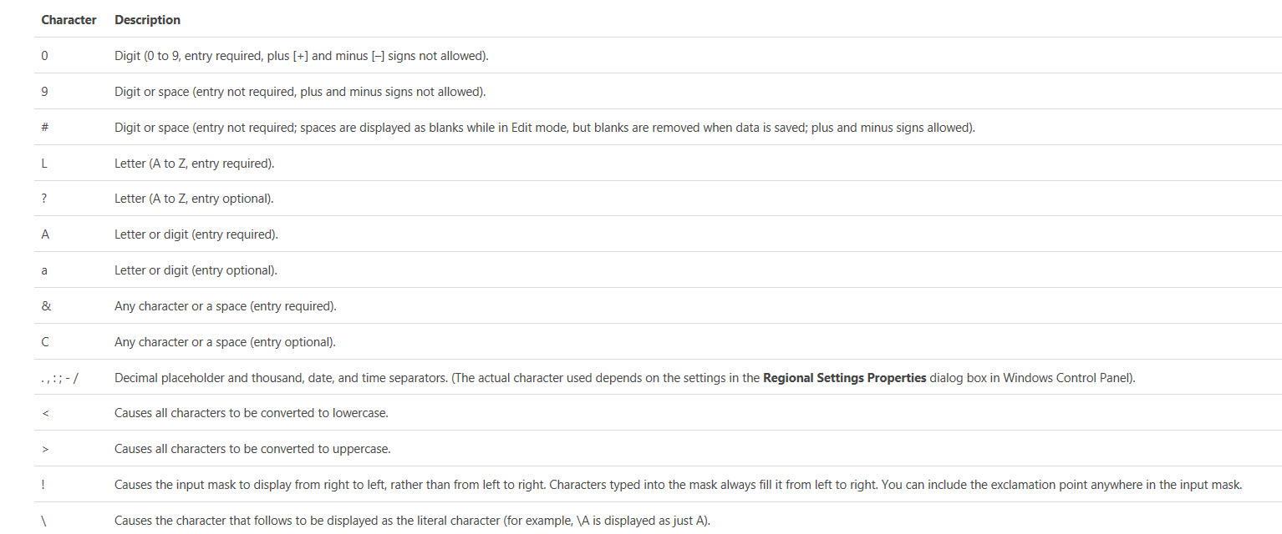  
     
   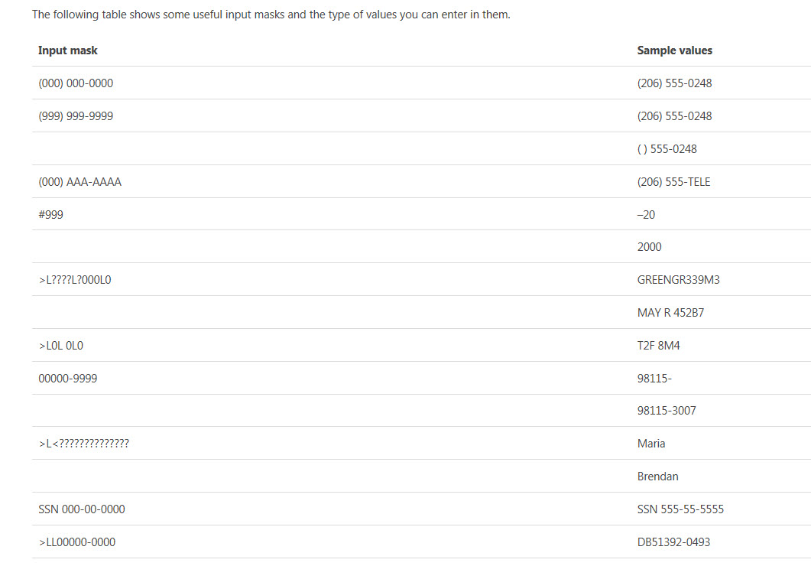
2. Numbers can have these Field Size Properties:
3. Create Data Base
   1. After opening Access, click “Blank Desktop Database”:  
      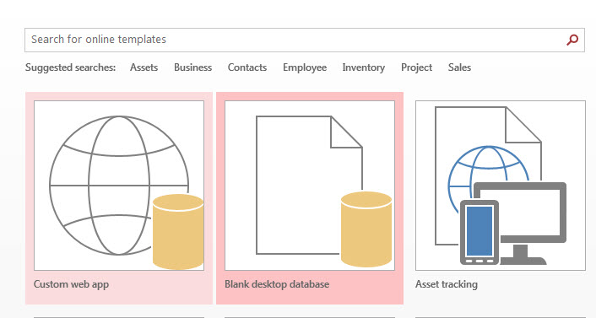
   2. Navigate to save file to Access Class Notes folder and type the file name “Products.accdb”, then click Create:  
      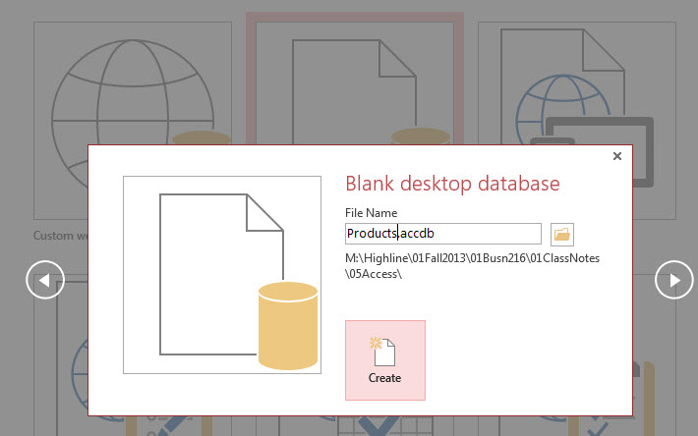
   3. This is what you will see after the database is created:  
        
      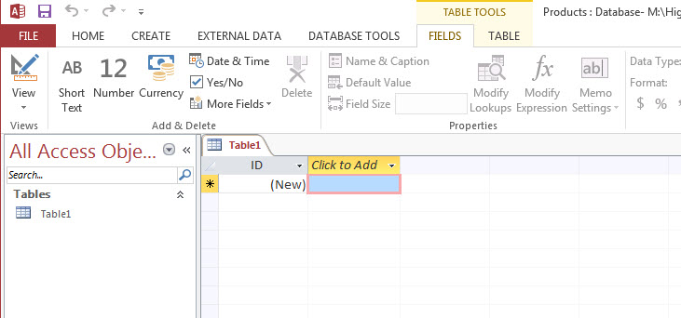
   4. Click the View button to get to “Design View”:  
      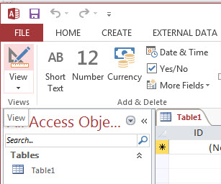
   5. After clicking the View button, the Save As dialog box for the Table appears. Type “Products” and click OK:  
        
      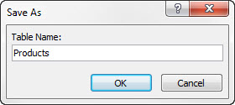
   6. Now we can see Design View. This is where we create the Fields for the Table and the Data Types and Data Validation for each field:  
        
      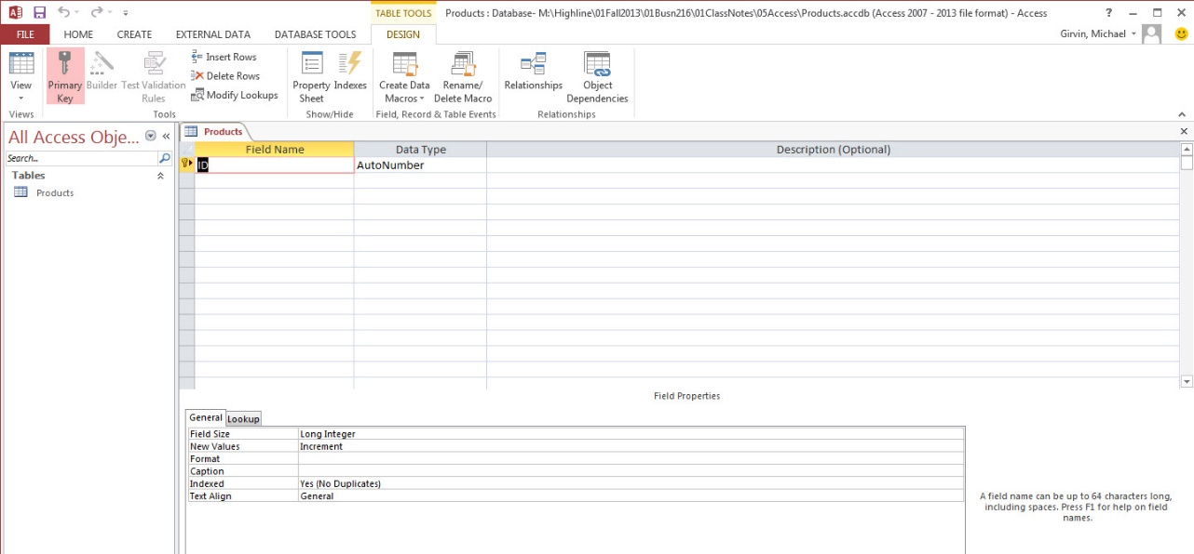
4. Close the Table for now.
5. Import Excel Table:
   1. On the External Data Tab, click the Excel button and follow the steps to import the Supplier Table that you downloaded from our Access page at our web site:
      1. 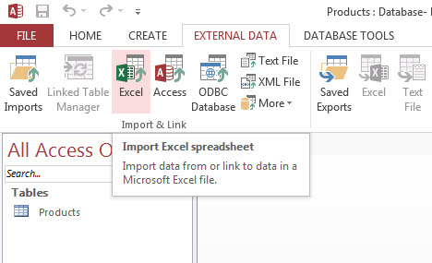
      2. 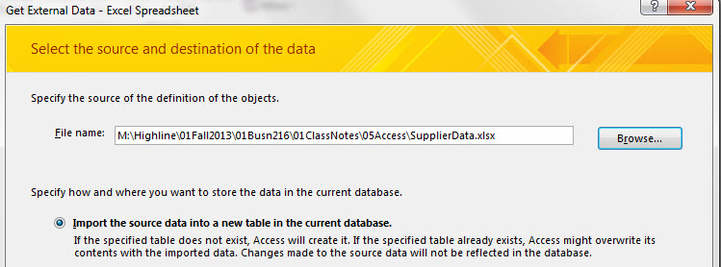
      3. 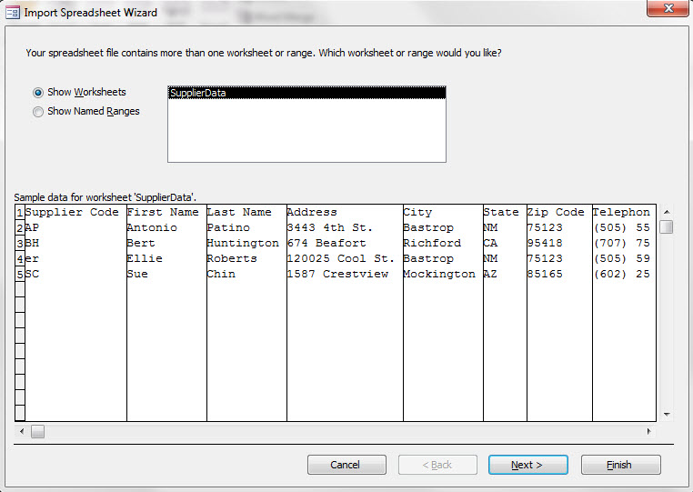
      4. 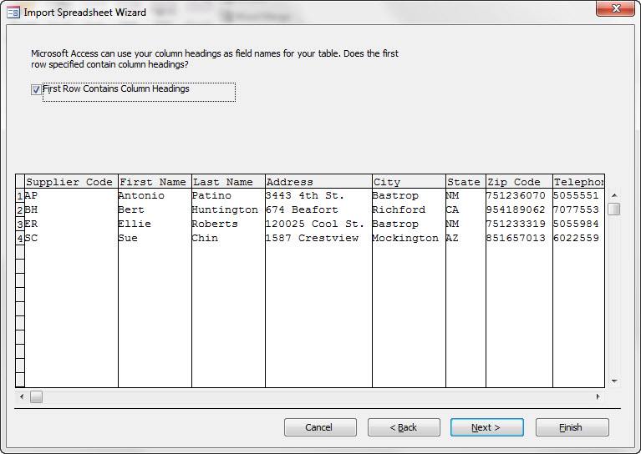
      5. 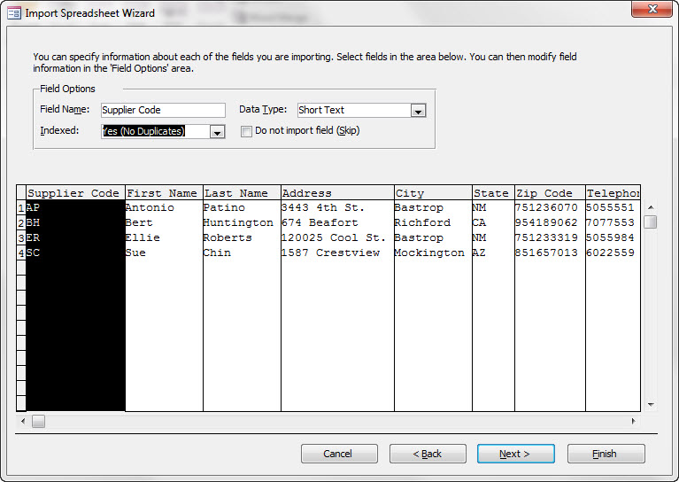
      6. 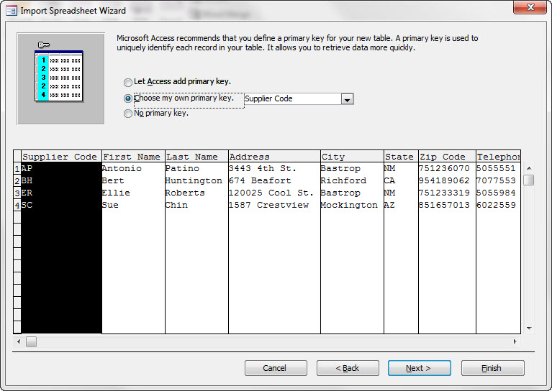
6. Add Data Types Field Properties (Data Validation) to Supplier Table. These are pictures from video:
   1. Open Table in Design View:  
      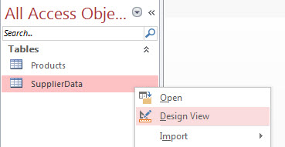
   2. Properties for each Field:

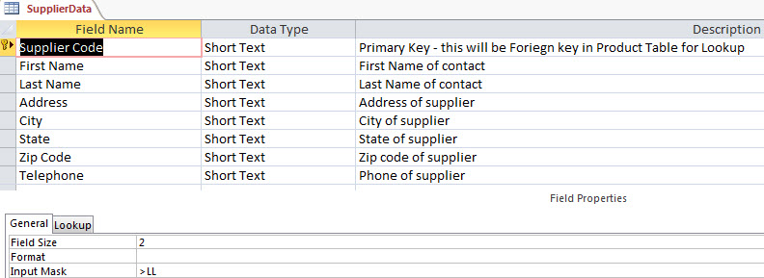  
  
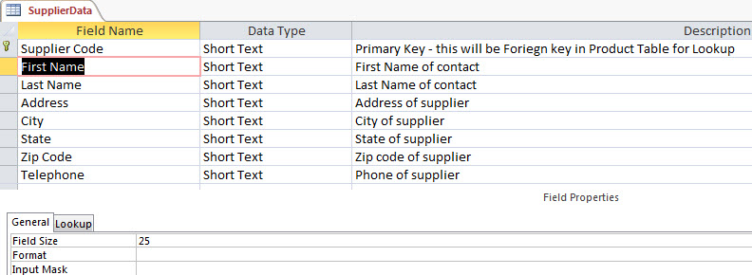  
  
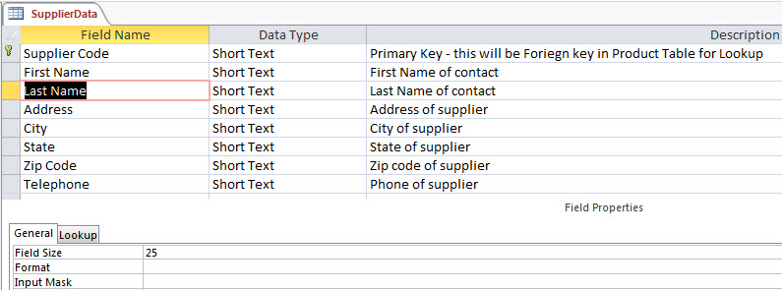  
  
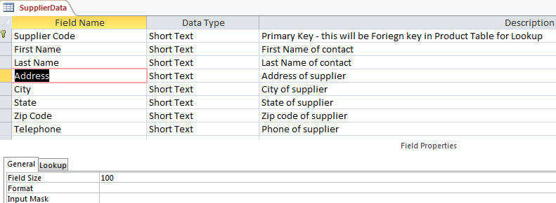  
  
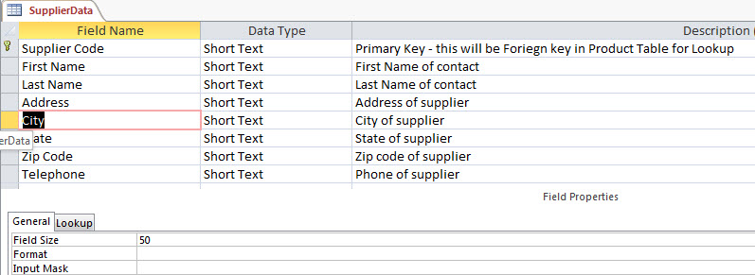  
  
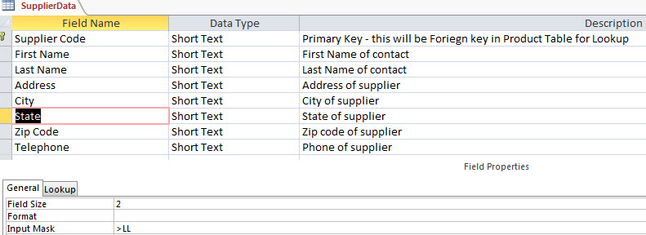  
  
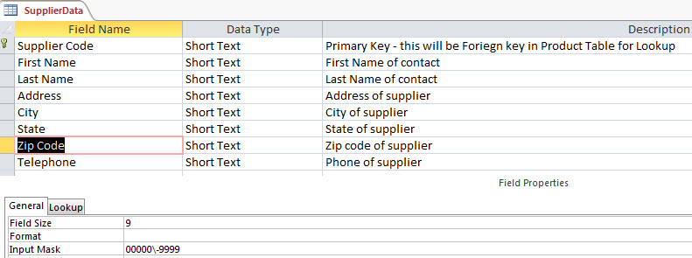  
  
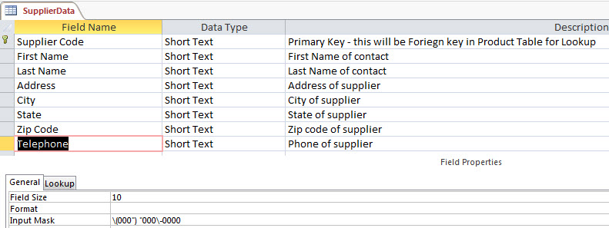

1. Create Fields and Properties for Product Table and then add the raw data. Here is a picture of the raw data and properties and Data Types for the Product Table:

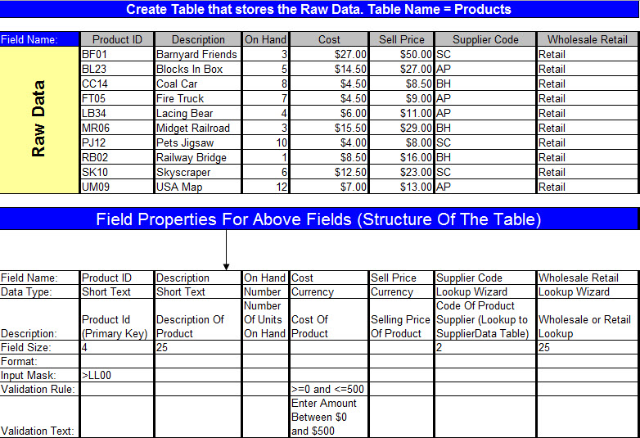

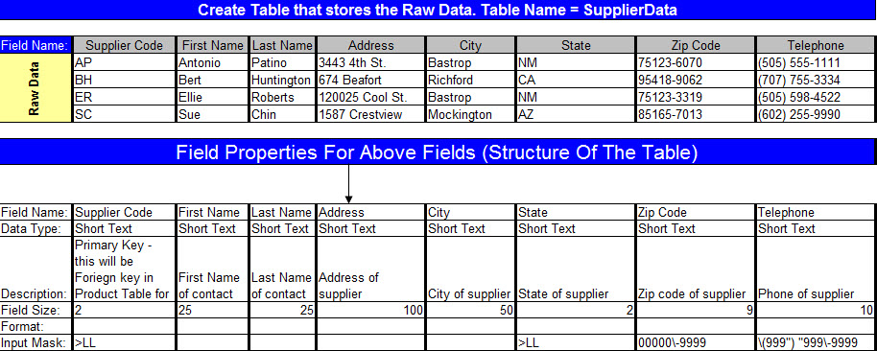

1. Example of screen shots from creating Lookup From Products Table to Supplier Table (Like a VLOOKUP in Excel):
   1. 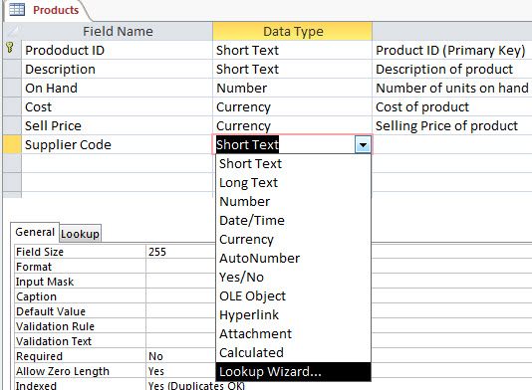  
        
      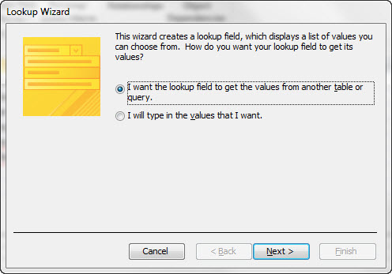  
        
      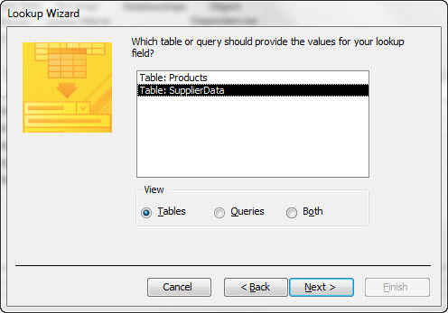  
        
      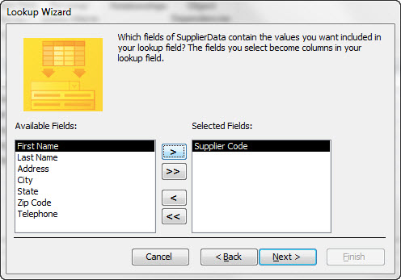  
        
      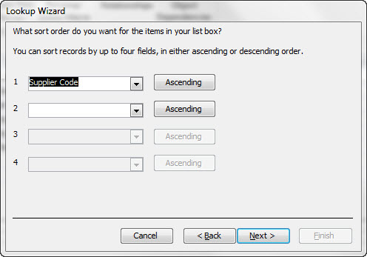  
        
      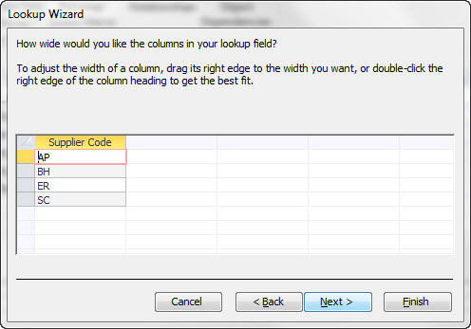  
        
      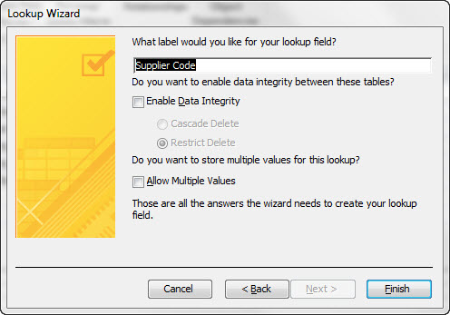  
        
      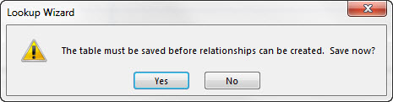
2. Create Relationships:
   1. Here are screen shots from the video:
   2. 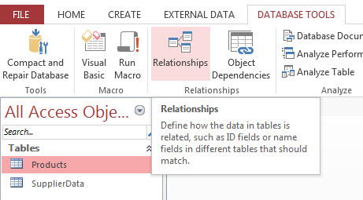
   3. 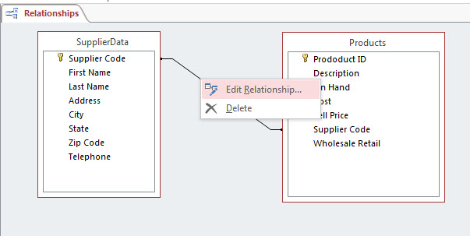
   4. 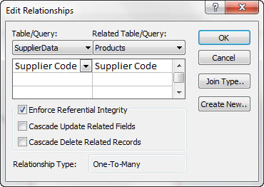
   5. 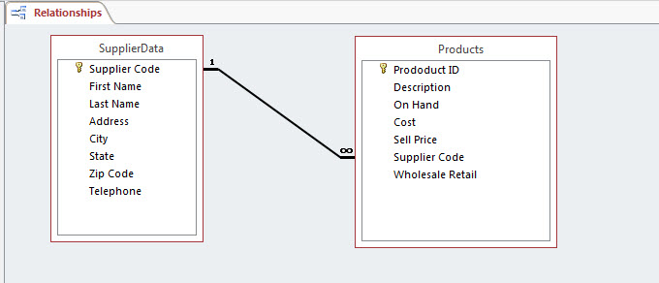
3. Create Form:
   1. Select Products Table, then create Form:  
      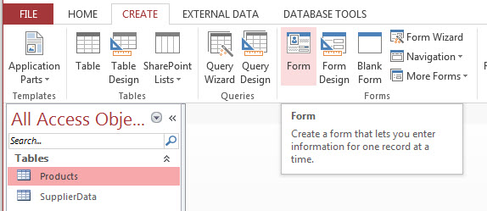
   2. Right-click Supplier Code field and point to Properties:  
      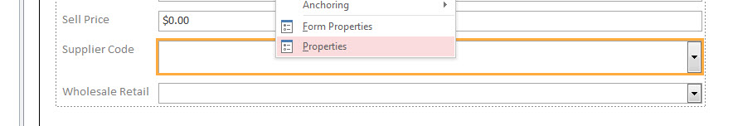
   3. Change height to 0.25:  
      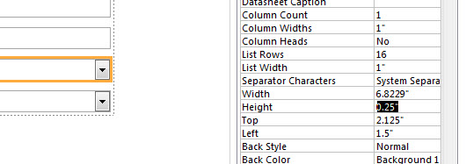
   4. Before using Form to enter raw data, get into “Form View”:  
      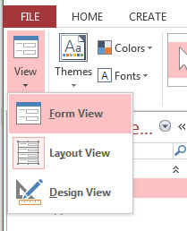
4. Build Queries (see video for details of how to build the queries in Design View):
   1. Here are the questions that we will ask of our database:  
      1. Define Data Analysis: Raw Data 🡺 into Useful Information
      2. Define Query: Ask a question of the raw data. The answer is the useful information used for decision making.
      3. Question: “Show just Description and Sell Price, Sorted by Sell Price”
         1. Name of Query: **Description and Sell Price**
         2. Show Fields:
            1. Description
            2. Sell Price
         3. Sort: Ascending on Sell Price field
      4. Question: “Show the product records for Supplier SC”
         1. Name of Query: **Products From SC**
         2. Show Fields: All
         3. Criteria:  
            Supplier Code Field: SC
      5. Question: “Show the product records, where On Hand units are greater than or equal to 10”
         1. Name of Query: **On Hand >= 10**
         2. Show Fields: All
         3. Criteria:  
            On Hand field: >=10
      6. Question: “Show records where Sell Price is less than $10 and On Hand units are greater than or equal to 8”
         1. Name of Query: **Sell Price < $10 AND On Hand >=8**
         2. Show Fields:
            1. Description
            2. Sell Price
            3. On Hand
         3. Criteria (AND Criteria goes on same line (row)):  
            Sell Price field: <10 AND On Hand field: >=8
      7. Question: “Show Products that have a Sell Price between $5 and $10”
         1. Name of Query: **Price Between $5 and $10**
         2. Show Fields: all
         3. Criteria (Between Criteria):  
            Sell Price field: Between 5 AND 10
         4. Sort: Ascending on Sell Price field
      8. Question: “Show records for the Suppliers SC or AP”
         1. Name of Query: **Suppliers “SC” OR “AP”**
         2. Show Fields: all
         3. Criteria(OR Criteria goes on different lines (rows)):  
            Supplier Code field: SC  
            OR  
            Supplier Code field: AP
      9. Question: “Calculate average Sell Price”
         1. Name of Query: A**verage Sell Price**
         2. Show Fields:
            1. Sell Price
         3. Totals Row:
            1. Avg function
      10. Question: “Calculate average Sell Price for each Supplier”
          1. Name of Query: A**verage Sell Price by Supplier**
          2. Show Fields:
             1. Sell Price
             2. Supplier Code
          3. Totals Row:
             1. Sell Price: Avg function
             2. Supplier Code: Group by
      11. Question: “Calculate Inventory Value”
          1. Name of Query: **Inventory Value**
          2. Show Fields:
             1. Description
          3. Cacluated Field:  
             Inventory Value:[On Hand]*[Cost]
      12. Question: “Gross Profit per Product”
          1. Name of Query: **Gross Profit per Product**
          2. Show Fields:
             1. Description
          3. Cacluated Field:  
             Gross Profit:[Sell Price]-[Cost]
      13. Question: “Show records that have a Description that contains RAIL”
          1. Name of Query: **RAIL Query**
          2. Show Fields: all
          3. Criteria:  
             Description field: *rail*
      14. Question: “Show phone and supplier contact for products that have On Hand less than 5”
          1. Name of Query: **Reorder Phone List**
          2. Show both Tables
          3. Show Fields:
             1. Product ID
             2. Description
             3. On Hand
             4. Cost
             5. First Name
             6. Phone
      15. Question: “Parameter Query for Supplier Code”
          1. Name of Query: **Records by Supplier**
          2. Show Fields: all
          3. Criteria:  
             Square brackets with phrase in it, like: [Enter Supplier Code]
5. Create Reports using Wizard: See video.
6. Export To Excel: See video.