Video Project 38: Excel 2013 Basics 20: Relative, Absolute and Mixed Cell References
Goal in video: Learn how to use Relative, Absolute and Mixed Cell References in formulas.
Topics Covered in Video: see next page.

- Cell reference notes on next two pages.
- Keyboard shortcut F4 key: Toggles between the four types of cell references
- Why do we use Mixed Cell References:
  - BECAUSE THEY SPEED UP FORMULA CREATION TIME!!!
  - For a 12 month budget, using Mixed Cell References will allow you to create your formula 12 times faster than someone who only used Relative and Absolute Cell References.
- Two methods for learn how to use Mixed Cell References:
  - Sledge Hammer Method:
    - Create formula
    - Copy to next cell
    - See what it was that changed (letter or number), which you did not want to change
    - Go back to top cell and put a dollar sign in front of the thing that changed (letter or number), which you did not want to change. You put the dollar sign in front of the letter or number stops it from changing as a relative reference.
  - Question method:
    - When creating formulas with cell references that you will copy to other cells, ask two questions of every cell reference in your formula in order to figure out which of the four cell references you need:
Q1: What do you want the cell reference to do when you copy it across the columns or horizontally?
        - Should the cell reference move relatively?
OR
        - Should the cell reference be locked or absolute?
Q2: What do you want it to do when you copy it vertically?
        - Should the cell reference move relatively?
OR
        - Should the cell reference be locked or absolute?
    - If your formula will never be copied to another cell, then you do not need to worry about which of the four cell references you need. Cell references without any dollar signs will work just fine. It is only when we copy the formula that it matters what type of cell reference it is.
- Copying Formulas into Rectangular Ranges:
  - If you are copying a formula to a rectangular range with your Angry Rabbit (Cross Hair) and Fill Handle, you must do it in 2 steps:
    - Copy it one direction
    - Let go of Mouse
    - Grab the Fill Handle with your Angry Rabbit a second time
    - Copy the other direction
  - If you have the rectangular range selected BEFORE you create your formula:
    - Create Formula in Active Cell (light colored cell)
    - To populate the contents of the Active Cell into all the selected cells, use keystroke: Ctrl + Enter
- New Keyboard Shortcut:
  - F4 key toggles between the four cell references.
  - To populate the contents of the Active Cell into all the selected cells: Ctrl + Enter

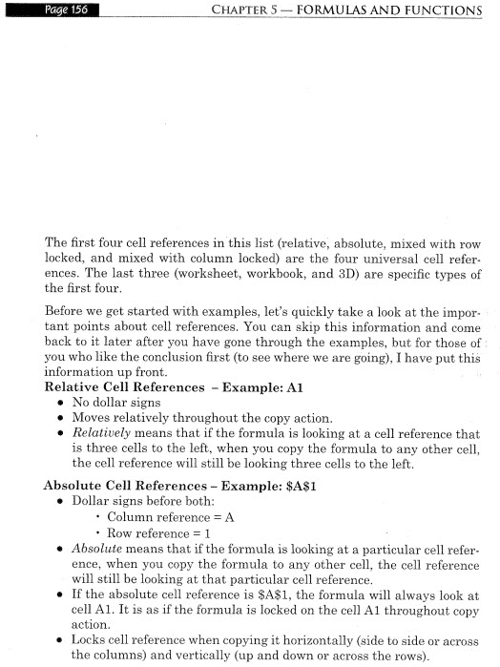

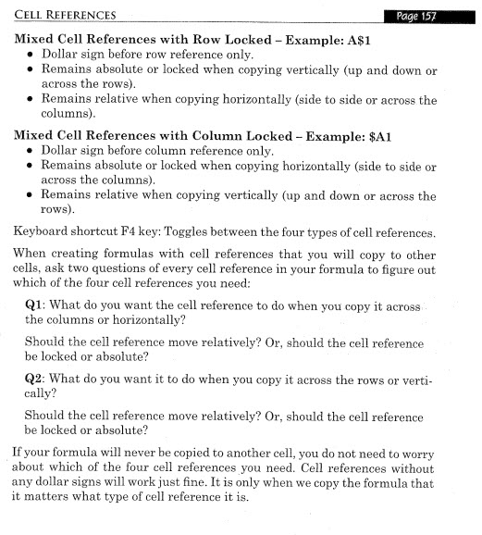

Video Project 39: Excel 2013 Basics 21: Assumption Tables for Formula Inputs
Goal in video: Learn how to Correctly Orientate Assumptions tables for Formula Inputs.
Topics Covered in Video:

- In order to use Mixed Cell References, the labels for the formula inputs in the Assumption Table must be orientated the same direction as the labels and formulas in the Formula Table:
  - Vertical, Vertical
or
Horizontal, Horizontal
- Why do we use Mixed Cell References:
  - BECAUSE THEY SPEED UP FORMULA CREATION TIME!!!
  - For a 12 month budget, using Mixed Cell References will allow you to create your formula 12 times faster than someone who only used Relative and Absolute Cell References.
- Reminder about when to use ROUND:
  - You are required to round, like with money.
  - When you are multiplying or dividing decimals.
  - The formula result will be used in subsequent formulas, like adding with SUM.

- New Keyboard Shortcut:
  - None.

