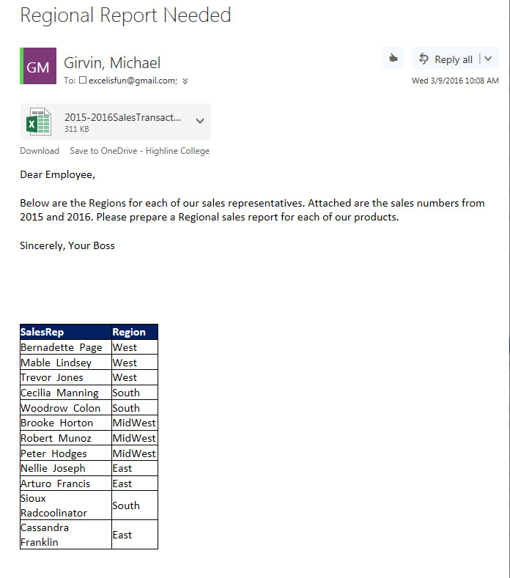

SalesRep | Region
Bernadette Page | West
Mable Lindsey | West
Trevor Jones | West
Cecilia Manning | South
Woodrow Colon | South
Brooke Horton | MidWest
Robert Munoz | MidWest
Peter Hodges | MidWest
Nellie Joseph | East
Arturo Francis | East
Sioux Radcoolinator | South
Cassandra Franklin | East

