Intro To Office 2013 Video Project 13: Tables
  - Why use a Word table instead of an Excel Table?
    - If you have only words and images, it is ok to use a Word Table.
    - If you have an unusual configuration of cells in the table, it may be easier to use Word.
    - If you have numbers, calculations, or patterned text (like Jan, Feb, Mar, etc.), use Excel to create a table, then copy and paste or Paste Special Link the Excel Table into Word.
  - To Insert a Table use Insert Ribbon Tab
  - Format a Word Table, use context sensitive Table Tools Design Ribbon Tab
  - If you copy Table from Excel and you want to do a “Paste Special Link”:
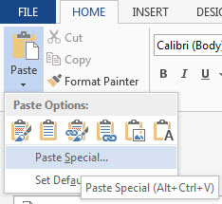 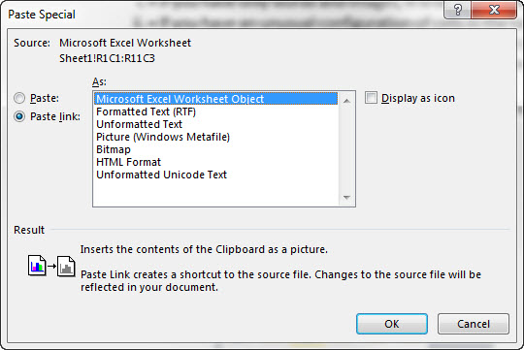
  - Table aspects:
    - Cell = intersection of row and column
    - Content = “words, pictures, etc.” in cells
    - Tab moves cursor forward
      - Ctrl + Tab = Tab
    - Shift Tab moves cursor backwards
    - Enter adds new line to cell
    - Cursor for highlighting cell is little black diagonally pointing arrow
      - Point at edge of cell to see
    - Cursor for highlighting row is large white diagonally pointing arrow
      - Point at beginning of row to see
    - Cursor for highlighting column is small black downward pointing arrow
      - Point at top of a column to see
    - Table resize handle is in lower right corner – you have to move cursor to it until you see a diagonally pointing arrow, and then click and drag.
    - Table Move Handle is in upper left corner (this selects the whole table)
    - Cursor for changing size of cell looks like two thin vertical lines with black horizontally pointing arrows
      - Point at the line between two cells
    - To Insert Row/Column, point to Row/Column, then right-click and point to Insert
    - To merge cells, highlight more than one cell, right-click, click on merge
    - To split cells, highlight one cell, right-click, click on split
    - To align cell content, right-click cell and point to cell alignment
Keyboards:
- F4 = Repeat. In Word, Excel, PowerPoint.
- In Excel, Ctrl + Enter = Puts thing in cell and keeps cell selected.
Intro To Office 2013 Video Project 14: Tabs

- Tabs
  - Paragraph Level Formatting.
    - Every time you hit Enter, the Tab settings carry forward.
  - Tabs are markers on the horizontal ruler that tells Word where to position the insertion point when you hit the Tab key.
  - Tab Stop Alignment (alignment of characters at the location of the tab stop):
    - Left
    - Center
    - Right
    - Decimal (line decimals up)
    - Bar (inserts bar – Not a real tab – usually set a tab immediately after the bar tab)

Keyboards:

Tabs dialog box = Alt, O, T

