Office 2013 Video Project 10: AutoCorrect versus AutoText
AutoCorrect:
- What is it?
  - Makes spelling corrections as you type
or
  - Allows you to create a “shorthand” like typing “hcc” and a space to get “Highline Community College”.
- How to add an item to AutoCorrect:
  - File, Options, Proofing (on Left), AutoCorrect Options button, AutoCorrect tab.
  - Here is picture:
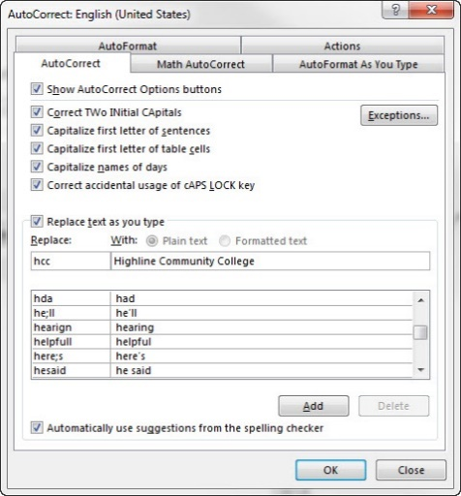
- How to enact: type “shorthand” or misspelled word and hit SPACEBAR.
AutoText:
What is it?
- Allows you to create a “shorthand” like typing “h” and then when you hit the F3 key it inserts “Highline Community College”.
- How to add AutoText:
  - Type text (“Highline Community College”), highlight, Insert Ribbon Tab, Text group, Quick Parts drop-down arrow, AutoText, “Save Selection to AutoText Gallery”, type “shorthand” text in Name textbox (“h”).
  - Here is picture:
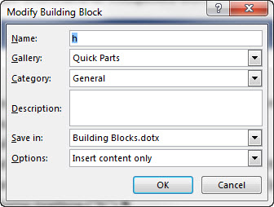
- How to enact: type shorthand and hit F3.

AutoCorrect: Type “shorthand” and hit Spacebar. AutoCorrect is automatic
AutoText: Type “shorthand” and hit F3. You get to choose.

Michael Thomas
Highline Community College
Michael Thomas
Highline Community College
I went to Michael Thomas Vernon
Mt
Michael Thomas

The

