Overview of In-class Access Project:



1. Create Blank Data Base
   1. Click Blank Database button
   2. Type the file name: Wooden Crafts.accdb
   3. Use the Folder button to save the database to your ClassNotes\04Access folder
   4. Click the Create button

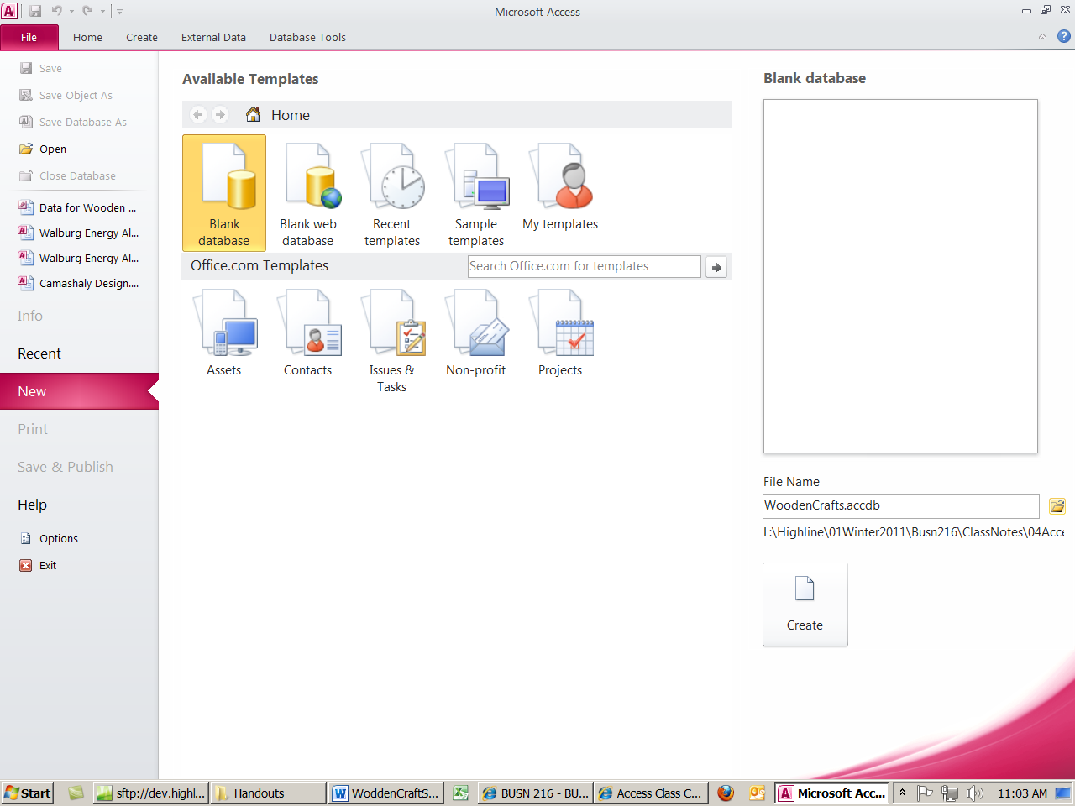

1. After you create database, you will see this::

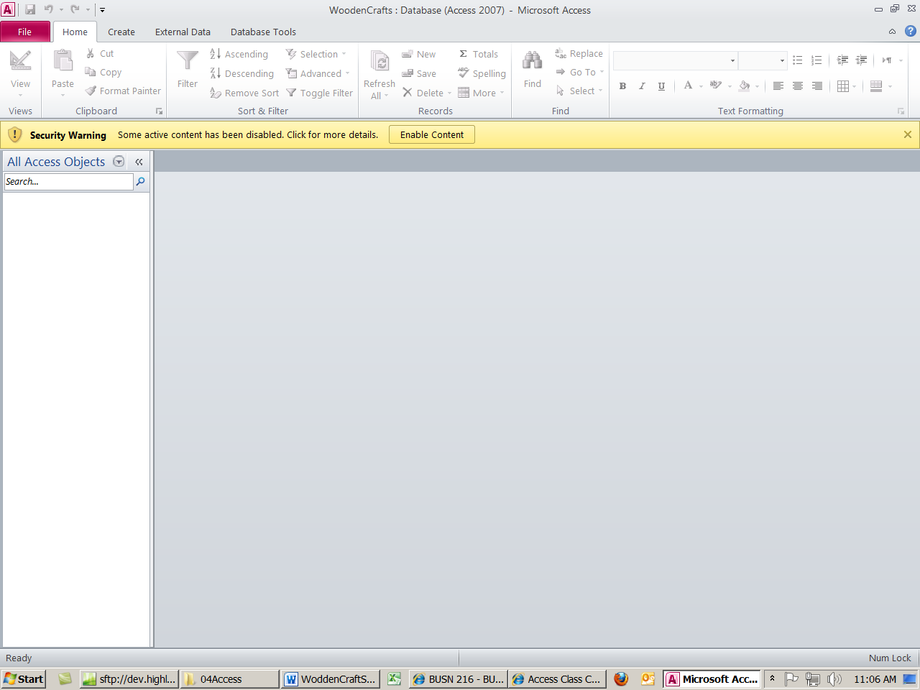

1. Click on Options button and “Enable this content”
2. Create Table:
   1. Import two tables into our database
      1. From the External Data Ribbon, click the Import Access database button:

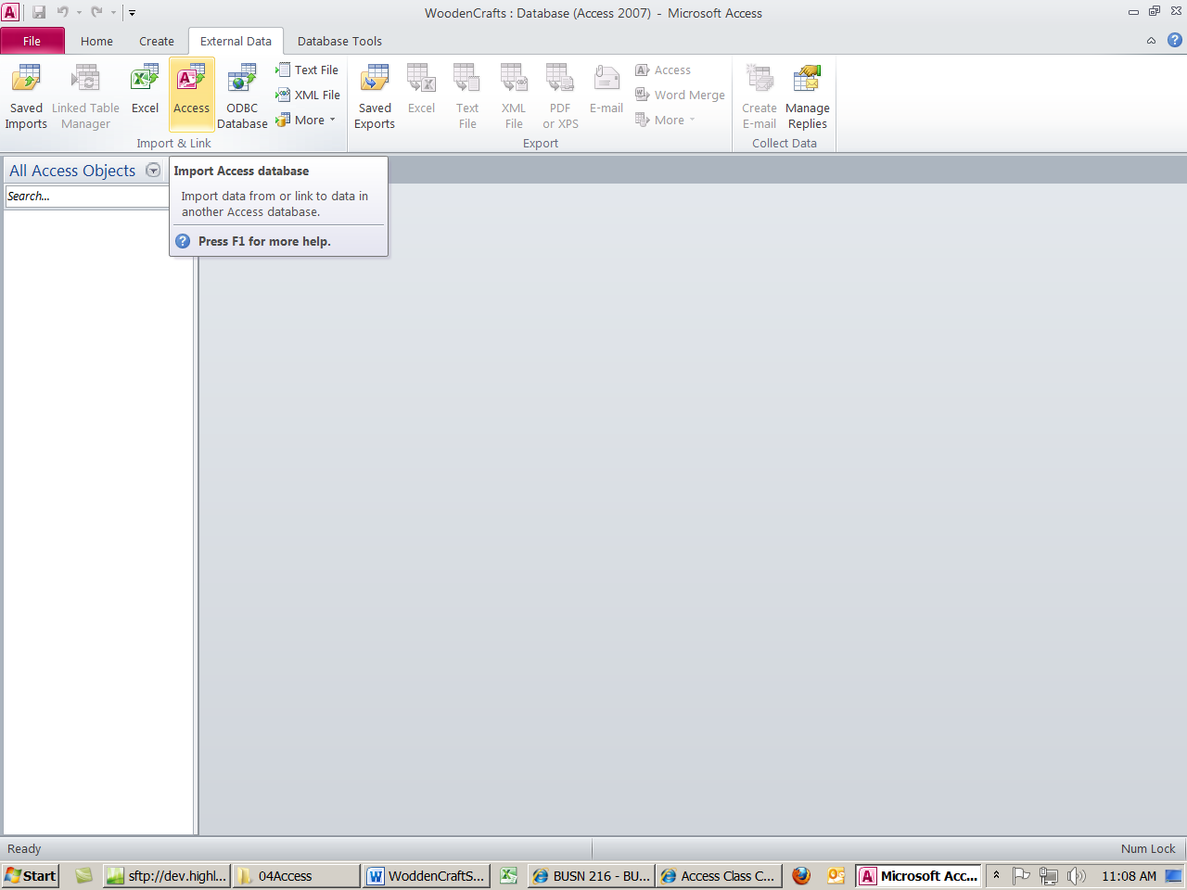

* 1. Create Product Table:



1. Create the Relationship between the Suppliers table (with primary key) and the Products table (with Foreign key):
   1. From the Database Tools Ribbon on the Show/Hide group, click the Relationships button.

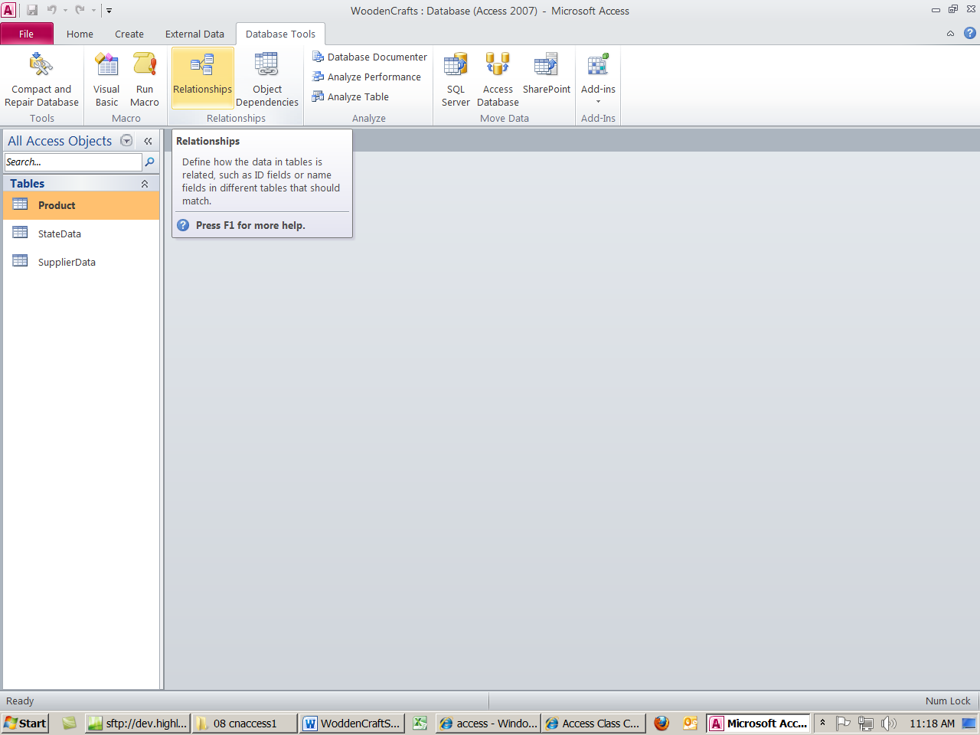

* 1. Using the title bar for each field list, drag the tables so that the order is as follows:

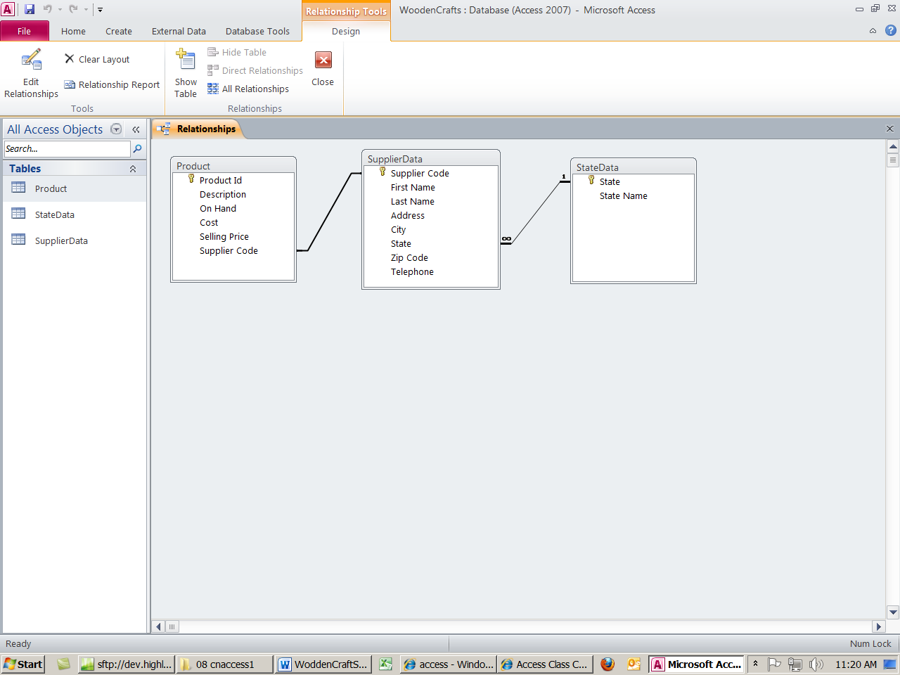

* 1. Right-click the join line and point to Edit-relationships:

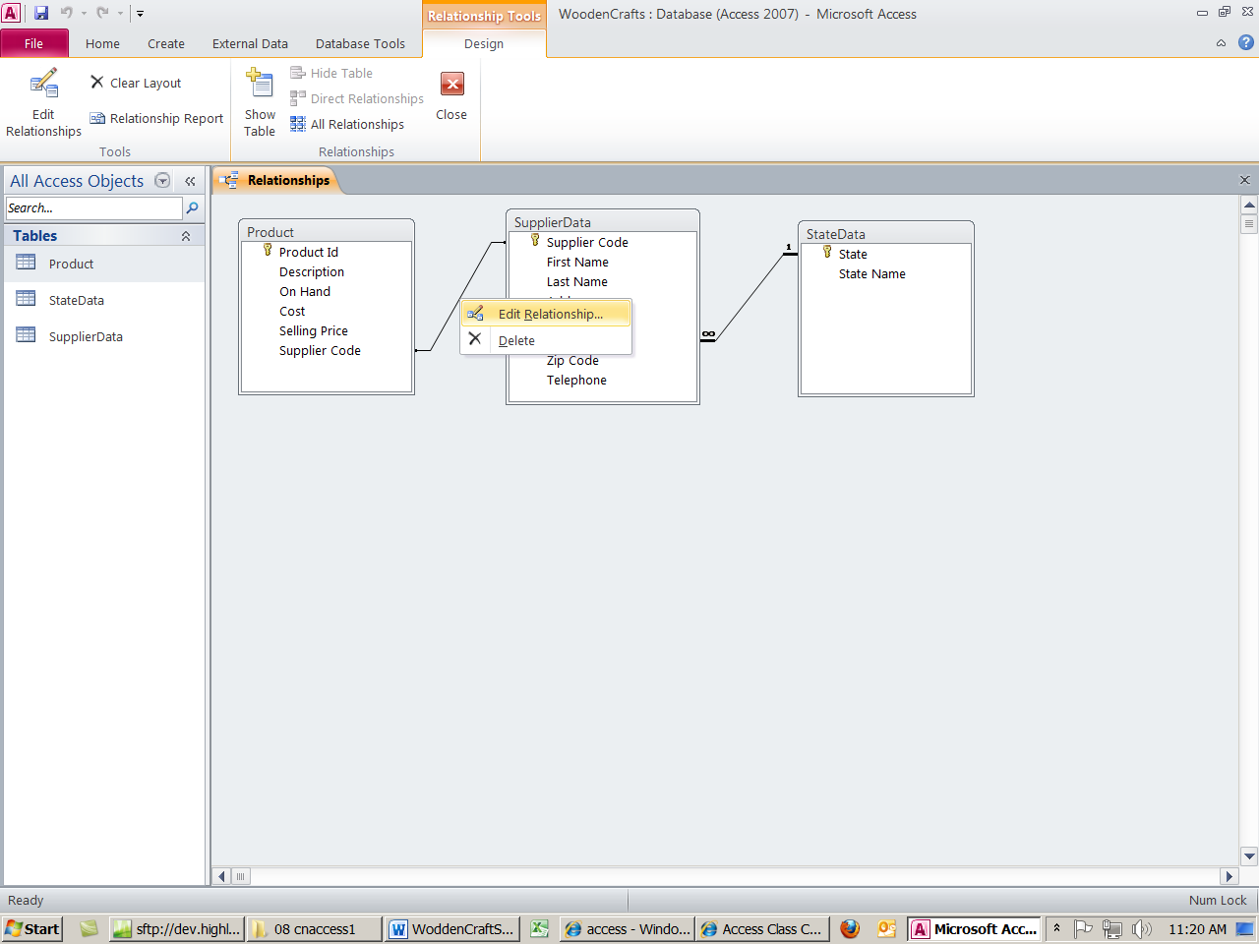

* 1. and then check Enforce Referential Integrity:

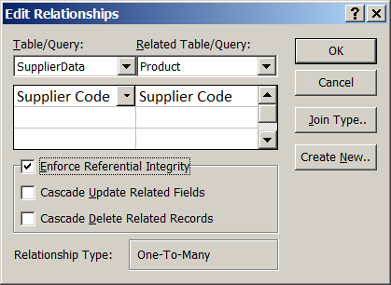

* 1. Click Save After you have Edited the Relationships

1. Create Form:
   1. From Create Ribbon we will create two forms:
      1. Default Form:
         1. From the Navigation Pane, select the table for which you would like to make a Form
         2. From the Create Ribbon, Query Group, click the Form button

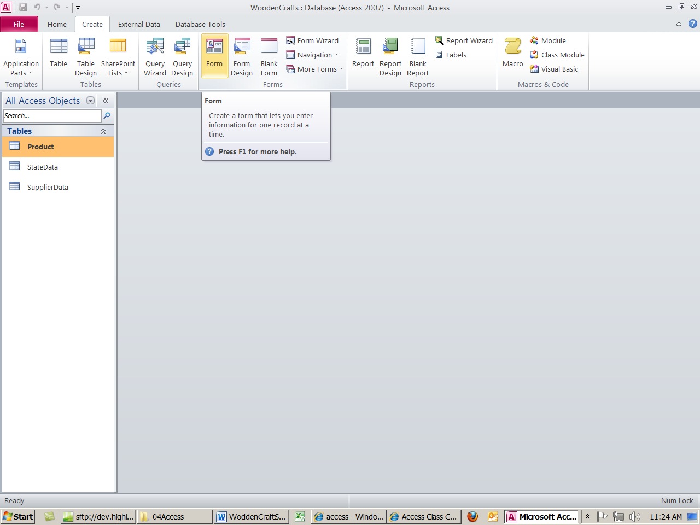

* + - 1. After you create Form and before you enter data, change the View to Form View

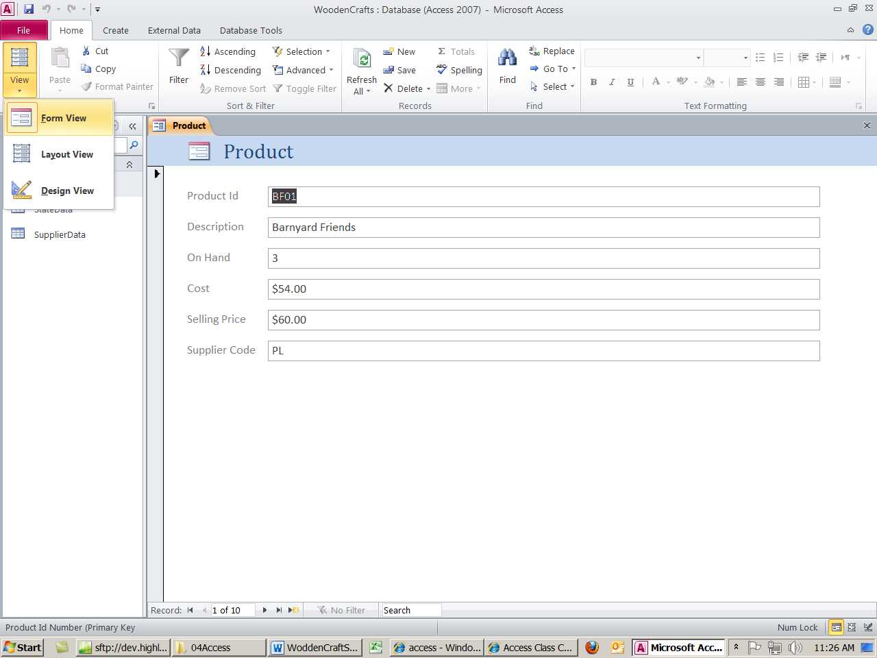

* + - 1. Save the Form with the name “Products Form”
  1. If you are viewing the objects in the Navigation Pane as “Object Type – All Access Objects”, after you create the forms you should see the following objects in the Navigation Pane:
     1. Object Type: 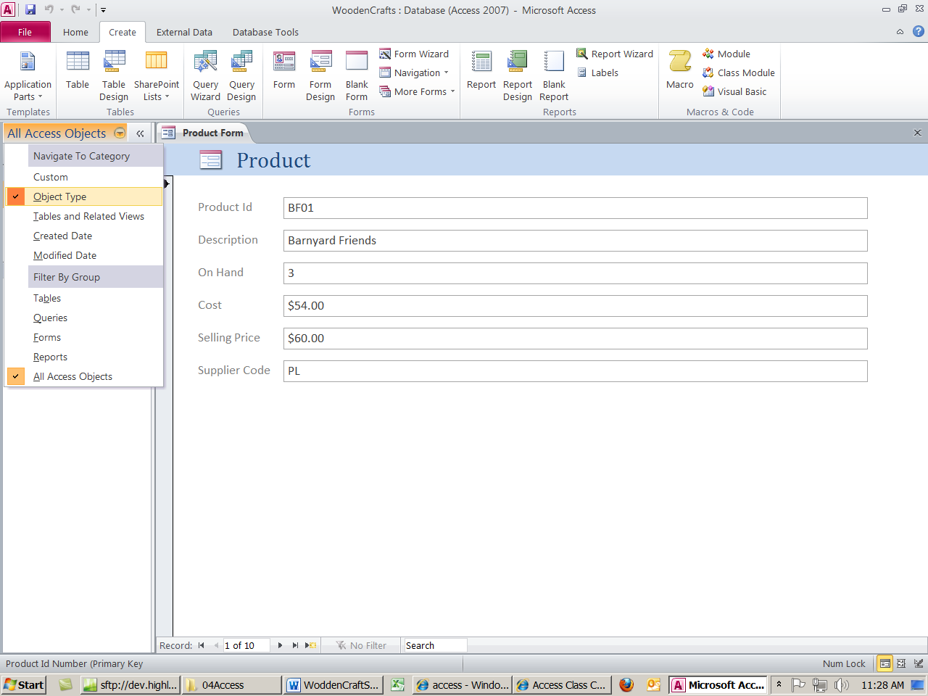 5 Objects: 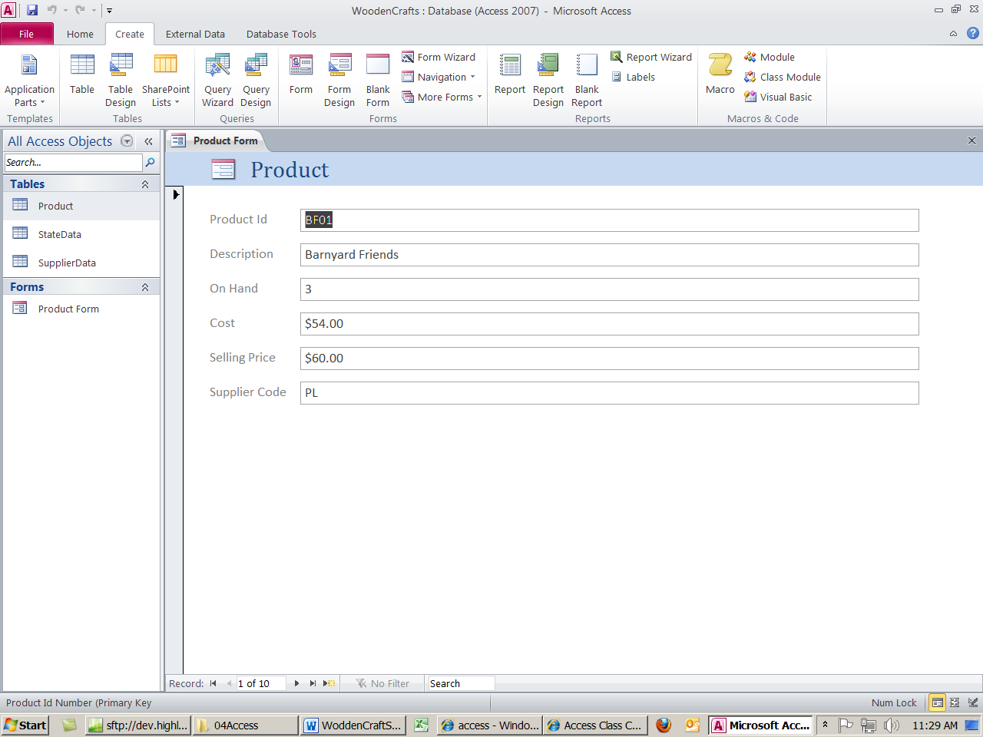

1. Wooden Crafts Queries:

# In-Class Wooden Crafts Queries:

* + 1. Question: “Show all Products, On Hand and Price”
       1. Show:
          1. Product ID
          2. Description

Each Number is a new query

* + - * 1. On Hand
        2. Selling Price
    1. Question: “Show Products, On Hand and Price for just SC”
       1. Show:
          1. Product ID
          2. Description
          3. On Hand
          4. Selling Price
          5. Supplier Code

Criteria: “SC”

* + 1. Question: “Show Products, On Hand and Price for the stated Supplier”
       1. Show:
          1. Product ID
          2. Description
          3. On Hand
          4. Selling Price
          5. Supplier Code

Criteria:

[Enter Supplier Code]

Called a “Parameter Query”

* + 1. Question: Show all Products and Cost
       1. Show:
          1. Product ID
          2. Description
          3. Cost
    2. Question: Show records that contain the word “rail”
       1. Show:
          1. Product ID
          2. Descriptions

Criteria:

*Rail*

Note: “*” is a wildcard that stands for 0 or more characters

* + 1. Question: “Show where cost less than 10”
       1. Show:
          1. Product ID
          2. Description
          3. Supplier Code
          4. Cost

Criteria: <10

* + 1. Question: “Show where sell price greater than or equal to 20.”
       1. Show:
          1. Product ID
          2. Description
          3. Sell Price

Criteria: >=20

* + 1. Question: “Show where Sell Price less than 15 AND On Hand greater than or equal to 10.”
       1. Show:
          1. All Fields
          2. Criteria:

Selling Price <15  
AND

On Hand >=10

Note: AND Criteria goes on “the same line”

* + 1. Question: “Show records for Supplier “SC” OR “BH”.
       1. Show:
          1. All Fields
          2. Criteria:

Supplier Code = SC  
OR

Supplier Code = BH

Note: OR Criteria goes on “different lines”

* + 1. Question: “What is the Inventory Value?”
       1. Show:
          1. Product ID
          2. Description
          3. Calculate:

Inventory Value:[On Hand]*[Cost]

Notes: Colon means that everything before colon is a label and everything after is a formula.

* + - * 1. Caption Property: Value Of Inventory
    1. Question: “What is Gross Profit per item?”
       1. Show:
          1. Product ID
          2. Description
          3. Calculate:

Inventory Value:[SellingPrice] - [Cost]

Notes: Colon means that everything before colon is a label and everything after is a formula.

* + 1. Question: “What is the Average Sell Price?”
       1. Show:
          1. Selling Price

Calculate:

Show Total Row (Right-click Design Grid, Totals)

Select: Ave

* + 1. Question: “What is the Average Sell Price for each Supplier?”
       1. Show:
          1. Supplier Code

Total Row:

Group by:

* + - * 1. Selling Price

Total Row:

Ave

* + 1. Question: “What is the Average Sell Price for each Supplier that is stated in popup text box?”
       1. Parameter Query
          1. Prompts for input whenever it is run
          2. Must use:

[ ]

A field name cannot be in brackets

* + - * 1. Copy Average Sell Price by Supplier query (12 from above)

Supplier Code

Criteria:

[Enter Supplier Code]

* + 1. Question: “Reorder Phone List”
       1. Show Two Tables: Product & Supplier
          1. Show:

Supplier Code

First Name

Last Name

Product ID

Description

Cost

On Hand

Criteria: <5

* + - * 1. Sort:

Supplier Code

Ascending

* + 1. Between Query
       1. Show:
          1. Product ID
          2. Description
          3. Selling Price:

Sort Ascending

Criteria:

Between 15 And 25

* + 1. Omit Duplicates Query
       1. Set the Unique Value Property to Yes
    2. Left Outer Query
       1. Using the Join Properties button
    3. If you use Multivalued fields, creating a query that asks to see one of the values is not allowed. However, you can show the values on separate rows by choosing the “Fieldname. Value” field from the field list drop down in the Query Design Grid

# Other Items:

* + 1. Save As is now under the Office Button (Orb) and it allows you to save the database with a different name

1. Create Reports:
   1. From the Navigation Pane, select the table for which you would like to make a Form
   2. From the Create Ribbon, Report Group, click the Report Wizard button
   3. In Step 1, make sure the correct table or query is selected
   4. Follow the steps in the wizard to create Report
   5. After you have created the Report, you can toggle to Design View and change the elements, spacing and format to make the report look organized, neat and professional.
2. Other topics:
   1. Subdatasheets:
      1. Use the Office Button (Orb) to Save As and change the name of the database
      2. View the Suppliers table and use the “+” (plus) signs to view related Product data for each Supplier