Intro To Office 2010 Video Project 6:
Hyperlinks and Save As Web Pages

- Insert Hyperlink
  - Select words, pictures, or other items
  - Then use one of the following to open the Insert Hyperlink dialog box:
    - Ctrl + K
    - Hyperlink icon button in the Links group on the Insert Ribbon
    - Right-click selection, and point to Hyperlink
  - Type address into the Address textbook
  - Click OK
  - See Figure 1:
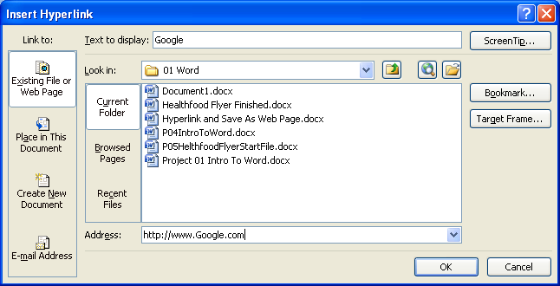
Figure 1
  - To follow hyperlink in Word, use keyboard shortcut:
    - Ctrl + Click
  - Edit hyperlink: Select hyperlink, then:
    - Ctrl + K
    - Hyperlink icon button in the Links group on the Insert Ribbon
    - Right-click selection, and point to Edit Hyperlink
  - Another method use to create links is to type the web address without a space at the end and then hit Enter. Hitting Enter AutoFormats the web address as a link.

- Save As Web Page
  - After creating the document, use Save As to change the file type to:
    - Web Page (*.htm;*.html)
  - Click Save
  - This file type converts the document to a file saved in html.
  - Using the file type “Web Page (*.htm;*.html)” creates two objects:
    - Object #1 is an .htm file
    - Object #2 is a folder
      - See Figure 2
Figure 2

- NEW Keyboard Shortcuts:
  - Insert Hyper Link = Ctrl + K

