Tables In Word

- How to add a Table to a Word document:
  - On the Insert Ribbon, click the drop-down arrow for table and then drag your cursor over the number of cells that you would like and click:
- After you create a table, the Design and Layout Ribbons appear:
- Table from Excel
  - Make a table in Excel, Copy, go to Word, click on the Paste drop-down arrow in the Clipboard group on the Home Ribbon, point to and click on the Paste Special item, click Paste Link and “Microsoft Office Excel Worksheet Object”, OK
    - 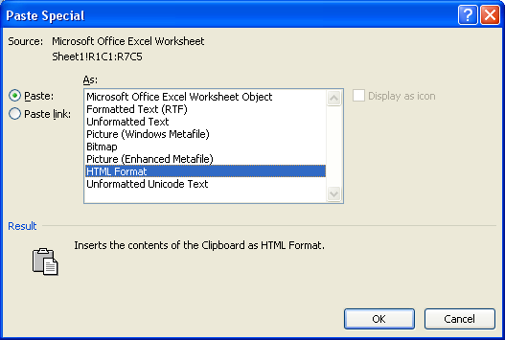

- Table aspects:
  - Cell = intersection of row and column
  - Content = “words, pictures, etc.” in cells
  - Tab moves cursor forward
    - Ctrl + Tab = Tab
  - Shift Tab moves cursor backwards
  - Enter adds new line to cell
  - Cursor for highlighting cell is little black diagonally pointing arrow
    - Point at edge of cell to see
  - Cursor for highlighting row is large white diagonally pointing arrow
    - Point at beginning of row to see
  - Cursor for highlighting column is small black downward pointing arrow
    - Point at top of a column to see
  - Table resize handle is in lower right corner – you have to move cursor to it until you see a diagonally pointing arrow, and then click and drag.
  - Table Move Handle is in upper left corner (this selects the whole table)
  - Cursor for changing size of cell looks like two thin vertical lines with black horizontally pointing arrows
    - Point at the line between two cells
  - To Insert Row/Column, point to Row/Column, then right-click and point to Insert
  - To merge cells, highlight more than one cell, right-click, click on merge
  - To split cells, highlight one cell, right-click, click on split
  - To align cell content, right-click cell and point to cell alignment

