Overview of In-class Access Project:



1. Create Blank Data Base
   1. Click Blank Database button
   2. Type the file name: Wooden Crafts.mdb
   3. Use the Folder button to save the database to your ClassNotes\04Access folder
   4. Click the Create button
   5. 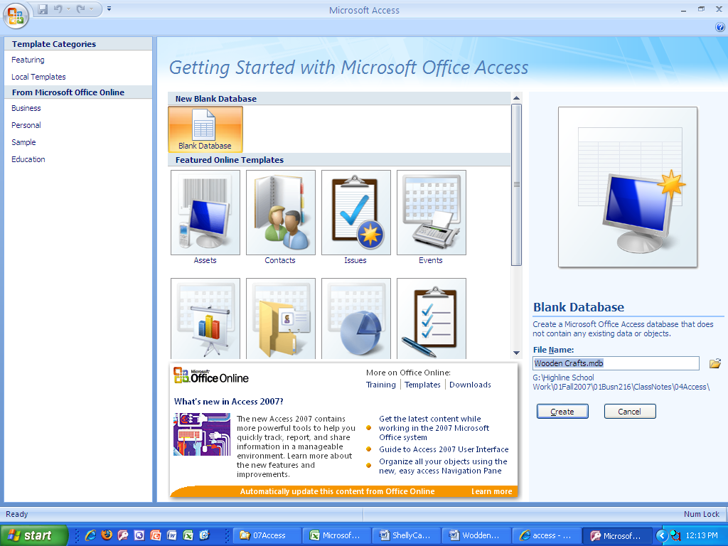
2. After you create database, you will see this::
   1. 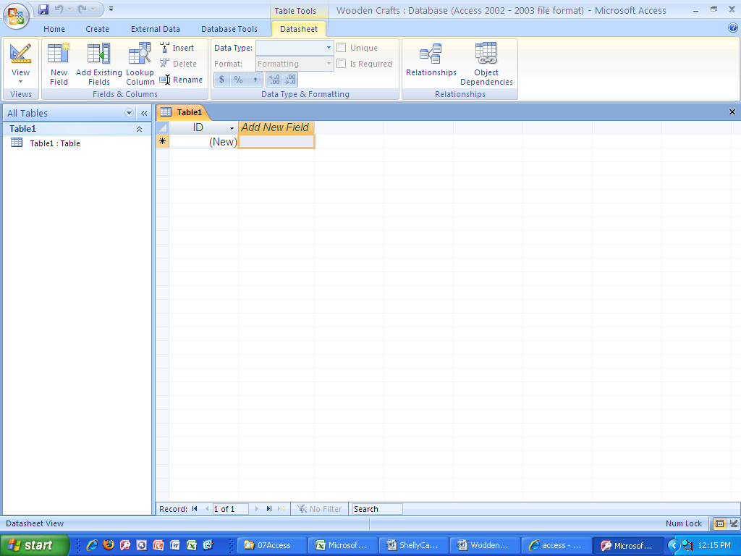
3. Click on Options button and “Enable this content”
4. Create Table:
   1. Import two tables into our database
      1. From the External Data Ribbon, click the Import Access database button:
         1. 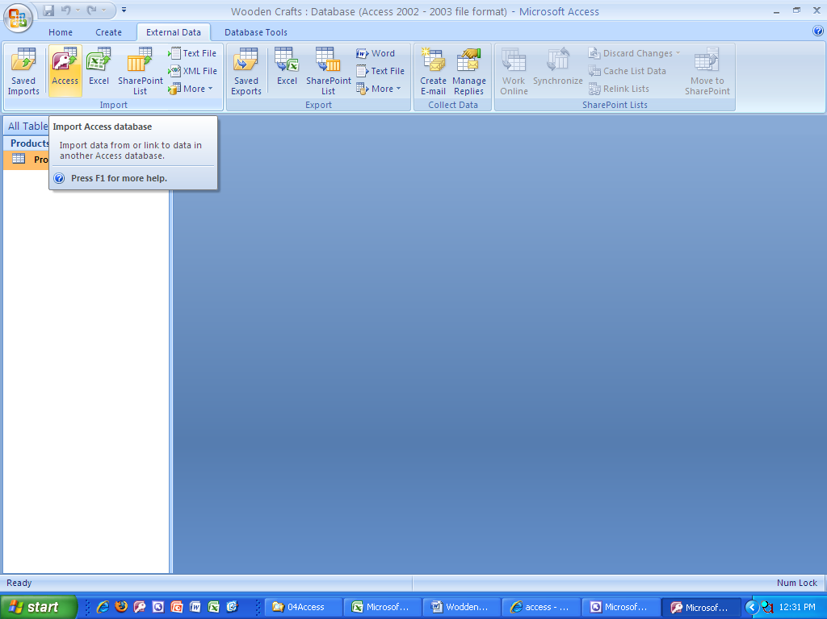
   2. Create Product Table:



1. Create the Relationship between the Suppliers table (with primary key) and the Products table (with Foreign key):
   1. From the Database Tools Ribbon on the Show/Hide group, click the Relationships button.
      1. 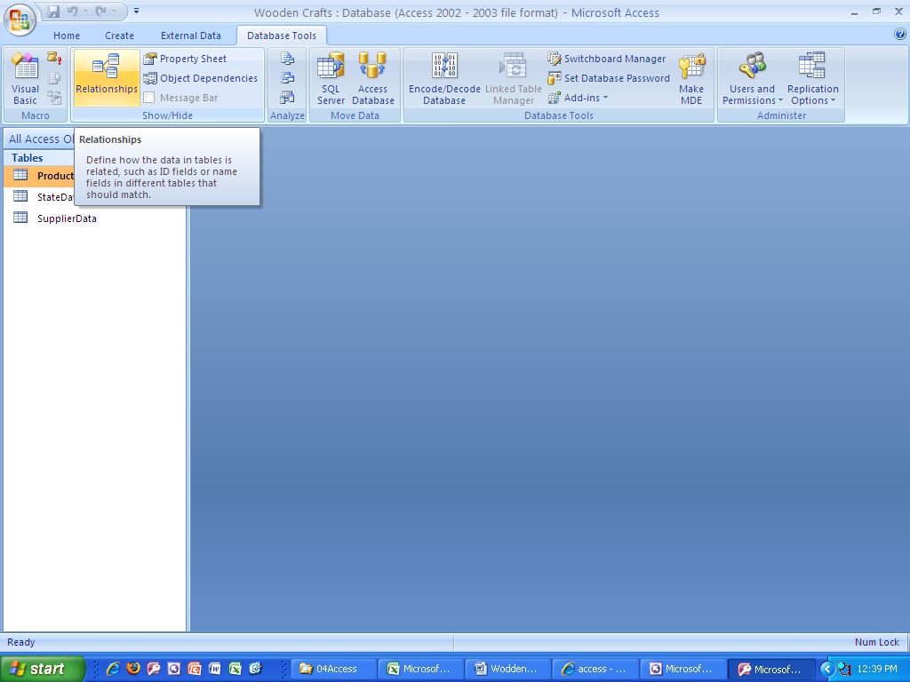
   2. Using the title bar for each field list, drag the tables so that the order is as follows:
      1. 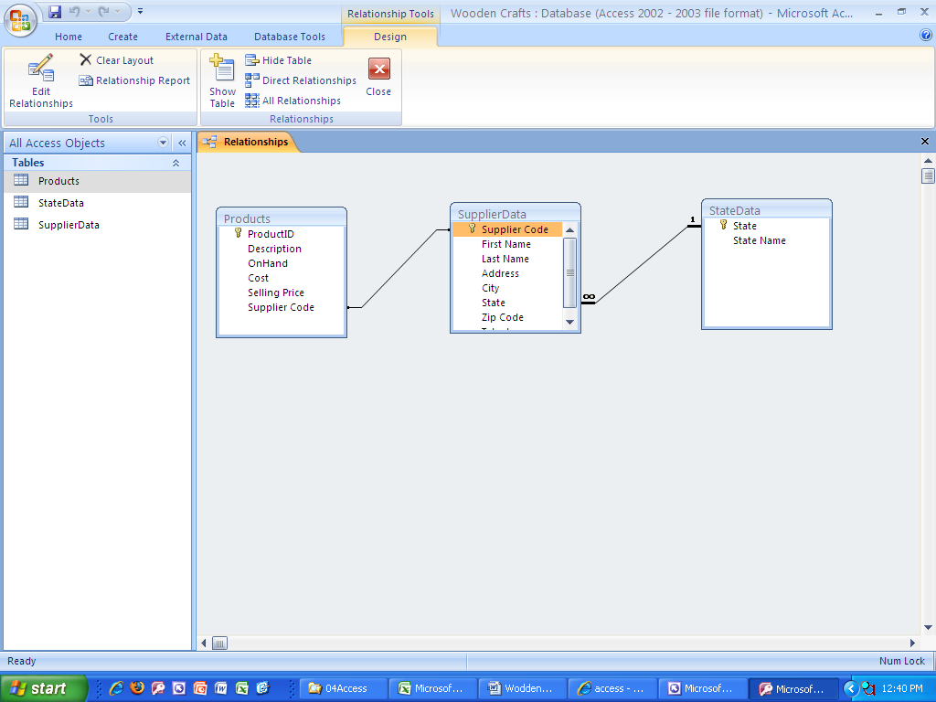
   3. Right-click the join line and point to Edit-relationships:
      1. 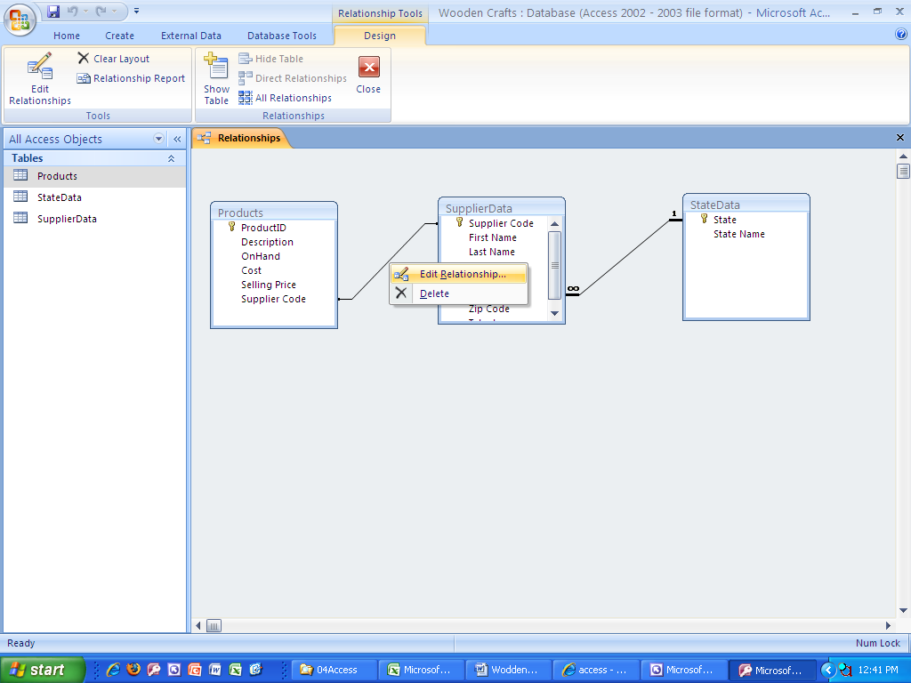
   4. and then click the three check boxes:
      1. 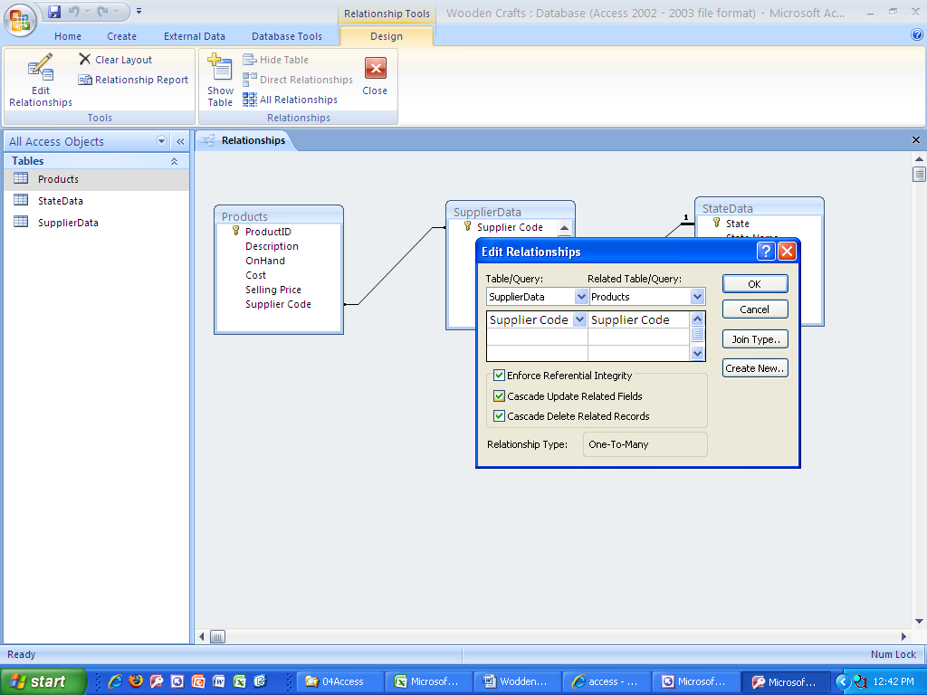
   5. Click Save After you have Edited the Relationships
2. Create Form:
   1. From Create Ribbon we will create two forms:
      1. Default Form:
         1. From the Navigation Pane, select the table for which you would like to make a Form
         2. From the Create Ribbon, Query Group, click the Form button
            1. 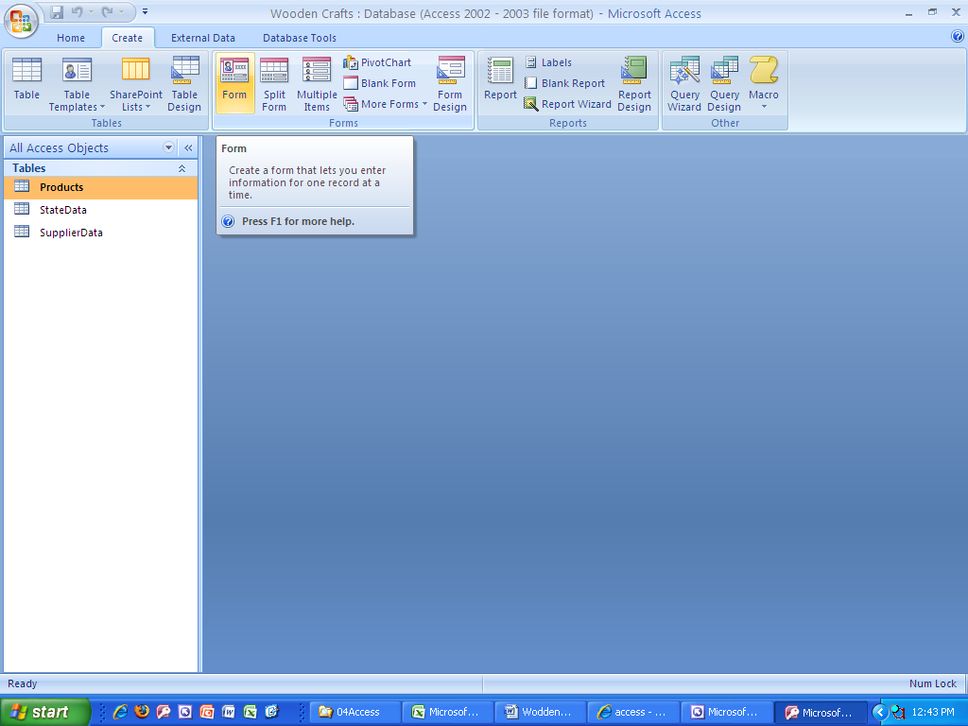
         3. After you create Form and before you enter data, change the View to Form View
            1. 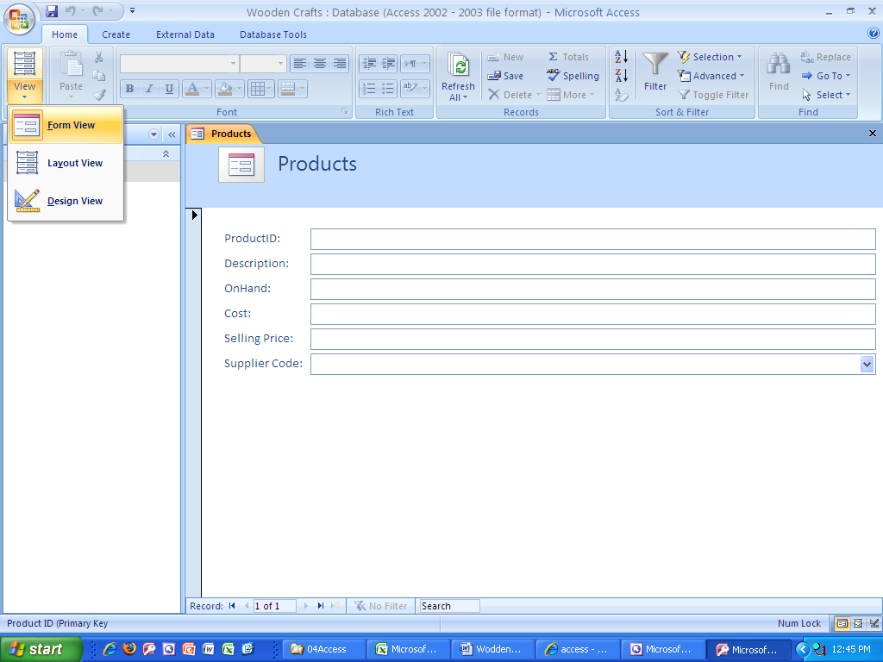
         4. Save the Form with the name “Products Form”
      2. Split Form:
         1. From the Navigation Pane, select the table for which you would like to make a Form
         2. From the Create Ribbon, Query Group, click the Split Form button
            1. 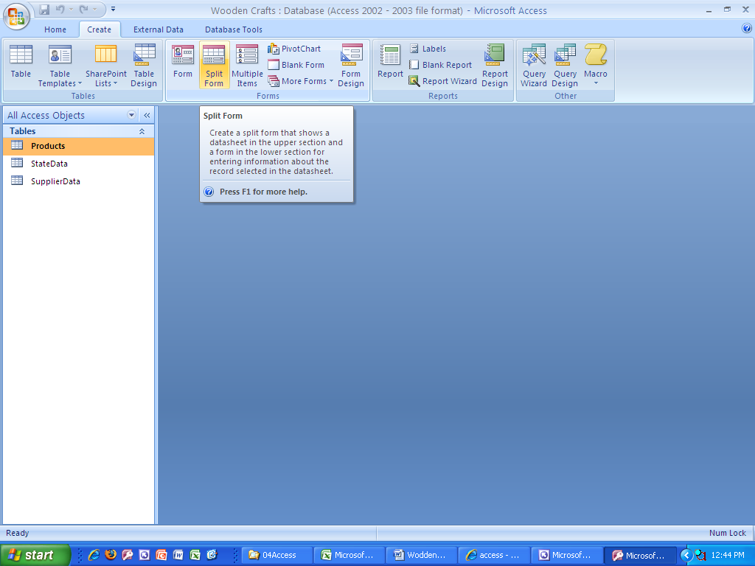
         3. After you create Form and before you enter data, change the View to Form View
         4. “Products Split Form”
   2. If you are viewing the objects in the Navigation Pane as Object Type, after you create the forms you should see the following objects in the Navigation Pane:
      1. Object Type: 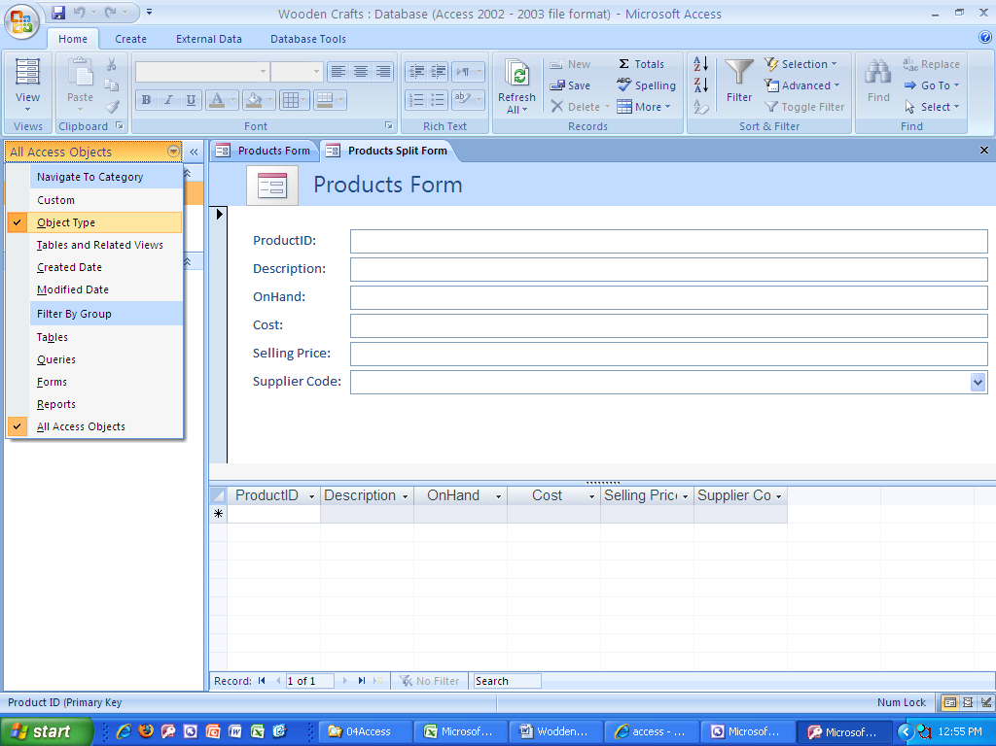 5 Objects: 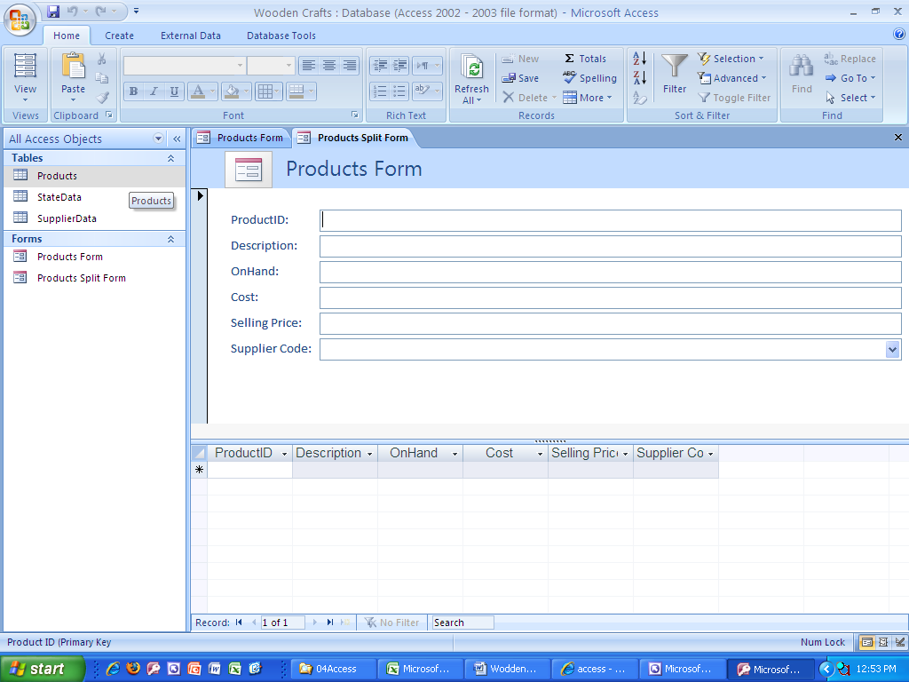
3. Wooden Crafts Queries:

# In-Class Wooden Crafts Queries:

* + 1. Show:

Each Number is a new query

* + - 1. Product ID
      2. Description
      3. On Hand
      4. Selling Price
    1. Show for AP:
       1. Product ID
       2. Description
       3. Cost
       4. Supplier Code

Criteria: AP

* + 1. Show:
       1. Product ID
       2. Descriptions
          1. Criteria:

*Rail*

* + 1. Show:
       1. Product ID
       2. Description
       3. Supplier Code
       4. Cost (Don’t Show)
          1. Criteria:

<15

* + 1. Show:
       1. Product ID
       2. Description
       3. Sell Price
          1. Criteria:

>20

* + 1. Show:
       1. All Fields
       2. Criteria:
          1. SP>10  
             AND
          2. ON HAND >=10
    2. Show:
       1. All Fields
       2. Criteria:
          1. Supplier Code: SC  
             OR
          2. SP >20
    3. Join Product & Supplier Table
       1. Show:
          1. Product ID
          2. Description
          3. Cost
          4. First Name
          5. Telephone
    4. Join Product & Supplier Table
       1. Show:
          1. Product ID
          2. Description
          3. Cost
          4. First Name
          5. Telephone
          6. Number On Hand

Criteria:

On Hand <5

* + 1. Show:
       1. Product ID
       2. Description
       3. Calculate:
          1. Inventory Value:[On Hand]*[Cost]
       4. Caption Property: Value Of Inventory
    2. Show:
       1. Selling Price
          1. Calculate:

Show Total Row (Right-click Design Grid, Totals)

Select: Ave

* + 1. Show:
       1. Supplier Code
          1. Total Row:

Group by:

* + - 1. Selling Price
         1. Total Row:

Ave

* + 1. Join Product & Supplier Table
       1. Show:
          1. Supplier Code
          2. First Name
          3. Last Name
          4. Product ID
          5. Description
          6. Cost
          7. On Hand
       2. Sort:
          1. Supplier Code

Ascending

* + 1. Parameter Query
       1. Prompts for input whenever it is run
       2. Must use:
          1. [ ]
          2. A field name cannot be in brackets
       3. Copy Average Sell Price by Supplier query (12 from above)
          1. Supplier Code

Criteria:

[Enter Supplier Code]

* + 1. Between Query
       1. Show:
          1. Product ID
          2. Description
          3. Selling Price:

Sort Ascending

Criteria:

Between 15 And 25

* + 1. Omit Duplicates Query
       1. Set the Unique Value Property to Yes
    2. Left Outer Query
       1. Using the Join Properties button
    3. If you use Multivalued fields, creating a query that asks to see one of the values is not allowed. However, you can show the values on separate rows by choosing the “Fieldname. Value” field from the field list drop down in the Query Design Grid

# Other Items:

* + 1. Save As is now under the Office Button (Orb) and it allows you to save the database with a different name

1. Create Reports:
   1. From the Navigation Pane, select the table for which you would like to make a Form
   2. From the Create Ribbon, Report Group, click the Report Wizard button
   3. In Step 1, make sure the correct table or query is selected
   4. Follow the steps in the wizard to create Report
   5. After you have created the Report, you can toggle to Design View and change the elements, spacing and format to make the report look organized, neat and professional.
2. Other topics:
   1. Subdatasheets:
      1. Use the Office Button (Orb) to Save As and change the name of the database
      2. View the Suppliers table and use the “+” (plus) signs to view related Product data for each Supplier