**Math 220  
6.5&6: Least Squares and Applications  
Questions for flipped class**

**Important terms**To find a least-squares solution, row reduce:

For this example, assume radians and make sure it is clear how to set up the matrices and use the calculator

**Least-squares linear algebra style**

To find least-squares solutions, construct *A* matrices and the *b* vector:

(1.) Find the equation  of the least-squares line that best fits the data points. 

(2.) Find the quadratic regression equation  of the least-squares line that best fits the data points. .

(3.) A certain experiment produces the data (1, 7.9), (2, 5.4), (3, -0.9). Describe the model that produces a least-squares fit of these points by a function of the form .

**Munchings and crunchings**

(6.5.1)



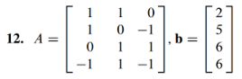

(6.5.2)



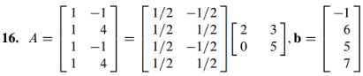

**Boil em, mash em, stick em in a stew**

(6.5.3)



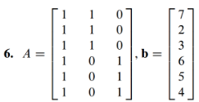

(6.6.2)

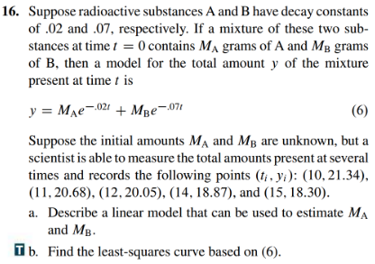

**The tragic moment when you come face to face with your final linear algebra True/False questions**

(6.5.6)

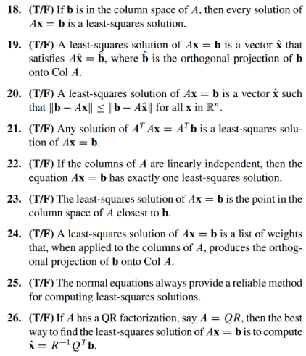

(6.6.1)





(solutions from the three practice questions)

(6.5.1 solution)

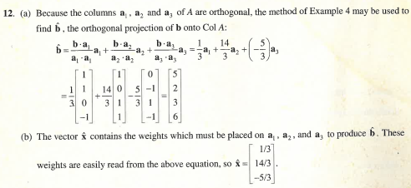

(6.5.2 solution)

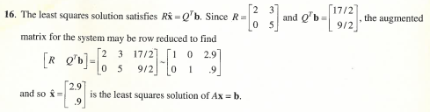

(6.5.3 solution)

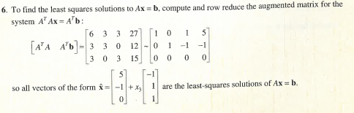

(6.6.1 solution)

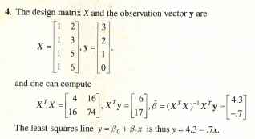

(6.6.2 solution)

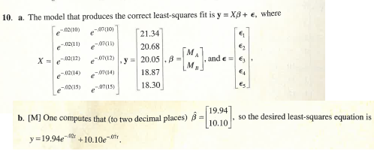

(6.5.6 solution)

