**Math 220  
1.3: Vector Equations  
Questions for flipped class**

**Key terms**:

Linear combination

The sum  is a linear combination of  with weights .

Span

The  is the set of all vectors in Rn that can be written as 

(1.3.1)

Sketch carefully and try to maintain the scale.





**For all**

(1.3.2)

Write a system of equations AND augmented matrix that is equivalent to the given vector equations.

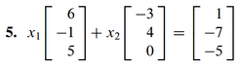

**A foreshadow of Project 1**

(1.3.3)



The question above is your first example of what I call, “a parallelogram grid.” How would you go about creating a parallelogram grid given two (non-parallel) vectors?

**A little bit of theory**

(1.3.4)

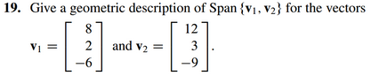

(1.3.5)

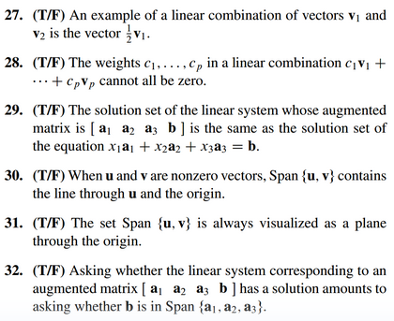

**A little bit more theory**

(1.3.6)

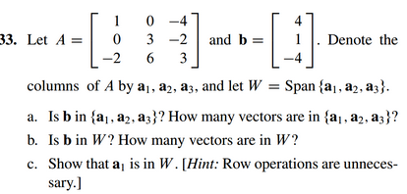

(1.3.7 theory question rehashed)

Claim: For all **u**, **v** in Rn:

**u**+**v** = **v**+**u**

Proof.

Claim: For all **u** in Rn and all scalars *c* and *d*:

(*c* + *d*) **u** = *c* **u +** *d* **u**

Proof.

(1.3.1 solution)



(1.3.2 solution)



(1.3.3 solution)



(1.3.4 solution)



(1.3.5 solution)



(1.3.6 solution)



(1.3.7 theory rehash solution)

