|  |  |
| --- | --- |
| Assessment 8 (10 or 11 am)Dusty Wilson Math 220 No work = no credit | **Name (first & last)**: ___________________________  *But just because geometry is so eminently fitted for the youthful mind it should be at first presented in such form as to be in accord with the general views of laymen, when these are not in direct opposition to the truth.*  Charlotte Angas Scott  1858-1931 (English mathematician) |

|  |  |  |  |
| --- | --- | --- | --- |
| Warm-ups (1 pt each): | = | = | = |

(1 pt) According to Scott (above), geometry should be taught in a way that makes sense to ordinary people. How could linear algebra be taught so as to make sense to more people? Please answer using complete sentences.

(4 pts) Consider the matrix  which has eigenvalues 1 and 0.9 with respective eigenvectors  and .

1. Diagonalize *A*.
2. Explain how you can use the result of (a.) to find .

1. Use diagonalization to find 

(4 pts) The matrix is a rotation-scaling matrix.   
  
a.) Find the scaling factor of *A* (Hint: It is irrational).  
  
  
  
  
b.) Find the angle of rotation of *A* (Hint: It is a familiar angle).  
  
  
  
  
  
  
  
c.) Suppose , find (i.) the angle between  and . Also find (ii.) the ratio of the two magnitudes. That is, find: . (Hint: How does this connect to parts (a.) and (b.)?).

(4 pts) Find the eigenvalue(s) and eigenvector(s) of 

(4 pts) Consider the dynamical system  with initial state 

a.) Carefully plot and the trajectory curve that begins at .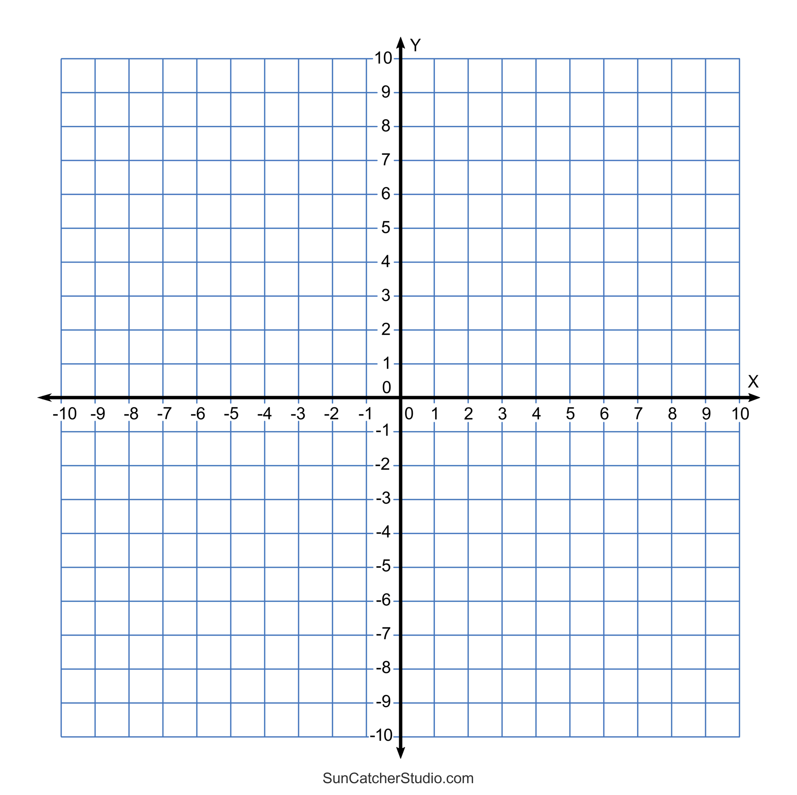

b.) Explain the process you would use to find a nice formula for  involving *k* and the eigenvalues/eigenvectors of *A*.