|  |  |
| --- | --- |
| Assessment 2 (10 or 11 am)Dusty Wilson Math 220 No work = no credit | **Name (first & last)**: ___________________________  *Unfortunately what is little recognized is that the most worthwhile scientific books are those in which the author clearly indicates what he does not know; for an author most hurts his readers by concealing difficulties.* Évariste Galois 1811 – 1832 (French mathematician) |

|  |  |  |  |
| --- | --- | --- | --- |
| Warm-ups (1 pt each): | = | = | = |

(1 pt) According to Galois (above), what most hurts scientific books? Answer using complete English sentences.

(8 pts) Let , , , and , and let  be a linear transformation that maps  into  and  into . Find the image of .

(8 pts) Determine whether the columns of  are linearly independent. If not, find a linear dependence relation among its columns 

(6 pts) True or False (circle one). Justify your answer.

1. (T or F) If *A* is an  matrix, then the range of the transformation  is .

1. (T or F) If a set in  is linearly dependent, then the set contains more vectors than there are entries in each vector.

1. (T or F) The homogeneous equation  has the trivial solution if and only if the equation has at least one free variable.

(5 pts) Complete the proof by filling in the missing pieces.

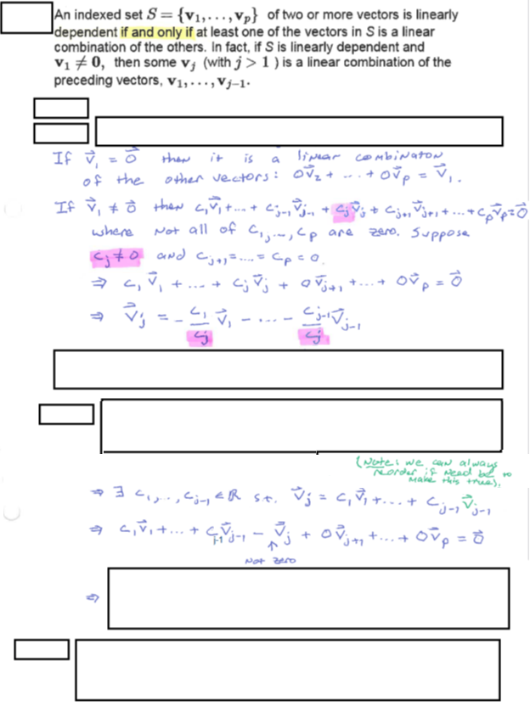

(8 pts) Consider the homogeneous “system” . Describe all solutions algebraically (in vector form) and geometrically (use words to describe the graph).