If  find .

If  for some invertible *P* and diagonal *D*, then is also easy to compute.

Let. Find a formula for  given that , where  and 

A square matrix *A* is said to be ___________________________ if *A* is similar to a diagonal matrix *D*.

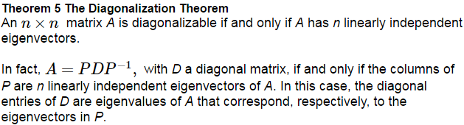

These eigenvectors, since they are linearly independent, form a __________________.

Diagonalize the matrix, if possible. . That is, find an invertible matrix P and diagonal matrix D such that . The eigenvalues are .

Diagonalize the matrix, if possible. .



Note: Having distinct eigenvalues is not a requirement for diagonalizable (see Ex 3).

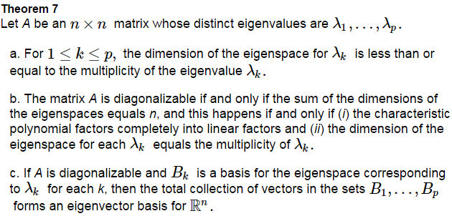

Diagonalize the matrix, if possible. .

