To find eigenvalues of a square matrix, we are finding non-trivial solutions to the equation . By the invertible matrix theorem, this is the same as finding  such that is _______________________________. But this occurs when the _______________________ is _________________.

Find the Eigenvalues of .

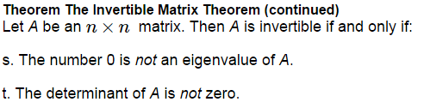

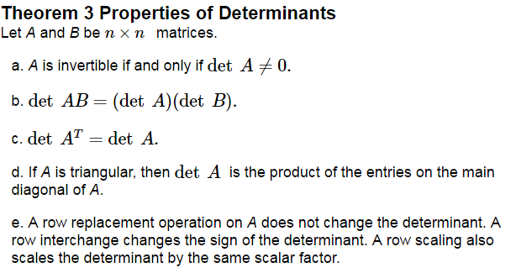

We can now determine when the matrix is not invertible by solving the _____________________________ _____________________, .

Find the characteristic equation and eigenvalues of .

Find the characteristic equation of .

If *A* is an  matrix, then  is a polynomial of ________________ called the _______________________ _______________________ of *A*.

The eigenvalue of 3 in Ex 3. is said to have ___________________________________ because the factor __________ occurs ___________ in the characteristic polynomial.

The characteristic polynomial of a  matrix is . Find the eigenvalues and their multiplicities.

**Similarity**

Two matrices *A* and *B* are considered _________________ if there is an invertible matrix *P* such that

or

We can also write *Q* for  and get

or

Vocabulary: Changing *A* into ___________ is called the _________________________.

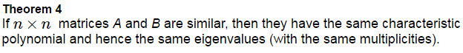

Proof:

