Recall the previous definitions of Linearly Independent and Linearly Dependent. We are now going to think in terms of a Vector Space *V*, rather than just .

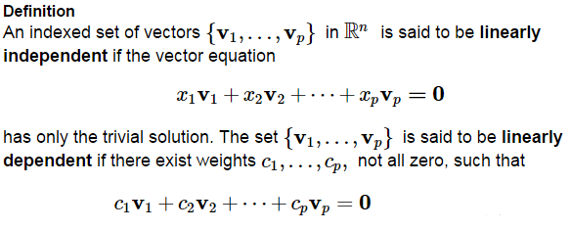

And recall that

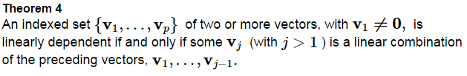

If a vector space is not  described with the easily solved matrix equation , then we need Theorem 4 to show a linear dependence relation to prove linear dependence.

Discuss the linear dependence or independence of the following sets on , the space of all continuous functions on .

 

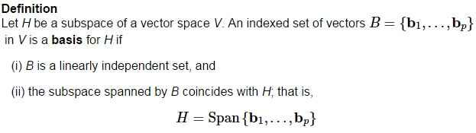

What can we say about an invertible n x *n* matrix *A*?

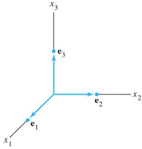

The columns of the identity matrix,  is called the __________________ ___________ for .

Determine whether  forms a basis for .



**Do**  **form a basis for** ?



A basis is an “efficient” spanning set because it contains no unnecessary vectors.

Let  as in Ex 3. Show that 



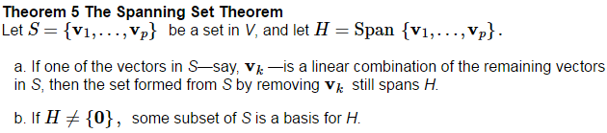

Proof:

We already know how to find a basis for the Nul A, as we saw that the row reduced system that describes the solutions of Nul A, is already linearly independent.

However, finding a basis for Col A that doesn’t have unneeded vectors is our next step.

Find a Basis for Col B where



Find a Basis for Col A where, A reduces to the matrix B in the previous example.



Since  and the reduced echelon form  have the exact same solution sets, then their columns have the exact same dependence relationships. Let’s check.

WARNING: You must use the original pivot columns of A.

Question: Why doesn’t ?



A basis is basically the smallest spanning set possible. Remove any vectors from it, and the set is no longer spanned, add any vectors to it, and it becomes linearly dependent.

