Although out of fashion, determinants played a large role in the early development of linear algebra. Four uses of determinants include the following: Determinants help us “determine” if a system of linear equations has a unique solution. They are a mechanism to “determine” whether the inverse of a matrix exists (this would have come later). They may be geometrically interpreted as the scaling factor of a linear transformation. And the determinant is also a calculating mechanism used elsewhere in math to find things such as the cross-product (Calculus III), Jacobian (Calculus IV), and the Wronskian (Differential Equations).

As to why they have fallen out of favor? Well they are computationally expensive even with modern technology. So we have adopted other ways to accomplish their original purpose.

Their primary reason for being in this course is that they are needed for our development of the eigenvalue and eigenvector in a subsequent chapter.

If  find which is also notated 

Calculate  by expanding across the second column.

Compute the determinant: 



Compute the determinant: 

**Theorem 3: Row Operations**

Let *A* be a square matrix

1. If a multiple of one row of *A* (old) is added to another row to produce a matrix *B* (new), then .
2. If two rows of *A* (old) are interchanged to produce *B* (new), then .
3. If one row of *A* (old) is multiplied by *k* to produce *B* (new), then 

Find the determinant by first row-reducing to echelon form.



Find the determinant by first row-reducing to echelon form.

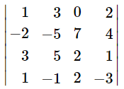

Let’s consider two different triangular matrices and their invertibility. The focus on triangular matrices is reasonable as we learned in a previous section that row operations do not impact the invertibility of matrices.

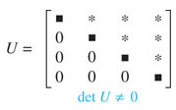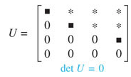



Revisiting (), at what point could we have stopped?





Verify Thm 6 for

