**Math 220  
6.3: Orthogonal Projections and 6.4: Gram-Schmidt Orthogonalization  
Questions for flipped class**

**Important terms**Gram-Schmidt Orthogonalization:

Two ways to do QR-Factorization (or QR-Decomposition):

(6.3.4)

Find the best approximation to  by vectors of the form 

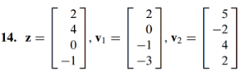

Expanded example of QR-Factorization from the notes.

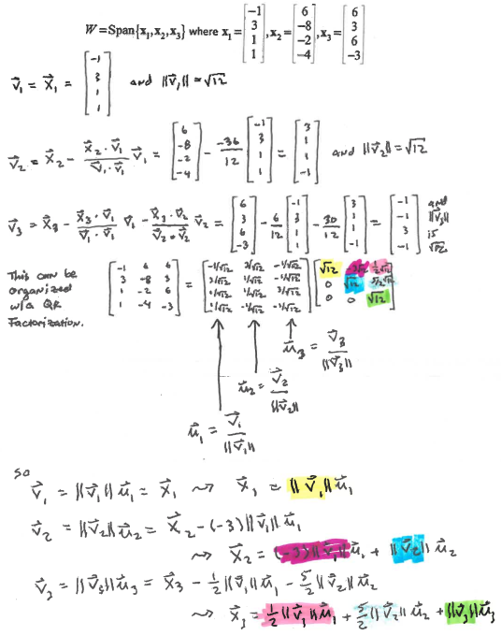

(6.3.5)

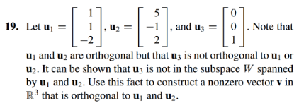

(6.4.2)



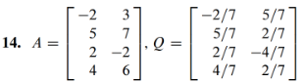

(6.4.1)

Find an orthogonal basis for the column space of the matrix. (Save your work as it will help you on the next question).

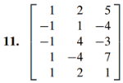

(6.4.3)

Find a QR factorization for the matrix from (6.4.1)

(6.4.4)

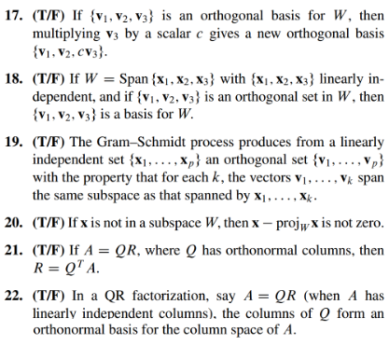

(6.3.6)

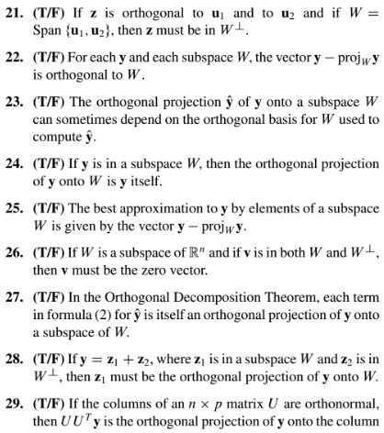

(6.3.4 solution)

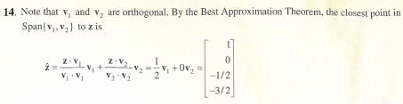

(6.3.5 solution)

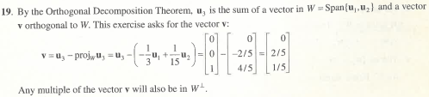

(6.4.2 solution)

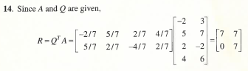

(6.4.1 solution)

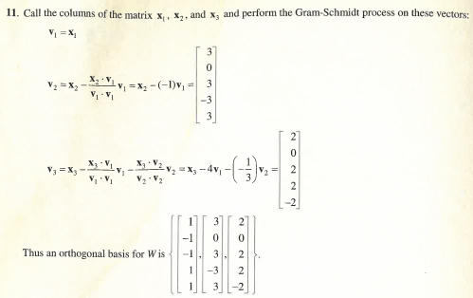

(6.4.3 solution)

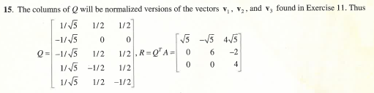

(6.4.4 solution)

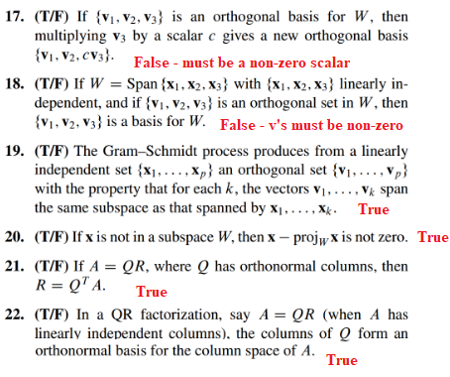

(6.3.6 solution)

