**Math 220  
5.3: Diagonalization  
Questions for flipped class**

**Important terms**Similar matrices:  
  
  
  
  
Diagonalizable matrices:

**Diagonalization is for Everyone!**

(5.3.1)



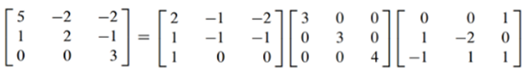

(5.3.2)

Diagonalize the matrix below given that one eigenvalue is  and one eigenvector is 



**Don’t miss the main point in all the munchings and crunchings: if *A* can be diagonalized, that means that *A* and *D* are the same transformation, but with respect to different bases.**

(5.3.3)

Diagonalize (if possible), the matrix below



(5.3.4)

Diagonalize (if possible), the matrix below

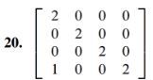

(5.3.5)

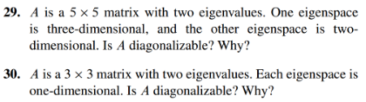

**Diagonalization Theorem is 100% Vitamin D**

(5.3.6)

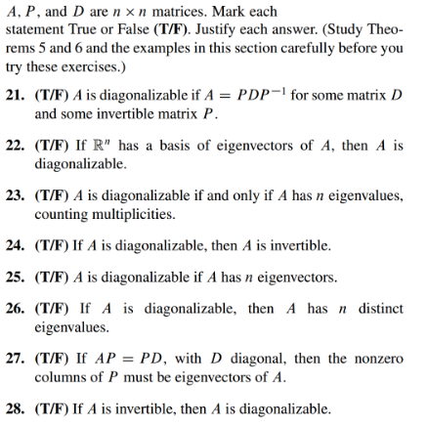



Similar matrices:  
  
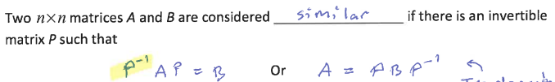  
  
Diagonalizable matrices:



Notice that the ith column of P is the eigenvector whose corresponding eigenvalue is in the ith column of D.

(5.3.1 solution)

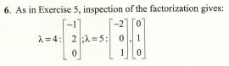

(5.3.2 solution)

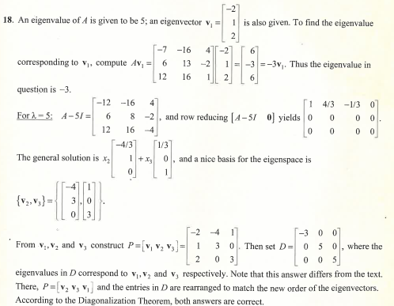

(5.3.3 solution)

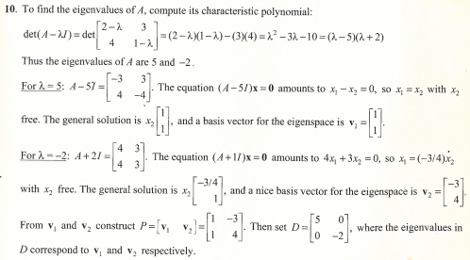

(5.3.4 solution)

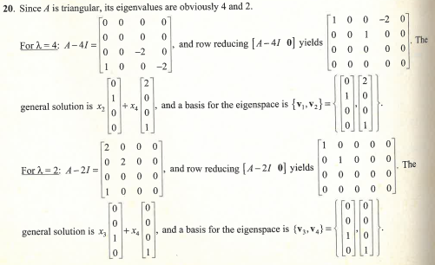

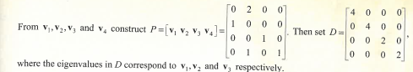

(5.3.5 solution)

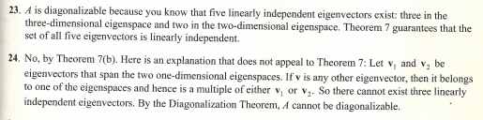

(5.3.6 solution)

