**Math 220  
5.1: Eigenvalues and Eigenvectors  
Questions for flipped class**

**Important terms**Eigenvectors identify:  
  
  
  
  
Eigenvalues identify:

(5.1.1)

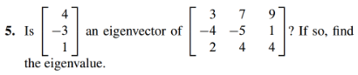

(5.1.2)

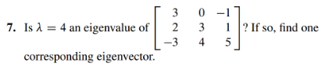

(5.1.3)





(5.1.4)



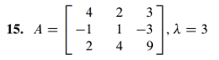

(5.1.5)

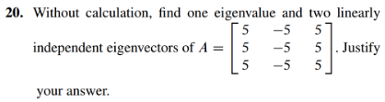

(5.1.6)

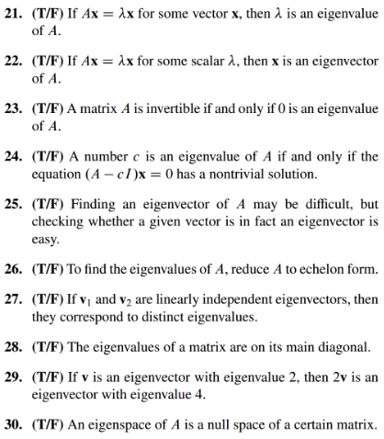

From the Google and tied to data analytics: Eigenvalues and eigenvectors can be used to extract the most important features of a dataset by identifying the directions of maximum variation in the data. These directions can be represented by the eigenvectors, and the amount of variation in each direction can be represented by the corresponding eigenvalue.

(5.1.1 solution)

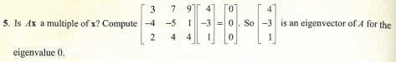

(5.1.2 solution)

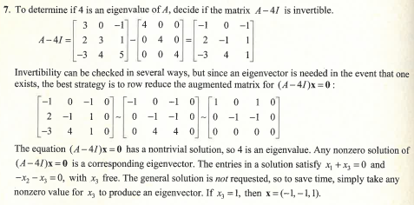

(5.1.3 solution)

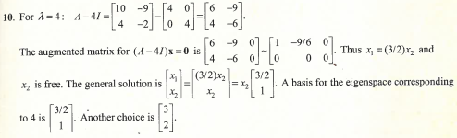

(5.1.4 solution)  
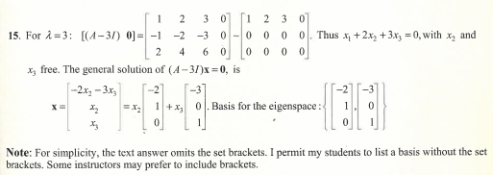

(5.1.5 solution)

Note: This solution doesn’t quite match as the A matrix students worked with includes a column of negative fives,

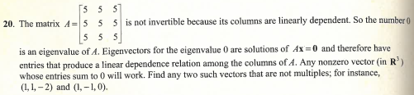

(5.1.6 solution)

