**Math 220  
4.6: Change of Basis  
Questions for flipped class**

Change of basis notation





 can be computed

* directly by rrefing 
* indirectly by noticing that 

Caution: Question 4.6.5 is a little subtle. An “easy” way is to think about [v1 v2 v3] as the Pv matrix that goes E <- V, P is … we want the Pu matrix that goes E <- U … The approach in the solutions requires more care.

**For everyone😊**

(4.6.1)

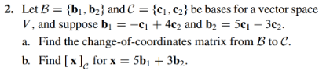

(4.6.2)





(4.6.4) <------- **EXTRA PRACTICE IF YOU WANT IT**

**Practice in 3D**

(4.6.3)

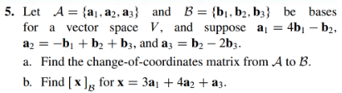

(4.6.5)

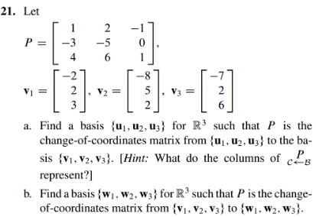

**Your daily dose of theory**

(4.6.6)

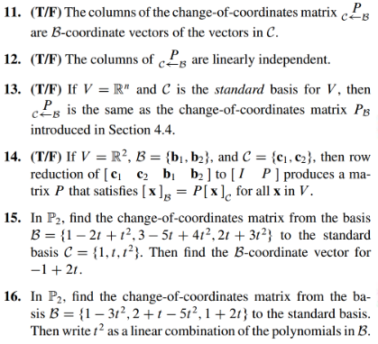

(4.6.1 solution)

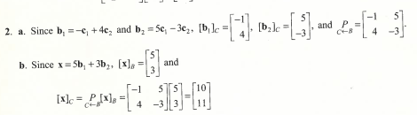

(4.6.2 solution)

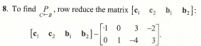

(4.6.3 solution)

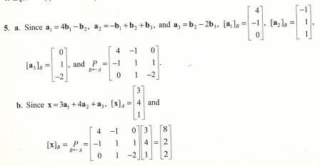

(4.6.4 solution)

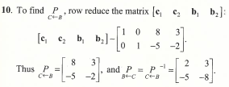

(4.6.5 solution)

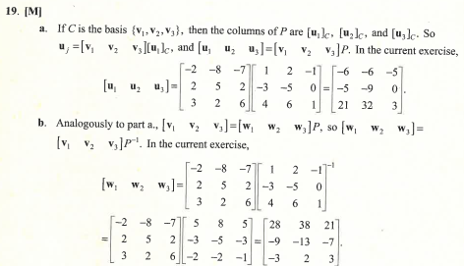

(4.6.6 solution)

