**Math 220  
4.5: Dimension and Rank  
Questions for flipped class**

**Important terms**Dimension  
  
  
  
  
Rank

Caution: Question 4.5.3 is asking for the null space.

**For everyone**

(4.5.2)

Determine the dimensions of Nul A, Col A, and Row A for the matrices shown.

(4.5.1)

Find a basis and state the dimension of the subspace

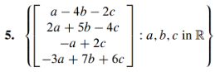

**Plug and chug**

(4.5.3)

Find a basis and state the dimension of the subspace



(4.5.4)





(4.5.8)

If *A* is a 6x8 matrix, what is the smallest possible dimension of Nul *A*? Why?

**Redundant redundant question**

(4.5.5)



**Your daily dose of theory**

(4.5.6)

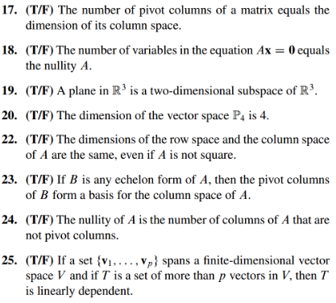

(4.5.7 theory question) Prove the Basis Theorem which states: Let *V* be a *p*-dimensional vector space . Any linearly independent set of exactly *p* elements in *V* is automatically a basis for *V*. Any set of exactly *p* elements that spans *V* is automatically a basis for *V*.

(4.5.1 solution)

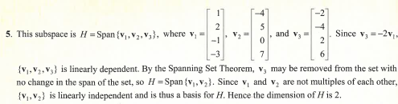

(4.5.2 solution)



(4.5.3 solution)

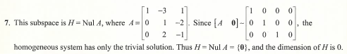

(4.5.4 solution)

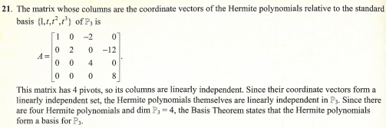

(4.5.5 solution)

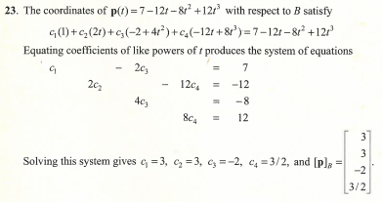

(4.5.6 solution)

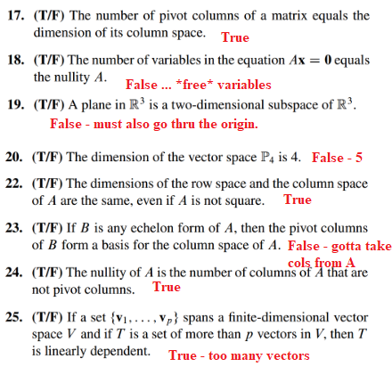

(4.5.7 theory question)

