**Math 220  
4.2b: The Null and Column Space  
Questions for flipped class**

Important stuff to know

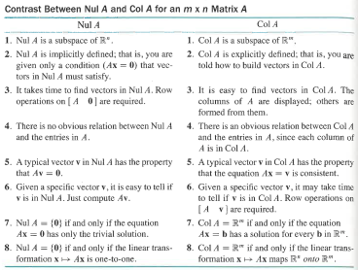

**Extra Linear Transformation practice**

(4.2.2)

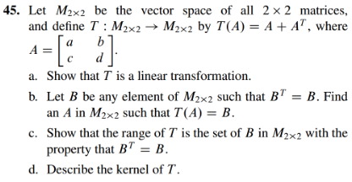







**For Everyone: Column Space questions**

(4.2.2)

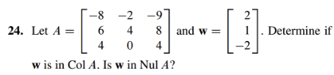

(4.2.3)

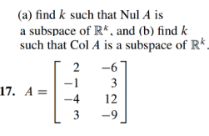

**More advanced Column Space and Kernal questions**

(4.2.4)

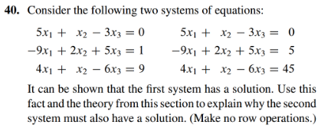

(4.2.6)

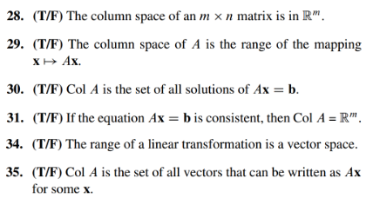

(4.2.3 solution)

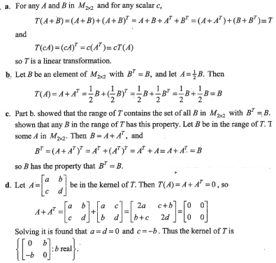

(4.2.2 solution)

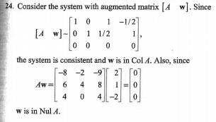

(4.2.3 solution)



(4.2.4 solution)

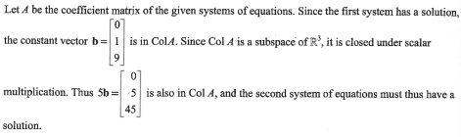

(4.2.5 solution)

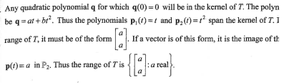

(4.2.6 solution)

