**Math 220  
4.1: Vector Spaces and Subspaces  
Questions for flipped class**

**Important terms**Subspace  
  
  
  
  
Spanning Set



**For Everyone!**

(4.1.1)

Determine if the sets are subspaces of .

1. All polynomials of the form , where 
2. All polynomials of the form , where 

(4.1.2)

Let *W* be the set of all vectors of the form , where *b* and *c* are arbitrary. Find vectors  and  such that . Why/how does this show that *W* is a subspace of ?

**Are these spaces subspaces?**

(4.1.3)

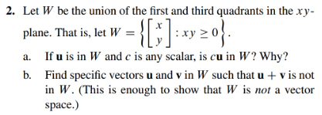

(4.1.4)

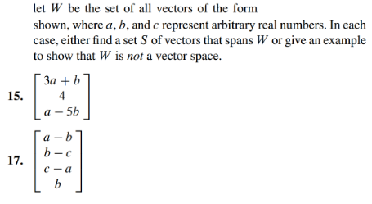

(4.1.5) 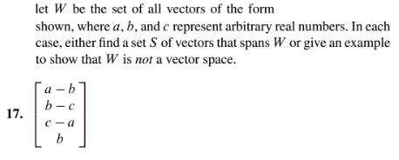

**True or False.**

Remember that an answer without a written explanation is only half of an answer.

(4.1.6)

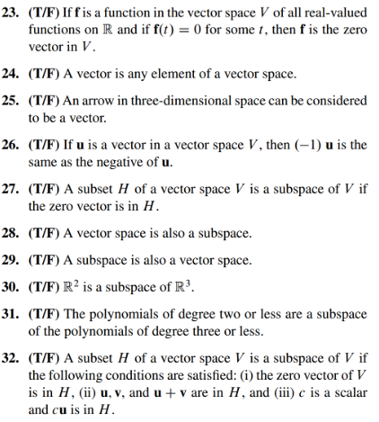

(4.1.1 solution)



7. No, because if you add two of these entries, the coefficient on the squared term in no longer one.

(4.1.2 solution)

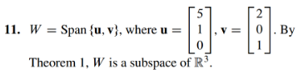

(4.1.3 solution)

a.) Consider the line through the origin parallel to the vector u. cu is in W because cu lies on this same line.

b.) An example that shows that W is not closed under addition: u=<-1,0> and v=<0,1>.

Their sum is <-1,1> which is in Q2.

(4.1.4 solution)

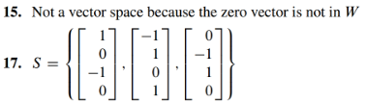

(4.1.5 solution)



(4.1.6 solution)

