**Math 220  
2.3: Characteristics of Invertible Matrices   
Questions for flipped class**

**Important terms**Invertible  
  
  
  
  
Singular

(2.3.1)

Determine which of these matrices are invertible using as few calculations as possible.

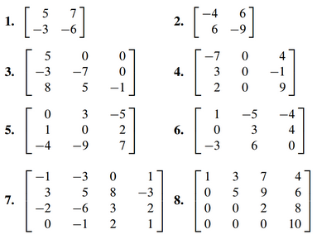

(2.3.2)



(2.3.3)

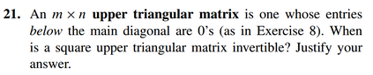

(2.3.4)



(2.3.5)

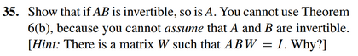

(2.3.7)

The Invertible Matrix Theorem essentially divides the set of all *n* x *n* matrices into two disjoint sets.

|  |  |
| --- | --- |
| **Invertible (*A* has an inverse)** | **Not invertible (*A* does not have an inverse)** |
|  |  |
|  |  |
|  |  |
|  |  |
|  |  |
|  |  |
|  |  |
|  |  |
|  |  |

(2.3.6)

Assume matrices are n x n unless otherwise specified.

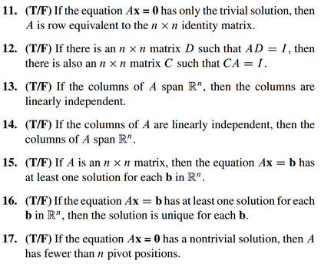

(2.3.1 solution)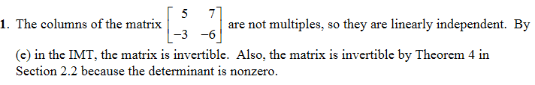



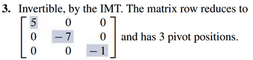

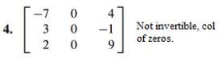

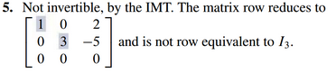

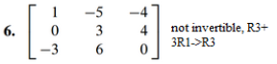

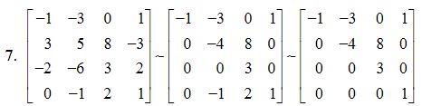

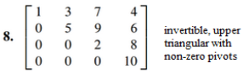

(2.3.2 solution)



(2.3.3 solution)



(2.3.4 solution)

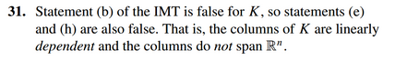

(2.3.5 solution)

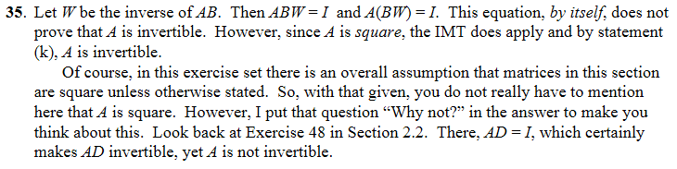

(2.3.6 solution)

