**Math 220  
1.8 Linear Transformations  
Questions for flipped class**

**Key terms**:

Standard basis vectors: , , …

Definition of a Linear Transformation

(1.8.1)

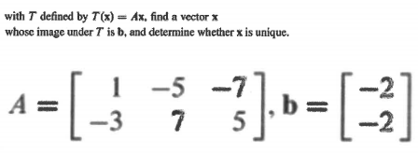

(1.8.7 theory question)

How will we begin showing a function is a linear transformation? That is, what are the assumptions/definitions we will make at the outset?

(1.8.2)



(1.8.3)

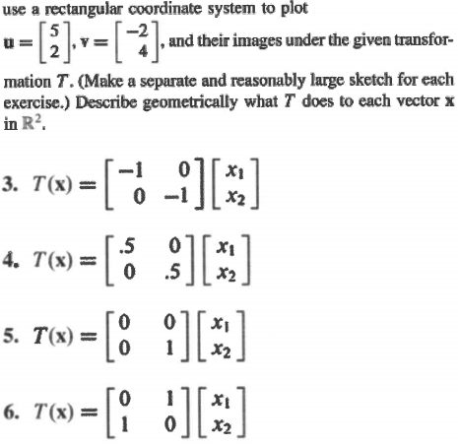

(1.8.4)

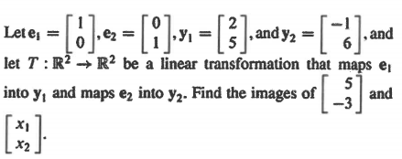

(1.8.5)

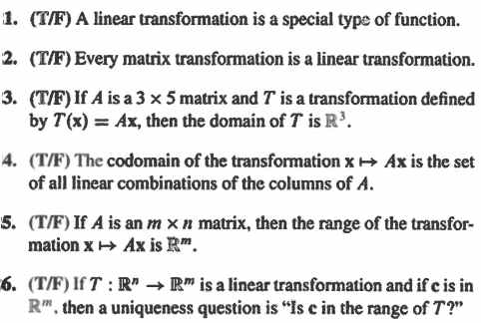

(1.8.6)

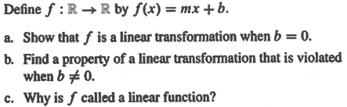

(1.8.1 solution)



(1.8.2 solution)



(1.8.3 solution)

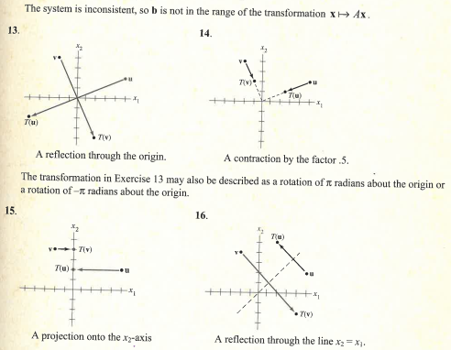

(1.8.4 solution)



(1.8.5 solution)

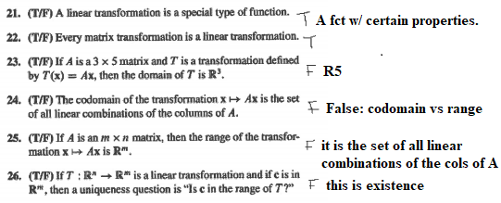

(1.8.6 solution)

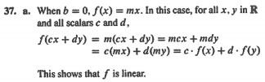

(1.8.7 theory solution)

How will we begin showing a function is a linear transformation? That is, what are the assumptions/definitions we will make at the outset?

Claim: T: X -> Y is a linear transformation.

Let T be as given above and scalar *c* and u,v in X be given.