**Math 220  
1.5: Solution Sets of Linear Systems  
Questions for flipped class**

**Key terms**:

Homogeneous equation

Trivial solution

Non-trivial solution to the homogeneous equation

(1.5.1)

Determine if the system has a non-trivial solution. Try to use as few row operations as possible. Then write the solution set of the system in parametric vector form.

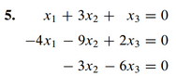

(1.5.2)





And

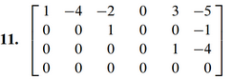

(1.5.3)



(1.5.4)





(1.5.5)

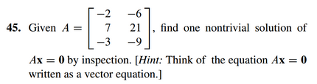

(1.5.6)

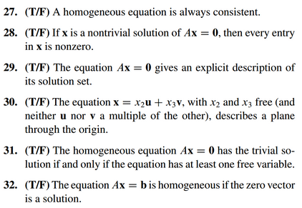

(1.5.7 theory question)

Prove the following claim.

Claim: Suppose is a solution of , so that . Let  be any solution to the homogeneous equation , and let , show that  is a solution of .

(1.5.1 solution)

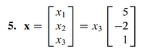

(1.5.2 solution)

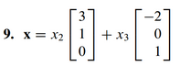

And

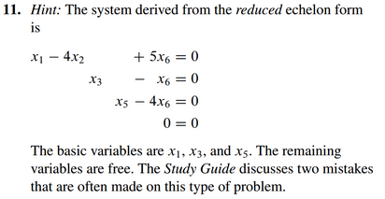

(1.5.3 solution)

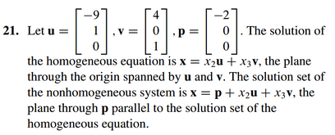

(1.5.4 solution)

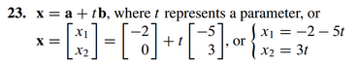

(1.5.5 solution)



(1.5.6 solution)

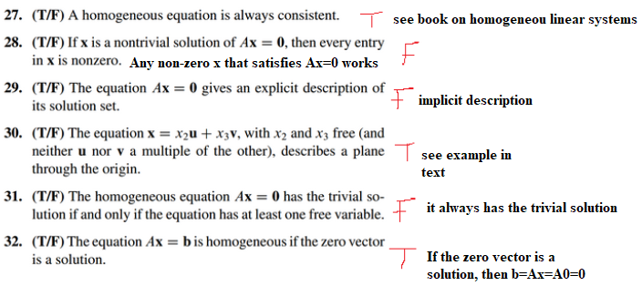

(1.5.7 theory solution)

