**Math 220  
1.4: The Matrix Equation Ax=b  
Questions for flipped class**

**Key terms**:

This is a section about “doing” and without lots of definitions and theorems.

(1.4.1)

Write the matrix equation as a vector equation, or vice versa

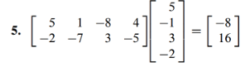

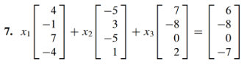

(1.4.2)

Write the system first as a vector equation and then as a matrix equation.

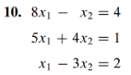

(1.4.3)

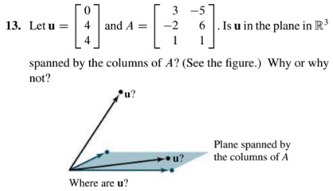

(1.4.4)

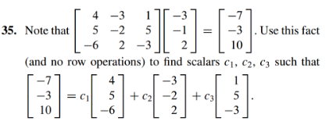

(1.4.5)

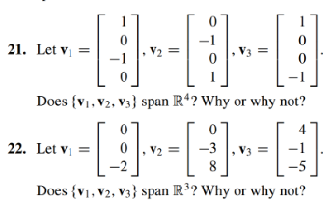

(1.4.6)

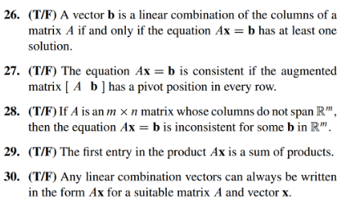

(1.4.7 theory question)

Prove:

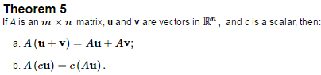

(1.4.1 solution)

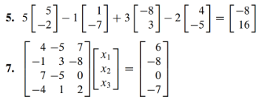

(1.4.2 solution)

Vector equation: 

Matrix equation: 

(1.4.3 solution)

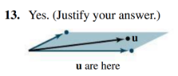

(1.4.4 solution)



(1.4.5 solution)

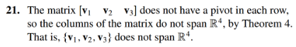

The matrix made up of the given three vectors does have a pivot in each row so the columns span R3.

(1.4.6 solution)

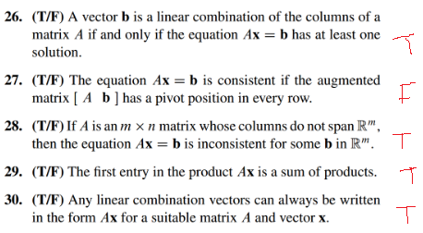

(1.4.7 theory solution)

