**Math 220  
1.2: Row Reduction and Echelon Forms  
Questions for flipped class**

(1.2.1)

Consider the given augmented matrix of a system”

* Row reduce the matrix to reduced echelon form.
* Circle the pivot positions in the final matrix and in the original matrix and list the pivot columns.
* Find the general solution of the system and write the answer in vector form.

(1.2.2)

Find the general solutions of the system whose augmented matrix is given:



(1.2.3)

Find the general solutions of the system whose augmented matrix is given:

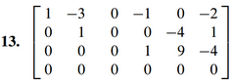

(1.2.4)

(a.)



(b.)



(c.)



(d.)



(1.2.5)



(1.2.6)

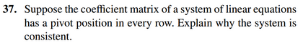

(1.2.7 theory questions)

a.) How would you go about proving that a solution is unique?

b.) What is the difference between constructing a solution and showing that a solution exists?

(1.2.1 solution)

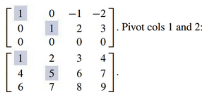

(1.2.2 solution)

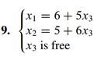

(1.2.3 solution)

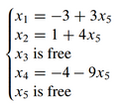

(1.2.4 solution)

a.) F – it’s unique

b.) F – the algorithm may be used on any matrix

c.) T

d.) T

(1.2.5 solution)

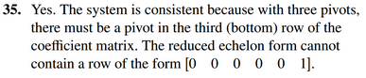

(1.2.6 solution)

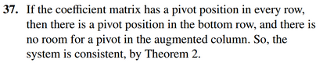

(1.2.7 theory solutions)

a.) How would you go about proving that a solution is unique?

Generally, we would assume that the solution is not unique (maybe solutions x and y) and then show that they must be equal.

b.) What is the difference between constructing a solution and showing that a solution exists?

When you construct a solution, you end with a formula for the solution. That is, you know exactly what the solution is. On the other hand, when you show that a solution exists, you may be proving that something is there, but not know anything about it other than that it exists.