**Math 220  
1.1: Systems of Linear Equations  
Questions for flipped class**

(1.1.1)

Consider the accompanying matrix as the augmented matrix of a linear system. State in words the next two elementary row operations that should be performed in the process of solving the system.

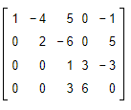

(1.1.2)

The augmented matrix of a linear system has been reduced by row operations to the form shown. Continue the appropriate row operations and describe the solution set of the original system.

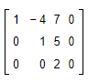

(1.1.3)

The augmented matrix of a linear system has been reduced by row operations to the form shown. Continue the appropriate row operations and describe the solution set of the original system.

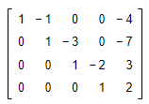

(1.1.4)

Solve the system using the matrix methods.

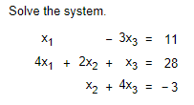

(1.1.5)

Determine the​ value(s) of *h* such that the matrix is the augmented matrix of a consistent linear system.

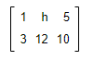

(1.1.6)

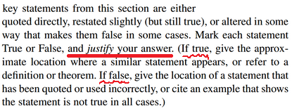

(1.1.7 theory question)

Rewrite statements (0.) and (2.) above as if-then statements. That is, if ________ then _________.

(1.1.1 solution)





(1.1.2 solution)



(1.1.3 solution)



(1.1.4 solution)



(1.1.5 solution)



(1.1.6 solution)

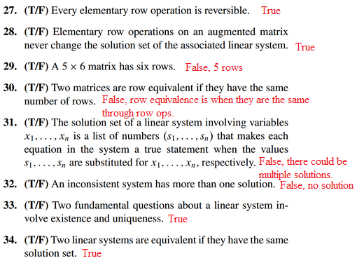

(1.1.7 solution)

Rewrite statements (0.) and (2.) above as if-then statements. That is, if ________ then _________.

1. If two matrices have the same number of rows, then the matrices are row equivalent.

(2.) If a system is inconsistent, then it has more than one solution.