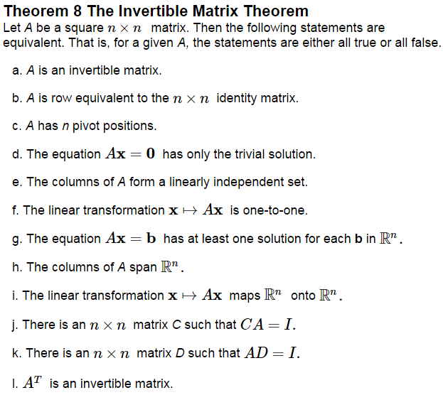

Theorem 5 from 2.2 could also make g. state ______________ solution.

If *A* and *B* are square matrices, and, then by j. and k. both *A* and *B* are invertible with  and .

The Invertible Matrix Theorem essentially divides the set of all  matrices into two disjoint classes:

Invertible

Not Invertible

Use the Invertible Matrix Theorem to determine if the following are invertible.

 

Be careful, the Invertible Matrix Theorem only applies to ____________ matrices.

If A is invertible, we can also think about __________________ in light of linear transformations.

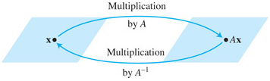

In general, a Linear Transformation  is ____________________ if there exists a function  such that



We call *S* the ____________________ of *T* and write it as ___________.

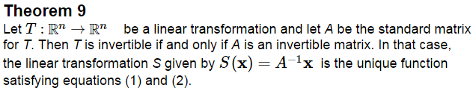

What can be said about a one-to-one linear transformation ?

**Practice Problems**

