Remember that the ___________________________ _____________ or ____________________ of a number, say 7 is ________ or ________. The actual definition of this is that



An (*)* matrix A is called ______________________ if there is a matrix *C* such that



( is the ** identity matrix.)

Here, C is called the _____________ of A. Is C unique?

Yes, so denote the inverse with  and



A matrix that is **NOT** invertible is called a ____________________ matrix while a matrix that **IS** invertible is called a __________________________ matrix.

If  and , verify that .

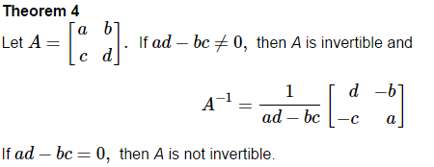

This value  is called the ____________________ and we write

So theorem 4 states that ______________________________ iff ___________.

Find the inverse of  .

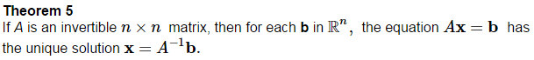

**Proof:**

Use the inverse of the matrix  from Ex 1    
to solve the system 

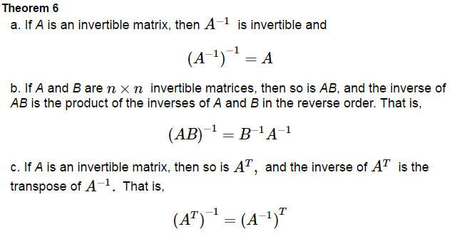

**Proofs:**

From Theorem 6b, we can extrapolate to the following.

 *(Read pages 108-109 on Elementary Matrices)*

We are going to look at finding the inverse of a matrix with a slightly different approach than this text.

If an  matrix *A* has an inverse, let’s call that matrix *B.*  Then



This can be written as:

We can think of this as many systems, where each solution forms the columns vectors of our matrix B.

We could solve each one of these individually, or stack them all together.

Find the inverse of  .

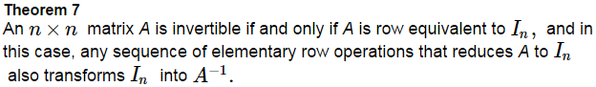

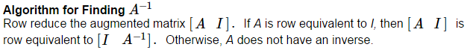

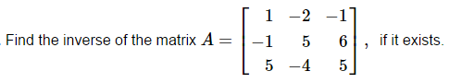

(Do this by hand – more practice.)