***Tangent Planes and Linear Approximations***

* **Review**

Recall from when you were first learning calculus that we sometimes refer to the slope of the tangent line to a curve at a point as the **slope of the curve** at the point. The idea is that if we zoom in far enough toward the point, then the curve looks almost like a straight line. For example, in the pictures below, we zoom in on the curve of  near . The more we zoom in, the more the parabola looks like a line. In other words, the curve becomes nearly indistinguishable from its tangent line.

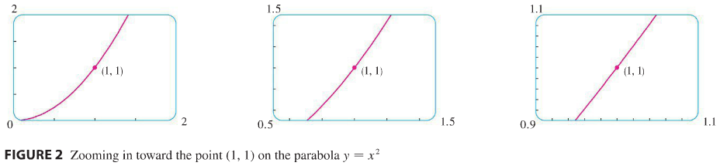

Later, we build upon the idea of a tangent line in order to approximate functions. The idea was that it might be easy to calculate a value  of a function, but difficult (or even impossible) to compute nearby values of *f*. So we settled for the easily computed values of the linear function *L* whose graph was the tangent line of *f* at .

In other words, we use the tangent line at  as an approximation for the curve  when *x* is near *a*.

|  |  |
| --- | --- |
| An equation of this tangent line is  and the approximation  is called the **linear approximation** or **tangent line approximation** of *f* at *a*. The linear function whose graph is this tangent line, that is, .  To make sure we understand this, let’s look at an example! |  |

**Example 1**: Find the linearization of the function  at  and use it to approximate .

In this section we develop similar ideas in 3D. As we zoom in toward a point on a surface of the graph of a differentiable function of two variables, the surface looks more and more like its tangent plane. We can approximate the surface by a linear function of two variables.

* **Tangent Plane**

|  |  |
| --- | --- |
| Recall that if  is a smooth parametric curve in 3D, then the tangent line to  at a point  is the line through  along the unit tangent vector to  at . |  |

The concept of a tangent plane builds upon this definition. If  is a point on surface , and if the tangent lines at  to all smooth curves that pass through  and lie on the surface  lie on a common plane, then we shall regard that plane to be the **tangent plane** to the surface at .

|  |  |
| --- | --- |
|  | Chapter 2: Section 4: Part 2 |

Definition: We say that  is **differentiable** at if  and  exist near and the partials are continuous at.

Logic questions (just for fun):

* Is it possible for a function  to be differentiable at  even though  and  do not exist at ?
* Is it possible for a function  to be non-differentiable at  even though  and  exist at ?

The tangent plane to the surface of function  at  exists if and only if  is **differentiable** at .

But how do we find the tangent plane?

Suppose we are given a surface  and asked to find the tangent plane at point . We recall that finding the equation of a plane requires that we know a point (which we already have) and a normal vector.

To find the normal vector, notice that at given point, the partial derivatives give the slope of vectors along the plane in the *x* and *y* directions.

* In the *x* direction: The slope is  and the vector is ____________________________.
* In the *y* direction: The slope is  and the vector is ____________________________.
* This means the normal vector to the plane at point  is _______________________________.

Recall: The **scalar equation of the plane** through the point  with normal vector  is 

Thus the equation of the tangent plane is: 

**Example 2**: Find the equation of the tangent plane to the surface  at the point .

Explore: Let’s look at  and its tangent plane with graphing software using the viewing window …crazy shape! It is hard to see where the plane and the surface really intersect. But we know the point is . Let’s get close by using these viewing windows:



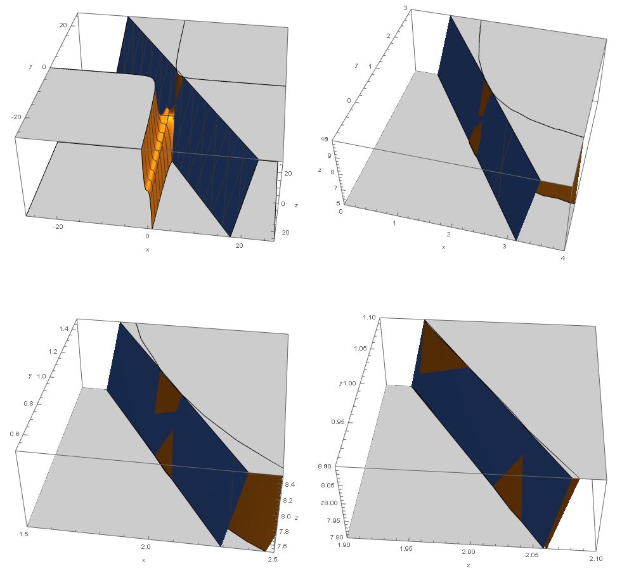

Notice that the closer we get to the point, the flatter the graph of the surface becomes and closer to the tangent plane. This observation is what we will use when we perform linear approximation in 3D.

* **Linear Approximation** **/** **Tangent Plane Approximation**

In the previous example, we found the equation of tangent plane to the function  at the point  to be . This can be written as . This function is called the **linearization** of  at .

The approximation  is called the **linear approximation** or **tangent plane approximation** of  at .

To see how this works, find and .

Note that if we look at a point farther from , for example , we no longer get a good approximation.

Now let’s find a general formula for **linearization** of  at **:**



Since , . Consider the point  in 3D: 



Definition: We say that the **linear approximation** or **tangent plane approximation** of  at  is:



Note:  is called **differentiable** at  if both  and  exist and the linearization of  at  closely approximates  when  is sufficiently close to .

**Example 3**: Show that  is differentiable at . Find its linearization and use it to approximate .

* ***Differentials***

Review of Differentials: Recall that if  is a differentiable function, then we defined the **differential** of , defined by , is an independent variable (which can be any real number). The **differential** of , defined by , is then dependent on  and can be defined by equation: .

To understand the geometric meaning of this, consider the given graph:

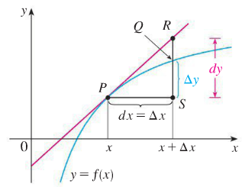

 and  are on the curve . They are  away from each other. Then is the *exact* change between their  values.

is on the tangent line,  away from  and the change between their  values is .

* What is the slope of this tangent line, using rise over run?
* What is the slope of this tangent line, using concept of calculus?

Therefore  represents the amount that the tangent line rises or falls (the change in linearization) and is the *approximate change*. On the other hand  represents the *exact* amount that the curve rises or falls.

Now let’s take this to 3D.

|  |  |
| --- | --- |
| For a differentiable function of two variables, , we define the **differentials** *dx* and *dy* to be independent variables (that is, they can be given any values). Then the **differential** *dz*, also called the **total differential**, is defined by:    This may look intimidating, but it is actually straight-forward. The total differential is the change in height on a tangent plane. |  |

In words: 

Remember:

  approximate change in height of the surface

  exact change in height of the surface

**Example 4**: Let .

1. Find the differential .
2. Use total differential to approximate the change in this function as  varies from  to .
3. Is the value you found in part (b.) close to the actual value of the fall/rise of the curve as you move from point  to point?

* ***Functions of Three or More Variables***

Linear approximations, differentiability, and differentials can be defined in a similar manner for functions of more than two variables.

In particular, if , then the **differential** *dw* is given by 

**Example 5**: Find the differential of the function 