***Functions of Several Variables***

So far we have dealt with the calculus of functions of a single variable. But, in the real world, physical quantities often depend on two or more variables. So now we turn our attention to functions of several variables.

* **Functions of Two or More Variables and Their Domains**

A function of two or more variables is a rule assigning a real number to every point in its domain. So, the domain is a subset of  and the range is a subset of .

There are many familiar formulas that depends on two or more variables. For example,

* Area of a triangle: 
* Volume of a box: 
* Average of a list of *n* values: 

We use the following notation:



Definition: A **function *f* of two variables** is a rule that assigns to each ordered pair of real numbers  in a set *D* a unique real number denoted by . The set *D* is the **domain** of *f* and its **range** is the set of values that *f* takes on, that is .

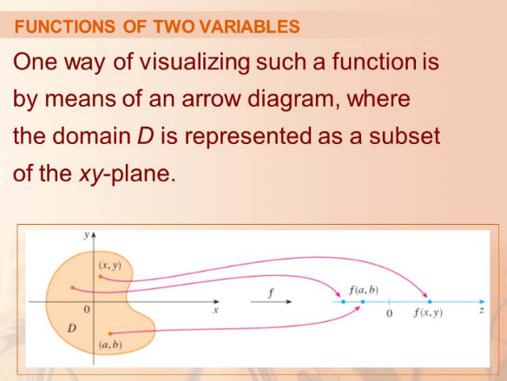**Domain**: If a function is given by a formula

and no domain is specified, then the domain

is the set of all points for which the given

expression is a well-defined real number

(no zero in the denominator, no negative

under radical of even index, no zero or

negative when taking logs,…)

**Example 1**: Evaluate  at the following:

1. 
2. What is the domain of this function? Can you graph it?

**Example 2**: Sketch the domain of the following functions.

1. 
2. 

* **Graph of Multivariable Functions**

Recall that for a function  of one variable, the graph of  was defined to be the collection of all the points  where . Similarly, the graph of  is defined to be the collection of all the points  where . Previous examples we have seen of this include planes and quadric surfaces in three dimensions.

Definition: If *f* is a function of two variables with domain *D*, then the **graph** of *f* is the set of all points  in  such that  and  is in *D*.

**Example 3**: Sketch 

The surfaces we studied previously are “easy” to graph by hand but many others are not! There are computer programs that are capable of graphing functions of two variables – surfaces in 3D. In most programs, traces in the vertical planes  and  are drawn for equally spaced values of .

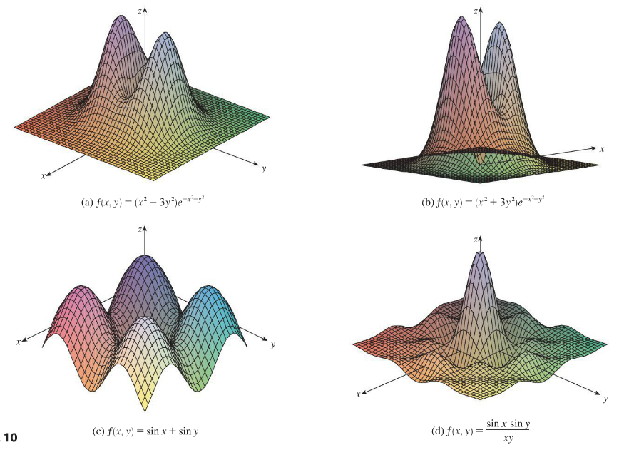

These figures are an example of computer-generated graphs. Note that (a) and (b) are the same function from two different perspective. You can see that the graph is becoming flat as you move away from the origin. This is because approaches zero ( aka the *xy*-plane) as  and/or  become larger.

* **LevelCurves**

Functions of two variables can be represented as surfaces, and can be described in two dimensions by contour maps and horizontal traces which are called **level curves**.

Definition: The **level curves** of a function *f* of two variables are the curves with equations , where *k* is a constant (in the range of *f*).

|  |  |
| --- | --- |
| A level curve  is the set of all points in the domain of *f* at which *f* takes on a given value *k*. In other words, it shows where the graph of *f* has height *k*.  In the picture, you can see the relation between level curves and horizontal traces. The level curves  are just the traces of the graph of *f* in the horizontal plane projected down to the *xy*-plane. So if you draw the level curves of a function and visualize them being lifted up to the surface at the indicated height, then you can mentally piece together a picture of the graph. The surface is steep where the level curves are close together. It is somewhat flatter where they are farther apart. |  |

Note: A graph made up of level curves is called a **contour plot**. Outside of math, perhaps you have seen a **topographical map**. This is (roughly) the same thing.

Important detail: When constructing a contour plot, the level curves should be equally spaced. For example  or  In the picture above, the level curves are graphed for 

**Example 4**: Recall the function in the previous example,  . What are the level curves? Sketch them for few values!

* **Level Surfaces**

The concept of a level curve for a function of two variables can be extended to functions of three variables. If  is a constant, then an equation of the form  will, in general, represent a surface in 3D. The graph of this surface is called the level surface with constant  for the function . They are generally more difficult to visualize than functions of two variables.

**Example 5**: Describe the level surface of the following functions.

1.  b) 

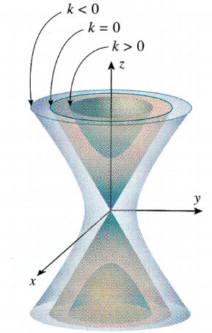

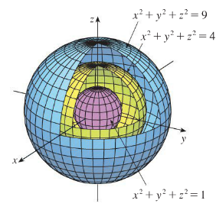

Note: In the spherical example, the values of *k* pictured are not equally spaced.