***Vector Functions and Space Curves***

In general, a function is a rule that assigns to each element in the domain an element in the range.

In this section we will look at **vector functions** in 3D.These are functions whose domain is a set of real numbers and whose range is a set of vectors, .

 is used to indicate the independent variable (input) because it often (but not always) represents time.  is the dependent variable (output) defined as:



Where  and  are real-valued functions called the **component functions** of .

**Example 1**: Find the domain of .

The **limit** of a vector function **r**is defined by taking the limits of its component functions as follows.

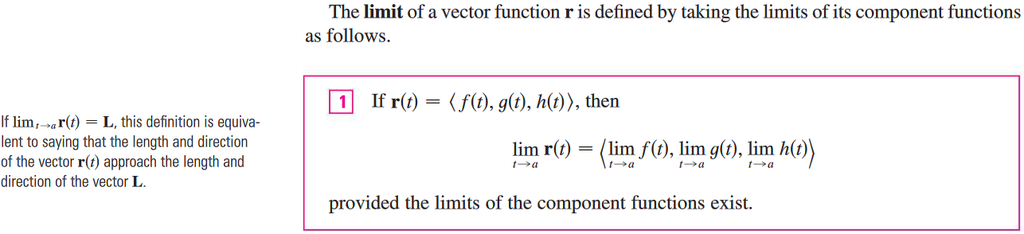

**Example 2**: Find  where .

A vector function  is continuous at  if . That is if and only if its component functions are continuous at .

|  |  |
| --- | --- |
| There is a close connection between parametric equations and space curves.   * Parametric equations: * Space curve:   For the given space curve,  is the position vector of the point *P* on *C*. |  |

Plane curves can also be represented in vector notation. For instance, the curve given by the parametric equation  could be described by the vector equation:



where  and .

We need to be able to identify and explain curves whose vectors are given and vice versa. For example, we have learned to write and identify the parametric equations of lines, circles, and ellipses.

**Example 3**: Sketch the curve whose vector equation is: 

|  |  |
| --- | --- |
| This curve is called a **helix**. |  |

|  |
| --- |
| **Into the helix**: A helix is a shape like a corkscrew or spiral staircase. It is a type of smooth space curve with tangent lines at a constant angle to a fixed axis. Helices are important in biology, as the DNA molecule is formed as two intertwined helices. The word helix comes from the Greek word for "twisted, curved". A "filled-in" helix – for example, a "spiral" (helical) ramp – is a surface called helicoid. The pitch of a helix is the height of one complete helix [turn](https://en.wikipedia.org/wiki/Turn_(angle)), measured parallel to the axis of the helix. |

**Example 4**: Graph the following functions using technology.

1. 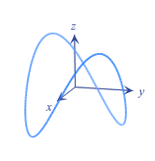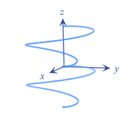 b) 

**Example 5**: Sketch the curve . Indicate the direction and think about its projection on -plane.

**Example 6**: Find a vector equation and parametric equations for the line segment that joins  and .

**Example 7**: Find a vector valued function that represents the curve of intersection of the two surfaces: The paraboloid and the parabolic cylinder .