***Vectors***

Some quantities such as length, area and temperature are determined by a number, which is called the *magnitude.*  Such quantities are called **scalar**.  On the other hand, to describe the displacement of an object, two numbers are required: the *magnitude* and the *direction*.  Similarly, while describing the velocity of a moving object we discuss the speed and direction of travel.  Quantities such as displacement, velocity, acceleration and force that involve *magnitudes* as well as *direction* are called **direct quantities**.  One way to represent such quantities mathematically is through the use of **vectors**.

A **vector** in the plane is a line segment (has magnitude-length) with an assigned direction.  The vector as shown has **initial point**  and **end point**.  Its magnitude is denoted by .







Two vectors are considered **equal** if their magnitude and direction are the same. All the vectors shown above are the *same*!  To understand this better, think about a vector as a displacement.  No matter how I get from one point (initial point) to the other (endpoint) or where those points are, my displacement is the same.

* **Sum of Vectors**

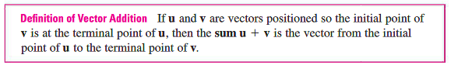

To find the sum of two vectors geometrically, do one of the following:

1. Triangle Law: Sketch vectors equal to the ones you need to add, with the initial point of one at the terminal point of the other.





1. Parallelogram Law: Sketch vectors equal to the ones you need to add, starting at the same point. Create a parallelogram and its diagonal is the sum.





**Example 1**: Sketch .





* **Multiplication of Vectors by a Scalar**

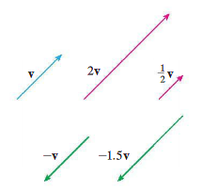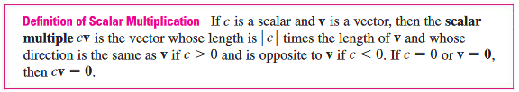

* **Difference of Vectors**

The difference of two vectors  and  is defined by  where  is the vector that has the same length as  but opposite direction.  To find the difference geometrically use the parallelogram.





**Example 2**: Sketch .





* **Components**

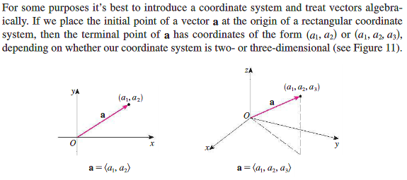

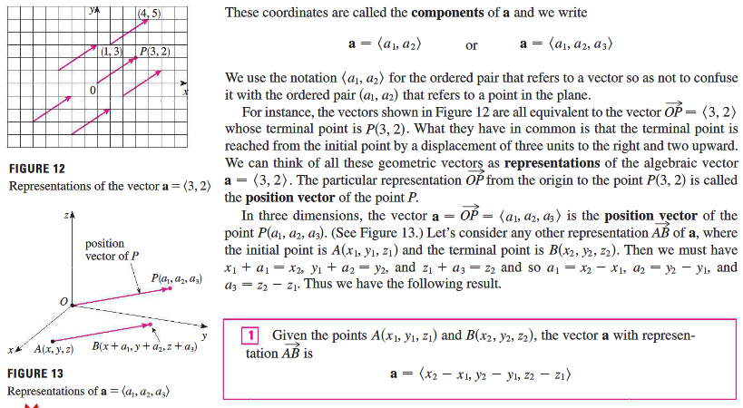

**Example 3**: Find the vector represented by the directed line segment with initial point and terminal point .

The **magnitude** or **length** of the vector **v** (also written ) is the length of any of its representations and is denoted by the symbol  or . By using the distance formula to compute the length of a segment *OP*, we obtain the following formulas.

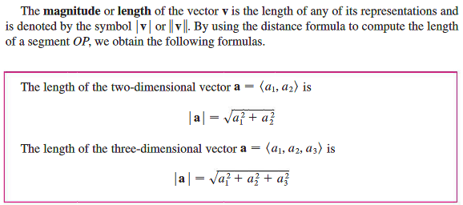

To add, subtract, or find scalar multiples of a vector, perform the operations component-wise.

|  |  |
| --- | --- |
|  |  |

**Example 4**: If  and  find the following:

1. 
2. 
3. 
4. 
5. 

**Example 5**: Find the component form and length of the vector with initial point and terminal point .

**Example 6**: A small cart is being pulled along a smooth horizontal floor with a 20-lb force making a angle to the floor. What is the effective force moving the cart forward?

Hint: the effective force is the horizontal component of 

We denote by  the set of all two-dimensional vectors and by  the set of all three-dimensional vectors. More generally, in subsequent math courses, we will need to consider the set  of all *n*-dimensional vectors. An *n*-dimensional vector is an ordered *n*-tuple:  where  are real numbers that are called the components of . Addition and scalar multiplication are defined in terms of components just as for the cases *n* = 2 and *n* = 3.

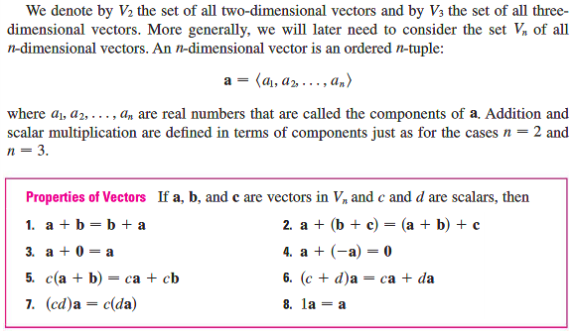

Three vectors in  play a special role. Let

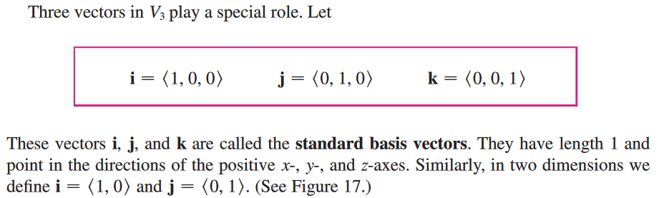

These vectors  are called the **standard basis vectors**. They have length 1 and point in the directions of the positive *x*-, *y*-, and *z-*axes. Similarly, in two dimensions  and .

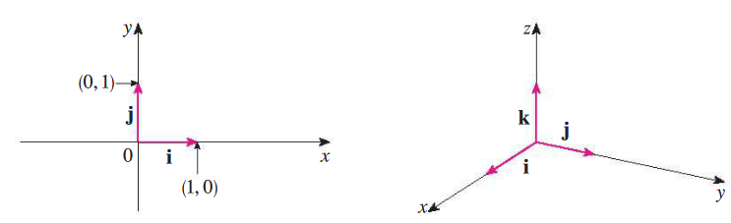

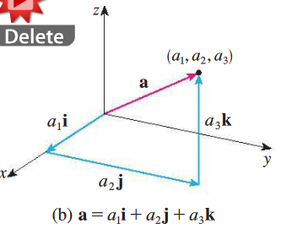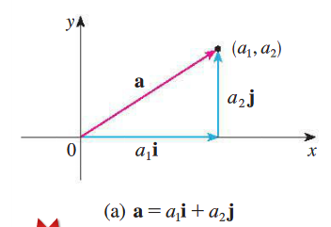Any vector can be written using the standard basis vectors.

**Example 7**: Express the following vectors in term of standard basis vectors.

1. 
2.  where and 

A **unit vector** is a vector whose length is 1. For instance,  are all unit vectors. In general, if , then the unit vector that has the same direction as  is .

**Example 8**: Find a unit vector in the direction of the vector from  to .

|  |
| --- |
| **Historical note**: The first mathematician to present a detailed theory of spaces of dimension greater than three was Hermann Grassmann (1809-1877). Grassmann was born and lived for most of his life in Stettin in Pomerania, now Szczecin, Poland. Although at the University of Berlin he mostly studied philology and theology, after leaving the university he returned to Stettin to pursue work in mathematics and physics to prepare himself to pass the state examination for teachers in those subjects. He subsequently taught briefly at a Berlin technical school and, after 1836, at various schools in his hometown. His great ambition in life was to qualify for a university position, but although he developed the ideas of the theory of **vector spaces**, few people read his efforts or recognized his great originality. Grassmann sent copies of his book to several influential mathematicians, but the only one who commented favorably on it was Hermann Hankel, a student of Riemann’s, who planned to include some of Grassmann’s material in his own book on complex variables. In the 1860’s Grassmann turned his attention to the subject of languages and made some important scholarly contributions to the study of Sanskrit. His later mathematics works, however, were of lesser quality and he never attained his goal of a university professorship.[1] |

**Example 9**: If is a velocity vector, express it as a product of its speed times a unit vector in the direction of motion.

* **Applications**

|  |  |
| --- | --- |
| Here is a preliminary example of an application that I learned about the hard way. A roof valley is where two roof planes meet.  Further, the pitch of a roof (steepness) in the U.S. is generally given as a ratio such as 4:12 which means that the roof has 4 inches of rise for every 12 inches of run. The second number is always given as 12. | A Guide to the Various Types of Roofing Valleys for Your Home - Southern  Premier Roofing |

**Example 10**: Suppose one plane of a roof has a 6:12 pitch and it is intersected by a second plane that has a pitch of 4:12. What is the pitch of the valley where the two planes meet?

**Example 10**: A jet airliner, flying due east at  mph in still air, encounters a -mph tailwind blowing in the direction north of east. The airplane holds its compass heading due east but, because of the wind, acquires a new ground speed and direction. What are they?

A very important application of vectors is **force**. This is a major theme in physics and engineering and will be revisited extensively in Calculus IV.

**Force** is also represented by a vector measured in Newtons (in the English system, pounds are a measure of force). If several forces are acting on an object, the result force experienced by the object is the vector sum of these forces.

**Example 11**: Lisa and Rose exercise at CrossFit. One of their trainings is to pick up a -lb weight (together) for a few seconds. Lisa is shorter than Rose, so they feel different amount of tension on their arms. Use the figure to find each tension.





In the last couple of examples, we have had to solve systems of equations. An efficient way to do this using a calculator involves matrices.

* **To Create a Matrix**

Press MATRIX, EDIT, ENTER and put in the correct dimensions and fill in the elements

* **To Add, Subtract, Divide, or Multiply two matrices**

Press MATRIX, arrow down to the matrix you want, press ENTER

This will put the matrix in your calculation screen

Press the appropriate operation (+, -, /, *)

Press MATRIX and arrow down to the matrix you want to add, press ENTER

Press ENTER

* **To Solve Linear Equations using matrices**

Create a coefficient matrix corresponding to the equation

Press MATRIX, MATH, and arrow down to “rref” and press ENTER

Press MATRIX, arrow down to the matrix you want and press ENTER

Press ENTER

|  |  |
| --- | --- |
| If you have a system:    the “augmented matrix” is    The “reduce row Echelon form” is    So the solution is: | Creating an (augmented) matrix    Reduced row echelon form (the solution) |

1. From A History of Mathematics, 3rd Ed. By Victor Katz. Pages 862-3.