**Math 163: A somewhat Historical Approach to Power Series  
PS4: Focus on the coefficients  
Questions for flipped class**

**(PS4.2)**

Find a power series representation for  using long division (Hint: Remind yourself how long division works with decimals: To find  in decimal form, calculate . Show the work as it will help you with the polynomial division ).

**(PS4.1)**

Remind yourself how long division works with decimals: To find  in decimal form, we calculate 

**(PS4.3)**

Find a power series representation for  two ways … using (i.) using long division and (ii.) by manipulating the geometric series.

**(PS4.4)**

Find a somewhat general solution to  using power series.

To do this, rewrite the equation above assuming a power series solution of the form below



(Notice ):

Then set up equations matching coefficients. Separate the even and odd coefficients/terms.

**(PS4.1 solution)**

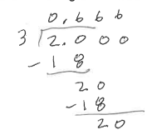

**(PS4.2 solution)**

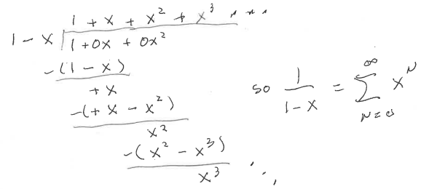

**(PS4.3 solution)**

**(PS4.4 solution)**



