**Math 163  
PS3: A somewhat Historical Approach to Power Series, Lesson 3  
Questions for flipped class**

**(PS3.1)**

Evaluate the indefinite integral as a power series.

**(PS3.3)**

Find a power series representation for 

**(PS3.2)**

Use a power series to approximate the definite integral  to six decimal places.

**(PS3.4)**

Find a power series representation for .

**(PS3.5)**

Evaluate the indefinite integral as a power series.

**(PS3.6)**

Use the power series for  to prove the following expression for  as the sum of an infinite series:



**(PS3.1 solution)**

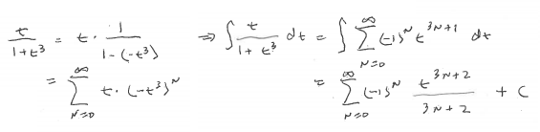

**(PS3.2 solution)**

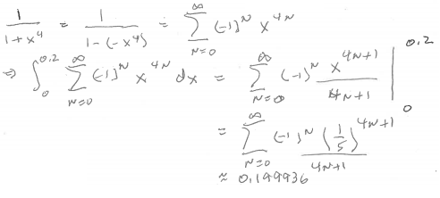

**(PS3.3 solution)**

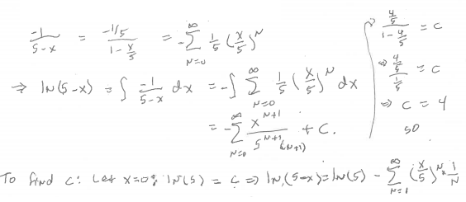

**(PS3.4 solution)**

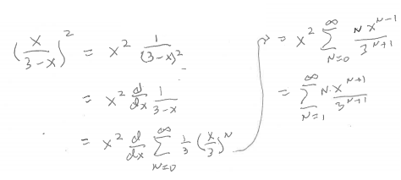

**(PS3.5 solution)**

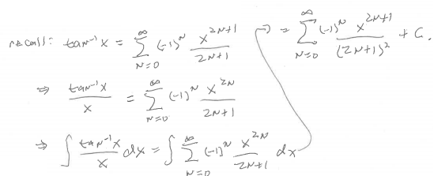

**(PS3.6 solution)**

