**Math 163  
15.1: Double Integrals over Rectangles  
Questions for flipped class**

**(15.1.1)**

Estimate the volume of the solid that lies below the surface  and above the rectangle 

Use a Riemann sum with  and  and take sample points in the upper right corner of each sub rectangle.

**(15.1.5)**

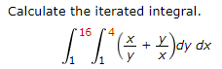

**(15.1.2)**

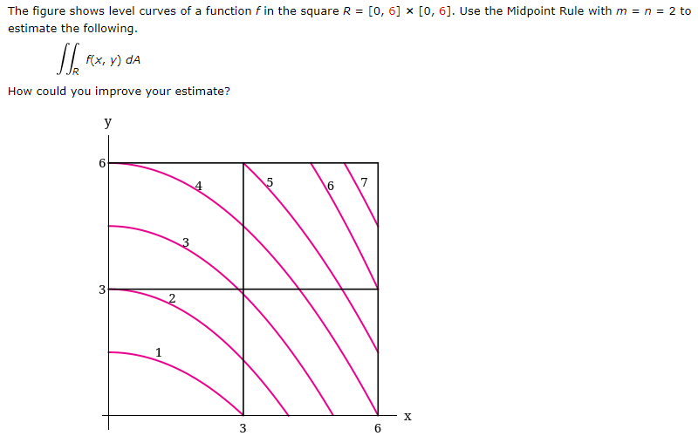

**(15.1.3)**

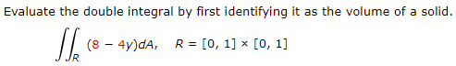

**(15.1.4)**

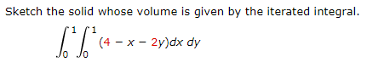

**(15.1.6)**

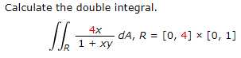

**(15.1.1 solution)**

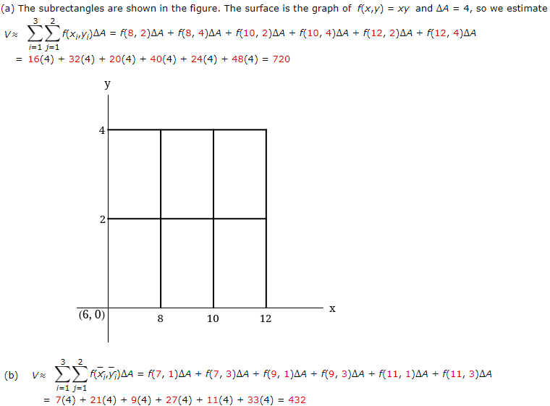

**(15.1.2 solution)**

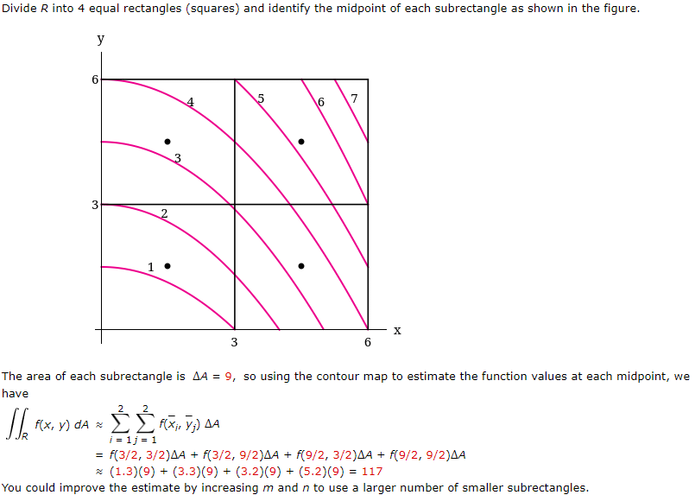

**(15.1.3 solution)**

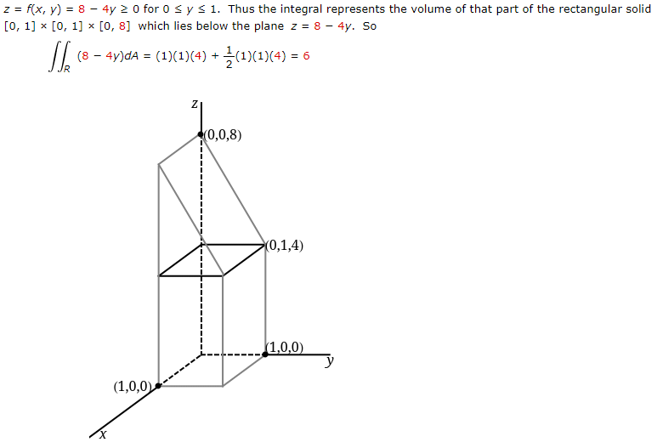

**(15.1.4 solution)**

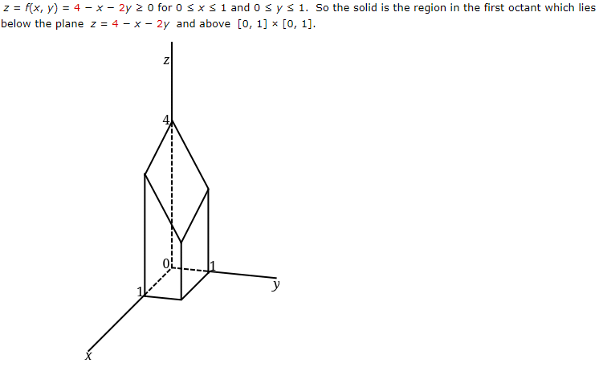

**(15.1.5 solution)**

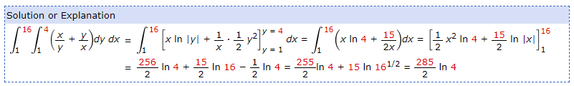

**(15.1.6 solution)**

