**Math 163  
14.5: The (Multivariate) Chain Rule  
Questions for flipped class**

**(14.5.1)**



**(14.5.2)**



**(14.5.3)**

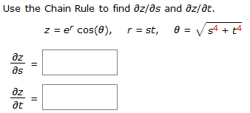

**(14.5.4)**



**(14.5.5)**



**(14.5.6)**



**(14.5.1 solution)**

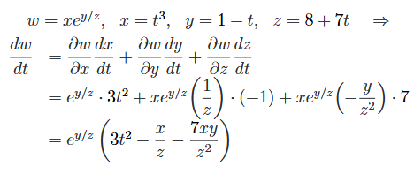

**(14.5.2 solution)**

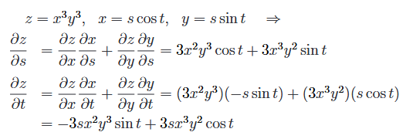

**(14.5.3 solution)**

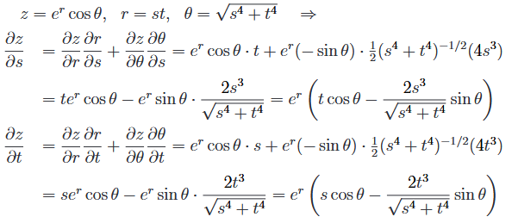

**(14.5.4 solution)**

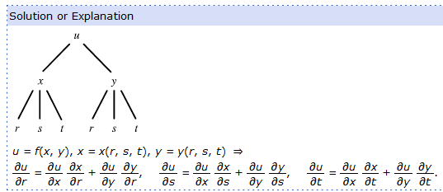

**(14.5.5 solution)**

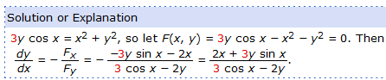

**(14.5.6 solution)**

