**Math 163  
14.4: Tangent Planes and Linear Approximations  
Questions for flipped class**

**(14.4.1)**

Find an equation of the tangent plant to  at the point 

**(14.4.3)**

Find the linear approximation of  at  and use it to approximate . (Round to five decimal places).

**(14.4.2)**

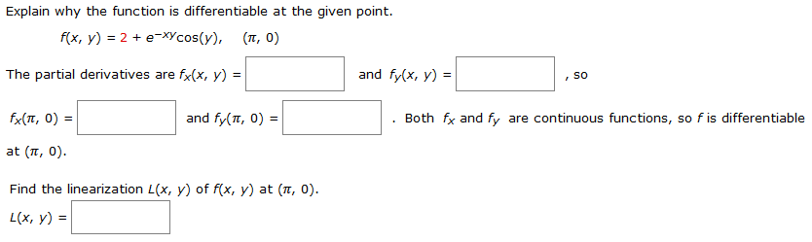

**(14.4.4)**

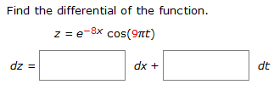

**(14.4.5)**



**(14.4.6)**



**(14.4.1 solution)**

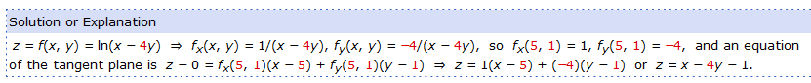

**(14.4.2 solution)**

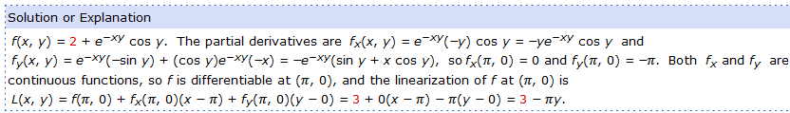

**(14.4.3 solution)**

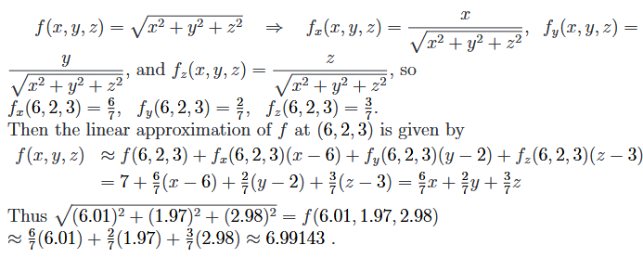

**(14.4.4 solution)**

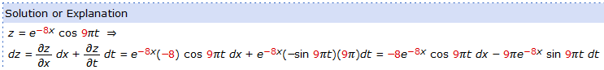

**(14.4.5 solution)**

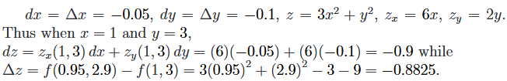

**(14.4.6 solution)**

