**Math 163  
14.1: Functions of Several Variables  
Questions for flipped class**

**(14.1.4)**

Level curves (isothermals) are shown for the typical water temperature (in Celsius) in Long Lake (Minnesota) in 1998 as a function of depth and time of year. (i.) Estimate the temperature in the lake on August 8 (day 220) at a depth of 10 m. (ii.) Estimate the temperature on October 7 (day 280) at a depth of 5 m.

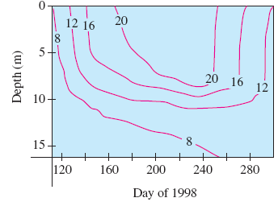

**(14.1.5)**

Carefully draw a contour map of  showing at least 7 level curves. What if it was a square root?

**(14.1.1)**



**(14.1.2)**



**(14.1.3)**



**(14.1.6)**



**(14.1.1 solution)**

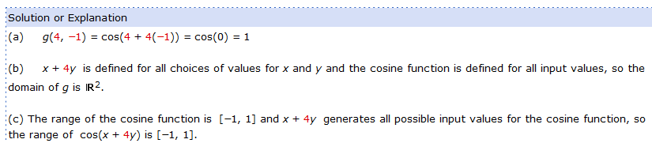

**(14.1.2 solution)**

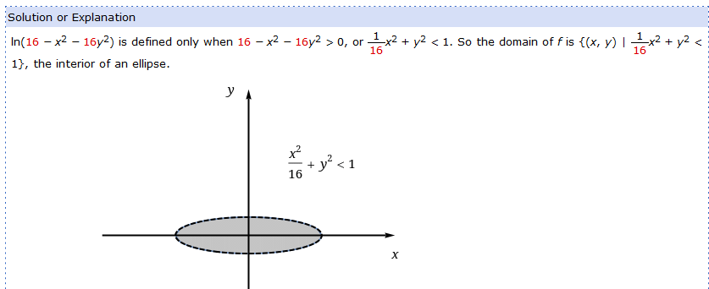

**(14.1.3 solution)**

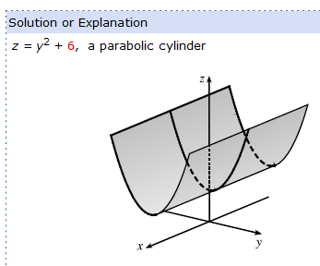

**(14.1.4 solution)**

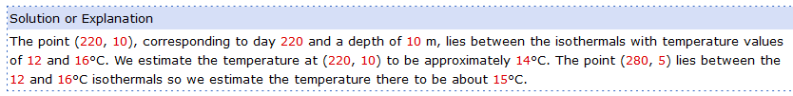

**(14.1.5 solution)**

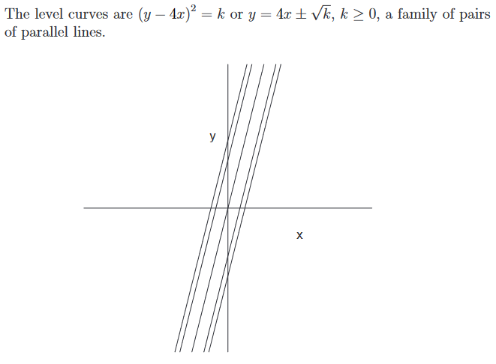**(14.1.6 solution)**

