**Math 163  
13.4: Motion in Space  
Questions for flipped class**

**(13.4.3)**

Find the velocity and position vectors of a particle that has acceleration , initial velocity  and initial position .

**(13.4.4)**

Find the tangential and normal components of acceleration of the particle whose position is given by .

**(13.4.1)**



**(13.4.2)**



**(13.4.5)**



**(13.4.6)**



**(13.4.1 solution)**

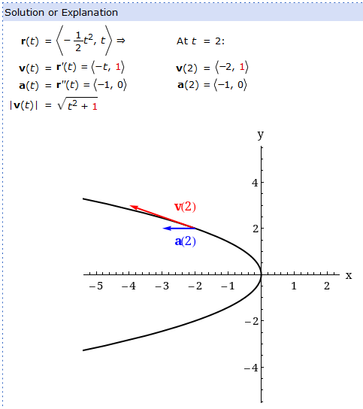

**(13.4.2 solution)**

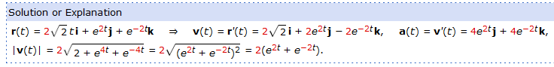

**(13.4.3 solution)**

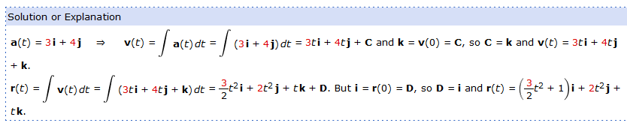

**(13.4.4 solution)**

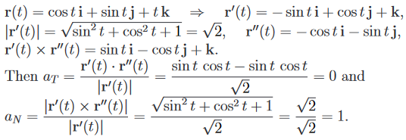

**(13.4.5 solution)**

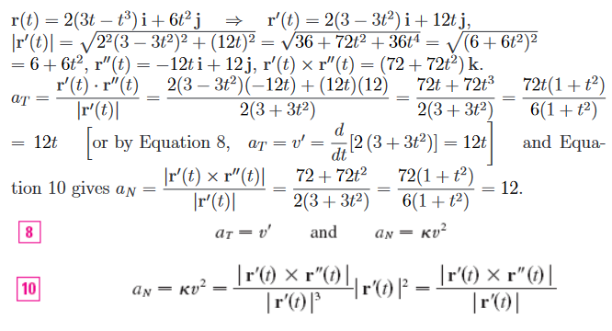

**(13.4.6 solution)**

