**Math 163  
13.3: Calculus with Parametric Equations  
Questions for flipped class**

**(13.3.1)**

Find the length of the curve  on 

**(13.3.3)**

Find the curvature of 

**(13.3.2)**

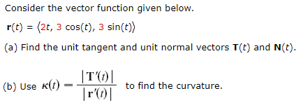

Find (a.) the unit tangent vector, (b.) the unit normal vector and (c.) the curvature of the curve at *t*.

**(13.3.4)**

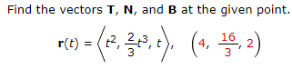

**(13.3.5)**

The function has a minimum at . Find the equation of the kissing circle to  and graph the function and kissing circle on the same grid (using a graphing calculator).  
  
Hint: Look in the book for a 4th curvature formula … for   
  
Hint: The graphing is easier if done parametrically.

**(13.3.6)**

Go back to (13.3.2) and find the parametric equations of the kissing circle when 

**(13.3.1 solution)**

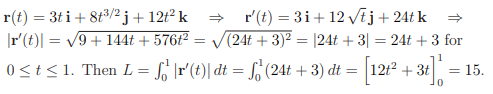

**(13.3.2 solution)**

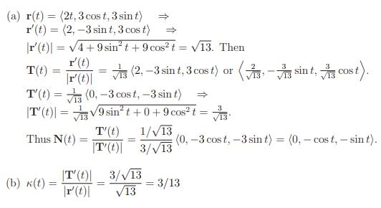

**(13.3.3 solution)**

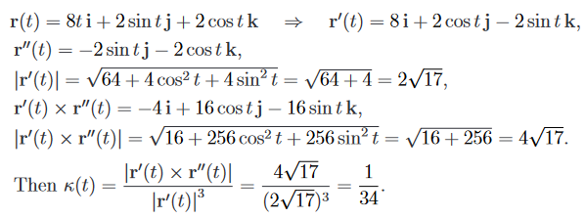

**(13.3.4 solution)**

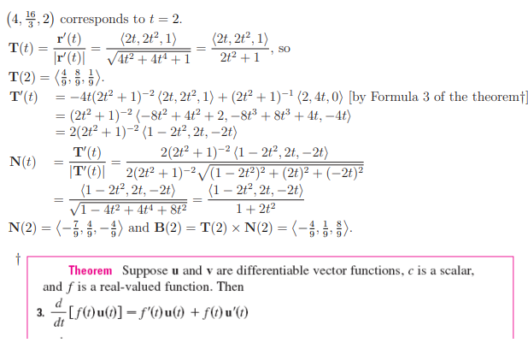

**(13.3.5 solution)**

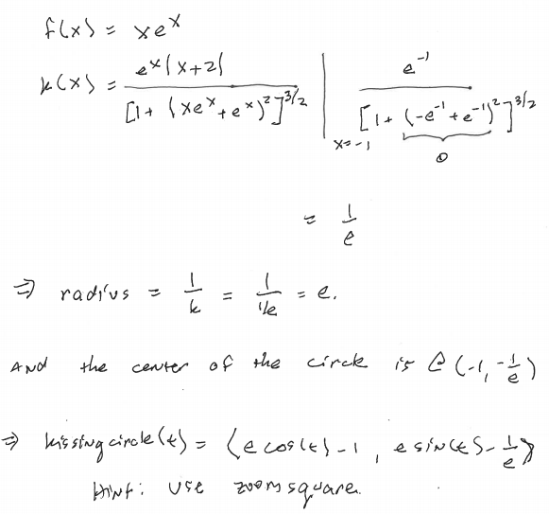

**(13.3.6 solution)**

