Math 163
13.2: Derivative and Integrals of Vector Functions
Questions for flipped class

(13.2.1)
Consider the vector equation
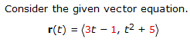
Find the derivative and sketch the (a.) plane curve together with the (b.) position vector and (c.) tangent vector at t = 2.

(13.2.2)
Find the unit tangent vector of the given curve at the point with the parameter value t = 0

(13.2.3)

(13.2.4)
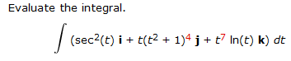

(13.2.5)
Find parametric equations for the tangent line to the curve with the given parametric equations at the specified point.

(13.2.6)

(13.2.1 solution)
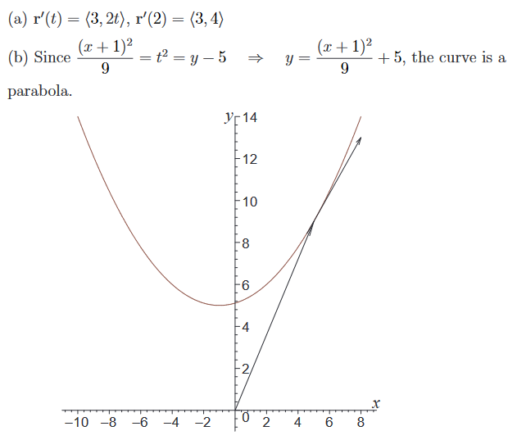

(13.2.2 solution)
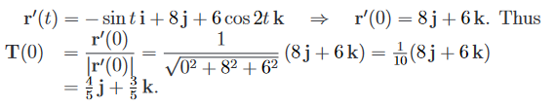

(13.2.3 solution)
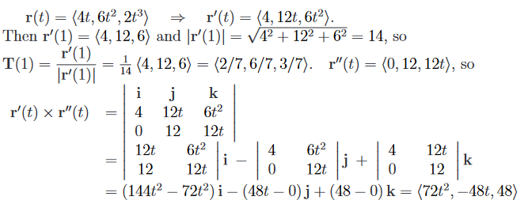
(13.2.4 solution)
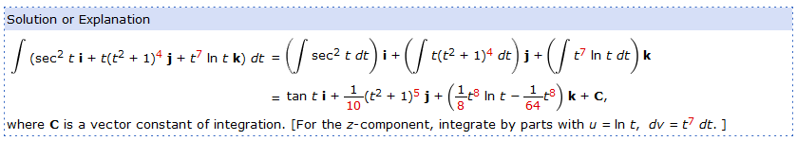
(13.2.5 solution)
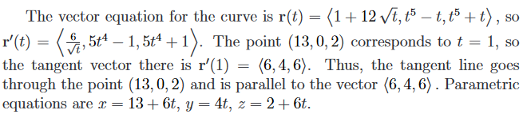
(13.2.6 solution)
